Name: Ibe Chidumebi Theodora
Matric no: 17/MHS01/141
Course: Gross anatomy of head and neck
Date: 30th April 2020.
Assignment:1. Discuss the anatomy of the tongue and comment on its applied anatomy
2. Write an essay on the air sinuses

1.The tongue is a muscular organ situated on the floor of the mouth. It is associated with functions of speech, mastication and deglutition. It has an oral part that lies in the pharynx. It is associated with functions of speech, mastication and deglutition. It has an oral part that lies in the pharynx

Development of the tongue
- Development begins at the 4th week of the gestation.
- The tongue develops in relation to the pharyngeal arches in the developing
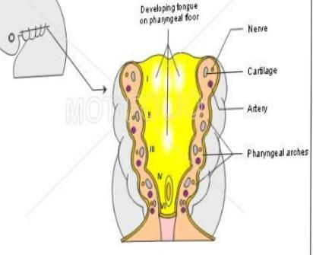
mouth.

Development of Anterior 2/3rd of the tongue
- Formed by fusion of
A. 2lingual swellings
b.Tuberculum impart,

- Thus derived from first branchial arch.
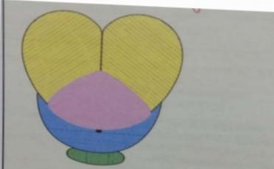
- It is supplied by lingual nerve ( post – trematic) and chords tympani (pre-tramatic)

Development of the Posterior 1/3 of the tongue
- From the cranial half of the hypobranchial eminence, I.e, from the third arch.
- Supplied by gloss I pharyngeal nerve.
Development of the most Posterior part
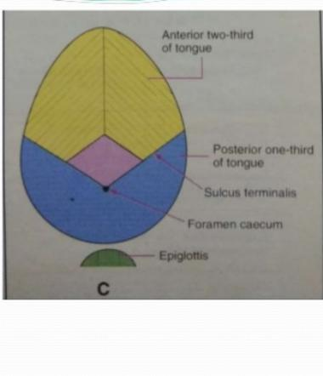
- From the 4th arch

Development of the Musculature of the tongue
- Derived from occipital myotomes
- Nerve supply is by hypoglossal nerve

Anatomy of the tongue
The tongue has:
- A root
- A tip/apex
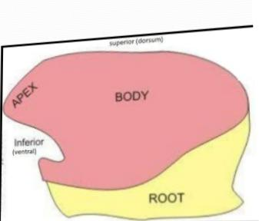
- A body which has a curved upper surface or dorsum and an inferior surface.
The root is attached to the mandible and soft palate above and to the hyoid bone below.
The tip of the tongue forms the anterior free end which at rest lies behind the upper incisor.
The dorsum of the tongue is convex and divided into:
- The oral part or anterior 2/3rds
- A pharyngeal part or posterior 1/3rd

It is associated with functions of speech, mastication and deglutition. It has an oral part that lies in the pharynx

DORSAL SURFACE
Oral part
Anterior two third;
- Mucosa is rough
- Shows four types of papillae
i. Filiform
ii.. Fungiform
iii.Vallate
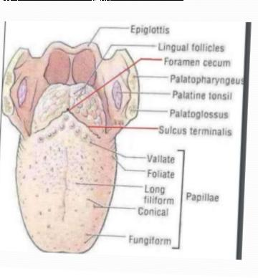
iv.Foliate

Papillae of the tongue
These are projections of the mucous membrane which gives the anterior 2/3rds of the tongue its characteristics roughness.

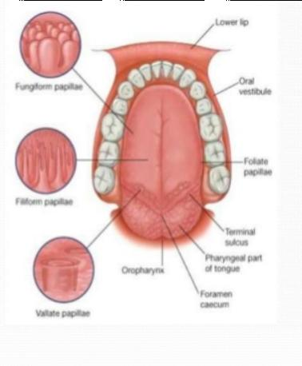
Filiform pappilae
- Makes up majority of the papillae and covers the anterior part of the tongue.
- They appear as slender, threadlike keratinized projections
- These papillae facilitates mastication( by compressing and breaking food when tongue is apposed to the hard palate) and movement of the food on the surface of the tongue.
- No taste buds.

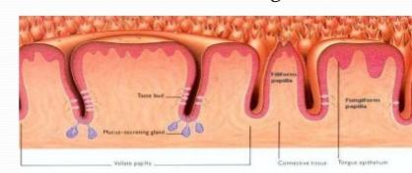
Vallate papillae
- Largest among papillae
- Shape: Blunt-ended cylindrical
- Size: 1-2mm in diameter
- Number: 8 to 12
- Location: in front of sulcus terminalis
- Arrangement: Occur in V shape
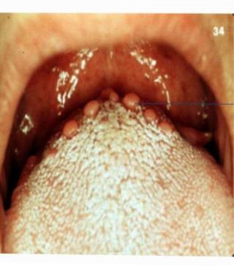

Fungiform papillae
- These are mushroom shaped, more numerous near tip and margins of the tongue but some of them scattered over the dorsum.
- Smooth, round structures that appear red because of their highly vascular connective tissue core
- Taste buds are usually seen within the epithelium.

Foliate papilla
- Red leaf- like mucosal ridges
- Bilaterally at the sides of the tongue near sulcus terminalis
- Bear numerous taste buds
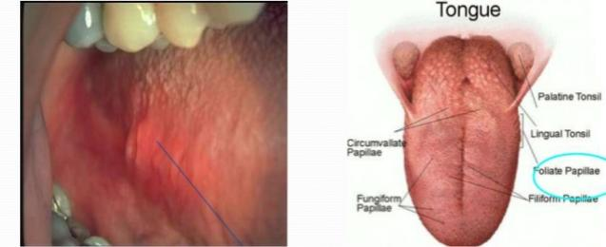

PHARYNGEAL PART
Posterior 1/3rd
- Lies behind the palatoglossal arches
- Forms the anterior wall of the oropharynx
- Absence of papillae
- The mucous membrane has many lymphoid follicles that collectively constitute the lingual tonsil

VENTRAL SURFACE
- Covered by smooth mucous membrane
- The thin strip of tissue that runs vertically from the floor of the mouth to the undersurface of the tongue is called frenelum.
- It tends to limit the movement of the tongue.
- On either side of frenelum there is a prominence produced by deep lingual veins and more
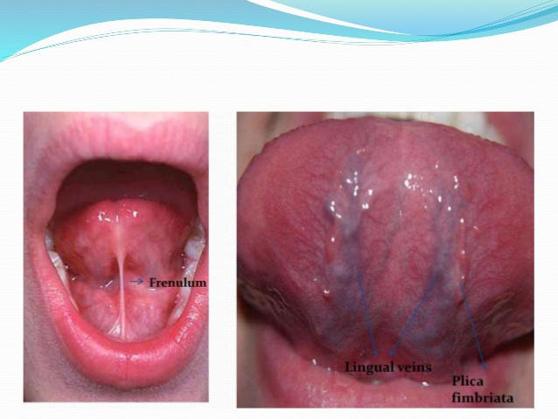
- laterally there is a fold called plica fimbriata.

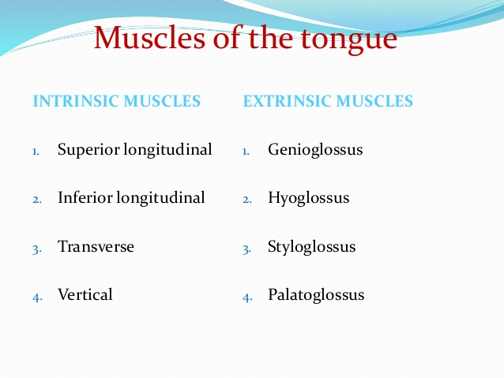

Intrinsic muscles
- Four paired intrinsic muscles originate and insert within the tongue
- These muscles alter the shape of the tongue
- It is not attached to any bone.

Development of Anterior 2/3rd of the tongue
- Formed by fusion of
A. 2lingual swellings
b.Tuberculum impart,

- Thus derived from first branchial arch.
- It is supplied by lingual nerve ( post – trematic) and chords tympani (pre-tramatic)

2. THE AIR SINUSES
The paranasal sinuses are air-filled extensions of the respiratory part of the nasal cavity. There are four paired sinuses, named according to the bone in which they are located; maxillary, frontal, sphenoid and ethmoid. The function of the sinuses is not clear. It is thought that they may contribute to the humidifying of the inspired air. They also reduce the weight of the skull. Sinuses are formed in childhood by the nasal cavity eroding into surrounding bone. As they are outgrowths of the nasal cavity, they all drain back into it – openings to the paranasal sinuses are found on the roof and lateral walls of the nasal cavity. The inner surface is lined by a respiratory mucosa.
Frontal Sinuses: These are the most superior in location, found under the forehead. The frontal sinuses are variable in size, but always triangular-shaped. They drain into the nasal cavity via the frontonasal duct, which opens out at the hiatus semilunaris on the lateral wall.

Sphenoid Sinuses: The sphenoid sinuses also lie relatively superiorly, at the level of the spheno-ethmodial recess. They are found more posteriorly, and are related superiorly and laterally to the cranial cavity. The sphenoid sinuses drain out onto the roof of the nasal cavity. The relationships of this sinus are of clinical importance – the pituitary gland can be surgically accessed via passing through the nasal roof, into the sphenoid sinus and through the sphenoid bone.

Ethmoidal Sinuses: There are three ethmoidal sinuses; anterior, middle and posterior. They empty into the nasal cavity at different places:

Anterior – Hiatus semilunaris

Middle – Ethmoid bulla

Posterior – Superior meatus

Maxillary Sinuses: The largest of the sinuses. It is located laterally and slightly inferiorly to the nasal cavities. It drains into the nasal cavity at the hiatus semilunaris, underneath the frontal sinus opening. This is a potential pathway for spread of infection – fluid draining from the frontal sinus can enter the maxillary sinus.

Clinical Relevance: Sinusitis

As the paranasal sinuses are continuous with the nasal cavity, an upper respiratory tract infection can spread to the sinuses. Infection of the sinuses causes inflammation (particularly pain and swelling) of the mucosa, and is known as sinusitis. If more than one sinus is affected, it is called pansinusitis.

The maxillary nerve supplies both the maxillary sinus and maxillary teeth, and so inflammation of that sinus can present with toothache.

