Uzoukwu Mellisa chinazom
15/eng01/020
Chemical engineering
Alternative energy assignment 1
Question 1

Kinetic Energy:
The energy exists due to the motion of an object is known as Kinetic Energy. For example, a moving van, flowing water, etc.
K.E.=12×m×v2
Where,
K.E. | Kinetic Energy
m | Mass of the object
v | The velocity of the object

Potential Energy:
This is the energy stored in an object due to its position and height. It is measured by the amount of work done. For example, a book on a table, water stored in a lake, etc.
P.E.=m×g×h
Where,
P.E. | Potential Energy
m | Mass of the object
g | Acceleration due to gravity
h | Height

Mechanical Energy:
It is the sum total of potential energy and kinetic energy which is the energy associated with the motion & position of any object. Therefore, the formula of mechanical energy will be:
Mechanical Energy = Kinetic Energy + Potential Energy

Solar Energy
The light and heat from the sun, harnessed using technologies like, solar heating, photovoltaics, solar thermal energy, solar architecture, and artificial photosynthesis is known as solar energy. It is the prime source of renewable energy.

Wind Energy
It is one of the various forms of energy. The energy present in the flow of wind, used by wind turbines is called wind energy. This energy is a major cheap source to produce electricity. In this phenomena, the kinetic energy of the wind is converted into mechanical power.

Nuclear Energy
The energy present in the nucleus of an atom is known as nuclear energy. The particles of an atom are tiny and need the energy to hold themselves. Nuclear energy is that enormous energy in the bonds of an atom which helps to hold the atom together. Nuclear energy can be used to make electricity.

Geothermal Energy
The energy or heat present inside the Earth is known as geothermal energy. It is a cheap & convenient heat and power resource and use of this energy don’t have a side effect like greenhouse gas emission etc.

Tidal Energy
Tidal energy or tidal power is a form of hydropower (energy present in water), which converts the energy present in the tides to produce electricity.

Biomass Energy
Biomass is organic matter obtained from living organisms. The energy produced from biomass is called biomass energy.

Electrical Energy
The energy caused by moving electric charges is known as electrical energy. Electric energy is a type of kinetic energy as the electrical charges moves.

Thermal Energy
As the name suggests, thermal energy is the energy obtained from heat. It is a microscopic, disordered equivalent of mechanical energy.
Question 2

Sustainable energy and resources
Sustainable enegy is a form of energy that meet our today’s demand of energy without putting them in danger of getting expired or depleted and can be used over and over again. Sustainable energy should be widely encouraged as it does not cause any harm to the environment and is available widely free of cost. All renewable energy sources like solar, wind, geothermal, hydropower and ocean energy are sustainable as they are stable and available in plenty. There are many forms of sustainable energy sources that can be incorporated by countries to stop the use of fossil fuels. Sustainable energy does not include any sources that are derived from fossil fuels or waste products. This energy is replenishable and helps us to reduce greenhouse gas emissions and causes no damage to the environment. If we are going to use fossil fuels at a steady rate, they will expire soon and cause adverse effect to our planet.

Non sustainable energy and resources
Non-sustainable energy resources are available in limited supplies, usually because they take a long time to replenish. The advantage of these non-renewable resources is that power plants that use them are able to produce more power on demand. The non-renewable energy resources are: Coal,Nuclear,Oil,Natural gas.
Question 3

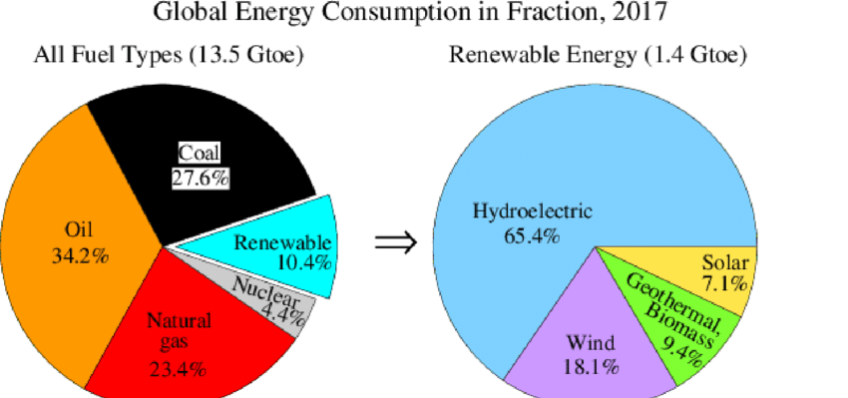
For illustrative purposes, a community that has relied heavily on coal energy and is facing increasing demand as energy use per capita rises. Such a community might choose to diversify its energy mixture by adding wind energy. Some communities may rely more heavily on hydroelectric power because of their proximity to a major river. Other communities may get a portion of their electricity from solar power, but still provide the base of their electricity from a resource that is more reliable, such as coal or hydroelectric power. Communities may choose a higher percentage of one energy resource because it has a lower cost in their area than another resource or because political incentives or policies encourage or limit the use of some types of resources.

Assignment 3
Question 1
Monday p = $\frac{1.4*1300000*10}{0.991}=18365287.59w$
Q= p * $∆t$
$$∆t=6hrs=6*3600=21600s$$
Q = 18365287.59 * 21600 = 396700MJ

Tuesday p = $\frac{1.4*1300000*11}{0.991}=20201816.35w$
Q = $20201816.35$* 21600 = 436300MJ

Wednesday p = $\frac{1.4*1300000*10}{0.991}=18365287.59w$
Q = 18365287.59 * 21600 = 396700MJ

Thursday p = $\frac{1.4*1300000*11}{0.991}=20201816.35w$
Q = $20201816.35$* 21600 = 436300MJ

Friday p = $\frac{1.4*1300000*12}{0.991}=22038345.11w$
Q = $22038345.11$ * 21600 = 476000MJ
Average =$\frac{396700+436300+396700 +436300+476000}{5}=420460MJ$
The average daily thermal energy from the sun reaching ABUAD is 420460MJ

Question 2
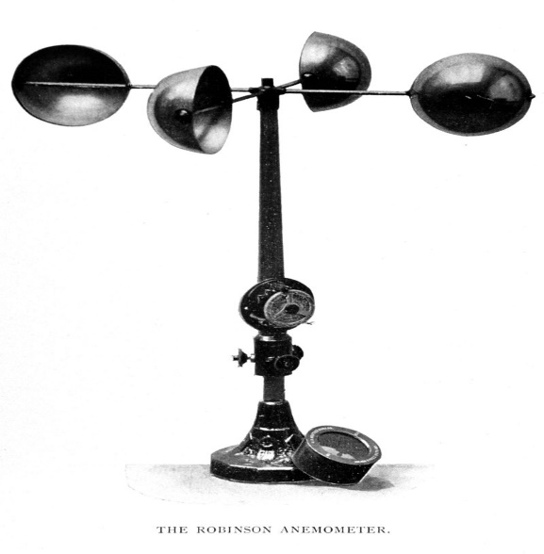
Anemometer, device for measuring the speed of airflow in the atmosphere, in wind tunnels, and in other gas-flow applications. Most widely used for wind-speed measurements is the revolving-cup electric anemometer, in which the revolving cups drive an electric generator. The output of the generator operates an electric meter that is calibrated in wind speed. The useful range of this device is approximately from 5 to 100 knots. A propeller may also be used to drive the electric generator, as in the propeller anemometer. In another type of wind-driven unit, revolving vanes operate a counter, the revolutions being timed by a stopwatch and converted to airspeed. This device is especially suited for the measurement of low airspeeds.

