NAME: ENUNWA ADAKU F
MATRIC NUMBER: 17/MHS01/117
DEPARTMENT: MEDICINE AND SURGERY
COURSE: ANATOMY- HEAD AND NECK
PART 1
WRITE AN ESSAY ON THE CAVERNOUS SINUS
The human brain is a highly vascular organ responsible for coordinating a myriad of processes throughout the body. Therefore, it is important that a pathway exists to return blood that enters the cranium to systemic circulation. The cavernous sinuses are one of several drainage pathways for the brain that sits in the middle. In addition to receiving venous drainage from the brain, it also receives tributaries from parts of the face.
The left and right cavernous sinuses communicate by through the anterior and posterior intercavernous sinuses. The cavernous sinus drains to the superior and inferior petrosal sinuses, which then join the sigmoid sinus.
The cavernous sinus is a paired dural venous sinus located within the cranial cavity. It is divided by septa into small ‘caves’ – from which it gets its name. Each cavernous sinus has a close anatomical relationship with several key structures in the head, and is arguably the most clinically important venous sinus. The dural venous sinuses are channels between the two layers of dura mater which are responsible for the venous drainage of the brain, skull, orbit and internal ear.
The cavernous sinuses are located within the middle cranial fossa, on either side of the sella turcica of the sphenoid bone (which contains the pituitary gland). They are enclosed by the endosteal and meningeal layers of the dura mater. The borders of the cavernous sinus are as follows:
- Anterior – superior orbital fissure.
- Posterior – petrous part of the temporal bone.
- Medial – body of the sphenoid bone.
- Lateral – meningeal layer of the dura mater running from the roof to the floor of the middle cranial fossa.
- Roof – meningeal layer of the dura mater that attaches to the anterior and middle clinoid processes of the sphenoid bone.
- Floor – endosteal layer of dura mater that overlies the base of the greater wing of the sphenoid bone.
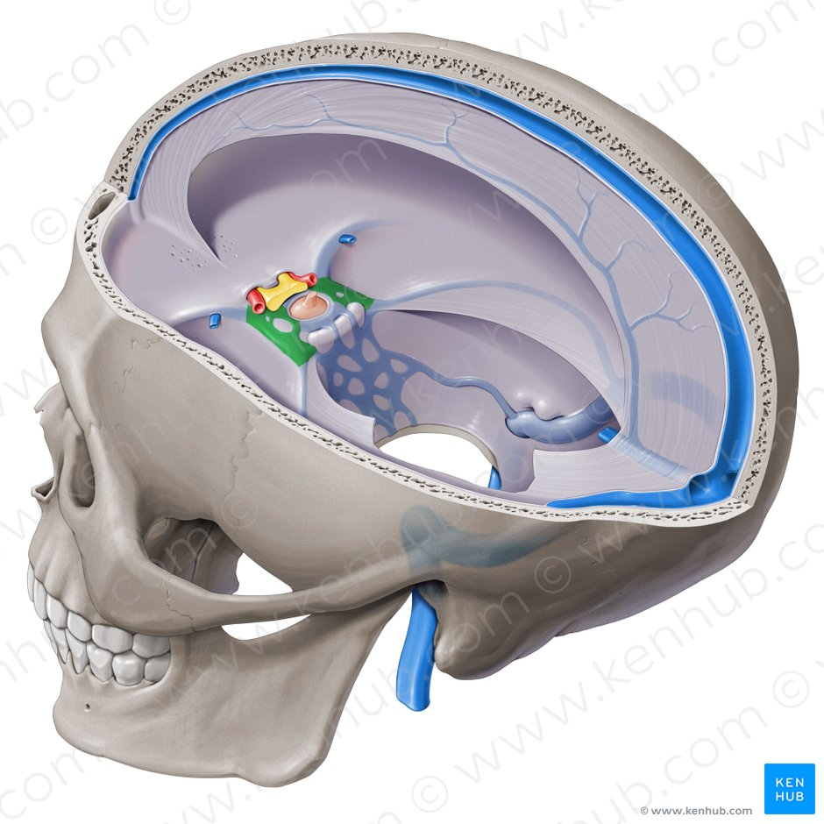
Key facts about the cavernous sinus
Location | Paired venous cavities that sit on either side of the sphenoid bone, extending from the most posterior aspect of the orbit to the petrous part of the temporal bone.
Contents | Oculmotor nerve (III), Internal Carotid artery, Ophthalmic nerve (V1), Abducens nerve (VI), Trochlear nerve (IV)  Mnemonic: Oh, COAT
Source | Superior ophthalmic vein  Inferior ophthalmic vein  Superficial middle cerebral vein  Middle meningeal vein  Hypophyseal veins
Drains to | Superior and inferior petrosal sinuses
Clinical relations | Carotid-cavernous fistula, cavernous sinus thrombosis

Contents
The cavernous sinus contains the internal carotid artery and several cranial nerves. Abducens nerve (CN VI) traverses the sinus lateral to the internal carotid artery. The remainder of the cranial nerves pass through the lateral wall of the carotid sinus, and from superior to inferior they are:
- Oculomotor nerve (CN III)
- Trochlear nerve (CN IV)
- Trigeminal nerve (CN V) - ophthalmic and maxillary divisions.
The contents of the cavernous sinus can be easily remembered with the mnemonic Oh, COAT, that stands for the Oculmotor nerve (III), Internal Carotid artery, Ophthalmic nerve (V1), Abducens nerve (VI), Trochlear nerve (IV).

Internal carotid artery/ Internal carotid artery (Arteria carotis interna)
In addition to the thin walled veins that traverse the cavernous sinus, a lone arterial vessel also uses the area as a conduit. The internal carotid artery (a branch of the common carotid artery) – along with its postganglionic sympathetic plexus from the superior cervical ganglion – gains access to the cavernous sinus posteriorly.As the petrous part of the internal carotid artery leaves the carotid canal, it curves vertically and superiorly above foramen lacerum to enter the cavernous sinus. Here the artery is also referred to as the cavernous part.
Within the sinus, the internal carotid artery travels anteriorly, in a horizontal manner until it reaches the anterior limit of the sinus. Here it curves vertically and superiorly to exit the sinus through its roof and become the cerebral part of the internal carotid artery. It is noteworthy that the cavernous part of the internal carotid artery is the only arterial vessel that is completely surrounded by venous networks. This fact is of great clinical significance, which will be discussed later.

Abducent nerve/ Abducens nerve (Nervus abducens)
There are also other non-vascular structures that utilize the cavernous sinus as a pathway to their points of supply. Five cranial nerves (CN) use this pathway to gain access to their points of innervation. The first to be discussed is the abducent nerve (CN VI). This motor nerve leave the pons and gains access through the posterior part of the sinus after passing of the apical potion of the petrous temporal bone. It has also been known to access the cavernous sinus by way of the petrosal sinus, adjacent to the clivus.Within the cavernous sinus, it takes an inferolateral course, relative to the internal carotid artery. It exits the sinus by way of the superior orbital fissure to gain access to the orbit, where it innervates the lateral rectus muscle of the eyeball.

Oculomotor nerve/ Oculomotor nerve (Nervus oculomotorius)
The other nerves travelling through the cavernous sinus do so between the endothelial lining and the dura mater of its lateral wall. The most superior of the four nerves in the lateral wall is the oculomotor nerve (CN III). At the posterior aspect of the roof of the cavernous sinus, the free and attached edges of tentorium cerebelli forms a space through which CN III enters the lateral wall of the sinus. It takes an anterior, inferomedial course (relative to the other nerves in the lateral wall) towards the anterior extremity of the sinus.
Here it bifurcates into its superior and inferior rami that pass through the superior orbital fissure. Along with sympathetic fibers from the internal carotid plexus, CN III provides motor supply to inferior oblique, levator palpebrae superioris, and the inferior, medial and superior recti muscles.

Trochlear nerve
The smallest of the cranial nerves, the trochlear nerve (CN IV), enters the posterior aspect of the cavernous sinus after leaving the posterior part of the brainstem and decussating with the same nerve from the opposite side. It continues anteriorly in the lateral wall of the cavernous sinus, inferior to CN III and passes through the superior orbital fissure at the anterior aspect of the sinus. Once in the orbit, CN IV has the responsibility of innervating the muscles of the eyeball that are responsible for inferolateral motions.

Trochlear nerve (Nervus trochlearis)/ Trigeminal nerve
Finally, two of the three branches of the trigeminal nerve (CN V) pass through the cavernous sinus. Prior to entering the cavernous sinus, the proximal portion of the nerve lies in Meckel’s cave, where it forms the trigeminal ganglion. After leaving the cave, the mandibular division (CN V3) courses inferiorly to pass through foramen ovale (without entering the cavernous sinus).
The other two branches, the ophthalmic and the maxillary (CN V1 and CN V2, respectively), travel through the lateral wall of the sinus. Both take courses inferior to CN III and CN IV, however, CN V2 is the most inferior of them all. Both CN V branches in the sinus travels horizontally. CN V2 leaves the sinus via foramen rotundum, while the three branches of CN V1 exit the cranial fossa via the superior orbital fissure. CN V1 and CN V2 are purely sensory and supply specific regions of the face.

Communications

The cavernous sinus is an unconventional venous system in the sense that it does not have a unidirectional flow of blood. Owing to the fact that there are no valves in the sinus and its connected veins, the direction of blood flow is dependent on venous pressure. The veins that communicate with the cavernous sinus are:
- Superior ophthalmic vein
- Inferior ophthalmic vein
- Superficial middle cerebral vein
- Middle meningeal vein
- Hypophyseal veins

Superior ophthalmic vein
Superior ophthalmic vein (Vena ophthalmica superior)
The cavernous sinus generally has five venous tributaries. The superior ophthalmic vein receives blood from the ethmoidal, nasofrontal, vorticose (drains the ocular choroid), and central retinal veins. It drains into the anterior part of the sinus via the superior orbital fissure.

Inferior ophthalmic vein
The inferior ophthalmic vein collects blood from the eyelids, lacrimal sac, and some vorticose contributions, as well as the anterior floor and medial wall of the orbit. In addition to draining to the cavernous sinus, it also drains to the pterygoid plexus.

Superficial middle cerebral vein
At the point where the internal carotid artery emerges, the superficial middle cerebral vein pierces the roof of the sinus. Here, it drains blood from the cortices that are adjacent to it as it courses through the lateral sulcus.

Middle meningeal vein
Finally, branches of the middle meningeal vein may join the sphenoparietal sinus on its way to the cavernous sinus. Before piercing the roof of the sinus, it travels along the edge of the lesser wing of the sphenoid between the layers of dura mater.

Hypophyseal veins
Additionally, efferent hypophyseal veins of both the adenohypophysis and neurohypophysis drain to the cavernous sinus.

Intercavernous sinuses and drainage

Anterior intercavernous sinus (Sinus intercavernosus anterior)
The left and right cavernous sinuses communicate by way of the anterior and posterior intercavernous sinuses. These vessels travel anteriorly and posteriorly (respectively) around the infundibulum of the pituitary gland, deep to the diaphragma sellae, between the layers of dura mater.
The cavernous sinus in turn drains to the superior and inferior petrosal sinuses. Both sinuses join the sigmoid sinus, which then becomes the internal jugular vein. The internal jugular vein meets with the subclavian vein to become the left (or right) brachiocephalic vein.
PART 2
DISCUSS THE WALLS OF THE NOSE

The nasal cavity
The nares serve as the entryway to the nasal cavities, which open posteriorly into the nasopharynx via the choanae. The walls of the nasal cavity include the following features:
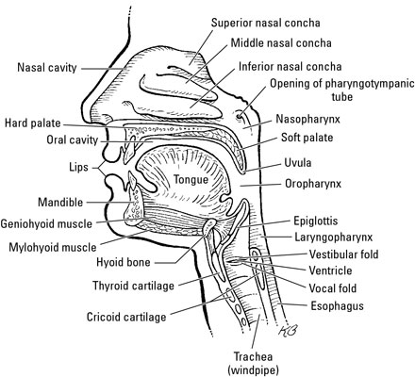
- Roof: The roof is divided into three parts: frontonasal, ethmoidal, and sphenoidal. Each part corresponds to the underlying bone of the same name.
- Floor: The floor consists of the palatine process of the maxilla and the horizontal plate of the palatine bone.
- Medial wall: This wall is the nasal septum, which is formed by the perpendicular plate of the ethmoid bone, the vomer, cartilage, and the nasal crests of the maxillary and palatine bones.
- Lateral wall: This wall is hallmarked by three nasal conchae (superior, middle, and inferior) that project inferiorly from the wall. They divide the nasal cavity into four passages that have openings to the paranasal sinuses:
  - The sphenoethmoid recess lies posterior to the superior concha and has the opening for the sphenoidal sinus.
  - The superior nasal meatus lies between the superior and middle conchae and has openings to the posterior ethmoidal sinuses.
  - The middle nasal meatus is longer and deeper than the superior nasal meatus. The frontal sinus communicates with the middle nasal meatus via the infundibulum, a passageway that opens into the semilunar hiatus (groove in the ethmoid bone). The maxillary sinus opens into the semilunar hiatus. An ethmoidal bulla (a round swelling formed by the middle ethmoidal cells, or air-filled cavities) is formed just above the semilunar hiatus. The middle and anterior ethmoidal sinuses drain into the middle nasal meatus.
  - The inferior nasal meatus is found below the inferior nasal concha. The nasolacrimal duct opens into this meatus.
The nasal cavity is lined with nasal mucosa, except for the nasal vestibule, which is lined with skin. The mucosa over the superior one-third of the nasal cavity is the olfactory area. Air is drawn past the specialized mucosal cells called the olfactory epithelium as air is sniffed though the nose. The olfactory epithelium contains receptors of olfactory neurons that detect smells. Olfactory neurons (from CN I) join together to form nerve bundles that run up through the cribiform plate of the ethmoid bone to the olfactory bulb. The olfactory tract transmits the sensory information about smell from

