17/mhs03/014
Ejeh Hillary
Anatomy
ANA314 assignment

- What is comparative anatomy
Comparative anatomy is the study of similarities and differences in anatomy of different species . Comparative anatomy is the comparative study of the body structures of different species of animals in order to understand the adaptive changes they have undergone in the course of evolution from common ancestors. Organisms with similar anatomical features are assumed to be relatively closely related evolutionarily, and they are assumed to share a common ancestor. As a result of the study of evolutionary relationships, anatomical similarities and differences are important factors in determining and establishing classification of organisms.

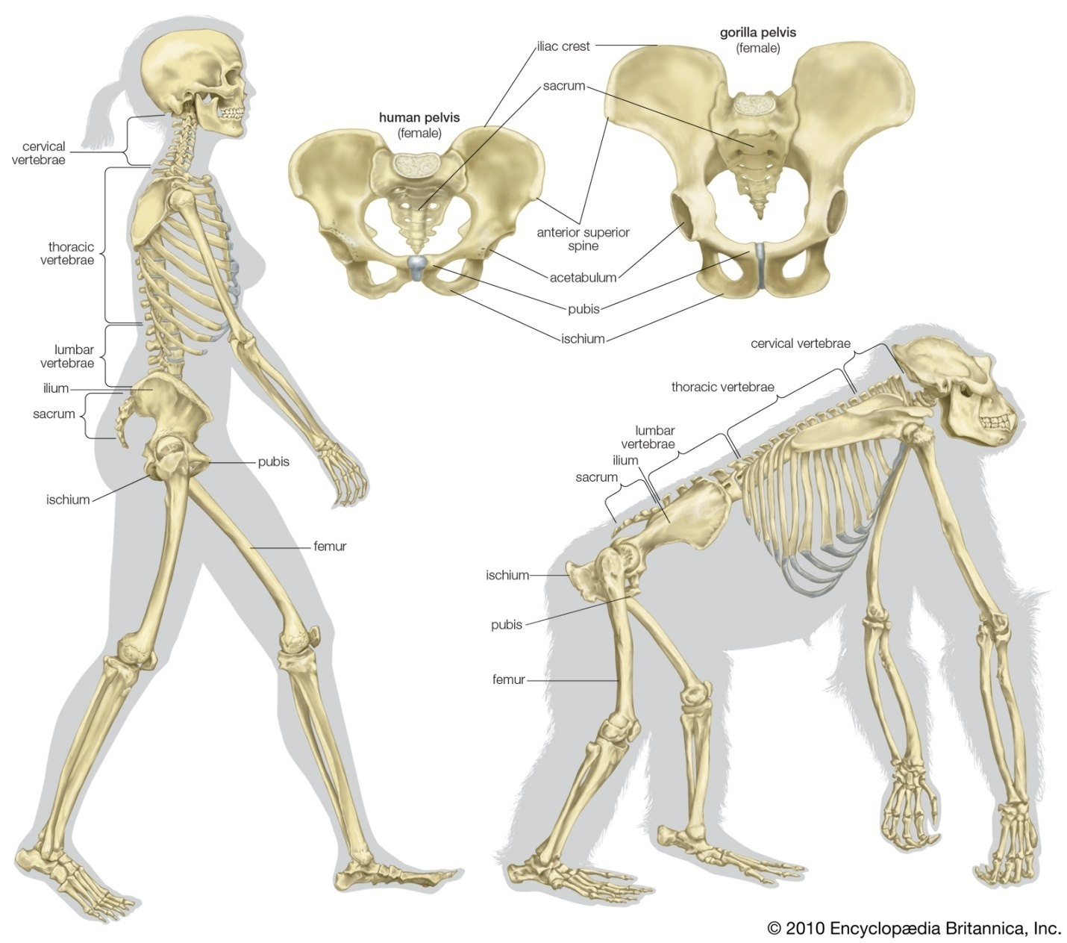

skeletons of humans and gorillas comparedThe skeletal structure of a human being (left) and of a gorilla (right). Several differences allow the human to walk erect on two legs with a striding gait rather than move in a knuckle-walking fashion like the gorilla. In the pelvis these differences include shorter ischia, a broader sacrum, and broader, curved-in ilia with a lower iliac crest. In the legs the femurs (thighbones) are relatively long and are set farther apart at the hips than they are at the knees. Encyclopædia Britannica, Inc.

2.CRITERIA NECESSARY FOR CARING FOR LABORATORY ANIMALS
- Ventilation
- Room temperature
- Illumination and light schedule
- Noise moderation
- Humidity

VENTILATION :
Optimum air quality in laboratory animal facilities is essential for the general health and well-being of researchers, animal caregivers, and the animals, as well as for the integrity of the studies. Since both genetic heritage and the environment influence biological responses, researchers must always be aware of the influence of the environment on the animals' biological responses.

TEMPERATURE AND HUMIDITY :
Maintenance of body temperature within normal circadian variation is necessary for animal well-being. Animals should be housed within temperature and humidity ranges appropriate for the species, to which they can adapt with minimal stress and physiologic alteration.
Regulation of body temperature within normal variation is necessary for the well-being of homeotherms. Generally, exposure of unadapted animals to temperatures above 85ºF (29.4ºC) or below 40ºF (4.4ºC), without access to shelter or other protective mechanisms, might produce clinical effects (Gordon 1990). Temperature of 65-75 fahrenheit(18-23 celsius ) with 40-60 % humidity recommended ( for mouse or rats )

ILLUMINATING AND LIGHT SCHEDULE :
Light can affect the physiology, morphology, and behavior of various animals (Azar et al. 2008; Brainard et al. 1986; Erkert and Grober 1986; Newbold et al. 1991; Tucker et al. 1984). Potential photostressors include inappropriate photoperiod, photointensity, and spectral quality of the light (Stoskopf 1983).For practical considerations due to common work hours , researchers should be aware of lighting schedules used in the rodent housing rooms (commonly 12 hours light :12 hours dark or 14 hours light : 10 hours dark ) . If researchers turn on the light during the animals dark period the disruption of the light schedule may cause animals to be perturbed , which may have effects on the breeding performance and on circadian rhythms .

NOISE MODERATION :
Because changes in patterns of sound exposure have different effects on different animals (Armario et al. 1985; Clough 1982), personnel should try to minimize the production of unnecessary noise. Excessive and intermittent noise can be minimized by training personnel in alternatives to noisy practices, the use of cushioned casters and bumpers on carts, trucks, and racks, and proper equipment maintenance (e.g., castor lubrication). Radios, alarms, and other sound generators should not be used in animal rooms unless they are part of an approved protocol or enrichment program. Any radios or sound generators used should be switched off at the end of the working day minimize to associated adverse physiologic changes (Baldwin 2007)

4. IMAGE OF THE DIGESTIVE SYSTEM

DIGESTIVE SYSTEM OF FROG
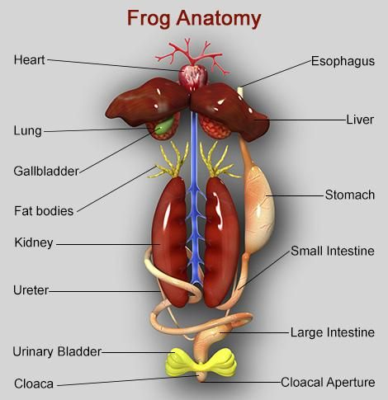
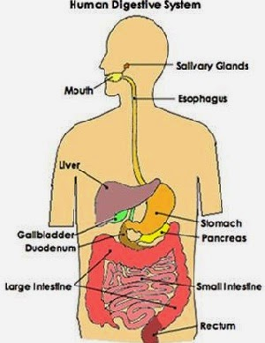

DIGESTIVE SYSTEM OF MAN

- SIMILARITIES BETWEEN AMPHIBIANS (FROG) AND MAN
- They both have mouth
- The presence of esophagus in both
- The presence of the tongue in both
- The presence of the teeth in in both
- Presence of the small intestine in both
- Presence of the liver in both
- Presence of gallbladder in both
- The presence of the large intestine both

DIFFERENCES BETWEEN THE DIGESTIVE SYSYTEM OF AMPHIBIAN (FROG) AND MAN
FROG | MAN
1. The tongue is very sticky | The tongue is not sticky
2. It has shorter intestines and the two parts of the intestine are the duodenum and the ileum . | Man has a longer small intestine and the three parts of the intestine are the duodenum , jejunum,and the ileum
3.The frog swallow their prey without chewing | Chewing is a mechanism of digestion in humans
4.Frogs have two sets of theeth;maxillary teeth and the vomerine teeth | Man has one set of teeth in their oral cavity
5.During deglutition frogs do not blink or close their eyes | This mechanism is not seen in humans
6.The absorption of nutrient in frogs occurs in the ileum | The absorption of nutrients of man occurs in the jejunum
7.Elimination of indigested food occurs in the cloaca | Elimination of indigested food occurs through the rectum

