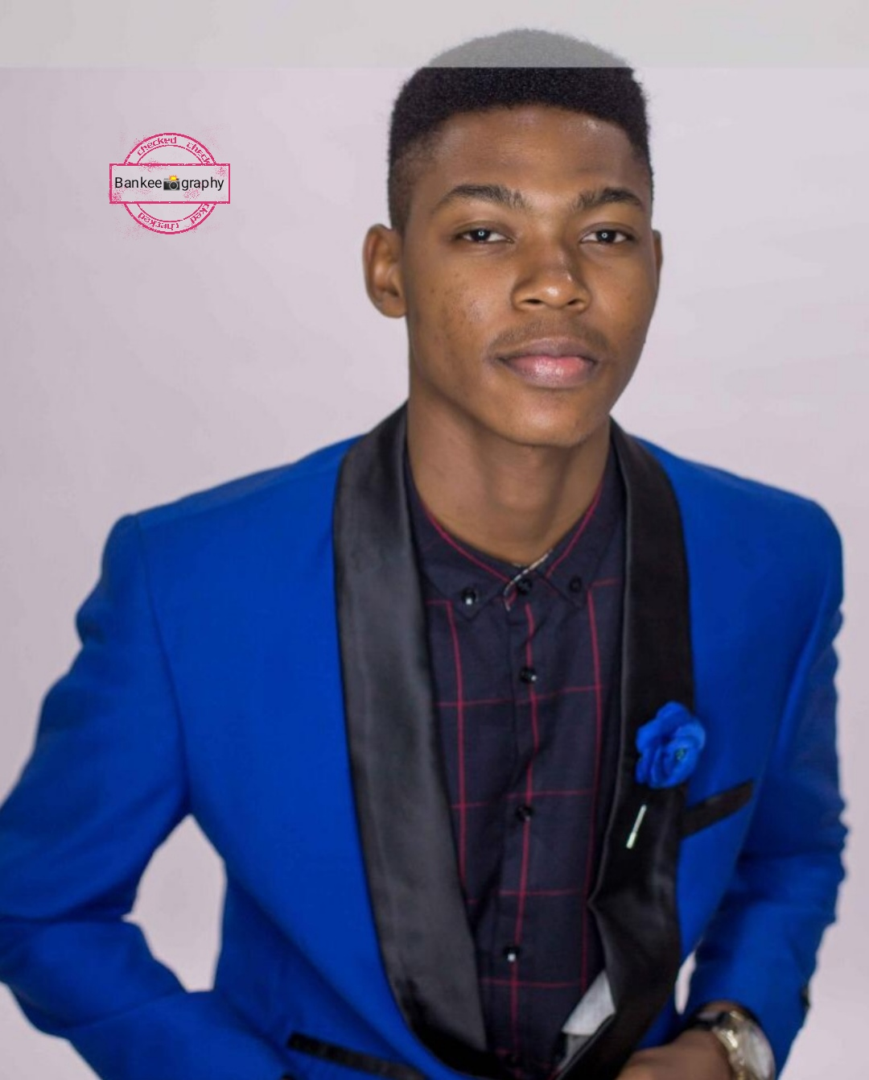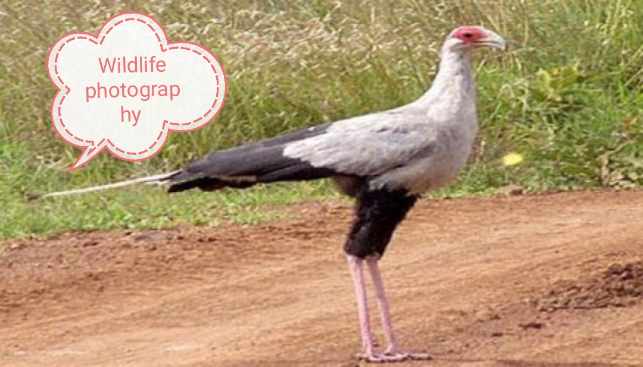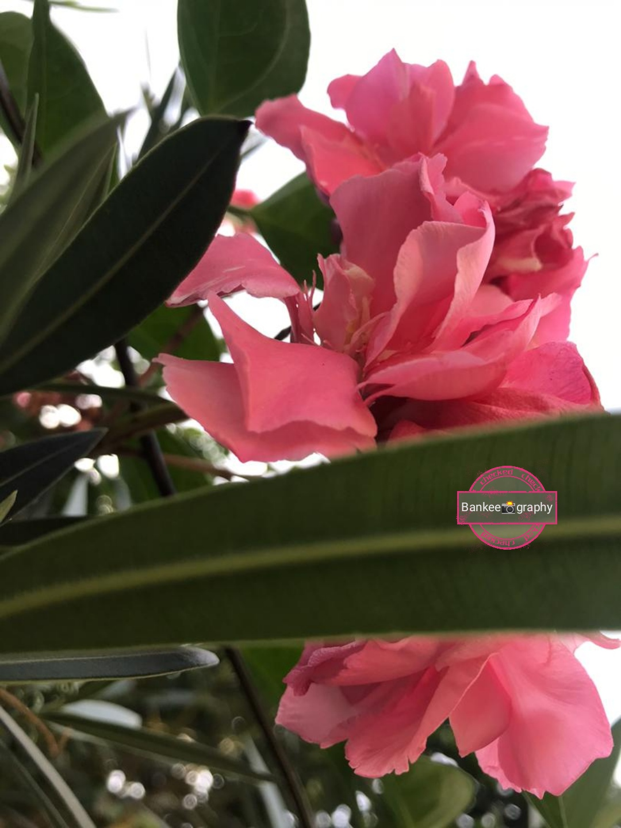

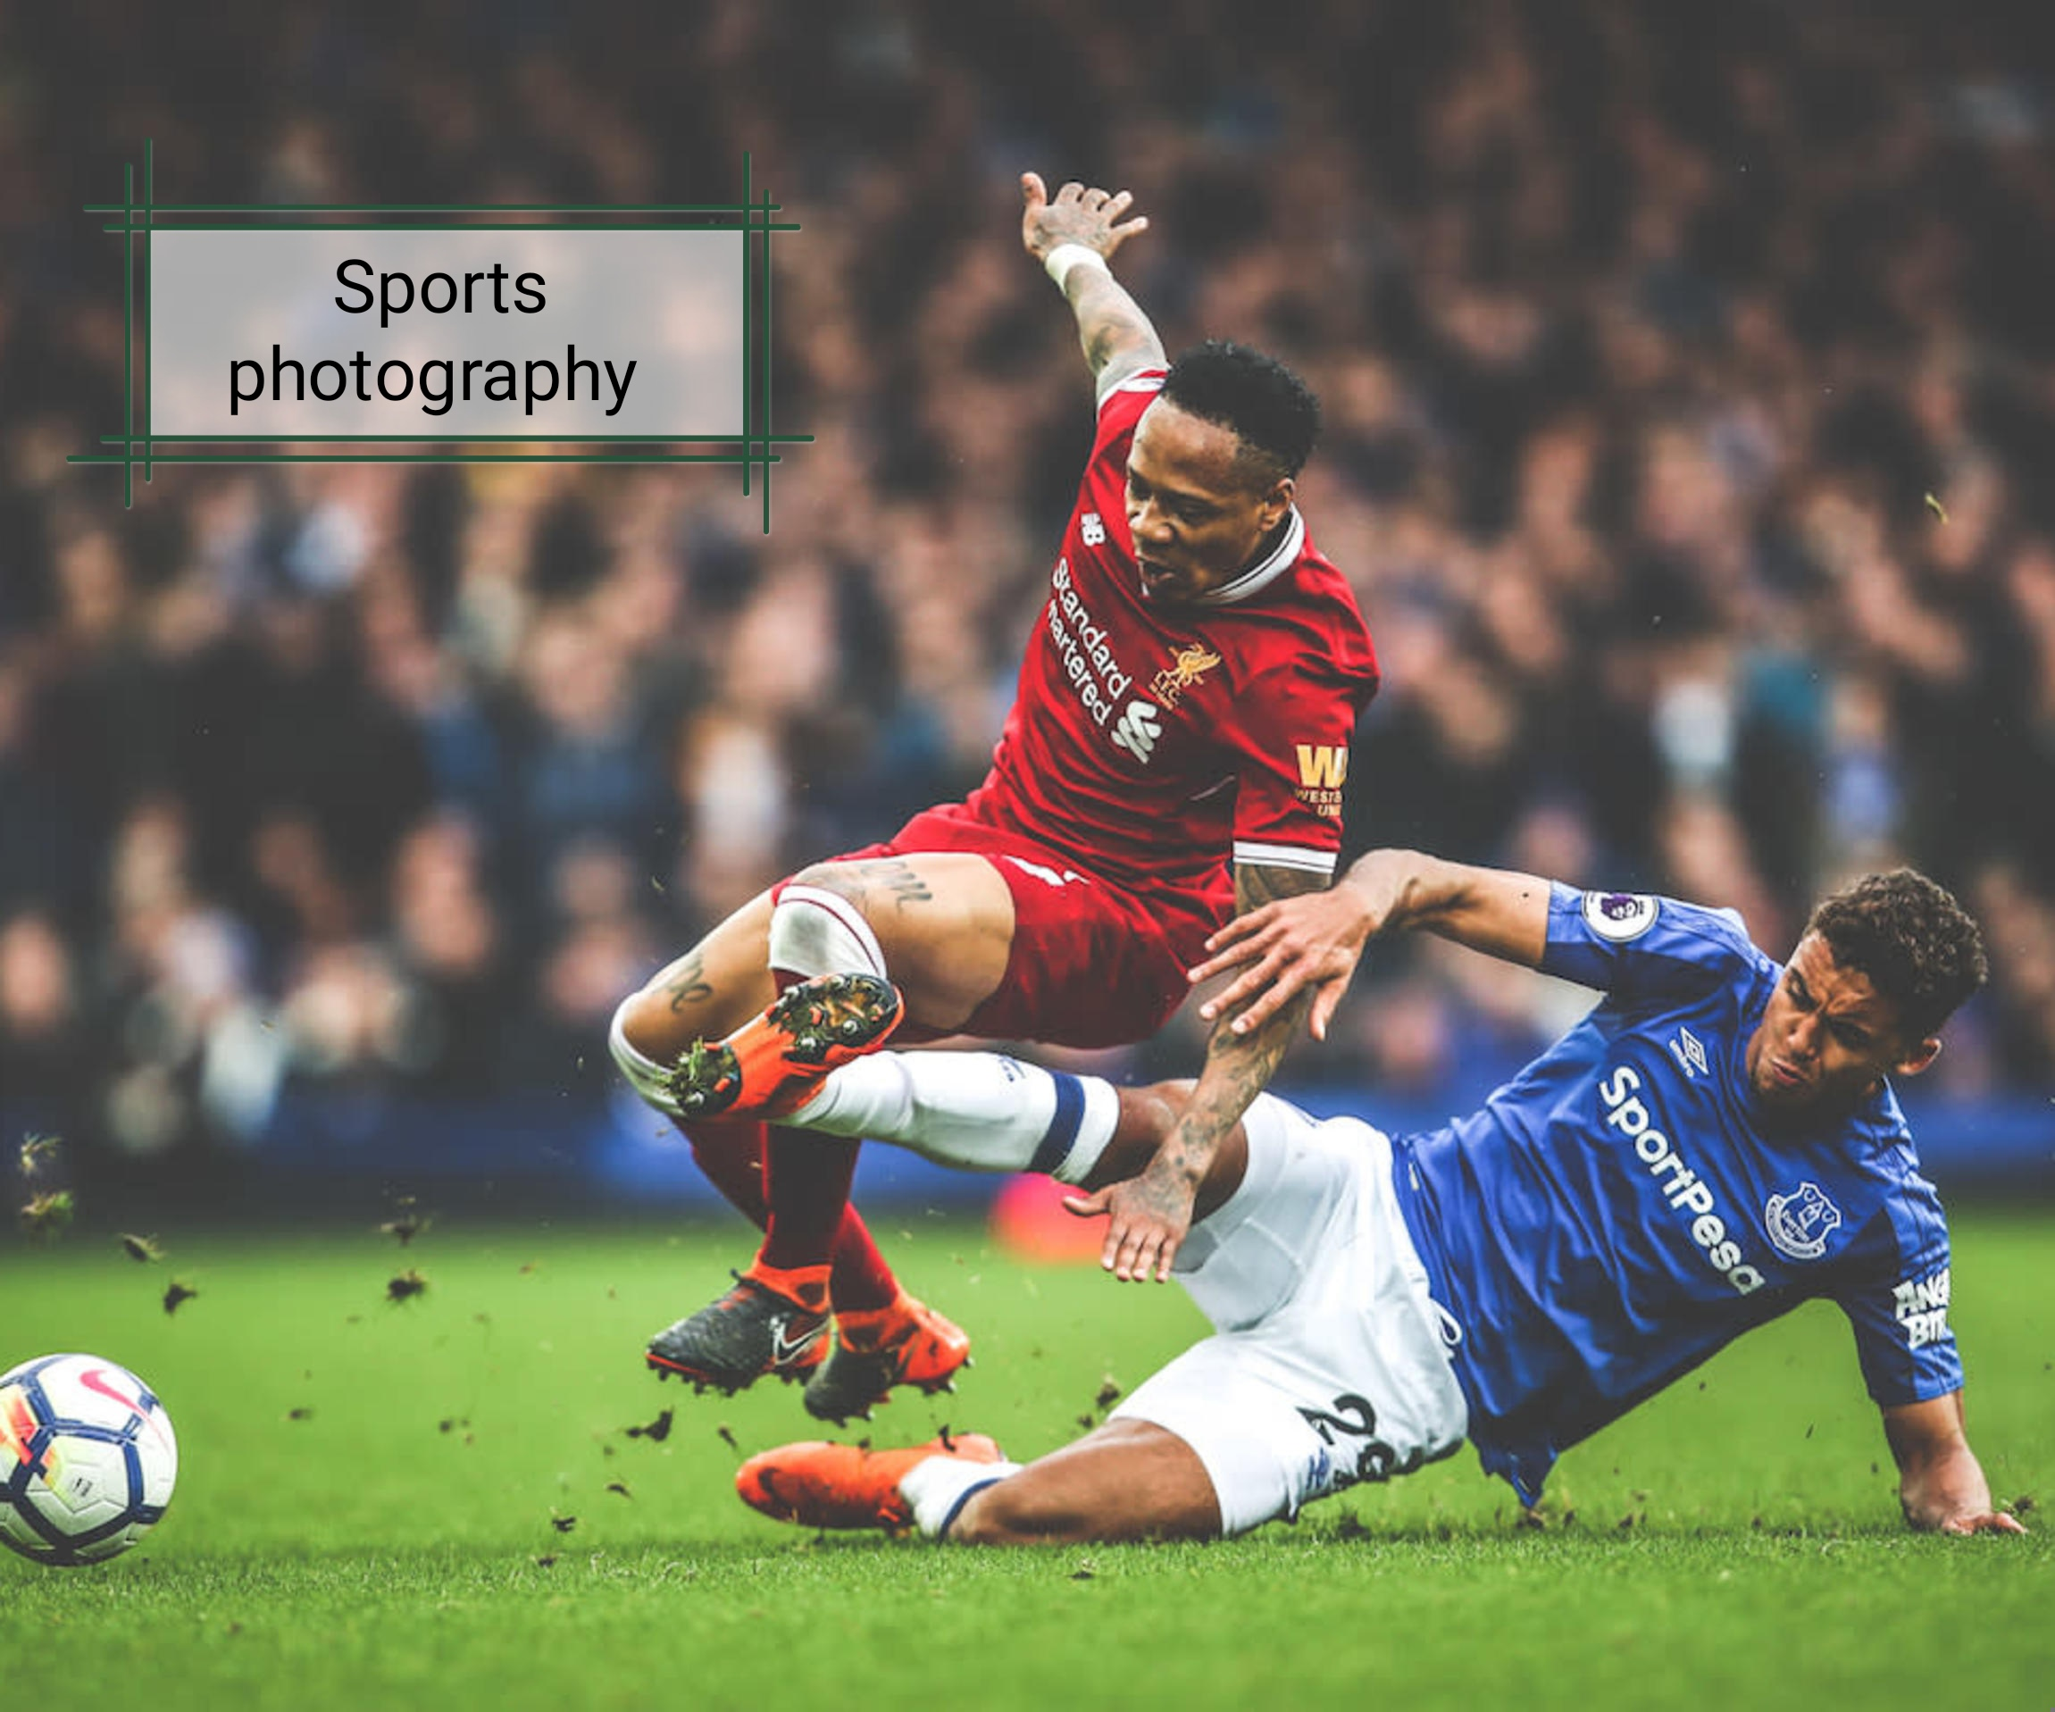

The pictures are:
- Model Photography
- Wildlife Photography
- Nature Photography
- Events Photography
- Sports Photography

BANKOLE MUBARAK OLAWALE 19/sms04/009 CMS 106 PROJECT

