EPELLE SOTONYE
15/ENG07/020
PETROLEUM ENGINEERING
CHE 574
Question
- (a) With adequate mathematical relations, explain the various forms of energy (b) distinguish between the sustainable energy and resources and non-sustainable energy and resources
- With the aid of appropriate pie chart or bar chart briefly discuss the typical energy resource mix for sustainable energy development and provide your own view the case for the Nigerian environment.
- Monitor the average ambient temperature between on Monday, 17th and Friday, 21st of February 2020 and estimate the average daily thermal energy from the sun reaching land
- With the aid of a beautiful diagram ONLY, describe anemometer.
Answer

Form of energy | description | Examples
Electrical | The energy of moving electrons.a magnet rotating in a coil of wire can cause electrons to start to flow and move along the wire  E=IVt | Anything that is plugged into an outlet or uses batteries
Sound | The energy in vibrating particles. Sound must have a medium through which to travel because particles get compressed in waves | Anything that causes particles to vibrate produces sound
chemical | A form of potential energy that is stored in the bonds of a molecule. | Chemical energy is found in glucose,gasoline,anything that can burn contains chemical energy
light | Produced by the vibrations of electrically charged particles,does not need medium to travel  E=λf | Visible light,UV light,infared light
Nuclear | Energy produced when the nucleus of an atom splits(fission) or when two nuclei combine(fusion)  E=mc² | Fusion of two hydrogen atoms to form helium
Thermal | Energy or heat from internal substance of heat.  The vibration and movement of atoms and molecules within substances  Q=mcΔT | Geothermal energy

1b)
Sustainable energy practices must rely on resources which can continue to supply our needs. Resources are considered non-renewable if they have a very long time to be created
Technologies that promote sustainable energy include renewable energy sources such as
- Hydroelectricity
- Solar energy
- Wind energy
- Geothermal energy
- Tidal power
Non sustainable energy is a form of energy which is declined and not maintain for the future generation.non-sustainable energy can refer to non-renewable energy
A non-renewable energy is called a finite energy,a resource that does not renew is replenished
Non-renewable energy are;
Fossil fuels and oil and natural gas

Few differences between sustainable and non-sustainable energy sources include
sustainable | Non-sustainable
They arent hazardous to the health | They are hazardous to the health
They cause no long term damage to the environment | They could cause long-term damages to the environment
It should be responsible to change and uncertainties | They are not responsible to change and uncertainties
2)
According to the statistics from the International Energy Agency (IEA), total Nigerian primary energy supply was 118,325 Kilotonne of Oil Equivalent (ktoe) - excluding electricity trade - in 2011. As depicted in the figure below, biomass and waste dominated with 82.2%. Renewable energy sources only accounted for a small share of the energy supply. For instance hydropower only accounted for 0.4%.Wind and solar are also utilized, but at an insignificant level at present.
Biomass is the dominant energy source in Nigeria due to the huge reliance on the energy source for cooking and heating purposes by majority of the Nigerian people. According to the global initiative on accessible, clean and efficient energy - Sustainable Energy For All (SE4ALL), little progress has been made with regards to providing access to non-solid cooking fuels since 1990. As visible in the figure below, in 2010, only 26% of the population had access to non-solid cooking fuels with a big difference between urban and rural areas^{[4]}.
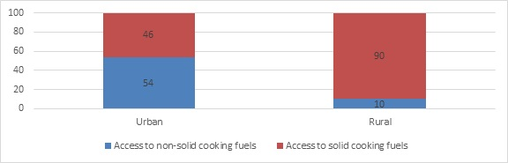

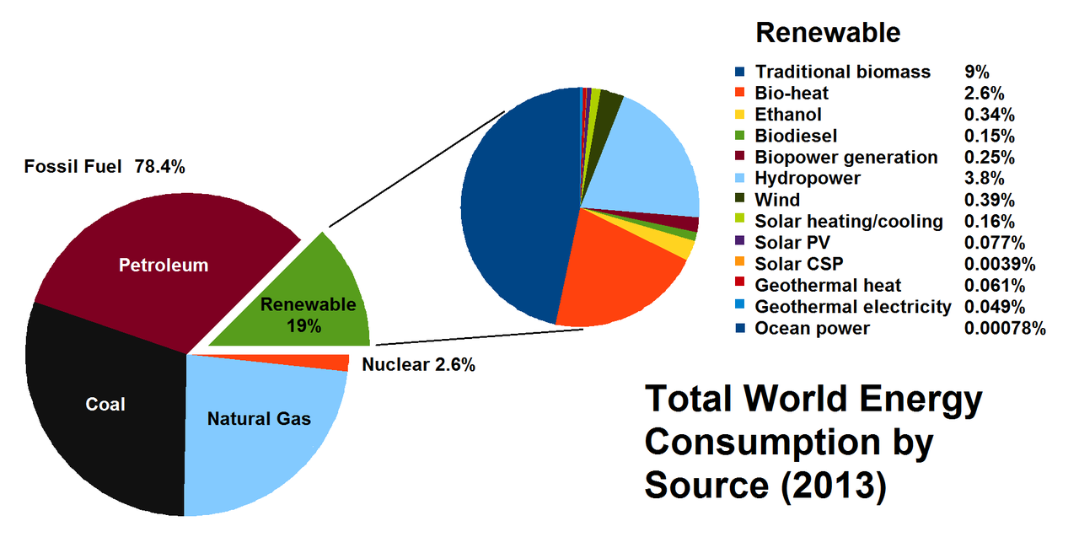

3)

Monday 17th February 2020 | Tuesday 18th February 2020 | Wednesday 19th February 2020 | Thursday 20th February 2020 | Friday 21st February 2020 | Average
35⁰/26⁰ | 36⁰/26⁰ | 36⁰/26⁰ | 36⁰/26⁰ | 37⁰/28⁰ | 32°/25°

4)

Cup anemometers

Cup anemometer animation
A simple type of anemometer was invented in 1845 by Rev Dr John Thomas Romney Robinson, of Armagh Observatory. It consisted of four hemispherical cups mounted on horizontal arms, which were mounted on a vertical shaft. The air flow past the cups in any horizontal direction turned the shaft at a rate that was roughly proportional to the wind speed. Therefore, counting the turns of the shaft over a set time interval produced a value proportional to the average wind speed for a wide range of speeds. It is also called a rotational anemometer.
On an anemometer with four cups, it is easy to see that since the cups are arranged symmetrically on the end of the arms, the wind always has the hollow of one cup presented to it and is blowing on the back of the cup on the opposite end of the cross. Since a hollow hemisphere has a drag coefficient of .38 on the spherical side and 1.42 on the hollow side, more force is generated on the cup that is presenting its hollow side to the wind. Because of this asymmetrical force, torque is generated on the axis of the anemometer, causing it to spin.
Theoretically, the speed of rotation of the anemometer should be proportional to the wind speed, because the force produced on an object is proportional to the speed of the fluid flowing past it, but other factors influence the rotational speed, including turbulence produced by the apparatus, increasing drag in opposition to the torque that is produced by the cups and support arms, and friction of the mount point. When Robinson first designed his anemometer, he asserted that the cups moved one-third of the speed of the wind, unaffected by the cup size or arm length. This was apparently confirmed by some early independent experiments, but it was incorrect. Instead, the ratio of the speed of the wind and that of the cups, the anemometer factor, depends on the dimensions of the cups and arms, and may have a value between two and a little over three. Every previous experiment involving an anemometer had to be repeated after the error was discovered.
The three-cup anemometer developed by the Canadian John Patterson in 1926 and subsequent cup improvements by Brevoort & Joiner of the United States in 1935 led to a cup wheel design with a nearly linear response and had an error of less than 3% up to 60 mph (97 km/h). Patterson found that each cup produced maximum torque when it was at 45° to the wind flow. The three-cup anemometer also had a more constant torque and responded more quickly to gusts than the four-cup anemometer.
The three-cup anemometer was further modified by the Australian Dr. Derek Weston in 1991 to measure both wind direction and wind speed. Weston added a tag to one cup, which causes the cupwheel speed to increase and decrease as the tag moves alternately with and against the wind. Wind direction is calculated from these cyclical changes in cupwheel speed, while wind speed is determined from the average cupwheel speed.
Three-cup anemometers are currently used as the industry standard for wind resource assessment studies & practice

