OWOPE MAYOWA MICHELLE
17/MHS01/279
MBBS
ANA 301- GROSS ANATOMY OF THE HEAD AND NECK

- WRITE ON THE GROSS ANATOMY OF THE TONGUE
The tongue is a mass of muscle that is almost completely covered by a mucous membrane. It occupies most of the oral cavity and oropharynx. The tongue is a pink, muscular organ located within the oral cavity proper. It is kept moist by the products of the major and minor salivary glands, which aids the organ as it facilitates deglutition, speech, and gustatory perception. While there is significant variability in the length of the tongue among individuals, on average, the organ is roughly 10 cm long. It has three main parts:
- The tip or apex of the tongue is the most anterior, and most mobile aspect of the organ.
- The tip is followed by the body of the tongue. It has a rough dorsal (superior) surface that abuts the palate and is populated with taste buds and lingual papillae, and a smooth ventral (inferior) surface that is attached to the floor of the oral cavity by the lingual frenulum.
- The base of the tongue is the most posterior part of the organ. It is populated by numerous lymphoid aggregates known as the lingual tonsils along with foliate papillae along the posterolateral surface.
It is limited anteriorly and laterally by the upper and lower rows of teeth. Superiorly, it is bordered by the hard (anterior part) and soft (posterior part) palates. Inferiorly, the root of the tongue is continuous with the mucosa of the floor of the oral cavity; with the sublingual salivary glands and vascular bundles being located below the mucosa of the floor of the oral cavity.
The palatoglossal and palatopharyngeal arches (along with the palatine tonsils) have lateral relations to the posterior third of the tongue. Posterior to the base of the tongue is the dorsal surface of the epiglottis and laryngeal inlet, and the posterior wall of the oropharynx. On the lateral surface of the oral tongue are foliate papillae arranged as a series of vertical folds. The ventral mucosa of the oral tongue is comparatively unremarkable. It is smooth and continuous with the mucosa of the floor of the mouth and the inferior gingiva. The lingual veins are relatively superficial and can be appreciated on either side of the lingual frenulum. They are angled anteromedially towards the apex of the tongue.
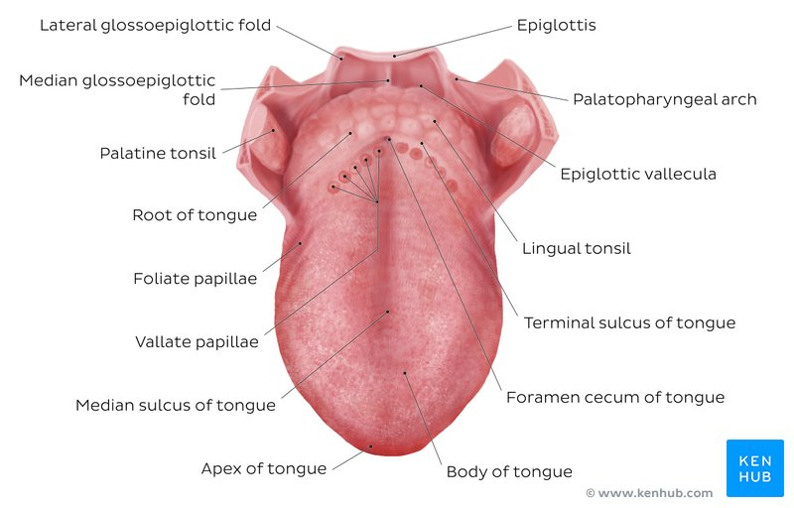

Muscles
The tongue is chiefly a muscular organ with some amount of fatty and fibrous tissue distributed throughout its substance. All the muscles of the tongue are paired structures, with each copy being found on either side of the median fibrous septum. There are 2 groups of muscles the first known as extrinsic muscles and the other set of muscles; the intrinsic muscles.
The intrinsic muscles are responsible for adjusting the shape and orientation of the tongue and they are :
- Superior longitudinal
- Inferior longitudinal
- Transverse muscle
- Vertical muscle
The extrinsic muscles control the movement of the tongue in and out of the oral cavity:
- Genioglossus
- Hyoglossus
- Styloglossus
- Palatoglossus

ARTERIAL SUPPLY TO THE TONGUE:
- Lingual Artery (dorsal lingual, sublingual, deep lingual arteries)
- Ascending palatine artery
- Tonsillar artery
- Ascending pharyngeal artery
The vascular supply to the tongue muscles is provided by derivatives of the lingual artery. This is a branch of the external carotid artery that traverses the region between the middle pharyngeal constrictor and hypoglossus in order to access the floor of the mouth. It takes a sharp superior turn at the anterior border of hypoglossus as it travels alongside CN IX. The tongue has good collateral supply as the lingual artery also anastomosis with the contralateral vessel. The named branches of the lingual artery are as follows:
- The dorsal lingual arteries are relatively small derivatives of the lingual artery that arise medial to hypoglossus. In addition to supplying the dorsal mucosa of the tongue, it also gives branches to the palatoglossus, soft palate, palatine tonsils, and epiglottis.
- Emerging at the anterior limit of the hypoglossus, the sublingual arteries course between the mylohyoid and genioglossus as it travels towards the sublingual glands in the floor of the oral cavity. As it arborizes, one of its branches anastomoses with the submental branches of the facial artery, while another traverses the gingiva of the mandible to anastomose with the analogous contralateral vessel.
- As the lingual artery terminates near the lingual frenulum on the ventral surface of the tongue, it is referred to as the deep lingual artery.
The lingual artery is supported by other branches of the external carotid artery. The facial artery gives off the ascending palatine and tonsillar arteries that also supply the tongue. The ascending pharyngeal branch of the external carotid artery also supplies the organ.
VENOUS DRAINAGE:
The veins of the tongue are named similarly to the arteries that they accompany. They are formed from numerous venous tributaries that eventually coalesce. As the deep lingual vein forms adjacent to the apex of the tongue, it courses along the ventral surface of the tongue (deep to the mucosa). As the deep lingual vein anastomosis with the sublingual vein, they become the vena comitans of CN XII. This venous network eventually drains to the lingual vein that later join the facial or the anterior division of the retromandibular veins. Here, they form the common facial vein, which is a tributary to the internal jugular vein. Alternatively, the venae comitantes may drain directly to the internal jugular vein. The dorsal lingual veins are responsible for draining the lateral margins and dorsal surface of the tongue. They travel alongside the similarly named artery as they drain into the internal jugular vein.
LYMPHATIC DRAINAGE:
The marginal and central groups drain the anterior parts of the tongue, while the dorsal group drains lymph from the posterior third of the organ. It is not uncommon to see the central area of the tongue draining to both marginal and dorsal groups of lymph vessels.
The marginal lymph vessels will carry lymph to the submandibular nodes or to the jugulo-omohyoid nodes. It is not uncommon to see lymph vessels decussating to drain to contralateral lymph nodes. The vessels from the central region may go to the deep cervical nodes, with a particular preference for the jugulo-omohyoid or jugulodigastric nodes. The dorsal group of vessels also pass laterally on either side to eventually join the marginal vessels in their course to the jugulo-omohyoid and jugulodigastric vessels.

NERVOUS SUPPLY:
The nervous supply to the tongue can be grouped based as efferent fibers that carry motor impulses, general sensory that conveys touch and proprioception, and special afferent that conveys gustatory impulses. The CNXII provides motor innervation to all the muscles of the tongue except palatoglossus which is supplied by the CNX.
The lingual nerve is a branch of CNV3 and is responsible for conveying general somatic afferent impulses from the anterior two-thirds of the tongue. General afferent impulses from the circumvallate papillae along with the posterior one-third of the tongue are carried by fibers of CN IX.
Taste Innervation:
There are three cranial nerves responsible for conveying taste sensation from the tongue to the brain. These are CN VII, CN IX, and (to a lesser extent) CN X. The region of the tongue covered by each nerve is dependent on the proximity of the developing taste bud (and lingual papilla) to the free nerve ending. CN VII mitigates special sensory signals from the anterior two-thirds of the tongue, as well as from the inferior part of the soft palate.
Fibers of the chorda tympani travel by means of the lingual nerve to detect impulses from the sulcal tongue. The postsulcal tongue, circumvallate papillae, palatoglossal arches, and oropharynx are governed by CN IX. CN X only provides supply to taste buds in the extreme areas of the pharyngeal tongue. These impulses are conveyed by the internal laryngeal branch of the vagus nerve.

CLINICAL ANATOMY:
A particular pharyngeal arch defect known as PIERRE ROBIN SYNDROME, causes glossoptopsis among other symptoms. This particular defect causes the tongue to be displaced posteriorly and may cause airway obstruction or apnea.

- WRITE ON THE AIR SINUSES
The air sinuses also known as Paranasal sinuses are a group of four paired air-filled spaces that surround the nasal cavity. The maxillary sinuses are located under the eyes; the frontal sinuses are above the eyes; the ethmoidal sinuses are between the eyes and the sphenoidal sinuses are behind the eyes. The sinuses are named for the facial bones in which they are located.
Humans possess four paired paranasal sinuses, divided into subgroups that are named according to the bones within which the sinuses lie:
- The maxillary sinuses, the largest of the paranasal sinuses, are under the eyes, in the maxillary bones (open in the back of the semilunar hiatus of the nose). They are innervated by the trigeminal nerve (CN Vb).
- The frontal sinuses, superior to the eyes, in the frontal bone, which forms the hard part of the forehead. They are also innervated by the trigeminal nerve (CN Va).
- The ethmoidal sinuses, which are formed from several discrete air cells within the ethmoid bone between the nose and the eyes. They are innervated by the ethmoidal nerves, which branch from the nasociliary nerve of the trigeminal nerve (CN Va).
- The sphenoidal sinuses, in the sphenoid bone. They are innervated by the trigeminal nerve (CN Va & Vb)
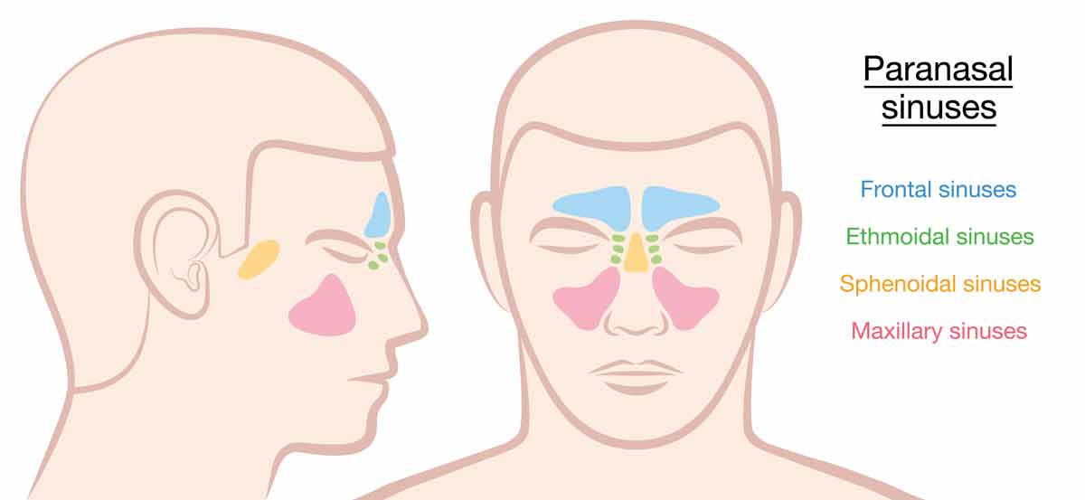
CLINICAL ANATOMY:
The paranasal sinuses are joined to the nasal cavity via small orifices called ostia. These become blocked easily by allergic inflammation, or by swelling in the nasal lining that occurs with a cold. If this happens, normal drainage of mucus within the sinuses is disrupted, and sinusitis may occur. Because the maxillary posterior teeth are close to the maxillary sinus, this can also cause clinical problems if any disease processes are present, such as an infection in any of these teeth. These clinical problems can include secondary sinusitis, the inflammation of the sinuses from another source such as an infection of the adjacent teeth.
- These conditions may be treated with drugs such as decongestants, which cause vasoconstriction in the sinuses; reducing inflammation; by traditional techniques of nasal irrigation; or by corticosteroid.

