Name: Nwapa Bernard Ukachukwu
Matric Number: 17/MHS01/209
Assignment Title: Assignment 2
Course Title: Gross Anatomy of Head and Neck
Course Code: ANA 301
College: Medicine and Health Sciences (MHS)
Department: Medicine and Surgery (MBBS)
Level: 300 level
Assignment Question
1. Write an essay on the cavernous sinus
2. Discuss the walls of the nose
Answers
- Cavernous sinus
The cavernous sinus within the human head is one of the dural venous sinuses. It is situated in the middle cranial fossa on each side of the sella turcica, it consist of a venous plexus. Each sinus extends anteriorly from the superior orbital fissure to the apex of the temporal bone posteriorly, it is of great clinical importance because of the connection and structures that pass through them.
It is a network of veins that sit in a cavity, approximately 1 x 2 cm in size in an adult.
Nearby structures
- Above: optic tract, optic chiasma, internal carotid artery.
- Inferiorly: Foramen lacerum and the junction of the body and greater wing of sphenoid bone.
- Medially: Hypophysis cerebri or (pituitary gland) and sphenoidal air sinus.
- Laterally: temporal lobe with uncus.
- Anteriorly: superior orbital fissure and the apex of the orbit.
- Posteriorly: apex of petrous temporal bone.
Venous connections
The cavernous sinus receives blood from:^{[2]}
- Superior and inferior ophthalmic veins
- Sphenoparietal sinus
- Superficial middle cerebral veins
- Inferior cerebral veins
Blood leaves the sinus via superior and inferior petrosal sinuses as well as via the emissary veins through the foramina of the skull (mostly through foramen ovale). There are also connections with the pterygoid plexus of veins via inferior ophthalmic vein, deep facial vein and emissary veins
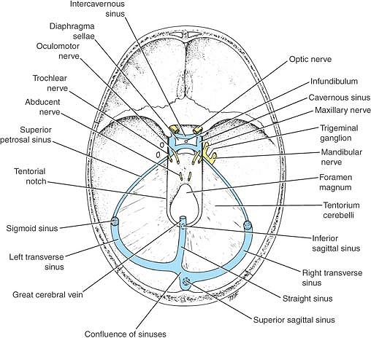
Contents
Apart from the blood which passes through a venous sinus, several anatomical structures, including some cranial nerves and their branches, also pass through the sinus.^{[2]}
Structures within the outer (lateral) wall of the compartment from superior to inferior:^{[2]}
- Oculomotor nerve
- Trochlear nerve
- Ophthalmic and maxillary branches of the trigeminal nerve
Structures passing through the midline (medial) wall.
- Abducens nerve
- Internal carotid artery accompanied by the Internal carotid plexus
These nerves, with the exception of CN V₂, pass through the cavernous sinus to enter the orbital apex through the superior orbital fissure. The maxillary nerve, division V₂ of the trigeminal nerve travels through the lower portion of the sinus and exits via the foramen rotundum. The maxillary branch passes external to, but immediately adjacent to, the lateral wall of the sinus)^{[1]}
The optic nerve lies just above and outside the cavernous sinus, superior and lateral to the pituitary gland on each side, and enters the orbital apex via the optic canal.
Connecting the right and left cavernous sinuses are the intercavernous sinuses on the anterior and posterior sides of the pituitary stalk
Clinical anatomy
- Carvenous sinus thrombosis(CST): refers to the formation of clot within the cavernous sinus
- These connections provide pathways for infections to pass from extracranial sites into intracranial locations
- In addition, because structures pass through the cavernous sinuses and are located in the walls of these sinuses they are vulnerable to injury due to inflammation

- The Nose
The nose is the most protruding part of the face. It bears the nostrils and is the first organ of the respiratory system. It is also the principal organ in the olfactory system. The shape of the nose is determined by the nasal bones and the nasal cartilages, including the nasal septum which separates the nostrils and divides the nasal cavity into two. On average the nose of a male is larger than that of a female.
The main function of the nose is breathing, and the nasal mucosa lining the nasal cavity and the paranasal sinuses carries out the necessary conditioning of inhaled air by warming and moistening it. Nasal conchae, shell-like bones in the walls of the cavities, play a major part in this process. Filtering of the air by nasal hair in the nostrils prevents large particles from entering the lungs. Sneezing is a reflex to expel unwanted particles from the nose that irritate the mucosal lining. Sneezing can transmit infections, because aerosols are created in which the droplets can harbour pathogens.
Another major function of the nose is olfaction, the sense of smell. The area of olfactory epithelium, in the upper nasal cavity, contains specialised olfactory cells responsible for this function.
The nose is also involved in the function of speech. Nasal vowels and nasal consonants are produced in the process of nasalisation. The hollow cavities of the paranasal sinuses act as sound chambers that modify and amplify speech and other vocal sounds.
Boundaries of the Nasal Cavity
- The nasal cavity has a:
- roof
- floor
- medial wall
- lateral wall
The roof :
- is curved and narrow, except at its posterior end
- it is divided into 3 parts
- frontonasal
- ethmoidal
- sphenoidal
- They are named from the bones forming each part
The floor:
- is wider than the roof
- is formed by the;
- palatine processes of the maxilla
- horizontal plates of the palatine bone
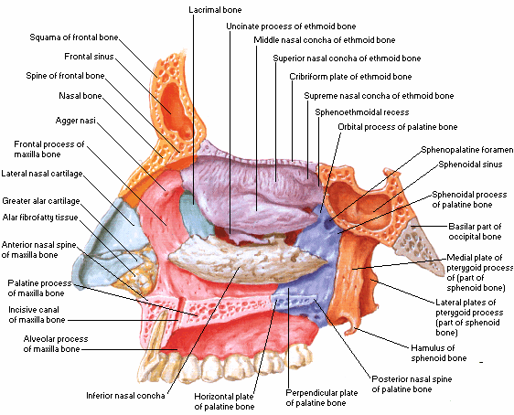
The medial wall :
formed by the nasal septum
The lateral walls :
- are irregular owing to three bony plates, the nasal conchae, which project inferiorly, somewhat like louvers
Features on the lateral wall of the nasal cavity
- There is the presence of nasal conchae and they curve inferomedially
- The nasal conchae include;
- Superior nasal concha
- middle nasal concha
- inferior nasal concha
- The conchae or turbinates of many mammals (especially running mammals and those existing in extreme environments) are highly convoluted, scroll-like structures that offer a vast surface area for heat exchange
- Underneath each concha in both humans with simple nasal conchae and animals with complex turbinates is a recess or meatus {passage(s) in the nasal cavity}

CLINICAL ANATOMY
Epistaxis
- Epistaxis (nosebleed) is relatively common because of the rich blood supply to the nasal mucosa
- In most cases, the cause is trauma and the bleeding is from an area in the anterior third of the nose (Kiesselbach area)
- Epistaxis is also associated with infections and hypertension
- Spurting of blood from the nose results from rupture of arteries
- Mild epistaxis may also result from nose picking, which tears veins in the vestibule of the nose
Rhinitis
- The nasal mucosa becomes swollen and inflamed (rhinitis) during severe upper respiratory infections and allergic reactions (e.g., hayfever)
- Swelling of the mucosa occurs readily because of its vascularity

