NAME: SIFO BLESSING OGHENEMARO
MATRIC NUMBER: 18/MHS02/179
DEPARTMENT: NURSING
COURSE TITLE: PHYSIOLOGY
COURSE CODE PHS 212

BREAST
Development of breast
The breast begins to develop at puberty. This development is stimulated by the estrogens of the monthly female sexual cycle; estrogens stimulate growth of the breasts’ mammary glands plus the deposition of fat to give the breast mass. In addition, far greater growth occurs during the high estrogen state of pregnancy, and only then does the glandular tissue become completely developed for the production of milk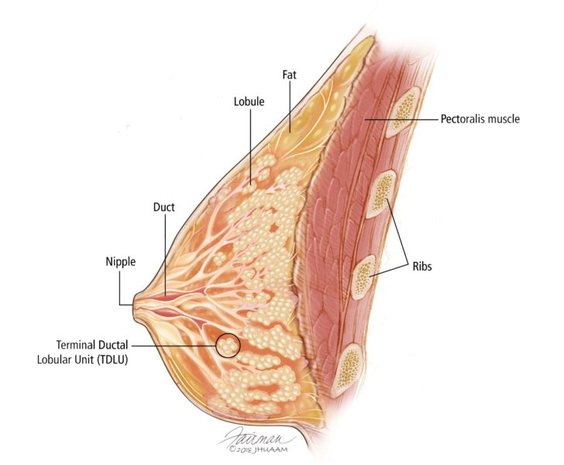
The breast is an organ whose structure reflects its special function: the production of milk for lactation (breast feeding). The epithelial component of the tissue consists of lobules, where milk is made, which connects to ducts that lead out to the nipple. Most cancers of the breast arise from the cells which form the lobules and terminal ducts. These lobules and ducts are spread throughout the background fibrous tissue and adipose tissue (fat) that make up the majority of the breast. The male breast structure is nearly identical to the female breast, except that the male breast tissues lacks the specialized lobule, since there is no physiologic need for milk production by males
Effects of estrogen on the breasts.
The primordial breasts of females and males are exactly alike. In fact, under the influence of appropriate hormones, the masculine breast during the first 2 decades of life can develop sufficiently to produce milk in the same manner as the female breast.
Estrogens cause (1) development of the stromal tissues of the breasts (2) growth of an extensive ductile system, and (3) deposition of fat in the breasts. The lobules and alveoli of the breast develop to a slight extent under the influence of estrogens alone, but it is progesterone and prolactin that cause the ultimate determinative growth and function of these structures.
In summary, the estrogen initiate growth of the breasts and of the milk-producing apparatus. They are also responsible for the characteristic growth and external appearance of the mature female breast. However, they do not complete the job of converting the breasts into milk-producing organs.
Effect of progesterone on the breasts
Progesterone promotes development of the lobules and alveoli of the breasts, causing the alveolar cells to proliferate, enlarge, and become secretory in nature. However, progesterone does not cause the alveoli to secrete milk, milk is secreted only after the prepared breast is further stimulated by prolactin from the anterior pituitary gland.
Progesterone also causes the breasts to swell. Part of this swelling is due to the secretory development in the lobules and alveoli, but part also results from increased fluid in the subcutaneous tissue.
Cyclic changes in breast.
In younger women, breast pain is often linked to one’s menstrual cycle. This kind of pain is called cyclical breast pain. The hormones that rise and fall during menstruation can cause breast tenderness, swelling, aches, and even tingling in your breast.
If your breasts are fibrocystic (noncancerous changes that give your breasts a lumpy or rope-like texture), you’ll also notice lumps and bumps more easily during your menstrual period.
Causes
Your monthly menstrual cycle is determined by fluctuations in levels of estrogen and progesterone. These important hormones prepare your breasts and reproduction system for potential pregnancy. Sensations of breast tenderness may come from breast lobes and breast ducts enlarging around the time of ovulation.
Breast pain may be worse just before menstruation, and then gradually taper off during and after your period. For some women, breast pain persists constantly but varies in intensity as her cycle progresses. Cyclical breast pain is typically not a symptom of breast cancer.
Breast cysts, fibrocystic changes, and breast fibroadenomas may also cause fluctuating pain, even though all these are benign breast conditions.
Fluctuating hormone levels account for most episodes of cyclic changes in breast. Your hormones rise and fall during a normal menstrual cycle. The exact timing of the hormonal changes varies for each woman. Estrogen causes the breast ducts to enlarge. Progesterone production causes the milk glands to swell. Both of these events can cause your breasts to feel sore.
Estrogen and progesterone both increases during the second half of the cycle days 14 to 28 in a typical 28 day cycle. Estrogen peaks in the middle of the cycle, while progesterone levels rise during the week before menstruation. Medications that contains estrogen can also cause breast changes such as tenderness and swelling
Tenderness and heaviness in both breasts are the main symptoms of premenstrual pain and swelling. A dull aching in the breasts can also be a problem for some women. Your breast tissue could feel dense or coarse to the touch. Symptoms tend to appear the week before your period and disappear almost immediately when menstrual bleeding begins. Most women do not experience severe pain.
In some cases, breast tenderness affects the everyday routines of some women of childbearing age, and is not necessarily connected to the menstrual cycle. Due to the natural change in hormone levels that occur as a women ages, premenstrual breast swelling and tenderness usually improves as menopause approaches. The symptoms of PMS can closely resemble those of early pregnancy
VAGINAL
The vaginal is an elastic, muscular canal with a soft, flexible lining that provides lubrication and sensation. The vagina connects the uterus to the outside world. The vulva and labia from the entrance, and the cervix of uterus protrudes into vagina, forming the interior end.
The vaginal receives the penis during sexual intercourse and also serves as a conduit for menstrual flow from the uterus. During childbirth, the baby passes through the vaginal (birth canal). The hymen is a thin membrane of tissues that surrounds and narrows the vaginal opening. It may be torn or ruptured by sexual activity or by exercise.
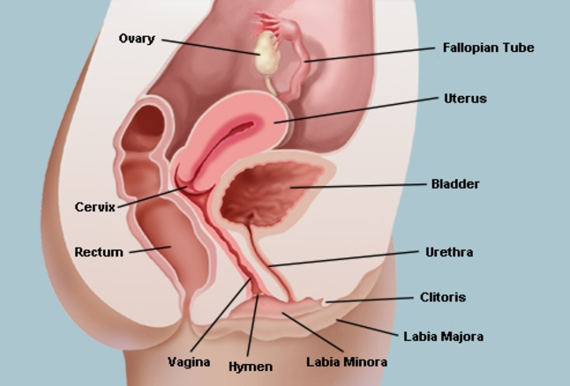

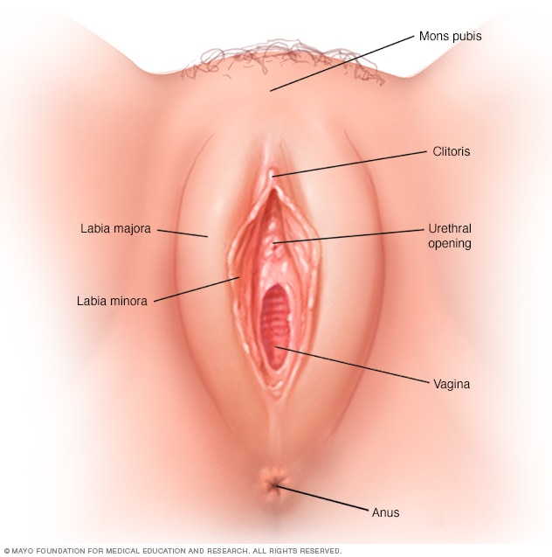Cyclic changes in the vagina
The vaginal epithelium is under the endocrine control of estrogens and progesterone. Estrogens stimulate cellular proliferation and differentiation in both epithelium and lamina propria. Progesterone reinforces estrogens in glycogen synthesis, opens the intercellular channels and mobilizes through them the migrating lymphocytes from the lamina propria
The cyclical changes of the vaginal epithelium are less pronounced than those of the endometrium. Differential cytology of the vaginal epithelium can be used to identify the stages of the cycle. The epithelium is highest in the proliferative stage and reaches the highest glycogen content during ovulation. During the secretory phase the thickness of the epithelium again decreases due to the shedding of cells. The vaginal surface loses its intact structure once the luteinization starts. After desquamation on the surface of isolated vaginal epithelium cells the contamination with physiological coatings can occasionally be observed too, as well as non-structural substances, resulting from bacterial cytolysis.
HORMONAL REGULATION OF THE MENSTRUAL CYCLE
The hypothalamus secretes GnRH, which causes the anterior pituitary gland to secrete LH and FSH. Secretion of most of the anterior pituitary hormones is controlled by “releasing hormones” formed in the hypothalamus and then transported to the anterior pituitary gland by way of the hypothalamic-hypophysial portal system. In the case of the gonadotropins, one releasing hormone, GnRH, is important. This hormone has been purified and has been found to be decapeptide.
Intermittent, pulsatile secretion of GnRH by the hypothalamus stimulates pulsatile release of LH from the anterior pituitary gland. Experiments have demonstrated that the hypothalamus does not secrete GnRH continuously but instead secretes it in pulses lasting 5 to 25 minutes that occur every 1 to 2 hours. It is intriguing that when GnRH is infused continuously so that it is available all the time rather than in pulses, its ability to cause the release of LH and FSH by the anterior pituitary gland is lost. Therefore, for reasons unknown, the pulsatile nature of GnRH release is essential to its function.
Hypothalamic centers for release of GnRH. The neuronal activity that causes pulsatile release of GnRH occurs primarily in the mediobasal hypothalamus, especially in the arcuate nuclei of this area. Therefore, it is believed that these arcuate nuclei control most female sexual activity, although neurons located in the preoptic area of the anterior hypothalamus also secretes GnRH in moderate amounts. Multiple neuronal centers in the higher brain’s “limbic” system (the arcuate nuclei to modify both the intensity of GnRH release and the frequency of the pulses, thus providing a partial explanation of why psychic factors often modify female sexual function.
Negative feedback effects of estrogen and progesterone in decreasing both LH and FSH secretion.
Estrogen in small amounts has a strong effect to inhibit the production of both LH and FSH. Also, when progesterone is available, the inhibitory effect of estrogen is multiplied, even though progesterone by itself has little effect. These feedback effects seem to operate mainly on the anterior pituitary gland directly, but they also operate to a lesser extent on the hypothalamus to decrease secretion of GnRH, especially by altering the frequency of the GnRH pulses.
Hormone inhibin from the corpus luteum inhibits FSH and LH secretion. In addition to the feedback effects of estrogen and progesterone, other hormones seem to be involved, especially inhibin, which is secreted along with the steroid sex hormones by the granulosa cells of the ovarian corpus luteum in the same way that sertoli cells secrete inhibin in the male testes. This hormone has the same effect in the female as in the male-inhibiting the secretion of FSH and, to a lesser extent, LH by the anterior pituitary gland. Therefore, it is believed that inhibin might be especially important in causing the decrease in secretion of FSH and LH at the end of the monthly female cycle.
Positive feedback effect of estrogen before ovulation-The preovulatory LH surge
Experiments have shown that infusion of estrogen into in a female above a critical rate for 2 to 3 days during the latter part of the first half of the ovarian cycle will cause rapidly accelerating secretion of ovarian estrogens. During this period, secretions of both FSH and LH by the anterior pituitary gland are at first slightly suppressed. Then secretion of LH increases abruptly sixfold to eightfold, and secretion of FSH increases about twofold. The greatly increased secretion of LH causes ovulation to occur.
The cause of this abrupt surge in LH secretion is not known. However, several possible explanations are as follows: (1) It has been suggested that estrogen at this point in the cycle has a peculiar positive feedback effect of stimulating pituitary secretion of LH and, to a lesser extent, FSH: this is in sharp contrast to its normal negative feedback effect that occurs during the remainder of the female monthly cycle, (2) The granulosa cells of the follicles begin to secrete small but increasing quantities of progesterone a day or so before the preovulatory LH surge, and it has been suggested that this might be the factor that stimulates the excess LH secretion. Without this normal preovulatory surge of LH, ovulation will not occur.
Feedback Oscillation of the hypothalamic-pituitary-ovarian system.
- Postovulatory secretion of the ovarian hormones, and depression of the pituitary Gonadotropins. The easiest part of the cycle to explain is the events that occur during the postovulatory phase-between ovulation and beginning of menstruation. During this time, the corpus luteum secretes large quantities of both progesterone and estrogen, as well as the hormone inhibin. All these hormones together have a combined negative feedback effect on the anterior pituitary gland and hypothalamus, causing the suppression of both FSH and LH secretion and decreasing them to their lowest levels about 3 to 4 days before the onset of menstruation
- Follicular growth phase. 2 to 3 days before menstruation, the corpus luteum has regressed to almost total involution, and the secretion of estrogen, progesterone, and inhibin from the corpus luteum decreases to a low ebb. This releases the hypothalamus and anterior pituitary from the negative feedback effect of these hormones. Therefore, a day or so later, at about the time that menstruation begins, pituitary secretion of FSH begins to increase again, as much as twofold; then, several days after menstruation begins, LH secretion increases slightly as well. These hormones initiate new ovarian follicle growth and a progressive increase in the secretion of estrogen, reaching a peak estrogen secretion of estrogen, reaching a peak estrogen secretion at about 12.5 ro 13 days after the onset of the new female monthly sexual cycle. During the first 11 to 12 days of this follicle growth, the rates of pituitary secretion of the gonadotropins FSH and LH decrease slightly because of the negative feedback effect, mainly of estrogen, on the anterior pituitary gland. Then there is a sudden; marked increase in the secretion of LH and, to a lesser extent, FSH. This is the preovulatory surge of LH and FSH, which is followed by ovulation.
- Preovulatory surge of LH and FSH causes ovulation. At about 11.5 to 12 days after the onset of the monthly cycle, the decline in secretion of FSH and LH comes to an abrupt halt. It is believed that the high level of estrogens at this time (or the beginning of progesterone secretion by the follicles) causes a positive feedback stimulatory effect on the anterior pituitary as explained earlier, which leads to a terrific surge in the secretion of LH and, to a lesser extent, FSH. Whatever the cause of this preovulatory LH and FSH surge, the great excess of LH leads to both ovulation and subsequent development of and secretion by the corpus luteum. Thus, the hormonal system begins its new round of secretions until the next ovulation.
Abnormalities of secretion by the ovaries
Hypogonadism. Less than normal secretion by the ovaries can result from poorly formed ovaries, lack of ovaries can result from poorly formed ovaries, lack of ovaries, or genetically abnormal ovaries that secrete the wrong hormones because of missing enzymes in the secretory cells. When ovaries are absent from birth or when they become nonfunctional before puberty, female eunuchism occurs. In this condition, the usual secondary sexual characteristics do not appear, and the sexual organs remain infantile
Irregularity of menses, and amenorrhea caused by hypogonadism. As pointed out in the preceding discussion of menopause, the quantity of estrogens produced by the ovaries must rise above a critical value in order to cause rhythmical sexual cycles. Consequently, in hypogonadism or when the gonads are secreting small quantities of estrogens as a result of other factors, such as hypothyroidism, the ovarian cycle often does not occur normally. Instead, several months may elapse between menstrual periods, or menstruation may cease although (amenorrhea). Prolonged ovarian cycles are frequently associated with failure of ovulation, presumably because of insufficient secretion of LH at the time of the preovulatory surge of LH at the time of the preovulatory surge of LH, which is necessary for ovulation
Hypersecretion by the ovaries. Extreme hypersecretion of ovarian hormones by the ovaries is a rare clinical entity, because excessive secretion of estrogens automatically decreases the production of gonadotropins by the pituitary, and this limits the production of ovarian hormones. Consequently, hypersecretion of feminizing hormones is usually recognized clinically only when a feminzing tumor develops.
A rare granulosa cell tumor can develop in an ovary, occurring more often after menopause than before. These tumors secrete large quantities of estrogens, which exert the usual estrogenic effects, including hypertrophy of the uterine endometrium and irregular bleeding from this endometrium. In fact, bleeding is often the first and only indication that such a tumor exists.

