NAME: UGORJI NKEMJIKA JANE
MATRIC NO: 18/MHS05/012
DEPARTMENT: PHYSIOLOGY
COLLEGE: COLLEGE OF MEDICINCE AND HEALTH SCIENCES
COURSE CODE: ANA 206
ASSIGNMENT: DEVELOPMENT OF THE LUNGS AND THE STOMACH

DEVELOPMENT OF THE LUNGS
ROLE OF EMBRYOLOGY IN DISEASE MANAGEMENT
• To know the exact etiology and prognosis of disease. E.g. Tracheobronchial fistula
• To understand multisystem disorder
• To understand imaging features.
• To get cellular level of information regarding normal/abnormal tissue.
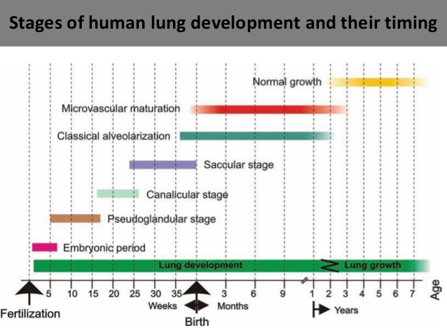

Stages of human lung development and their timing
- Embryonic Period (Weeks 4--7): A LUNG ANLAGE
- The lung anlage appears at day 26 as two ventral buds of the foregut at the caudal end of the laryngotracheal sulci.
- It will give rise to the left and right lung. Both buds elongate, grow into the surrounding mesenchyme, and form the left and right main bronchi (day 32).
The terminal ends of the growing bronchial tree start a repetitive process of growth and mainly dichotomous branching.
- By day E37 the future conducting airways are preformed to the lobar
- By day E41 to the segmental
- And by day E48 to the sub segmental bronchi.
Pulmonary Underdevelopment
- Agenesis - Bronchus and lung are absent.
- Aplasia - Rudimentary bronchus is present and limited to a blind end pouch without lung tissue.
- Hypoplasia - Bronchial hypoplasia with variable reduction of lung tissue. Pulmonary underdevelopment
Agenesis of the lungs
Agenesis occurs during the embryonic period (approximately 4 weeks gestation).
- Can occur bilaterally or unilaterally.
- Presence of both bronchi and alveoli in an underdeveloped lobe.
- Due to early failure of the respiratory bud to develop and/or branch (e.g. insufficient mesoderm, teratogens such as RA or alcohol, or genetic mutation).
- Unilateral lung agenesis is compatible with life (remaining side usually hyper expands and compensates).
- 50% of children with pulmonary agenesis have associated congenital anomalies.
- Cardiovascular (more frequent patent ductus arteriosus and patent foramen ovale), gastrointestinal, skeletal, and genitourinary systems
Pulmonary hypoplasia
- Reduction in the number of lung cells, airways, and alveoli that results in a lower organ size and weight. (U/l or B/L)
- Associated congenital anomalies - cardiac, gastrointestinal, genitourinary, and skeletal malformations. (50-80%)
- Etiologies include prolonged rupture of membranes, fetal renal dysplasia and obstruction, and fetal neuromuscular diseases.
Congenital Lung Cysts
Arise secondary to abnormal budding of the primitive ventral foregut, early in fetal life.
Location - Mediastinum (Commonest – 70 %) Pulmonary parenchyma. Rarely - Neck, pericardium, or abdominal cavity
Symptoms
- Incidental finding
- Symptomatic infants – Respiratory distress
- Older children - Infected cysts
- Spontaneous pneumothorax – Rarely
Cysts (filled with fluid or air) are formed by the dilation of terminal bronchi, due to branching irregularities in later development

Complications
- Infection
- Hemorrhage
- Erosion into adjacent structures.
Treatment
- Medical therapy -antibiotics in children with CCAM complicated by pneumonia and supportive care, ranging from oxygen supplementation to mechanical ventilation, in older children with respiratory distress.
- Surgical Resection – main line of treatment
Tracheal Bronchus
A bronchial anomaly originating from the trachea.
- Usually in the right lateral wall of the trachea.
- 2 cm above the carina.
Tracheal bronchus – Displaced (More frequent) or supernumerary Prevalence
- Right tracheal bronchus - 0.1%–2%.
- Left tracheal bronchus - 0 3. % – 1 %.
Symptoms
Asymptomatic usually. Consider diagnosis in persistent/recurrent upper lobe pneumonia or atelectasis or air trapping.
Bronchial atresia
Focal obliteration of a proximal segmental or sub-segmental bronchus.
- Lacks communication with the central airways
- Development of distal structures is normal. Most often affects segmental bronchi at or near their origin.
- Bronchi distal to the stenosis become filled with mucus → bronchocele.
- May be acquired postnatally - Traumatic/ post inflammatory insult.
- Upper-lobe bronchi are more frequently affected.
- Usually asymptomatic incidental finding in approximately 50% of cases, mostly in young men.
- Dyspnea, pneumonia, and bronchial asthma have been
Splitting of foregut into esophagus and trachea
- Initially, the lung bud is in open communication with the foregut then tracheoesophageal ridges, separate it from the foregut
- These ridges fuse to form the tracheoesophageal septum.
- The foregut is divided into a dorsal portion esophagus, and a ventral portion, the trachea and lung buds.
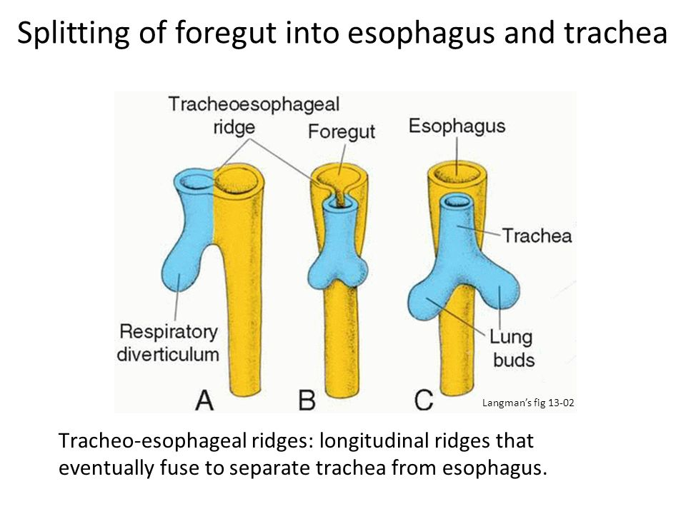
Tracheo-esophageal fistulas
- Incomplete separation of esophagus and trachea by tracheosophageal septum results in atresia of esophagus with or without tracheosophageal fistula.
- Defect likely in mesoderm and usually associated with other defects involving mesoderm (cardiovascular malformations, VATER / VACTERL, etc
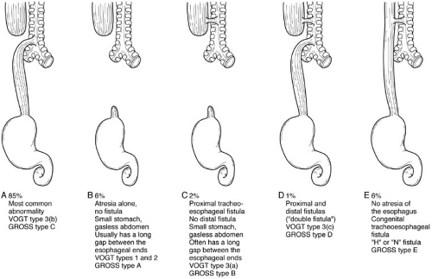
Complications
- PRENATAL: Polyhydramnios (due to inability to swallow amniotic fluid in utero)
- POSTNATAL
– Gastrointestinal: Infants cough and choke when swallowing because of accumulation of excessive saliva in mouth and upper respiratory tract. Milk is regurgitated immediately after feeding.
– Respiratory: Gastric contents may also reflux into the trachea and lungs, causing choking and often leading to pneumonitis.
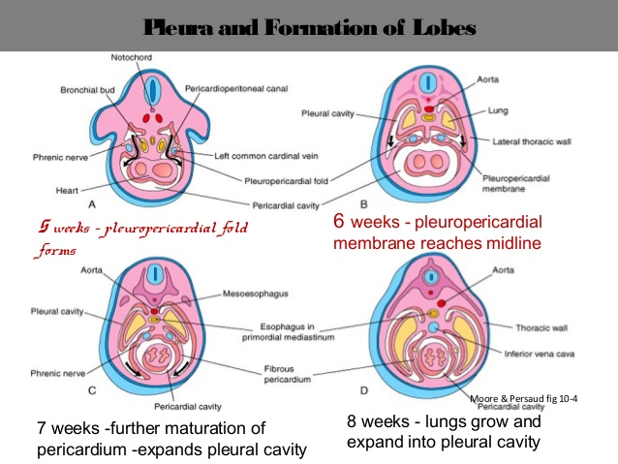
Pleura and Formation of Lobes
- 5 weeks - pleuropericardial fold forms
- 8 weeks - lungs grow and expand into pleural cavity
- 6 weeks - pleuropericardial membrane reaches midline
- 7 weeks -further maturation of pericardium -expands pleural cavity Moore & Persaud
The growing lung buds expand in caudolateral direction into the pericardioperitoneal canals.
During week 5, the pleuropericardial folds meet and fuse with the foregut mesenchyme.
During weeks 5–7, pleuroperitoneal membranes meet and fuse with the posterior edge of the septum transversum and close the pleural cavities. The visceral pleura have formed by the splanchnic mesoderm, which covers the outside of the lung. Pleura
The parietal pleura have formed by the somatic mesoderm layer covering the inner surface of the body wall. Visceral pleura invaginations of the pleura start to separate the lobar bronchi and give rise to the lobar fissure and the lung lobes.
Branching continues to be regulated by epithelial- mesenchymal interactions.
Organogenesis
Respiratory tract is derived from foregut endoderm and associated mesoderm from endoderm: epithelial lining of trachea, larynx, bronchi, alveoli From splanchnic mesoderm: cartilage, muscle, and connective tissue of tract and visceral pleura.
Growth Factors- Transcription factors likeTTF-1, Gli2, and Gli3; as well as growth factors like FGF-10, TGF-β, BMP-4, SHH, EGF, and VEGF.
Vasculogenesis of the Pulmonary Circulation
The mesenchyme surrounding the lung buds contains a number of progenitor cells of endothelial cells. The newly formed endothelial cells are connecting to each other to form first capillary tubes. These capillaries coalesce to form small blood vessels alongside the airways, so the earliest pulmonary vessels form by vasculogenesis.
Distal angiogenesis to form branches of vessels.
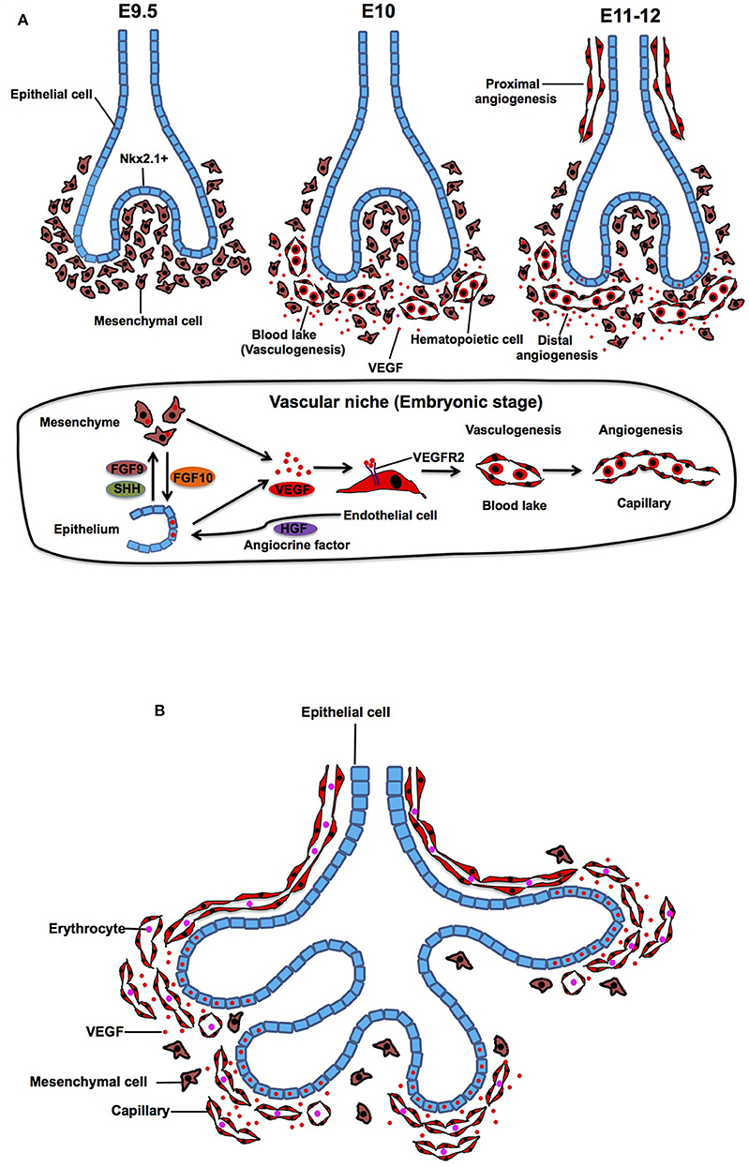

Development of the airways and arteries.
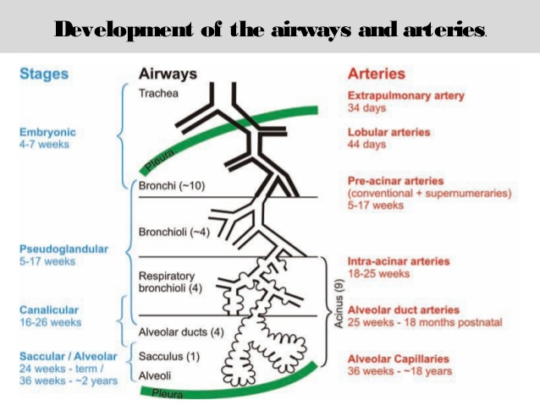
FETAL LUNG DEVELOPMENT
Pseudo glandular stage, (5-17 week)
- Formation of bronchial tree and large parts of prospective respiratory parenchyma; birth of the acinus
- Histology- the epithelial tubules branch constantly and penetrate into the surrounding mesenchyme. A loose three-dimensional capillary network is located in the mesenchyme.
Canalicular Period (16-26 weeks)
(1) The differentiation of the pulmonary epithelium and formation of the typical air-blood barrier
(2) The beginning of surfactant synthesis and secretion
(3) The “canalization” of the lung parenchyma by capillaries.
At the end of the canalicular stage, the lung has reached a state of development in which gas exchange is possible in principle. Before these developmental steps, a prematurely born infant has no chance to survive.
POST NATAL LUNG DEVELOPMENT
Alveoli start to form in the weeks before birth and the process lasts well into the postnatal period. At birth the lung contains between zero and about 50 million alveoli.
Changes at time of birth
- Lungs are fluid filled; fluid squeezed out and into lymphatics and blood vessels, expelled via trachea at delivery.
- Surfactant remains on surface, lowers air/blood tension.

Alveolar stage 36 weeks to 1–2 years
- These airspaces are mostly of the classical ‘saccular’ type, i.e. their walls are made of thick septa with a central layer of connective tissue sandwiched between two capillary networks.
- These septa present at birth have been termed originally ‘primary septa’. The double capillary network septa represent the basic structures needed for alveolarization.
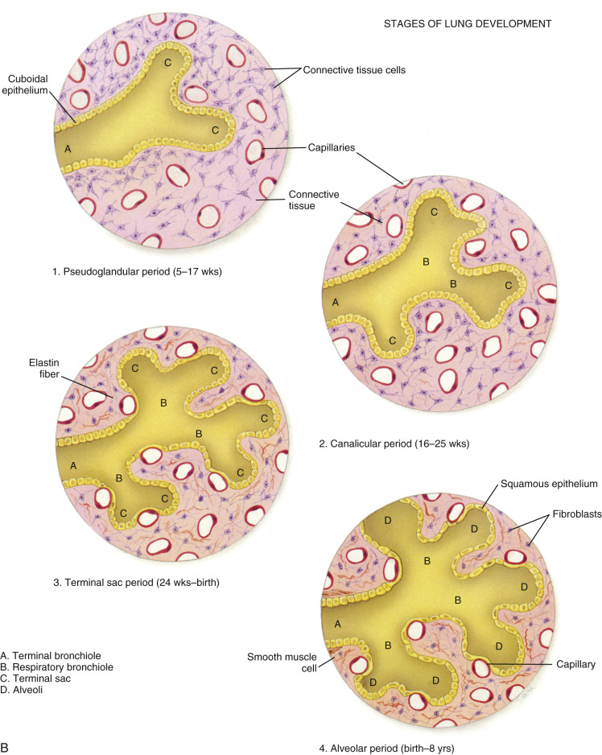
Alveolarization
The alveoli are formed by lifting off of new tissue ridges from the existing primary septa. This process produces a large number of small buds appearing along the primary septa. These buds correspond to low ridges representing newly forming septa; soon these low ridges increase in height and subdivide the airspaces into smaller units, the alveoli.
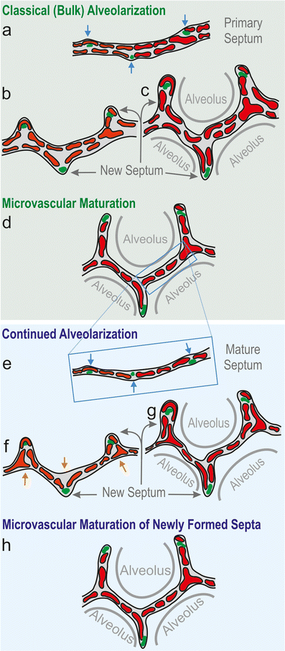
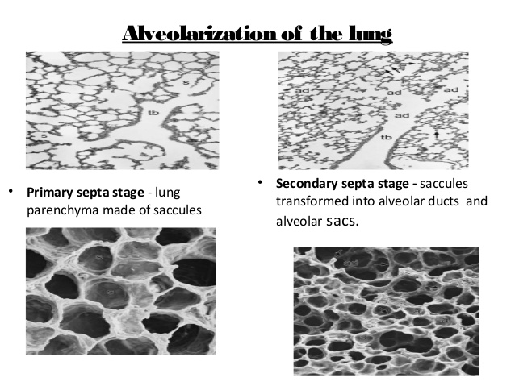
Micro vascular Maturation Stage (Birth to 2--3 Years)
The essence of this stage is the restructuring of the double capillary networks in the parenchymal septa to the mature aspect with a single capillary system by 3 steps
a. Capillary Fusion and Differential Growth
b. Programmed Cell Death
c. Interalveolar Pores (Pores of Kohn)
Circulatory changes
- During fetal life, blood flow through the lung is limited to between 10 and 15 percent of the cardiac output.
- At birth ductus arteriosus closes and the shunting of the entire cardiac output through the lung.
- The ductus arteriosus, first obstructed by muscular contraction, and is anatomically closed within a few weeks by the fibrotic organization of an intravascular clot and is known as ligamentum arteriosus.

Late Development
18 months until body growth stops
The lung volume increases to the power of 1 to body weight, and the pulmonary compartments augment linearly with lung volume.
The surface area for gas exchange also increases the power of 1 to body mass.
Surfactant proteins
Four major surfactant proteins: A, B, C, and D
- Surfactant A: activates macrophages to elicit uterine contractions, also important in host defense.
- Surfactant B: organizes into tubular structures that are much more efficient at reducing surface tension (specific deficiency in Surfactant B can lead to respiratory distress). It’s a phospholipoprotein formed by type 2 alveolar cells.
- Surfactant C: enhances function of surfactant phospholipids
- Surfactant D: important in host defense.
Hyaline membrane disease
This disease affects 2% of live newborn infants, with prematurely born being most susceptible. 30% of all neonatal disease results from HMD or its complications Surfactant deficiency causes RDS or HMD: The lungs are underinflated and the alveoli contain a fluid of high protein content, probably derived from circulation substances and injured pulmonary epithelium.
In addition to prematurity, prolonged intrauterine asphyxia may produce irreversible changes in Type II alveolar cells, rendering them incapable of producing surfactant.
Prolonged, labored breathing damages alveolar epithelium, leading to protein deposition, or “hyaline” changes
Complications
- Alveolar rupture
- Infection
- Intracranial hemorrhage and periventricular leukomalacia
- Patent ductus arteriosus (PDA) with increasing left-to- right shunt
- Pulmonary hemorrhage
- Necrotizing enter colitis (NEC) and/or gastrointestinal (GI) perforation
- Apnea of prematurity
ROTATION OF THE STOMACH AND THE FORMATION OF THE OMENTAL BURSA
The omental bursa or lesser sac is a hollow space that is formed by the greater and lesser omentum and its adjacent organs. It communicates with the greater sac via the epiploic foramen of Winslow, which is known as the general cavity of the abdomen that sits within the peritoneum, but outside the lesser sac.
This space has well-defined borders which are represented by certain organs or their parts, so they are quite easy to spot and form a mental image of the omental bursa. In addition, like anything in anatomy, the omental bursa doesn't just exist as a standalone and isolated entity, but rather it communicates with several other spaces and recesses found throughout the body.
Key facts about the omental bursa
Borders:
Anteriorly - quadrate lobe of liver, gastro colic ligament, lesser omentum
Left - left kidney, left adrenal gland
Posteriorly - pancreas
Right - epiploic foramen, lesser omentum, greater sac

Communications: Superior recess, splenic recess, inferior recess, folds and recesses around the cecum and duodenum
Clinical: Congenital anomalies, hematomas, bilomas, abscess, pancreatitis, neoplasms, hydatid cyst, tuberculosis infection, mechanical irritation.
- Borders
The borders of the omental bursa are demarcated as follows:
- Anteriorly by the quadrate lobe of the liver, the gastro colic ligament and the lesser omentum
- To the left it is limited by the left kidney and the left adrenal gland
- Posteriorly it is walled off by the pancreas
- To the right, the epiploic foramen and lesser omentum can be found and the greater sac beyond that.
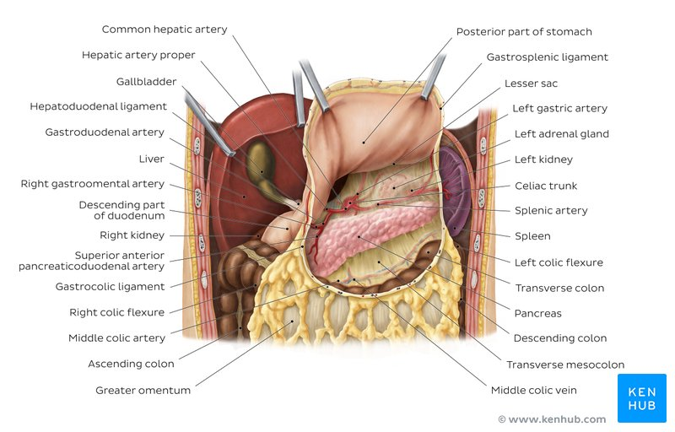
Overview of the omental bursa and neighboring structures (ventral view)
Communications and connections
The cavity itself is almost completely closed, save its communication with the greater sac and the entrance through the omental foramen and is filled with a capillary film. The greater part of the omental bursa consists of its superior recess which extends cranially between the esophagus and the inferior vena cava.
The splenic recess extends to the left between the splenic ligaments and the stomach. Finally, the inferior recess of the omental bursa extends caudally between the stomach and the transverse colon. Other anatomical landmarks of note include a varied number of small peritoneal folds, recesses and fossae which seem to accumulate mostly around the cecum and the duodenum.
Embryology
During embryonic development, the peritoneum is anchored to the gut in the midline of the abdomen anteriorly, with the dorsal mesentery securing it posteriorly. The mesenteric layers develop in an anterior direction around the upper alimentary canal, carrying the blood supply and creating the ventral mesentery.
Due to the growth of the organs, they gradually become larger and have to shift in order to fit into the abdominal cavity. The stomach rotates 90 degrees, the spleen is displaced to the left and the liver moves to the right. The peritoneum twists with these movements which lead to the formation of the falciform ligament, the lesser omentum and the coronary ligaments of the liver. Throughout this entire process, the cavity of the lesser sac is created.
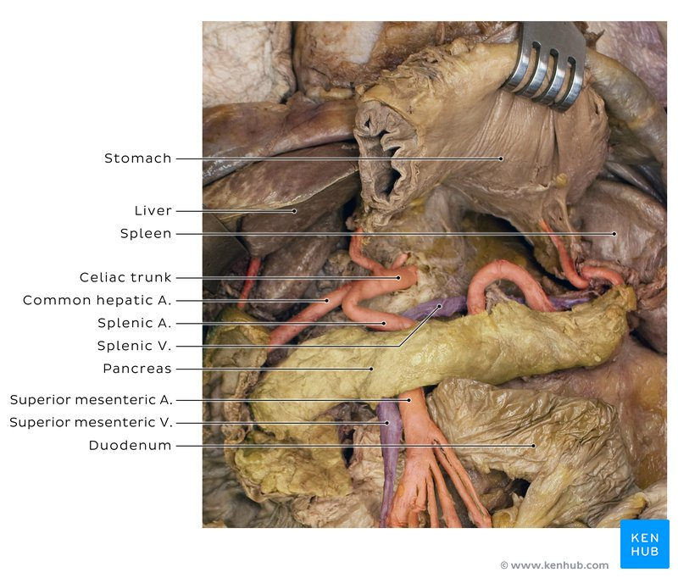
Omental bursa in a cadaver: Omental bursa is located posterior to the stomach. Therefore, it's very easy to find it during a cadaveric dissection by simply lifting the stomach. It communicates with the greater peritoneal sac via the omental foramen.
Clinical aspects
The lesser sac has seven distinctly categorized pathological groups under which its potential disorders may be listed:
Congenital anomalies include duplication cysts and cystic lymphangiomas.
A hematoma or a biloma are classed as traumatic injuries.
Inflammatory states could be due to an abscess, a pseudo cyst or even acute pancreatitis.
Neoplastic changes may lead to the growth of a stromal tumor, a leiomyoblastoma, a leiomyosarcoma, a liposarcoma, a schwannoma, both benign and malignant pancreatic neoplasms that may have endocrine involvement or not, hepatic tumors and desmoid tumors.
A hydatid cyst indicates a parasitic infestation.
The only infective cause of a lesser sac disorder as yet known of is tuberculosis.
Mechanical irritation could potentially be caused by hernias of the cecum, transverse colon, small intestine and gallbladder.
Stomach
During the fourth week of gestation, the rudimentary stomach appears as a fusiform-shaped dilation of the distal foregut. Subsequently, its appearance and position drastically changes; the latter can be better understood by visualizing a longitudinal axis and an antero-posterior axis around which the stomach rotates.
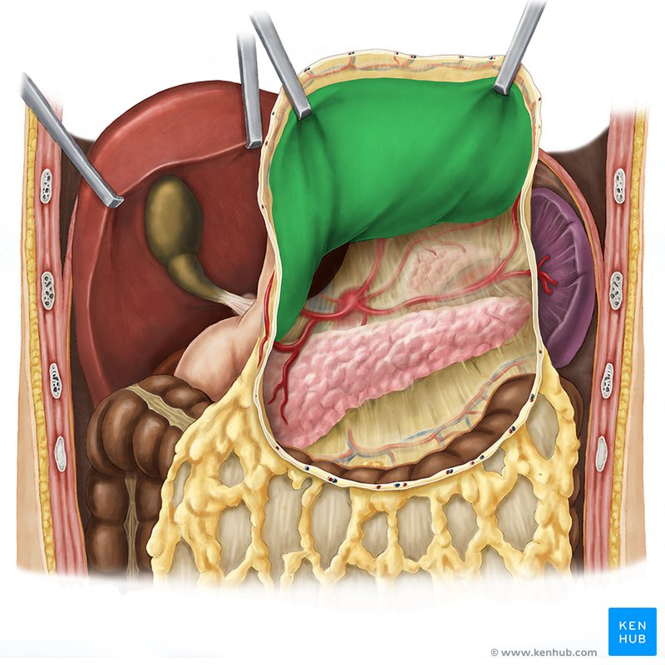
Posterior part of stomach (ventral view)
The stomach rotates 90 degrees clockwise around its longitudinal axis, resulting in its left side facing anteriorly and its right side posteriorly. This explains why the left vagus nerve innervates the anterior wall, as it once innervated the left side of the stomach, whereas the right vagus nerve innervates the posterior wall, as it once innervated the right side. Concurrent with this rotation, cellular proliferation occurs much faster in the posterior wall of the stomach than in the anterior wall, resulting in the formation of the greater and lesser curvatures, respectively.
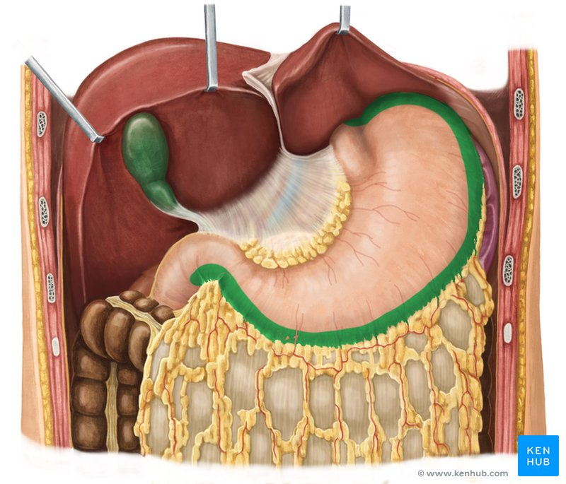
Greater curvature of the stomach (ventral view)
The stomach also rotates around its antero-posterior axis, resulting in the caudal end (pyloric part) to move upward and to the right and the cranial end (cardiac part) slightly downward and to the left. Thus, the stomach assumes its final position, with its pylorus located superiorly to the left and its cardia inferiorly to the right.
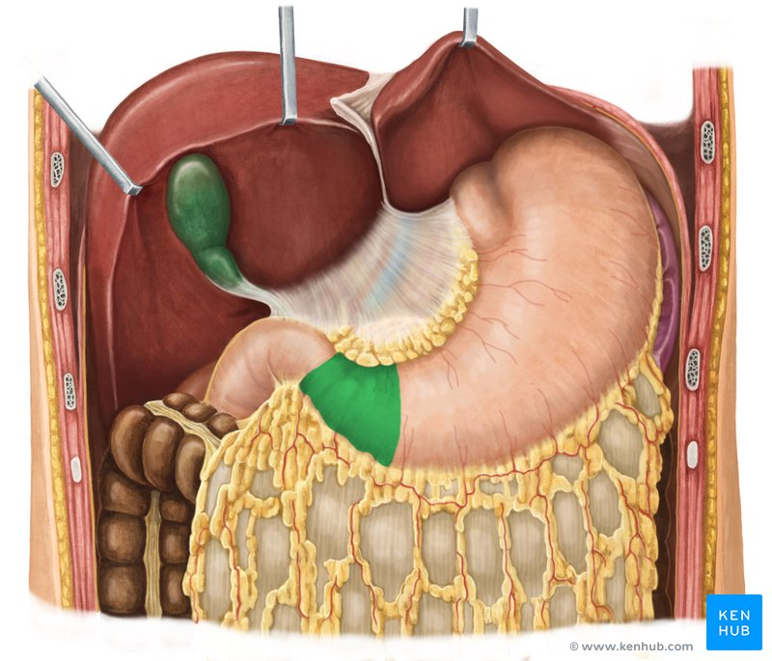
Pyloric part of the stomach (ventral view)

The rotational changes of the stomach also alter the position of the mesenteries. Recall that the stomach is attached to the dorsal and ventral walls via the dorsal mesogastrium and the ventral mesentery (a.k.a. mesogastrium), respectively. The rotation of the stomach around the longitudinal axis pulls the dorsal mesogastrium to the left and the ventral mesogastrium to the right: this creates a space behind the stomach known as the omental bursa (lesser peritoneal sac).
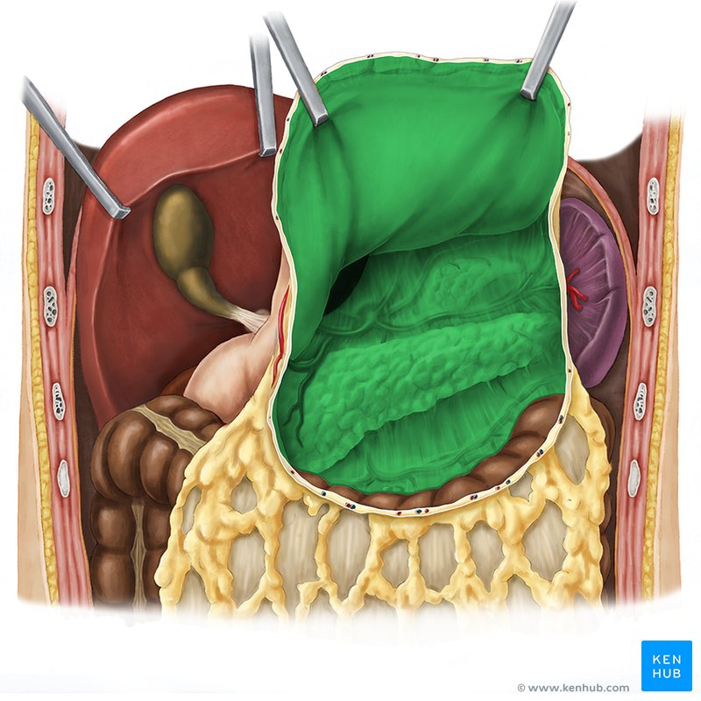
Lesser sac (ventral view)
DEVELOPMENT OF THE ESOPHAGUS
During the third week of gestation, a respiratory diverticulum (lung bud) forms as an outgrowth from the ventral wall of the proximal foregut. While the lung bud continues to expand, it becomes separated from the foregut, which forms the esophagus. Initially, the esophagus is short, but becomes rapidly elongated as a result of the growth and relocation of the heart and lungs.
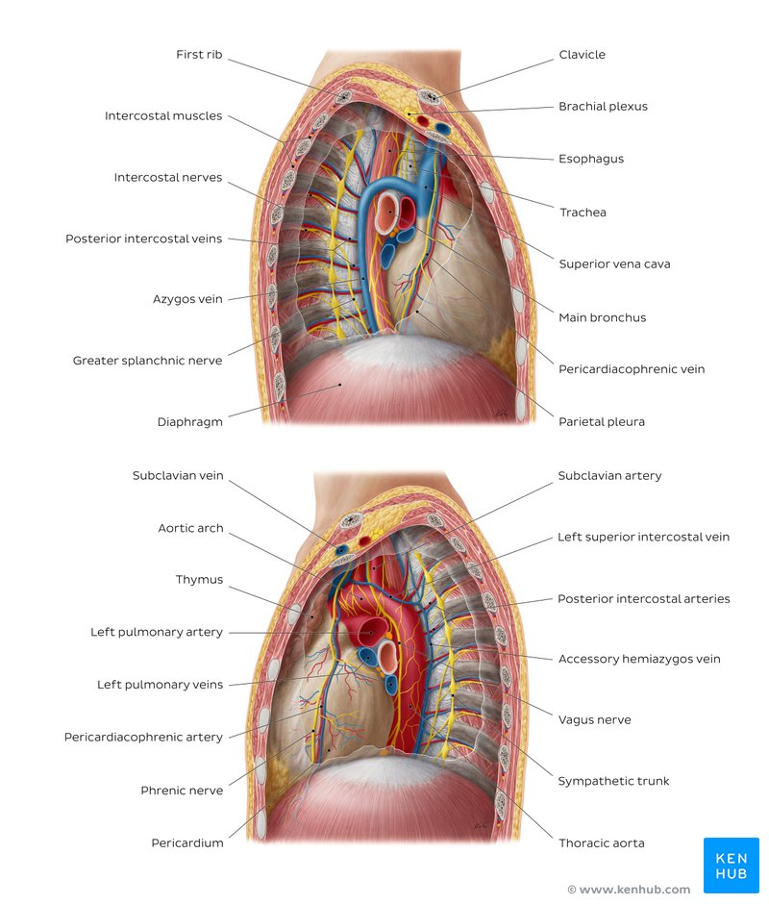
Esophagus (lateral-left view)
In early embryogenesis, the esophagus develops from the endodermal primitive gut tube. The ventral part of the embryo abuts the yolk sac. During the second week of embryological development, as the embryo grows, it begins to surround parts of the sac. The enveloped portions form the basis for the adult gastrointestinal tract. The sac is surrounded by a network of vitelline arteries. Over time, these arteries consolidate into the three main arteries that supply the developing gastrointestinal tract: the celiac artery, superior mesenteric artery, and inferior mesenteric artery. The areas supplied by these arteries are used to define the midgut, hindgut and foregut.
The surrounded sac becomes the primitive gut. Sections of this gut begin to differentiate into the organs of the gastrointestinal tract, such as the esophagus, stomach, and intestines. The esophagus develops as part of the foregut tube. The innervation of the esophagus develops from the pharyngeal arches.

Function
Swallowing
Food is ingested through the mouth and when swallowed passes first into the pharynx and then into the esophagus. The esophagus is thus one of the first components of the digestive system and the gastrointestinal tract. After food passes through the esophagus, it enters the stomach. When food is being swallowed, the epiglottis moves backward to cover the larynx, preventing food from entering the trachea. At the same time, the upper esophageal sphincter relaxes, allowing a bolus of food to enter. Peristaltic contractions of the esophageal muscle push the food down the esophagus. These rhythmic contractions occur both as a reflex response to food that is in the mouth, and also as a response to the sensation of food within the esophagus itself. Along with peristalsis, the lower esophageal sphincter relaxes.

Reducing gastric reflux
The stomach produces gastric acid, a strongly acidic mixture consisting of hydrochloric acid (HCl) and potassium and sodium salts to enable food digestion. Constriction of the upper and lower esophageal sphincters help to prevent reflux (backflow) of gastric contents and acid into the esophagus, protecting the esophageal mucosa. In addition, the acute angle of His and the lower crura of the diaphragm helps this sphincteric action.

Gene and protein expression
About 20,000 protein-coding genes are expressed in human cells and nearly 70% of these genes are expressed in the normal esophagus. Some 250 of these genes are more specifically expressed in the esophagus with less than 50 genes being highly specific. The corresponding esophagus-specific proteins are mainly involved in squamous differentiation such as keratins KRT13, KRT4 and KRT6C. Other specific proteins that help lubricate the inner surface of esophagus are mucins such as MUC21 and MUC22. Many genes with elevated expression are also shared with skin and other organs that are composed of squamous epithelia.

Clinical significance
The main conditions affecting the esophagus are described here. For a more complete list, see esophageal disease.
Inflammation
Main article: Esophagitis
Inflammation of the esophagus is known as esophagitis. Reflux of gastric acids from the stomach, infection, substances ingested (for example, corrosives), some medications (such as bisphosphonates), and food allergies can all lead to esophagitis. Esophageal candidiasis is an infection of the yeast Candida albicans that may occur when a person is immunocompromised. As of 2014 the cause of some forms of esophagitis, such as eosinophilic esophagitis, is not known. Esophagitis can cause painful swallowing and is usually treated by managing the cause of the esophagitis - such as managing reflux or treating infection.
Barrett's esophagus
Main article: Barrett's esophagus
Prolonged esophagitis, particularly from gastric reflux, is one factor thought to play a role in the development of Barrett's esophagus. In this condition, there is metaplasia of the lining of the lower esophagus, which changes from stratified squamous epithelia to simple columnar epithelia. Barrett's esophagus is thought to be one of the main contributors to the development of esophageal cancer.
Cancer
Main article: Esophageal cancer
There are two main types of cancer of the esophagus. Squamous cell carcinoma is a carcinoma that can occur in the squamous cells lining the esophagus. This type is much more common in China and Iran. The other main type is an adenocarcinoma that occurs in the glands or columnar tissue of the esophagus. This is most common in developed countries in those with Barrett's esophagus, and occurs in the cuboidal cells.

In its early stages, esophageal cancer may not have any symptoms at all. When severe, esophageal cancer may eventually cause obstruction of the esophagus, making swallowing of any solid foods very difficult and causing weight loss. The progress of the cancer is staged using a system that measures how far into the esophageal wall the cancer has invaded, how many lymph nodes are affected, and whether there are any metastases in different parts of the body. Esophageal cancer is often managed with radiotherapy, chemotherapy, and may also be managed by partial surgical removal of the esophagus. Inserting a stent into the esophagus, or inserting a nasogastric tube, may also be used to ensure that a person is able to digest enough food and water. As of 2014, the prognosis for esophageal cancer is still poor, so palliative therapy may also be a focus of treatment.
Varices
Main article: Esophageal varices
Esophageal varices are swollen twisted branches of the azygous vein in the lower third of the esophagus. These blood vessels anastomose (join up) with those of the portal vein when portal hypertension develops. These blood vessels are engorged more than normal, and in the worst cases may partially obstruct the esophagus. These blood vessels develop as part of a collateral circulation that occurs to drain blood from the abdomen as a result of portal hypertension, usually as a result of liver diseases such as cirrhosis. : 941–42 this collateral circulation occurs because the lower part of the esophagus drains into the left gastric vein, which is a branch of the portal vein. Because of the extensive venous plexus that exists between this vein and other veins, if portal hypertension occurs, the direction of blood drainage in this vein may reverse, with blood draining from the portal venous system, through the plexus. Veins in the plexus may engorge and lead to varices.

Esophageal varices often do not have symptoms until they rupture. A ruptured varix is considered a medical emergency, because varices can bleed a lot. A bleeding varix may cause a person to vomit blood, or suffer shock. To deal with a ruptured varix, a band may be placed around the bleeding blood vessel, or a small amount of a clotting agent may be injected near the bleed. A surgeon may also try to use a small inflatable balloon to apply pressure to stop the wound. IV fluids and blood products may be given in order to prevent hypovolemia from excess blood loss.

