Name: Nwapa Benedict Nzeregwu
Matric Number: 17/MHS01/333
Course Title: Gross Anatomy of Head and Neck
Course Code: ANA 301
Department: Medicine and Surgery

Question
1. Write an essay on the cavernous sinus
2. Discuss the walls of the nose
Answer
Cavernous sinus
- It is situated in the middle cranial fossa on each side of the sella turcica
- it consist of a venous plexus
- each sinus extends anteriorly from the superior orbital fissure to the apex of the temporal bone posteriorly
- It is of great clinical importance because of the connection and structures that pass through them
- The cavernous sinuses receive blood from the
- cerebral veins
- the superior and inferior ophthalmic veins (from the orbit)
- emissary veins (from the pterygoid plexus of veins in the infratemporal fossa)
Structures passing through each cavernous sinus are:
- Internal carotid artery
- Abducent nerve [VI]
- Structures in the lateral wall of each cavernous sinus are, from superior to inferior:
- the oculomotor nerve [III]
- the trochlear nerve [IV]
- the ophthalmic nerve [V₁]
- the maxillary nerve [V₂]
- Connecting the right and left cavernous sinuses are the intercavernous sinuses on the anterior and posterior sides of the pituitary stalk
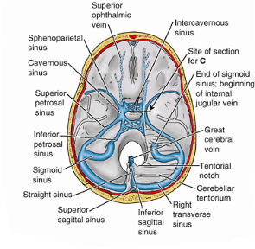
Clinical anatomy
- These connections provide pathways for infections to pass from extracranial sites into intracranial locations
- In addition, because structures pass through the cavernous sinuses and are located in the walls of these sinuses they are vulnerable to injury due to inflammation

2.
Boundaries of the Nasal Cavity
- The nasal cavity has a:
- roof
- floor
- medial wall
- lateral wall
The roof :
- is curved and narrow, except at its posterior end
- it is divided into 3 parts
- frontonasal
- ethmoidal
- sphenoidal
- They are named from the bones forming each part
The floor:
- is wider than the roof
- is formed by the;
- palatine processes of the maxilla
- horizontal plates of the palatine bone
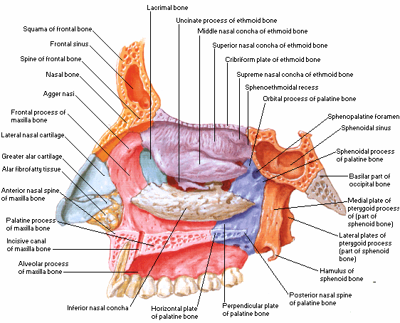
The medial wall :
formed by the nasal septum
The lateral walls :
- are irregular owing to three bony plates, the nasal conchae, which project inferiorly, somewhat like louvers
Features on the lateral wall of the nasal cavity
- There is the presence of nasal conchae and they curve inferomedially
- The nasal conchae include;
- Superior nasal concha
- middle nasal concha
- inferior nasal concha
- The conchae or turbinates of many mammals (especially running mammals and those existing in extreme environments) are highly convoluted, scroll-like structures that offer a vast surface area for heat exchange
- Underneath each concha in both humans with simple nasal conchae and animals with complex turbinates is a recess or meatus {passage(s) in the nasal cavity}
CLINICAL ANATOMY
Epistaxis
- Epistaxis (nosebleed) is relatively common because of the rich blood supply to the nasal mucosa
- In most cases, the cause is trauma and the bleeding is from an area in the anterior third of the nose (Kiesselbach area)
- Epistaxis is also associated with infections and hypertension
- Spurting of blood from the nose results from rupture of arteries
- Mild epistaxis may also result from nose picking, which tears veins in the vestibule of the nose
Rhinitis
- The nasal mucosa becomes swollen and inflamed (rhinitis) during severe upper respiratory infections and allergic reactions (e.g., hayfever)
- Swelling of the mucosa occurs readily because of its vascularity

