NAME: AMAINO SAMUEL
DEPARTMENT: BIOMEDICAL ENGINEERING
MATRIC NO: 18/ENG08/026
COURSE CODE: BME 322
COUSE NAME: SYSTEMS BIOENGINEERING I

ASSIGNMENT

CARDIAC PRESSURE VOLUME LOOP
Keywords:( pressure-volume, cardiac, systolic, diastolic)
According to (https://www.ncbi.nlm.nih.gov/pmc/articles/PMC4692607/), Cardiac pressure-volume loop analysis is the “gold-standard” in the assessment of load-dependent and load-independent measures of ventricular systolic and diastolic function. Measures of ventricular contractility and compliance are obtained through examination of cardiac response to changes in afterload and preload. These techniques were originally developed nearly three decades ago to measure cardiac function in large mammals and humans. The application of these analyses to small mammals, such as mice, has been accomplished through the optimization of microsurgical techniques and creation of conductance catheters. Conductance catheters allow for estimation of the blood pool by exploiting the relationship between electrical conductance and volume.
INTRODUCTION
Cardiac pressure volume loop analysis provides detailed information of cardiac function and are the gold standard for functional assessment. While imaging techniques such as echocardiography or cardiac MRI provide functional measures, these measures are highly dependent on loading conditions. Load-independent measures of cardiac contractility and relaxation require dynamic measurements of the ventricular pressure and volume relation over a range of preload and afterload. This understanding of the pressure-volume relation arises from the groundbreaking work of Sagawa and colleagues. They demonstrated in ex vivo perfused canine hearts that the pressure-volume loop derived contractility measures were independent of loading conditions.
Real-time left ventricular (LV) pressure–volume loops provide a framework for understanding cardiac mechanics in experimental animals and humans. Such loops can be generated by real-time measurement of pressure and volume within the left ventricle. Several physiologically relevant hemodynamic parameters such as stroke volume, cardiac output, ejection fraction, myocardial contractility, etc. can be determined from these loops.
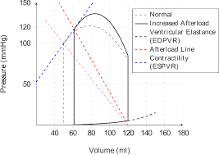

Fig 1.0 shows the p-v plot

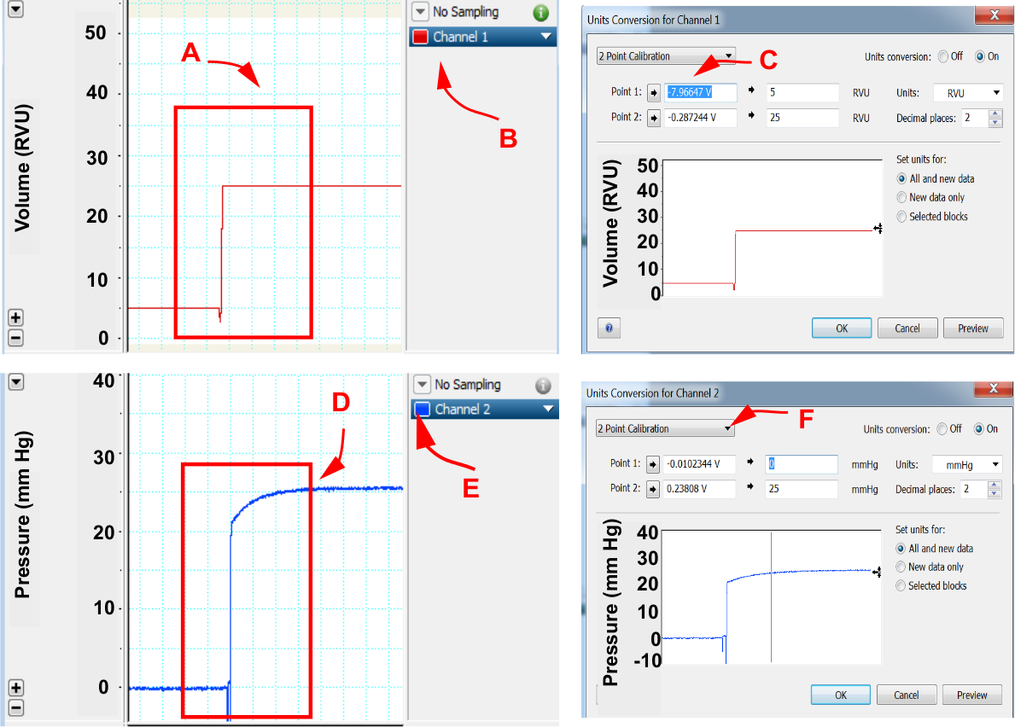

Fig 1.1 shows a Cardiac pressure and volume calibration.

Pressure–volume analysis

General considerations
Ideally, the PV loop is rectangular or trapezoidal, depicting the four phases of the cardiac cycle (Figure 1.3): isovolumetric contraction, ejection, isovolumetric relaxation, and passive filling.
Figure 1.3
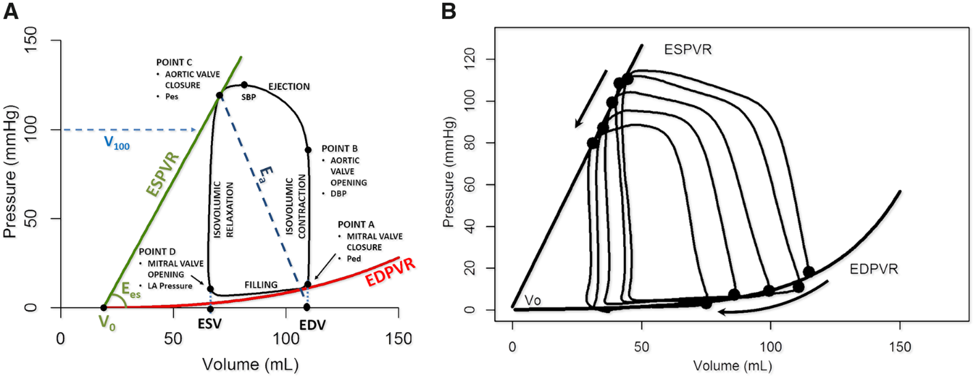
End-systolic and end-diastolic PV relationships (ESPVR and EDPVR) characterize LV systolic and diastolic properties, respectively (each detailed further below). Classically, measurement of these relationships requires transient modulations of preload (e.g. inferior caval vein occlusion) or afterload (e.g. hand grip manoeuvre) (Figure 1.3B).
Single-beat algorithms simplify PV analysis by estimating ESPVRs and EDPVRs from a single steady-state PV loop tracing and further relying on measurements of arterial systolic and diastolic pressures, SV, EF, pre-ejection time period, and total systolic period that are obtained with the conductance catheter, or by non-invasive means using echo-Doppler. These algorithms are readily programmed into spreadsheets and available online.
Depending on the purpose for which PV loops are measured, single-beat algorithms in combination with simplified means of PV catheter calibration may suffice and thus facilitate PV analysis.

End-systolic pressure–volume relationship
The ESPVR is approximately linear in the physiological range of end-systolic pressures (P_{es}) and volumes (V_{es}) (Figure 1.3A). It is characterized by a slope (end-systolic elastance, E_{es}) and a volume axis intercept V₀ such that P_{es} = E_{es}·(V_{es} − V₀). E_{es} represents the peak chamber elastance during a beat and reflects ventricular chamber mechanical properties when the maximum number of actin-myosin bonds is formed. E_{es} increases with positive inotropism (e.g. dobutamine, milrinone, levosimendan) and sympathetic activation, but decreases with negative inotropism (beta-blockers, calcium channel blockers), dyssynchrony, and myocardial ischaemia or infarction. E_{es} is a relatively load-independent measure of LV contractility.
Because ESPVR is a regression between multiple correlated V_{es} and P_{es} points, the impact of an intervention must simultaneously consider changes in E_{es} and V₀. Increased contractility occurs when changes in E_{es} and V₀ result in a leftward and/or upward ESPVR shift. Another index, V₁₀₀, is the ESPVR-extrapolated (or interpolated) volume at 100 mmHg. V₁₀₀ typically lies within the physiological range of PV values (Figure 1.3A). High V₁₀₀ reflects decreased contractility and vice versa.

End-diastolic pressure–volume relationships
In contrast to ESPVR, the EDPVR is non-linear (Figure 3A). The EDPVR reflects the passive mechanical properties of the LV chamber, when all actin–myosin bonds are uncoupled. Accordingly, the EDPVR is determined by the size, orientation and mass of myocytes, and the extracellular matrix. Fibrosis, ischaemia, oedema, myocyte remodelling, and hypertrophy affect the EDPVR. Its slope (dP/dV) indexes LV chamber stiffness, and is load-dependent. Compliance is the mathematical inverse of stiffness (i.e. dV/dP). The LV volume at 30 mmHg on the EDPVR (V₃₀) reflects compliance and would suggest remodelling (rightward shift of the EDPVR) or diastolic dysfunction (leftward shift of the EDPVR). V₃₀ increases in HF with reduced EF (HFrEF) and decreases in restrictive and hypertrophic cardiomyopathies
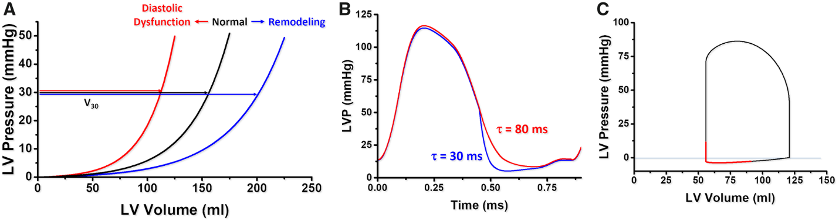
Ventricular performance is also highly influenced by the rate of relaxation (or lusitropy) (Figure 3B). The rate of pressure decay during isovolumetric relaxation is characterized by an exponential time constant of decay (τ), or the time for pressure to fall by 50% (t_{1/2}), reflecting the average rate of cross-bridge uncoupling within the myocytes. A normal value of τ is ∼20–30 ms. Impaired relaxation (e.g. LV hypertrophy, ischaemia) prolongs τ (e.g. 70–100 ms) and will affect LV diastolic filling especially at higher heart rates (Figure 3B). The maximal rate of pressure fall during relaxation (−dP/dt_{max}) is also used, but is highly load-dependent.

References
- https://www.ncbi.nlm.nih.gov/pmc/articles/PMC4692607/
- https://academic.oup.com/view-large/figure/201231581/ehz552f3.tif
- Clark JE, Marber MS. Advancements in pressure-volume catheter technology - stress remodelling after infarction. Exp Physiol. 2013;98(3):614–621. [PubMed] [Google Scholar]
- Google scholar
- Wikipedia search.

