NAME: NWUME BRENDA E.O.
DEPT: PHYSIOLOGY
MAT NO: 17/MHS01/214
COURSE CODE: BCH 308
COURSE TITLE: CELLULAR BIOCHEMISTRY.
ASSIGNMENT.
Describe in details the synthesis of two named neurotransmitters.
ANSWERS.
SYNTHESIS OF AMINO ACIDS.
Synthesis and/or collection of amino acids is critical for cell survival. They not only serve as the building blocks for proteins but also as starting points for the synthesis of many important cellular molecules including vitamins and nucleotides.
In most cases bacteria would rather use amino acids in their environment than make them from scratch. It takes a considerable amount of energy to make the enzymes for the pathway as well as the energy required to drive some of the reactions of amino acid biosynthesis. The genes that code for amino acid synthesis enzymes and the enzymes themselves are under tight control and are only turned on when they are needed.
The amino acids synthesis pathways can be grouped into several logical units. These units reflect either common mechanisms or the use of common enzymes that synthesize more than one amino acid. These categories are: simple reactions, branch chain amino acids, aromatic amino acids, threonine/lysine, serine/glycine, and unique pathways. The aromatic amino acids, threonine/lysine and serine/glycine pathways have a common beginning and then diverge to form the amino acid of interest.
Notice that each pathway begins with a central metabolite or something derived from "central metabolism". Using common compounds instead of synthesizing them from scratch saves energy and conserves genes since fewer enzymes are needed to code for the pathways.

Simple Reactions

glutamine, glutamate, aspartate, asparagine and alanine
In most cases these amino acids can be synthesize by one step reactions from central metabolites. They are simple in structure and their synthesis is also straight forward.
Glutamate can by synthesized by the addition of ammonia to a-ketoglutarate.
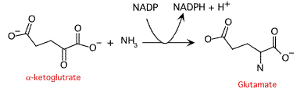
by the addition of another ammonia molecule to glutamate.
Figure 1 - The synthesis of glutamate.
Glutamine is made
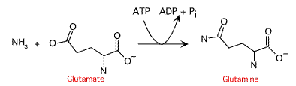
Figure 3 - The synthesis of aspartate.
Asparagine is made either by transamination from glutamine or by adding ammonia directly to aspartate.
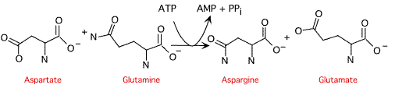
OR

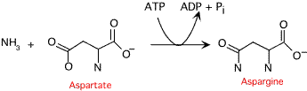
Figure 4 - Formation of asparagine. Notice the use of AMP instead of ADP in this reaction. This releases more energy which is needed to drive the synthesis.
Alanine synthesisis is a bit of a mystery. Several reactions have been identified, but it has been impossible to generate an alanine auxotroph and therefore positively identify a required pathway. There are several pathways and the most likely is formation of alanine by transamination from glutamate onto pyruvate. A transamination using valine instead of glutamate is also possible.
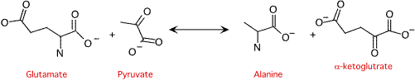
Figure 5 - Synthesis of alanine

Threonine/lysine
Synthesis of threonine and lysine begins by the conversion of oxaloacetate to aspartate semialdehyde. This shared pathway costs one ATP and two NADPH + H⁺
Threonine biosynthesis is completed in three steps. First a second reduction with NADPH + H⁺, yields homoserine. This is phosphorylated to homoserine phosphate by ATP and finally converted into threonine.

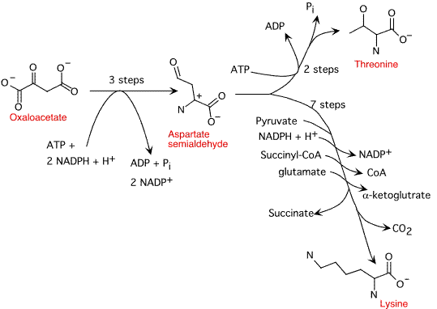
Figure 6 - Synthesis of Threonine and Lysine. Note the amount of energy that is expended in these biosytheses.
The synthesis of lysine has been found to consist of different reactions in different bacterial species. A somewhat generalize pathway is presented. Lysine synthesis involves the addition of pyruvate to aspartate semialdehyde, the use of a CoA intermediate (either acetyl CoA or succinyl-CoA) and the addition of an amino group from glutamate. The group added from CoA (either succinyl or acetyl) serves as a blocking group, protecting the amino group from attack during transamination by glutamate. NADPH + H⁺ is required for reduction in the second step of the pathway.

Serine/glycine
The biosynthesis of serine and glycine constitute a major metabolic pathway that plays a central role in the formation of other amino acids, nucleic acids and phospholipids. When E. coli is grown on glucose, fully 15% of carbon assimilated passes through the serine pathway. Synthesis of serine and glycine starts with oxidation of 3-phosphoglycerate forming 3-phosphohydroxy pyruvate and NADH. A transamination reaction with glutamate forms 3-phosphoserine and removal of the phosphate yields serine. Glycine is generated by removal of the methyl group from serine. Energy is not required for this pathway, in fact it yields energy in the form of reduced NADH.
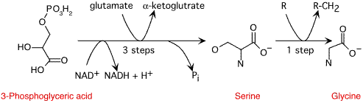
Figure 7 - Synthesis of Serine and Glycine. Note that this pathway actually yields energy and carbon for other uses. R (tetrahydropholate)

Branch chain amino acids

leucine, isoleucine and valine
Examination of the isoleucine pathway versus the valine pathway demonstrates that the only difference is the substitution of an ethyl group instead of a methyl group to the a-carbon of the intermediates.The intermediates are so similar that common enzymes catalyze four steps of each pathway. Isoleucine synthesis begins with threonine, which is deaminated to a-ketobutyrate. From here the 4 step synthesis costs one NADPH + H⁺ per amino acid synthesized.
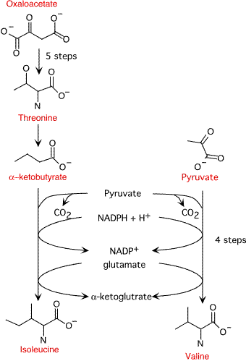
Figure 8 - Synthesis of valine and isoleucine.
Leucine biosynthesis starts of with the last intermediate in the valine synthesis, a-ketoisovalerate. In the first step Acetyl-CoA is used to add an acetyl group to the molecule. Electrons are transferred to NAD⁺ (note these can be used for other cellular processes) and one carbon is lost in the form of CO₂ at the fourth step of the pathway. In the final step, the amine from glutamate is added to a-ketoisocaproate to form leucine.
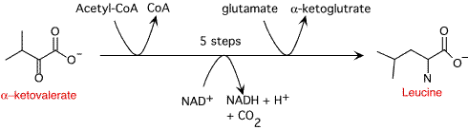
Figure 9 - Synthesis of leucine.

Aromatic amino acids

tryptophan, phenylalanine and tyrosine
Synthesis of the aromatic amino acids begins with the synthesis of chorismate - an important intermediate for many biosynthetic pathways. Phosphoenol pyruvate and erythrose 4-phosphate serve as beginning substrates for the pathway. A price of one NADPH + H⁺ and one ATP is exacted for every chorismate formed. In the sixth step of the synthesis another phosphoenol pyruvate molecule is added to the growing molecule.
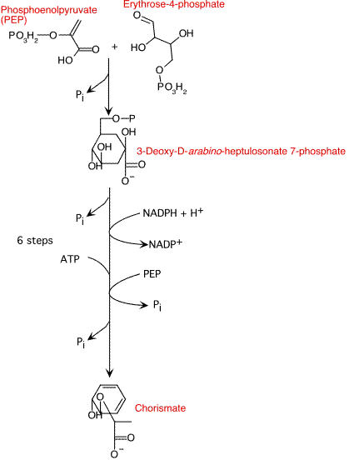
Figure 10 - Synthesis of chorismate

Phenylalanine
Chorismate is converted to phenylpyruvate in two steps and phenylalanine is synthesized by a transamination reaction with glutamate. No energy is require to run these reactions.
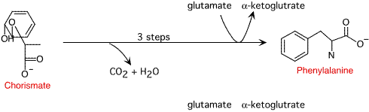
Figure 11 - Synthesis of phenylalanine.

Tyrosine
The synthesis of tyrosine is very similar to the synthesis of phenylalanine, but the reactions are carried out by different enzymes under different regulatory control. NADH is created in the formation of 4-hydroxyphenylpyruvate. Tyrosine is made by a similar transamination reaction as that seen in phenylalanine synthesis.
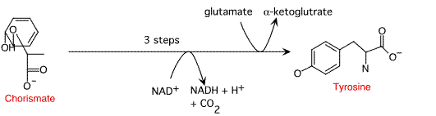
Figure 12 - Synthesis of tyrosine.

Tryptophan
Trytophan synthesis is complex and involves 5 steps from chorismate. Glutamate donates an amine group in the first step of the pathway and pyruvate is lost from chorismate. In the next threes steps a ribose sugar is added, this eventually contributes to the 5 membered ring of tryptophan. Energy is contributed to the process in the form of hydrolysis of pyrophosphate. This hydrolysis helps drive the addition of the ribose sugar in the second step of the reaction. In the last step of the pathway serine serves as the donor of the a carbon amino group of tryptophan.
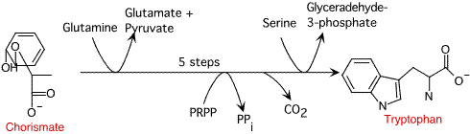
Figure 13 - Synthesis of tryptophan.

Unique pathways

cysteine, methionine, proline, histidine and arginine
These pathways involve something unusual, either the structure of the amino acid is different enough than the other common amino acids, or sulfur is involved in their synthesis. In any case, unique enzymes are involved in every step of the way. Here we just examine what they start with and how much it costs the cell.

Cysteine
Synthesis of cysteine is a two step reaction. Serine and acetyl-CoA combine to form O-acetylserine. Sulfide from sulfur assimilation is then added to O-acetylserine to form cysteine. The pathway for cysteine synthesis was covered in sulfate assimilation.

Methionine
Methionine is synthesized from oxaloacetate. Succinyl-CoA participates and cysteine donates a sulfur group to the molecule. Oxaloacetate is first converted into homoserine as described above in the threonine biosynthetic pathway. Homoserine then has a sulfur attached to the end in two steps and finally methionine is formed by the addition of a methyl group.
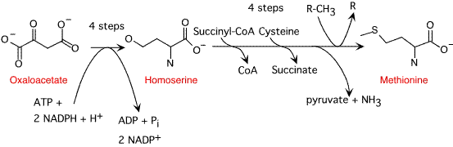
Figure 14 - Synthesis of methionine. The donor of the methyl group (R) is a methyl carrier in the cell, N⁵,N¹⁰-Methylene terahydropteroyl.

Proline
Proline synthesis involves a four step process starting with glutamate. One ATP and two NADPH + H⁺ is used per proline.
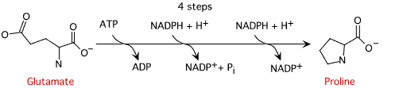
Figure 15 - Synthesis of proline.

Histidine
The synthesis of histidine is long and complex and its pathway is intertwined with nucleic acid biosynthesis (specifically purine). The pathway seems to be universal in all organisms able to synthesize histidine. The first five steps of the pathway take ribose from phosphoribosyl pyrophosphate (PRPP) and transform it into Imadiazoleglycerol phosphate. Once the imadiazole ring is formed, glutamate donates the a-amino group and the newly formed amine is oxidized to histidine in the last step of the pathway. Energy is required in the form of ATP (in this case elements of the ATP molecule actually becomes part of the amino acid) and pyrophosphate which is lost from phosphoribosyl pyrophosphate and ATP help drive the reaction.
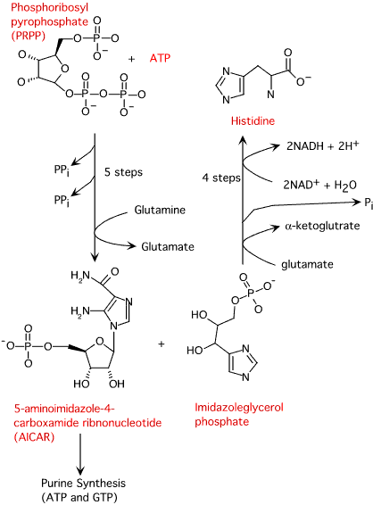
Figure 16 - Synthesis of Histidine
Investigations into histidine biosynthesis have yielded many insights into microbial metabolism that have contributed greatly to our understanding of how cells function at the genetic and biochemical level. Work in this area is still yielding important results.

Arginine
Synthesis of arginine is an eight step process starting with the amino acid glutamate. Two ATP and one NADPH + H⁺ are utilized to synthesize each arginine.
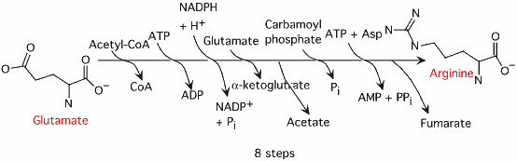
Figure 17 - Synthesis of arginine

SYNTHESIS OF PURINES.

De Novo Synthesis of Purine Nucleotides.
We use for purine nucleotides the entire glycine molecule (atoms 4, 5,7), the amino nitrogen of aspartate (atom 1), amide nitrogen of glutamine (atoms 3, 9), components of the folate-one-carbon pool (atoms 2, 8), carbon dioxide, ribose 5-P from glucose and a great deal of energy in the form of ATP. In de novo synthesis, IMP is the first nucleotide formed. It is then converted to either AMP or GMP.
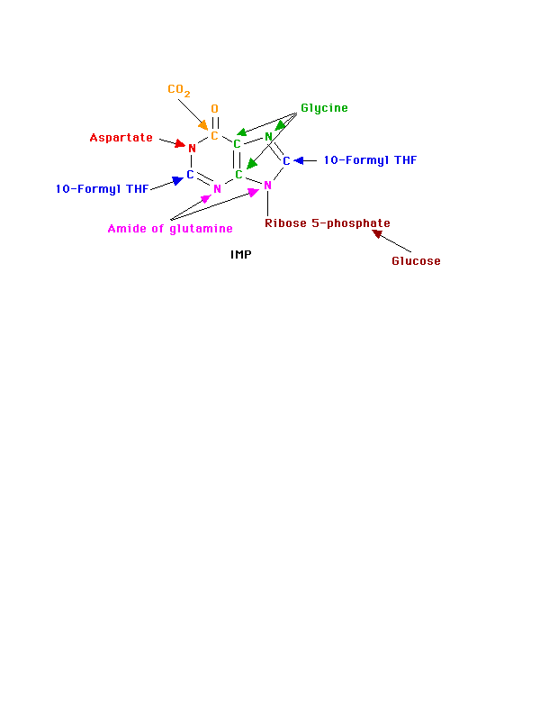

PRPP
Since the purines are synthesized as the ribonucleotides, (not as the free bases) a necessary prerequisite is the synthesis of the activated form of ribose 5-phosphate. Ribose 5-phosphate reacts with ATP to form 5-Phosphoribosyl-1-pyrophosphate (PRPP). 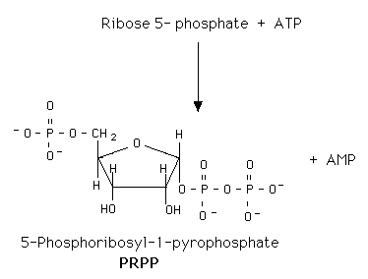
This reaction occurs in many tissues because PRPP has a number of roles - purine and pyrimidine nucleotide synthesis, salvage pathways, NAD and NADP formation. The enzyme is heavily controlled by a variety of compounds (di- and tri-phosphates, 2,3-DPG), presumably to try to match the synthesis of PRPP to a need for the products in which it ultimately appears.

Commitment Step
De novo purine nucleotide synthesis occurs actively in the cytosol of the liver where all of the necessary enzymes are present as a macro-molecular aggregate. The first step is a replacement of the pyrophosphate of PRPP by the amide group of glutamine. The product of this reaction is 5-Phosphoribosylamine. The amine group that has been placed on carbon 1 of the sugar becomes nitrogen 9 of the ultimate purine ring. This is the commitment and rate-limiting step of the pathway.
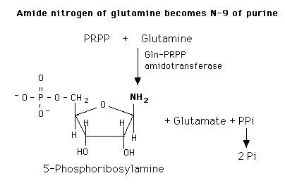
The enzyme is under tight allosteric control by feedback inhibition. Either AMP, GMP, or IMP alone will inhibit the amidotransferase while AMP + GMP or AMP + IMP together act synergistically. This is a fine control and probably the major factor in minute by minute regulation of the enzyme. The nucleotides inhibit the enzyme by causing the small active molecules to aggregate to larger inactive molecules.
[PRPP] also can play a role in regulating the rate. Normal intracellular concentrations of PRPP (which can and do fluctuate) are below the KM of the enzyme for PRPP so there is great potential for increasing the rate of the reaction by increasing the substrate concentration. The kinetics are sigmoidal. The enzyme is not particularly sensitive to changes in [Gln] (Kinetics are hyperbolic and [gln] approximates KM). Very high [PRPP] also overcomes the normal nucleotide feedback inhibition by causing the large, inactive aggregates to dissociate back to the small active molecules.
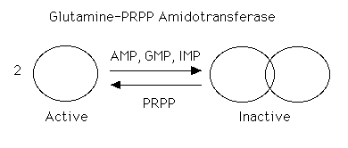
Purine de novo synthesis is a complex, energy-expensive pathway. It should be, and is, carefully controlled.

Formation of IMP
Once the commitment step has produced the 5-phosphoribosyl amine, the rest of the molecule is formed by a series of additions to make first the 5- and then the 6-membered ring. (Note: the numbers given to the atoms are those of the completed purine ring and names, etc. of the intermediate compounds are not given.) The whole glycine molecule, at the expense of ATP adds to the amino group to provide what will eventually be atoms 4, 5, and 7 of the purine ring (The amino group of 5-phosphoribosyl amine becomes nitrogen N of the purine ring.) One more atom is needed to complete the five-membered ring portion and that is supplied as 5, 10-Methenyl tetrahydrofolate.
Before ring closure occurs, however, the amide of glutamine adds to carbon 4 to start the six-membered ring portion (becomes nitrogen 3). This addition requires ATP. Another ATP is required to join carbon 8 and nitrogen 9 to form the five-membered ring.
The next step is the addition of carbon dioxide (as a carboxyl group) to form carbon 6 of the ring. The amine group of aspartate adds to the carboxyl group with a subsequent removal of fumarate. The amino group is now nitrogen 1 of the final ring. This process, which is typical for the use of the amino group of aspartate, requires ATP. The final atom of the purine ring, carbon 2, is supplied by 10-Formyl tetrahydrofolate. Ring closure produces the purine nucleotide, IMP.
Note that at least 4 ATPs are required in this part of the process. At no time do we have either a free base or a nucleotide.
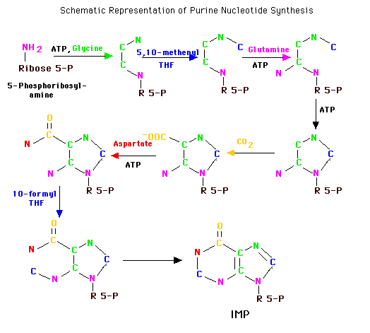

Formation of AMP and GMP
IMP can then become either AMP or GMP. GMP formation requires that IMP be first oxidized to XMP using NAD. The oxygen at position 2 is substituted by the amide N of glutamine at the expense of ATP. Similarly, GTP provides the energy to convert IMP to AMP. The amino group is provided by aspartate in a mechanism similar to that used in forming nitrogen 1 of the ring. Removal of the carbons of aspartate as fumarate leaves the nitrigen behind as the 6-amino group of the adenine ring. The monophosphates are readily converted to the di- and tri-phosphates.
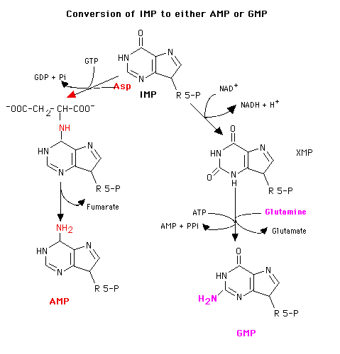

Control of De Novo Synthesis
Control of purine nucleotide synthesis has two phases. Control of the synthesis as a whole occurs at the amidotransferase step by nucleotide inhibition and/or [PRPP]. The second phase of control is involved with maintaining an appropriate balance (not equality) between ATP and GTP. Each one stimulates the synthesis of the other by providing the energy. Feedback inhibition also controls the branched portion as GMP inhibits the conversion of IMP to XMP and AMP inhibits the conversion of IMP to adenylosuccinate.
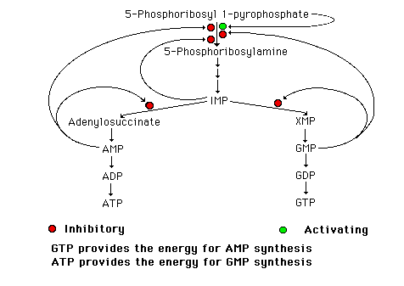

Salvaging Purines.
The more important of the pathways for salvaging purines uses enzymes called phosphoribosyltransferases (PRT):
PRTs catalyze the addition of ribose 5-phosphate to the base from PRPP to yield a nucleotide.:
Base + PRPP = Base-ribose-phosphate (BMP) + PPi
We have already seen one example of this type of enzyme as a normal part of de novo synthesis of the pyrimidine nucleotides, - O-PRT.
As a salvage process though, we are dealing with purines. There are two enzymes, A-PRT and HG-PRT. A-PRT is not very important because we generate very little adenine. (Remember that the catabolism of adenine nucleotides and nucleosides is through inosine). HG-PRT, though, is exceptionally important and it is inhibited by both IMP and GMP. This enzyme salvages guanine directly and adenine indirectly. Remember that AMP is generated primarily from IMP, not from free adenine.

Lesch-Nyhan Syndrome
HG-PRT is deficient in the disease called Lesch-Nyhan Syndrome, a severe neurological disorder whose most blatant clinical manifestation is an uncontrollable self-mutilation. Lesch-Nyhan patients have very high blood uric acid levels because of an essentially uncontrolled de novo synthesis. (It can be as much as 20 times the normal rate). There is a significant increase in PRPP levels in various cells and an inability to maintain levels of IMP and GMP via salvage pathways. Both of these factors could lead to an increase in the activity of the amidotransferase.

