NAME : UZOSIKE FAITH A.
MATRIC NO: 18/MHS03/019
DEPARTMENT : HUMAN ANATOMY
LEVEL : 300
COURSE :ANA 314 (ANIMAL HANDLING AND COMPARATIVE MAMMALIAN GROSS ANATOMY )
​
QUESTIONS
1. What is comparative anatomy
2. Highlight the criteria necessary to caring for laboratory animals
3. Highlight the similarities and differences in the digestive system anatomy of amphibians and man

Answers.
- Comparative anatomy, the comparative study of the body structures of different species of animals in order to understand the adaptive changes they have undergone in the course of evolution from common ancestors. Comparative anatomy is the study of similarities and differences in the anatomy of different species. It is closely related to evolutionary biology and phylogeny (the evolution of species).

- CRITERIA NECESSARY FOR CARING FOR LABORATORY ANIMALS
- Ventilation
- Illumination and light schedule
- Humidity
- Noise moderation
- Room temperature

VENTILATION :
Optimum air quality in laboratory animal facilities is essential for the general health and well-being of researchers, animal caregivers, and the animals, as well as for the integrity of the studies. Since both genetic heritage and the environment influence biological responses, researchers must always be aware of the influence of the environment on the animals' biological responses.

ILLUMINATING AND LIGHT SCHEDULE :
Light can affect the physiology, morphology, and behavior of various animals (Azar et al. 2008; Brainard et al. 1986; Erkert and Grober 1986; Newbold et al. 1991; Tucker et al. 1984). Potential photostressors include inappropriate photoperiod, photo intensity, and spectral quality of the light (Stoskopf 1983).For practical considerations due to common work hours , researchers should be aware of lighting schedules used in the rodent housing rooms (commonly 12 hours light :12 hours dark or 14 hours light : 10 hours dark ) . If researchers turn on the light during the animals dark period the disruption of the light schedule may cause animals to be perturbed , which may have effects on the breeding performance and on circadian rhythms .

HUMIDITY
Relative humidity
Extreme variations in relative humidity can have adverse effects on the well-being of animals (Clough, 1984) and, by affecting the rate of heat loss, can influence activity and food intake (Stille, Brezowsky & Weihe, 1968).
The relative humidity in animal rooms should normally be maintained at 55f10per cent irrespective of stocking density; prolonged periods below 40 per cent or above 70 per cent should be avoided. In most cases some form of humidification will be required. -Poultry are more tolerant than mammals and a range of 30-70 per cent is suitable (Prince et al., 1965).
For most amphibians and some reptiles, 70 per cent is desirable but 'dry' reptiles should be kept at 40-60 per cent. Some other amphibians and reptiles may require humidity outside those ranges (Avery, 1979; Davies, 1981; Spellerberg, 1982).

NOISE MODERATION :
Because changes in patterns of sound exposure have different effects on different animals (Armario et al. 1985; Clough 1982), personnel should try to minimize the production of unnecessary noise. Excessive and intermittent noise can be minimized by training personnel in alternatives to noisy practices, the use of cushioned casters and bumpers on carts, trucks, and racks, and proper equipment maintenance (e.g., castor lubrication). Radios, alarms, and other sound generators should not be used in animal rooms unless they are part of an approved protocol or enrichment program. Any radios or sound generators used should be switched off at the end of the working day minimize to associated adverse physiologic changes (Baldwin 2007).

TEMPERATURE:
Animal room temperatures should be continuously monitored and checked at least once daily.
Temperatures within the cages will be higher than room temperature. Even in rat cages with grid floors in a room with efficient ventilation, the temperature will be 3-6" above room temperature, according to the position of the cage in the room (Clough, 1984). If bedding material is present, the animal can manipulate its own immediate environment and provide a warm nest for its young. If an animal's thermoregulatory ability has been affected by anesthesia or other scientific procedures, a higher room temperature or more bedding material should be provided (Clough, 1982).
Temperature regulation should ensure that there are no undue fluctuations within or between rooms and so avoid causing unnecessary stress. In the majority of establishments in the United Kingdom it will be desirable to provide a cooling system for rooms containing rodents and rabbits to comply with the upper limitations for room temperatures. If this is not available ad hoc methods, such as reduction of stocking densities, may be necessary to avoid heat stress.
Breeding colonies do not usually require such close control of temperature. A tolerance of at least fS°C may be sufficient so long as the newborn can be kept warm.
Animals kept outdoors or under farm conditions indoors will be maintained at ambient temperatures; for some species shade or shelter will be required in the summer, and in winter, additional heat and food as well as shelter.
Requirements of birds may vary according to species (see MAFF Codes and UFAW, 1987).
Reptiles and amphibians are unable to control their body temperature except by behavior. Each species has a preferred body temperature and a range in which it will feed and behave normally. The aim in the laboratory should be to provide such a range (UFAW, 1987). Where amphibians are maintained at low temperatures, they and their environment should be checked daily.
Fish should be kept as close to their natural environmental temperature as practicable (Hawkins, 1981).

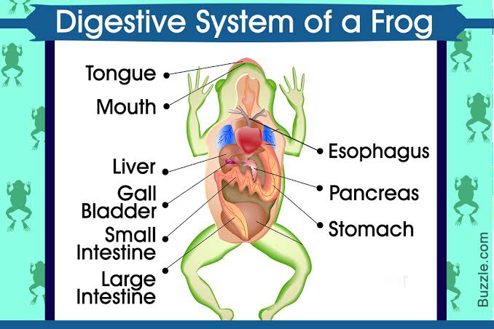

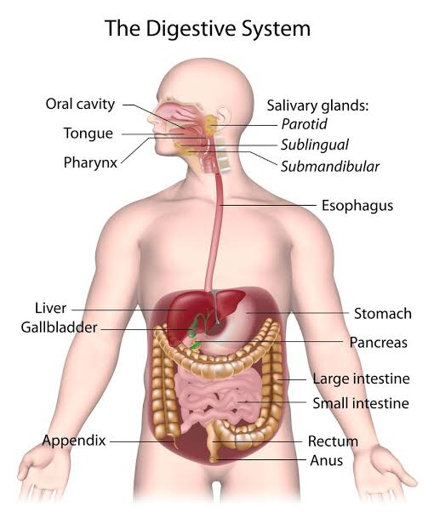

SIMILARITIES;
- Presence of the small intestine in both
- Presence of the liver in both
- Presence of gallbladder in both
- The presence of the large intestine both
- They both have mouth
- The presence of esophagus in both
- The presence of the tongue in both
- The presence of the teeth in in both

DIFFERENCES BETWEEN THE DIGESTIVE SYSTEM OF AMPHIBIAN (FROG) AND MAN

Man  - The tongue is not sticky  - Chewing is an important process in food digestion.  - Has longer intestines. The parts of the small intestine includes; duodenum, jejunum, ileum.  - Has one set of teeth in the oral cavity  - Deglutition does not affect the eyes.  - Nutrients are absorbed in the jejunum  - Elimination of indigested food occurs through the rectum | Frog  The tongue is very sticky  The frogs swallow their prey without chewing.  Has shorter intestine with just duodenum and ileum.  Has two sets of teeth; maxillary and vomerine teeth.  During deglutition, they close their eyes.  Nutrients are absorbed in the ileum  Elimination of indigested food occurs through the cloaca. .

