NAME: OKAM EDNA ACHI CHINMA
MATRIC NUMBER: 19/MHS03/015
DEPARTMENT: HUMAN ANATOMY
COURSE CODE: ANA 206

1,) DEVELOPMENT OF THE LUNG

Phases of lung development
-Embryonic phase
-Pseudoglandular phase
-Canalicular phase
-Saccular phase
-Alveolar phase

Development of the respiratory system begins early in the fetus. It is a complex process that includes many structures, most of which arise from the endoderm. Towards the end of development, the fetus can be observed making breathing movements. Until birth, however, the mother provides all of the oxygen to the fetus as well as removes all of the fatal carbon dioxide via the placenta.

Embryonic phase
The embryonic phase of lung development begins with the formation of a groove in the ventral lower pharynx, the sulcus laryngotrachealis (stage 10, ca. 28 days, 10). After a couple of days - from the lower part - a bud forms, the true lung primordium (stage 12, ca. 30 days,12). In the further subdivision into the two main bronchi (stage 14, ca. 33 days,14) the smaller bud on the left is directed more laterally than the somewhat larger one on the right that - parallel to the esophagus - is directed more caudally. Thus, the asymmetry of the main bronchi, as they present in adults, is already established. The subsequent divisions of the endodermal branches also take place unequally in that on the right three further buds form and, on the left, only two, corresponding to the later pulmonary lobes. In the next division step, which occurs at the end of the embryonic period, the segments of the individual pulmonary lobes arise.

At the end of the embryonic period the first segments appear in the five (three right and two left) lobes of the lungs. With their distended ends the lungs resemble an exocrine gland.
At this time the pulmonary vessels have formed themselves.

The pulmonary circulation system (smaller circulation system) is formed out of the 6th pharyngeal arch artery. These develop somewhat differently than the other 4 aortic arches in that first a vessel plexus forms around the lung anlage, originating from the aortic sac. The true 6th aortic arch is only then formed after vessels - also from the dorsal aorta - grow into this plexus and thus a connection between the truncus pulmonalis and dorsal aorta has arisen.

Development of the pulmonary vessels in stage 13 |  | Development of the pulmonary vessels in stage 15
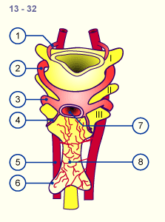  1 2 3 4 First aortic arch (atrophying) Second aortic arch Third aortic arch (internal carotid artery forms from the ventral part) Fourth aortic arch (on the right: part of the subclavian artery, left: arcus aortae) |  | 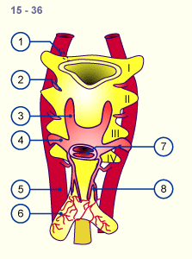  5 6 7 8 Dorsal aorta Lung buds Aortic sac Pulmonary plexus

Pseudoglandular phase

At this stage the lungs resemble the development of a tubulo-acinous gland. According to the classical view, the entire air-conducting bronchial tree up to the terminal bronchiole are set down in this phase (16 generations). Recent morphometric studies have shown that with the end of the pseudoglandular phase 20 generations are partially present in the lungs, which means that at this point in time the respiratory ducts have already been formed.
The primordial system of passages, the air-conducting bronchial tree, is initially coated by cubic epithelium. These are the precursor cells of the ciliated epithelium and of the secretory cells. In humans, the first ciliated epithelial cells can be found in the 13th week of pregnancy.

In the respiratory part the first typically lung-specific cells, connected to the terminal bronchiole, appear:
the type II pneumocytes (alveolar cells) .
The developing broncho-pulmonary epithelium begins to produce amniotic fluid, which is also found in the lungs up to the time of birth.
The differentiation of the lungs takes place in a centrifugal direction. In the central, air-conducting portions of the lungs the epithelium begins to differentiate into cilia-carrying cells and goblet cells. After the 10th week cartilage and smooth muscle cells as well as bronchial glands can be found in the wall of the bronchi. The peripheral sections partially retain - until far beyond the pseudoglandular phase - cubic epithelium that is still little differentiated. This is important for a further proliferation of the bronchial tree into the surrounding mesenchymal tissue.

Canalicular phase

In the classical description of lung development, in this phase the canaliculi branch out of the terminal bronchiole. The canaliculi compose the proper respiratory part of the lungs, the pulmonary parenchyma. All of the air spaces that derive from a terminal bronchiole form an acinus. Each one comprises respiratory bronchiole and the alveolar ducts and later the alveolar sacculi. The chief characteristic of this canalicular phase is the alteration of the epithelium and the surrounding mesenchyma. Along the acinus, which develops from the terminal bronchioles, an invasion of capillaries into the mesenchyma occurs. The capillaries surround the acini and thus form the foundation for the later exchange of gases. The lumen of the tubules becomes wider and a part of the epithelial cells get to be flatter. From the cubic type II pneumocytes develop the flattened type I pneumocytes.

Enough differentiation of the type II pneumocytes into the type I pneumocytes and the proliferation of the capillaries into the mesenchymal marks an important step towards the fetus being able to survive outside the uterus after roughly the 24th week of pregnancy.

The first breathing movement can be registered already at the end of the embryonic period. They are controlled by a breathing centre in the brain stem. Nevertheless, these breathing movements are paradoxical in that when the diaphragm contracts, the thorax moves inwardly and vice versa.

At the end of this canalicular phase which is the beginning of the saccular phase (ca. 25 weeks) - a large part of the amniotic fluid is produced by the lung epithelium. From this time on, the maturity of the lungs can be measured clinically based on the activity of the type II pneumocytes, which begin to produce the surfactant. The ratio of lecithin to sphingomyelin in the amniotic fluid, which increases with fatal age is determined. I
In this stage developmental damage already affects the gas-exchange components and result in structural alterations of the later pulmonary parenchyma.
The surfactant (abbreviation for surface active agent) consists of glycerophospholipids, specific proteins, neutral fats and cholesterol. It covers the alveolar surface and reduces the surface tension so that, following birth, the alveoli do not collapse during the expiration.

Saccular phase

From the last trimester whole clusters of sacs form on the terminal bronchiole, which represent the last subdivision of the passages that supply air. In the saccular phase the last generation of air spaces in the respiratory part of the bronchial tree is born. At the end of each respiratory tract passage smooth-walled sacculi form, coated with type I and type II pneumocytes. The septa (primary septa) between the sacculi are still thick and contain two networks of capillaries that come from the neighbouring sacculi. The interstitial space is rich with cells and the proportion of collagen and elastic fibers is still small. This matrix, though, plays an important role for the growth and differentiation of the epithelium that lies above It.
At the end of this phase the interstitial fibroblasts begin with the production of extracellular material in the interductal and intersaccular space.

At birth, i.e., at the end of the saccular phase, all generations of the conducting and respiratory branches have been generated. The sacculi are thin, smooth-walled sacks and correspond to the later alveolar sacculi.

Alveolar phase

Depending on the author, the alveolar phase begins at varying times. Probably in the last few weeks of the pregnancy, new sacculi and, from them, the first alveoli form. Thus, at birth, ca. 1/3 of the roughly 300 million alveoli should be fully developed. The alveoli, though, are only present in their beginning forms. Between them lies the parenchyma, composed of a double layer of capillaries, that forms the primary septa between the alveolar sacculi.

Already before birth these alveolar sacculi get to be increasingly complex structurally. Thereby, many small protrusions form along the primary septa. Soon, these become larger and subdivide the sacculi into smaller subunits, the alveoli, which are delimited by secondary septa.
Ultrastructural investigations show that overall where such alveoli appear, they are surrounded by elastic fibers that form the interstitial septa between two capillary nets.
In the first 6 months, their number increases massively. This "alveolarization" and there with the formation of secondary septa should - to a limited extent still - continue up to the first year and a half of life.

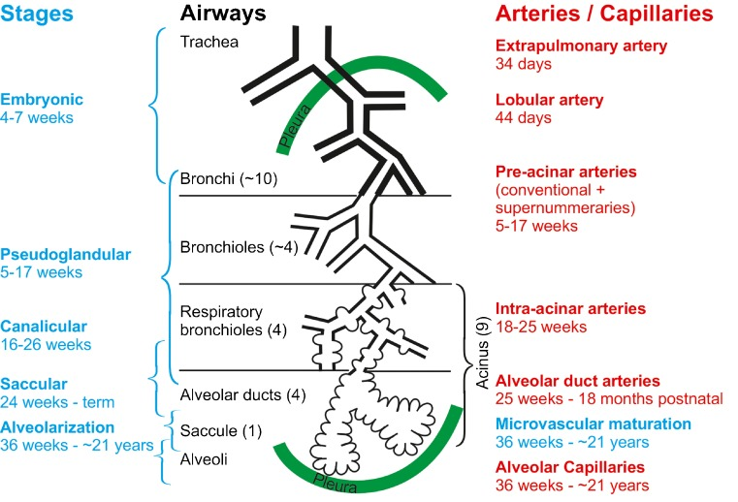
Respiratory Distress Syndrome
Respiratory distress syndrome (RDS) primarily occurs in infants born prematurely. Up to 50 percent of infants born between 26 and 28 weeks and fewer than 30 percent of infants born between 30 and 31 weeks develop RDS. RDS results from insufficient production of pulmonary surfactant, thereby preventing the lungs from properly inflating at birth. A small amount of pulmonary surfactant is produced beginning at around 20 weeks; however, this is not enough for inflation of the lungs. As a result, dyspnea occurs and gas exchange cannot be performed properly. Blood oxygen levels are low, whereas blood carbon dioxide levels and pH are high.
2i.) Rotation of the Stomach
The lower foregut begins at the level of the lung buds with the esophagus, followed by the stomach and the superior part of the duodenum. It extends as far as the liver bud and the pancreas; the bile passages also arise from it. Between stage 14 (ca. 33 days, 14) and 20 (ca. 49 days, 20) a massive lengthening of the whole intestines in a cranio-caudal growth gradient takes place: in the beginning it is mainly the esophagus and stomach that lengthen. Thus, a shift of these structures relative to the vertebral column occurs. One also speaks of a descent of the stomach. This lengthening not only leads to a relative relocation with respect to the spine, but it also coupled to the so-called "stomach rotation"
The stomach is shifted to the left and turns 90 degrees, the right wall lying dorsally. This result, though, more from a substantial growth of the left wall (later anterior wall) of the stomach and of the fundus than from an active rotation. The relatively short connective tissue bridge of the stomach to the posterior body wall stretches into a long, extended fold, the dorsal mesogastrium. Later the dorsal pancreas and the spleen anlage grow into it. Essential that the differing spurts of growth in the various stomach sections not only lead to shape but also to positional changes is the fact that the duodenum is fixed onto the posterior abdominal wall quite early. From its original intraperitoneal location, it assumes a secondary retroperitoneal position (stage 20, ca. 49 days, 20). The duodenum is thus a component of the vessel-pancreas-stalk. The caudal shifting of the entire foregut mentioned at the beginning comes to an end with the formation of the diaphragm and the resulting fixation of the esophagus-cardia passage as well as the formation of the vessel-pancreas-stalk at the level of the duodenum. With this fixation of the stomach at the cardia and pylorus the spurts of growth in the stomach wall now lead only to a horizontal movement of the organ to the left with the above-mentioned turn of 90 degrees.
ii.) Formation of the Omental Bursa
The omental bursa or lesser sac is a hollow space that is formed by the greater and lesser omentum and its adjacent organs. It communicates with the greater sac via the epiploic foramen of Winslow, which is known as the general cavity of the abdomen that sits within the peritoneum, but outside the lesser sac.
This space has well-defined borders which are represented by certain organs or their parts, so they are quite easy to spot and form a mental image of the omental bursa. In addition, like anything in anatomy, the omental bursa doesn't just exist as a standalone and isolated entity, but rather it communicates with several other spaces and recesses found throughout the body.
Borders | Anteriorly - quadrate lobe of liver, gastrocolic ligament, lesser omentum  Left - left kidney, left adrenal gland  Posteriorly - pancreas  Right - epiploic foramen, lesser omentum, greater sac
Communications | Superior recess, splenic recess, inferior recess, folds and recesses around the cecum and duodenum
Clinical | Congenital anomalies, hematomas, bilomas, abscess, pancreatitis, neoplasms, hydatid cyst, tuberculosis infection, mechanical irritation
This article will clarify all the above, including the borders, communications, and embryology together with some additional clinical information to make the topic more tangible.
Borders
- anteriorly by the quadrate lobe of the liver, the gastrocolic ligament and the lesser omentum
- to the left it is limited by the left kidney and the left adrenal gland
- posteriorly it is walled off by the pancreas
- to the right, the epiploic foramen and lesser momentum can be found and the greater sac beyond that.
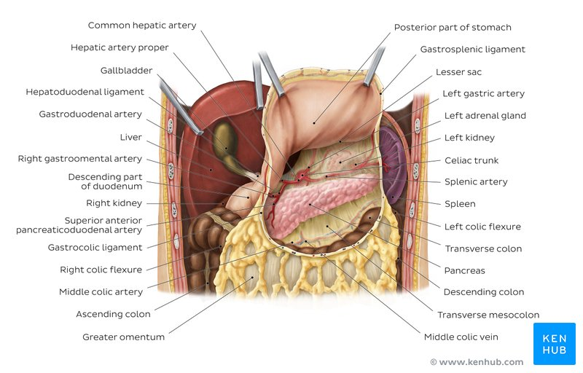
Overview of the Omental Bursa and neighbouring structures (Ventral View)
Communications and Connections
The cavity itself is almost completely closed, save its communication with the greater sac and the entrance through the omental foramen and is filled with a capillary film. The greater part of the omental bursa consists of its superior recess which extends cranially between the esophagus and the inferior vena cava.
The splenic recess extends to the left between the splenic ligaments and the stomach. Finally, the inferior recess of the omental bursa extends caudally between the stomach and the transverse colon. Other anatomical landmarks of note include a varied number of small peritoneal folds, recesses and fossae which seem to accumulate mostly around the cecum and the duodenum.
Embryology
During embryonic development, the peritoneum is anchored to the gut in the midline of the abdomen anteriorly, with the dorsal mesentery securing it posteriorly. The mesenteric layers develop in an anterior direction around the upper alimentary canal, carrying the blood supply and creating the ventral mesentery.
Due to the growth of the organs, they gradually become larger and must shift in order to fit into the abdominal cavity. The stomach rotates 90 degrees, the spleen is displaced to the left and the liver moves to the right. The peritoneum twists with these movements which lead to the formation of the falciform ligament, the lesser momentum and the coronary ligaments of the liver . Throughout this entire process, the cavity of the lesser sac is created.
Clinical aspects
The lesser sac has seven distinctly categorized pathological groups under which its potential disorders may be listed:
Congenital anomalies include duplication cysts and cystic lymphangiomas.
A hematoma or a biloma are classed as traumatic injuries.
Inflammatory states could be due to an abscess, a pseudocyst or even acute pancreatitis.
Neoplastic changes may lead to the growth of a stromal tumour, a leiomyoblastoma, a leiomyosarcoma, a liposarcoma, a schwannoma, both benign and malignant pancreatic neoplasms that may have endocrine involvement or not, hepatic tumours and desmoid tumours.
A hydatid cyst indicates a parasitic infestation.
The only infective cause of a lesser sac disorder yet known of is tuberculosis.
Mechanical irritation could potentially be caused by hernias of the cecum, transverse colon, small intestine and gallbladder.

3.) Development of the Esophagus
As early as the fourth week of development, the esophagus of the human embryo is merely a sphincter or constricted part of the primitive foregut, situated between the pharynx and stomach.
During the sixth and seventh weeks of gestation, the esophagus undergoes rapid elongation as cephalic development separates the head and neck from the thorax. The elongation is facilitated by development of the lungs and pleural cavities, which push the stomach dorsally and inferiorly, the esophagus is of dual origin, with an upper retrotracheal part originating from the pharyngeal portion and an intratracheal part originating from the pregastric segment of the foregut. During the sixth week of development, the esophagus is only 2 mm long, but at birth it extends to 100 mm. Its superior limit is marked by the inferior cricopharyngeal portion of the inferior pharyngeal constrictor. The cricopharyngeal part of the inferior pharyngeal constrictor relaxes suddenly during swallowing and simultaneously lengthens the vocal folds of the larynx. The lower limit of the esophagus is marked by its entrance to the stomach, in a region that constitutes a barrier to reflux of gastric contents, but it is not marked by an anatomically recognizable sphincter. At lower thoracic levels, the esophagus is supported away from the aorta, azygos vein, and body of the vertebrae, which permits advancement of the esophagus away from the vertebral column.
At the level of the last pharyngeal pouch of the embryo the foregut is suddenly very narrow and gives out ventrally the lung bud. This is the point where the esophagus originates which, in the beginning, is very short. During the lung development and the descent of the heart it lengthens considerably. The esophagus continues in the spindle-shaped stomach and the duodenum with the ventrally budding liver and the dorsally budding dorsal pancreas anlage.
The muscle layers of the esophagus arise in the late embryonic period. The lamina muscularis mucosae and the inner layer of the ring musculature arise subsequently out of cells of the local splanchnopleure.
The striated muscles of the outer layer of the circular musculature and the outer longitudinal muscles stem from the mesoderm of the last pharyngeal arch.
The entire musculature is innervated by the vagus nerve (cranial nerve X of the 4th pharyngeal arch).
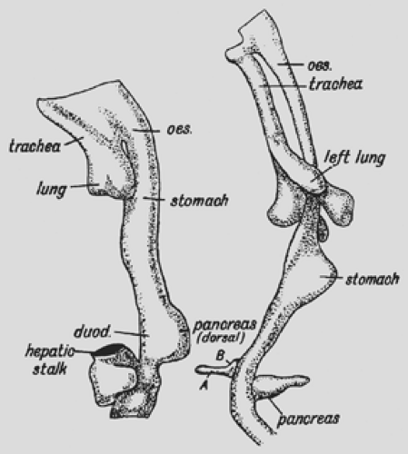

Foregut of a human embryo in the fourth week (left) and end of the fifth week (right). There is a progressive elongation of esophagus between the fourth and fifth weeks and relative posterioinferior position of the stomach.

