NAME: OMOLADE BRIGHT AYOMIDE
DEPARTMENT : COMPUTER SCIENCE
MATRIC NO. : 19/SCI01/078

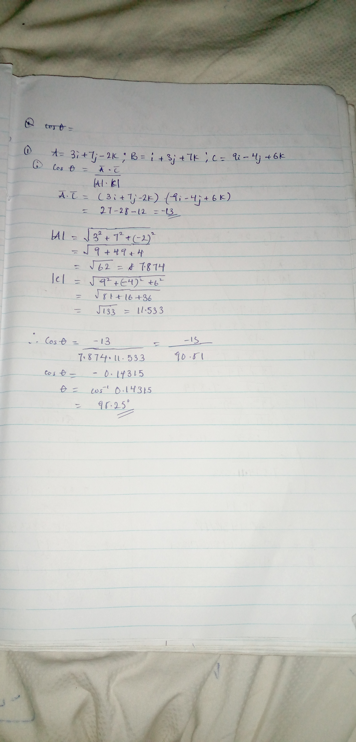
NUMBER 1A

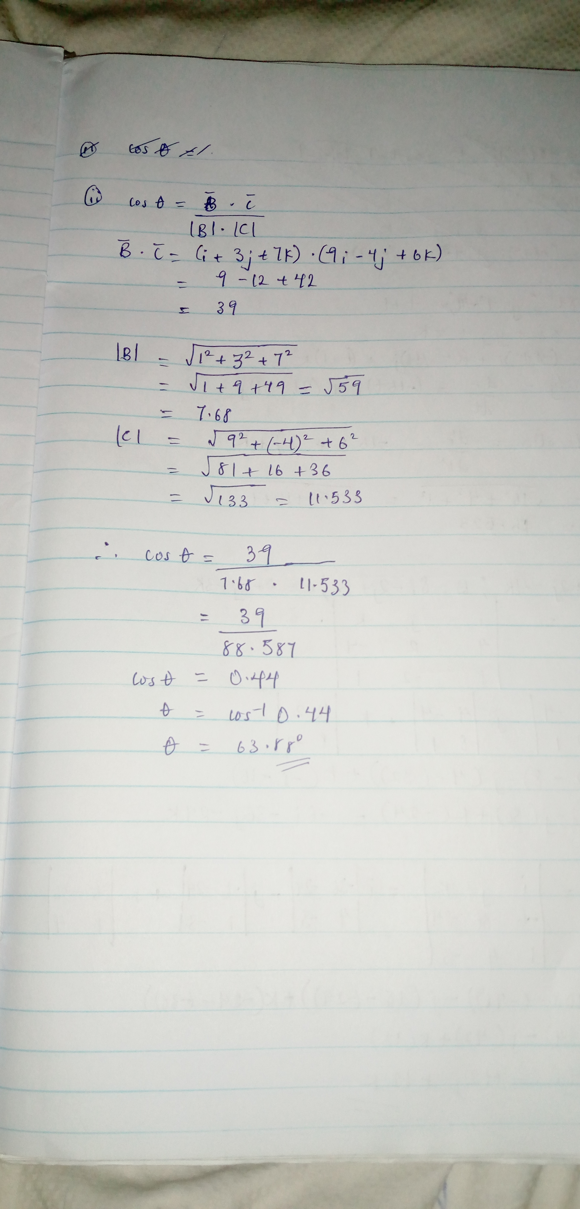
NUMBER 1B

NUMBER 2


