NAME: HALILU AMINA LAWAL
MATRIC NO: 17/MHS01/139
DEPARTMENT: MBBS
LEVEL: 300
COURSE: GROSS ASSIGNMENT 2
ASSIGNMENT
- Write an essay on the cavernous sinus.
The cavernous sinus within the human head is one of the dural venous sinuses creating a cavity called the lateral sellar compartment bordered by the temporal bone of the skull and the sphenoid bone, lateral to the sella turcica.
The cavernous sinus is one of the dural venous sinuses of the head. It is a network of veins that sits in the cavity, approximately 1 by 2cm in size in an adult. The carotid siphon of the internal carotid artery, and cranial nerves III, IV V (branches V1 and V2) and VI all pass through this blood filled space.
NEARBY STRUCTURES:
Superiorly: Optic tract, optic chiasma, internal carotid artery.
Inferiorly: Foramen lacerum and the junction of the body and greater wing of sphenoid bone.
Medially: Hypophysis cerebri or (pituitary gland) and sphenoidal air sinus.
Laterally: Temporal lobe with uncus.
Anteriorly: superior orbital fissure and the apex of the orbit.
Posteriorly: Apex of petrous temporal bone.

VENOUS CONNECTIONS
The cavernous sinuses receive blood from:
- Superior and inferior ophthalmic veins
- Sphenoparietal sinus
- Superficial middle cerebral veins
- Inferior cerebral veins
Blood leaves the sinus through superior and inferior petrosal sinuses as well as via the emissary veins through the foramina of the skull (mostly through foramen ovale). There are also connections with the pterygoid plexus of veins via inferior ophthalmic vein, deep facial vein and emissary veins.
CONTENTS
Apart from the blood which passes through a venous sinus, several anatomical structures, including some cranial nerves and their branches, also pass through the sinus.
Structures within the outer (lateral) wall of the compartment from superior to the inferior include:
- Oculomotor nerve
- Trochlear nerve
- Ophthalmic and maxillary branches of the trigeminal nerve.
Structures passing through the midline (medial) wall:
- Abducens nerve
- Internal carotid artery accompanied by the internal carotid plexus
These verves, with the exception of CN V2 pass through the cavernous sinus to enter the orbital apex through the superior orbital fissure. The maxillary nerve, division V2 of the trigerminal nerve travels through the lower portion of the sinus and exits via the foramen rotundum. The maxillary branch passes external to, but immediately adjacent to, the lateral wall of the sinus.
The optic nerve lies just above and outside the cavernous sinus, superior and lateral to the pituitary gland on each side and enters the orbital apex via the optic canal.

VENOUS DRAINAGE
As a venous sinus, the cavernous sinus receives blood from the superior and inferior ophthalmic veins and from the superficial cortical veins and is connected to the basilar plexus of veins posteriorly. The cavernous sinus drains by two large channels, the superior and inferior petrosal sinuses, ultimately into the internal jugular vein via the sigmoid sinus, also draining with emissary vein to pterygoid plexus.
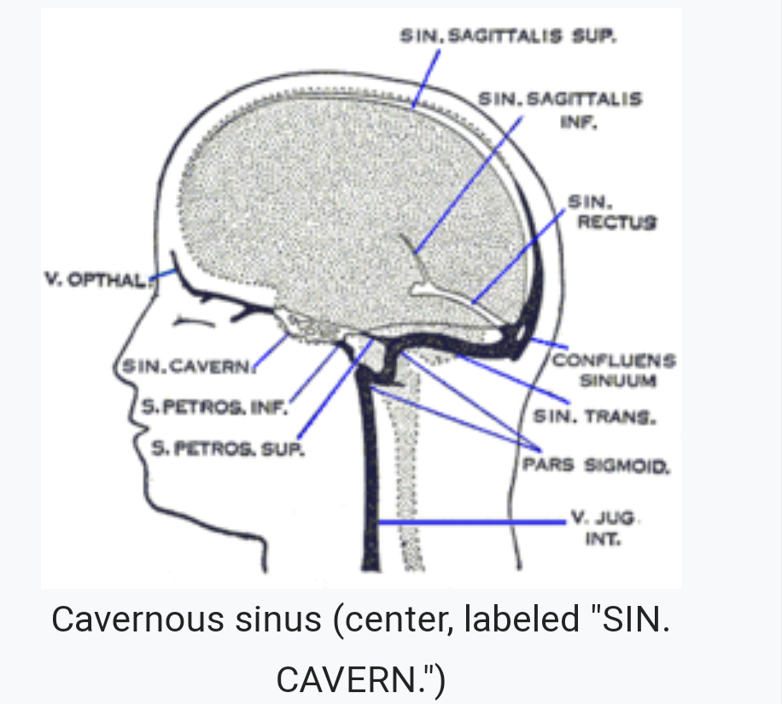

- Discuss the walls of the nose.

The border of the nose include: lateral, medial, roof and floor.
LATERAL WALL: the lateral wall of the nasal cavity is a region of the nasopharynx essential for humidifying and filtering the air we breathe in nasally. The lateral wall of each nasal cavity mainly consists of the maxilla. There is a deficiency that is compensated for by the perpendicular plate of the palatine bone, the medial pterygoid plate, the labyrinth of ethmoid and the inferior conchae. The paranasal sinuses are connected to the nasal cavity through small orifices called orifices. Most of these ostia communicate with the nose through the lateral nasal wall, via a semilunar depression in it known as the semilunar hiatus. The hiatus is bound laterally by a projection known as the uncinate process. The region is called the ostiomeatal complex.
We can also find a structure called agger nasi. The agger nasi is also referred to as the nasoturbinal concha or nasal ridge. It can also be describes as a small mound or ridge found in the lateral side of the nasal cavity.
MEDIAL WALL: Medial wall of the nasal cavity comprises the nasal septum, the septal cartilage and various bones of the skull. The nasal septum is a structure consisting of both bony and cartilaginous components. The bony components are the:
- Perpendicular plate of the ethmoid superoinferiorly
- The vomer posteroinferiorly
- The crests of the maxillary bone anteroinferiorly
- The crest of the palatine bone inferior to the vomer.
The septal cartilage divides the nasal cavity into two halves. The anteroinferior part of the cartilage has an extension known as the footplate which lies in free contact with the membranous septum. The cartilage is expanded in other regions, namely junction with the lateral nasal cartilage termed the posterior process. The cartilage is firmly adhered to the nasal bone by taut collagen fibres.
ROOF OF THE NASAL CAVITY: The roof of the nasal cavity is formed in its upper third to one half by the nasal bone and more inferiorly by the junctions of the upper lateral cartilage and nasal septum. Connective tissue and skin cover the bony and cartilaginous components of the nasal dorsum.
THE FLOOR OF THE NASAL CAVITIES: which also form the roof of the mouth, is made up by the bones of the hard palate: the horizontal plate of the palatine bone Posteriorly and the palatine process of the maxilla anteriorly. The most anterior part of the nasal cavity is the nasal vestibule. The vestibule is enclosed by the cartilages of the nose and lined by the same epithelium of the skin(stratified squamous, keratinized). Inside the nostrils of the vestibule are the nasal hair, which filter dust and other matter that are breathed in. The back of the cavity blends, via choanae, into the nasopharynx.

