NAME: OKAM EDNA ACHI CHINMA
MATRIC NUMBER: 19/MHS03/015
DEPARTMENT: HUMAN ANATOMY
COURSE CODE: ANA 212

GROSS ANATOMY OF THE EXTERNAL FEMALE GENITALIA

External female genitalia are a part of the female reproductive system, and include mons pubis, labia majora, labia minora, clitoris, vestibule, hymen, vestibular bulb and vestibular glands.

Components of the external female genitalia occupy a large part of the female perineum and together they are called the vulva. The functions of the external female genitalia are many, such as reproduction and sexual pleasure, parturition and the protection of the internal genital organs.

Parts
-Mons pubis
-Labia majora
-Labia minora
-Clitoris
-Vestibule
-Hymen
-Vestibular bulb
-Vestibular glands

Blood supply
-Internal pudendal artery

Innervation
-Anterior labial nerves
-Pudendal nerve
-Dorsal nerve of the clitoris

Components
External genitalia of a female occupy much of the perineum and are collectively referred to as the vulva (pudendum).
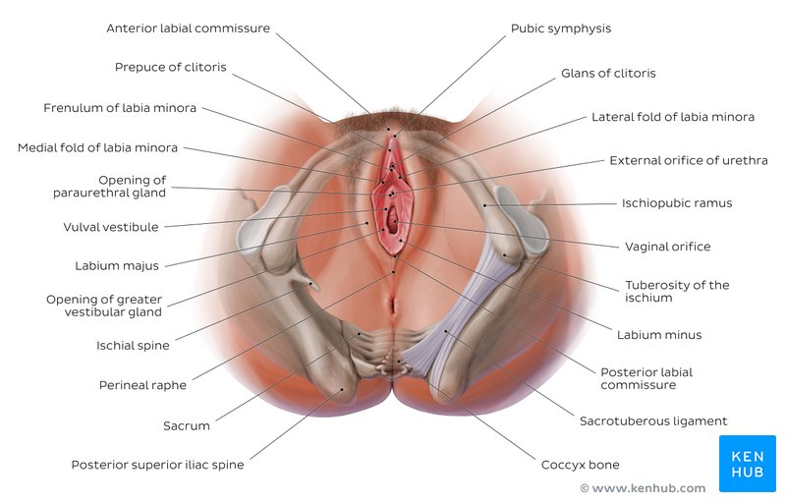

Female perineum and external female genitalia

Mons pubis
The mons pubis consists of a mass of subcutaneous adipose tissue anterior to the pubic symphysis and bears most of the pubic hair.

Labia majora
The labia majora (singular, labium majus) are a pair of thick folds of skin and adipose tissue found inferior to the mons. The fissure between the folds is called the pudendal cleft. Pubic hair can be found on the lateral surfaces of the labia majora once puberty hits, while the medial/internal surfaces will remain hairless. The round ligament of the uterus passes through the inguinal canal and continues into the labia majora, where the nerve fibers spread and mix with the tissue of the mons pubis. The labia majora are thicker in the front where they form by joining the anterior commissure and is found below the mons pubis. The posterior commissure of the labia majora is the rear joining of the labia majora and is located above the perineum.

Labia minora
Found medial to the labia majora are the labia minora (singular, labium minus), which are much thinner devoid of fat and entirely hairless. Their frontal ends split to form upper and lower layers. The upper layer goes superior to the clitoris and forms a fold called prepuce. The lower layer passes inferior to clitoris and forms the frenulum of the clitoris.

Clitoris
The clitoris is analogous to the structure of the penis, but it does not contain urethra and has no urinary role. It is richly supplied with autonomic efferent motor nerve endings via the cavernosal nerve of the clitoris and is highly sensitive to sexual stimulation. Also, unlike the penis, the clitoris is nearly entirely internal and does not have a corpus spongiosum or enclose the urethra.

The clitoris has a pair of corpora cavernosa which consist of erectile tissue enclosed in dense fibrous tissue. Each corpus (body) passes internally and is attached to the ischiopubic ramus by a crus. The suspensory ligament and two small muscles (ischiocavernosi) are attached to the crura just like the penis. The glans (head) of the clitoris is a small tubercle, which protrudes slightly from the prepuce. Arteries here include the dorsal and clitoral cavernosal arteries, which arise from the iliohypogastric pudendal bed.

Vestibule
The labia minora enclose an area called the vestibule, which contains the urinary and vaginal orifices along with the openings of the greater and lesser vestibular glands. The prepuce is found at the anterior margin of the vestibule.

Hymen
Most females (but not all) are born with a hymen, which is generally in the form of an elliptical/oval-shaped membranous ring around the vaginal orifice (It is generally perforated to some degree, most often in the centre, kind of like a 'donut' shape). The remnants of this membranous ring in adult females in known as hymenal caruncles, which appear as small thin elevations of mucous membrane around the vaginal opening. When the hymen completely covers the vaginal orifice, it is known as an imperforate hymen. An imperforate hymen may rupture naturally during various types of physical activity (aside from intercourse).

Some females may undergo a hymenotomy, which involves the surgical removal, or opening of the hymen, most often to facilitate menstruation, or relieve discomfort during intercourse. This procedure may also be undertaken in the instance when the hymen is abnormally thick, and/or when the opening is small, limiting access to the vaginal orifice.

Vestibular bulbs
Vestibular bulbs are located on each side of the vestibule. They consist of a pair of subcutaneous erectile tissues which correspond to the penile bulb and corpus spongiosum. Both bulbs join in front of urethral orifices under the vestibule of the vagina. Each one is covered with bulbospongiosus muscles.

Vestibular glands
Bartholin’s (greater vestibular) glands are pea-sized with a short duct that opens into the vestibule or lower vagina. One is found on each side of the vagina. Bartholin’s glands are homologous to the bulbourethral glands in the male, and function to keep the vulva moist, providing lubrication for sexual intercourse during sexual excitement. Additionally, lesser vestibular glands lubricate the vestibule. Finally, a pair of Skene’s (paraurethral) glands, homologous to the male prostate, open into the vestibule nears the external urethral orifice.

Skene's Glands
The Skene's glands, which are also known as the lesser vestibular glands (homologous to the prostate glands in males), are two glands located on either side of the urethra. These glands are believed to secrete a substance to lubricate the urethra opening. This substance is also believed to act as an antimicrobial. This antimicrobial is used to prevent urinary tract infections. The function of Skene's gland is not fully understood but is believed to be the source of female ejaculation during sexual arousal.

Urethra
The urethra is an extension of a tube from the bladder to the outside of the body. The purpose of the urethra is for the excretion of urine. The urethra in females opens within the vulva vestibule located inferior to the clitoris, but superior to the vagina opening.

Vagina
The vagina is an elastic, muscular tube connected to the cervix proximally and extends to the external surface through the vulva vestibule. The distal opening of the vagina is usually partially covered by a membrane called the hymen. The vaginal opening is located posterior to the urethra opening. The function of the vagina is for sexual intercourse and childbirth. During sexual intercourse, the vagina acts as a reservoir for semen to collect before the sperm ascending into the cervix to travel towards the uterus and fallopian tubes. Also, the vagina also acts as an outflow tract for menses.
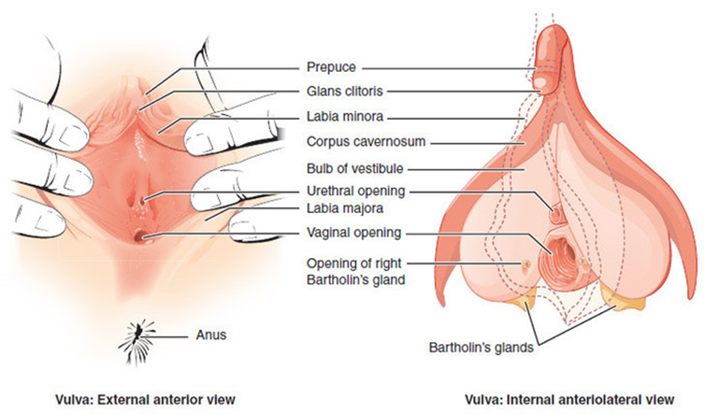

Blood supply
Vasculature of the external female genitalia is primarily supplied by the internal pudendal arteries, which are branches of the anterior division of the internal iliac artery.

Lymphatic drainage
Lymphatic drainage of the external female genitalia is via the superficial and deep inguinal lymph nodes. Lymph from the clitoris, vestibular bulb and anterior labia minora can alternatively drain into the internal iliac lymph nodes.

Innervation
The vulva is innervated from a variety of sources. The mons pubis and anterior labia is innervated via the anterior labial nerves, which derive from the lumbar plexus. The posterior aspect of the vulva is innervated via the pudendal nerve and its branches (posterior labial nerves), together with branches from the posterior cutaneous nerve of the thigh. Sensitive innervation to the clitoris is provided by the dorsal nerve of the clitoris.

Muscles
Many muscles act on the external female genitalia either by forming and supporting the perineum or the pelvic floor.

- Bulbospongiosus muscle
- Ischiocavernosus muscle
- Deep transverse perineal muscle
- Superficial transverse perineal muscle
- Levator ani muscle
- Iliococcygeus muscle
- Pubococcygeus muscle
- Puborectalis muscle
- Pubovaginalis muscle
- Coccygeus muscle
- Perineal body
- External anal sphincter
- External urethral sphincter

During embryology, the fetus starts with undifferentiated gonads. The gonads will either develop into testes or ovaries. The gonads form into testes due to the influences from the SRY gene, but without the SRY gene, the gonads will default into ovaries. The ovaries are the dominant organ in females that make and secrete sex hormones for females. The theca cells and granulosa cells within the ovaries produce sex hormones for females. The theca cells make androgens, and the granulosa cells take the androgen and convert it into estrogen. Estrogen is the dominant influence on the development of the female external genitalia.

The female external genitalia develop from many default structures such as the genital tubercle, urogenital sinus, urogenital folds, and the labioscrotal swellings/folds. The genital tubercles will differentiate into the glans clitoris and the vestibular bulbs in the females while the equivalent in males is the glans penis and the corpus cavernosum and spongiosum. The urogenital sinus will develop into the Bartholin's glands, Skene's glands, and the urethra in females. The urogenital sinus forms the bulbourethral glands and the prostate glands in males. The labia majora originates from the labioscrotal folds in females while it forms the scrotum in males. Lastly, the urogenital folds form the labia minora in females and it forms the ventral shaft of the penis in males. The reason that these default structures differentiate into female external genitalia instead of males' is due to the influence of estrogen. If these structures were under the influence of testosterone, they would develop into male external genitalia.

Surgical Considerations
In surgery, knowledge of the anatomy of the female external genitalia is crucial when it comes to repairing, reconstructing, or preventing undesirable defects to the genitals. Some common procedures done to the female external genitalia are episiotomy, labiaplasty, and vaginoplasty.

Episiotomy
In episiotomies, the vaginal opening is enlarged by an incision that is done either midline or laterally during delivery of a child that risks tearing and damaging the vaginal opening. If the incision is performed midline, the perineal body will be the target of the incision. While the lateral episiotomy targets the transverse perineal muscle. The reason for performing episiotomies is that an incision can be easily repaired and decrease healing time, in contrast with a torn vaginal opening that could potentially involve the perineum muscles and the rectum. The repair of a torn vaginal opening due to a large child delivery has a longer healing time. Episiotomies are done as procedures to aid in vaginal delivery of large offspring’s and the prevention of vaginal tearing into other perineum structures.

Labiaplasty
Labiaplasty is a surgical procedure with emphasize on altering the size and shape of the labia majora and labia minora. Indications for labiaplasty include multiple reasons, such as congenital defects, aging, cancers, and cosmetics. The focus of this procedure is to create a more desirable appearance of the labial folds.

Vaginoplasty
Vaginoplasty is a surgical procedure used to reconstruct or construct the vagina. Vaginoplasties are necessary for several reasons, such as pelvic organ prolapse, congenital defects, neoplasms, sex reassignments, and cosmetics. The goal of the vaginoplasty is to surgically make a vagina that is desirable for the patient.

Clinical Significance
The anatomy of the female external genitalia is vital in clinical settings. The importance of this anatomy comes to the fore with the diagnosis of various diseases and lesions that affect the female genitals. Also, the knowledge of the female genitals is important when it comes to performing procedures involving the vulva.

Urinary Tract
- Foley Catheter: One common procedure that is routinely due in healthcare is the catheterization of the female urethra. This procedure involves the introduction of a flexible tube into the urethra and securing it in place with a saline-filled balloon. This procedure is done to assist in the excretion of urine from the bladder. This method can be used to collect urine for surveillance monitoring of the amount of urine produced or to collect urine used for the analysis of other pathologies.

- Urinary Tract Infection: One common pathology that involves the urethra is a urinary tract infection (UTI). In urinary tract infections, the patient classically complains of dysuria, increased urination, foul-smelling urination, and cloudy urine. This condition commonly affects females due to their urethrae are shorter than males' urethrae. The short urethra in females allows the bacteria to ascend the urethra more readily, and the anatomical location of the urethra, vagina, and anus allows for cross-contamination between the vaginal and anal bacteria into the urethra. The most common bacteriologic ethology of urinary tract infections is gram-negative rods, with the most common bacteria being Escherichia coli.

Sexually Transmitted Infections
Haemophilus ducreyi
Klebsiella granulomatis
Haemophilus ducreyi
Chlamydia trachomatis
Neisseria gonorrhoeae
Treponema pallidum
Herpes Simplex Virus 1&2
Human Papillomavirus
Human immunodeficiency virus
Hepatitis B and C

Vulvar Pathology

- Bartholin cyst and abscess: Bartholin's glands are glands that produce secretions to lubricate the vulva and vagina. This gland can become obstructed and form a cyst containing the build-up of lubricant. If the cyst becomes infected, it then progresses to become an abscess. This condition tends to affect females of reproductive age. Bartholin cyst/abscess presents as a swelling located posterolateral to the vaginal orifice. This infection may result from infection with Escherichia coli, Chlamydia trachomatis, and Neisseria gonorrhoeae.

- Lichen sclerosus: The vulva region is a sensitive region that may be prone to irritations. In lichen sclerosus, the vulva is under chronic irritation resulting in itching. This itching causes the patient to scratch, and over time the trauma from scratching will cause the vulvar skin to undergo lichenification (thickening). Lichen sclerosus is the thinning of the epidermis and thickening/fibrosis of the dermis. It appears as white parchment paper like lesions. This condition affects prepubertal and postmenopausal females with an increased risk of vulvar cancer. The treatment is topical steroids.

- Lichen simplex chronicus: In lichen simplex chronicus, the vulvar region undergoes hyperplasia of the epithelium. This condition presents as a thick, leathery vulvar skin due to chronic scratching and rubbing. This condition is not associated with an increased risk of cancer.

- Imperforate hymen: In pubertal females that reach the age of menarche, but do not have menses is called primary amenorrhea. One cause of primary amenorrhea is imperforate hymen. These females present with monthly pain and pressure in the lower abdomen, but not excretion of mense. On physical examination, there will be a blue, brown round bulging mass protruding from the vagina. The mass protruding from the vagina is a collection of the menstrual products getting trapped due to an imperforate hymen. The treatment for this condition is incision and drainage of the mass.

Neoplastic
- Vulvar carcinoma: Cancer of the vulvar region is rare. The most common cancer involving the vulvar region is squamous cell carcinoma. This malignancy could be due to a transformation of leukoplakia or due to the infection from HPV16 or HPV18. Lichen sclerosus can also progress to vulvar cancer. A biopsy can confirm the diagnosis.

- Extramammary Paget Disease: Padget disease of the vulva is usually a type of carcinoma in situ. This condition presents as scaling plaques, crusting, pruritus, ulcers, and erythema. But there is no risk for underlying malignancies.

