NAME: SADIQ AYOTOMIWA S.
MATRIC NUMBER: 17/MHS01/290
ANA 301 ASSIGNMENT
Question: 1. Discuss the anatomy of the tongue and comment on its applied anatomy.
2. Write an essay on the air sinuses.
1.
The tongue is a mass of muscle that is almost completely covered by a mucous membrane. It is a pink, muscular organ that occupies most of the oral cavity and oropharynx. It is kept moist by the products of the major and minor salivary glands, which aids the organ as it facilitates deglutition, speech, and gustatory perception. There is significant variability in the length of the tongue among individuals, on average, the organ is roughly 10 cm long. It has three main parts:
- The tip or apex of the tongue is the most anterior, and most mobile aspect of the organ.
- The tip is followed by the body of the tongue. It has a rough dorsal (superior) surface that abuts the palate and is populated with taste buds and lingual papillae, and a smooth ventral (inferior) surface that is attached to the floor of the oral cavity by the lingual frenulum.
- The base of the tongue is the most posterior part of the organ. It is populated by numerous lymphoid aggregates known as the lingual tonsils along with foliate papillae along the posterolateral surface.
There are numerous important structures surrounding the tongue. It is limited anteriorly and laterally by the upper and lower rows of teeth. Superiorly, it is bordered by the hard (anterior part) and soft (posterior part) palates. Inferiorly, the root of the tongue is continuous with the mucosa of the floor of the oral cavity; with the sublingual salivary glands and vascular bundles being located below the mucosa of the floor of the oral cavity. The palatoglossal and palatopharyngeal arches (along with the palatine tonsils) have lateral relations to the posterior third of the tongue. Posterior to the base of the tongue is the dorsal surface of the epiglottis and laryngeal inlet, and the posterior wall of the oropharynx. As mentioned earlier, the presulcal and postsulcal parts of the tongue differ not only by anatomical location, but also based on embryological origin, innervation, and the type of mucosa found on its surface.
OVERVIEW OF THE STRUCTURE OF THE TONGUE SEEN FROM THE CRANIAL VIEW OF THE DORSUM.
Anterior two thirds(Presulcal):The presulcal tongue includes the apex and body of the organ. It terminates at the sulcus terminalis; which can be seen extending laterally in an oblique direction from the foramen cecum towards the palatoglossal arch. The mucosa of the dorsal surface of the oral tongue is made up of circumvallate, filiform, and fungiform papillae. There is also a longitudinal midline groove running in an anteroposterior direction from the tip of the tongue to the foramen cecum. This marks the embryological point of fusion of the lateral lingual swellings that formed the oral tongue. It also represents the location of the median lingual (fibrous) septum of the tongue that inserts in the body of the hyoid bone.
Posterior third(postsulcal):
The remainder of the tongue that lies posterior to the sulcus terminalis is made up by the base of the organ. It lies behind the palatoglossal folds and functions as the anterior wall of the oropharynx. Unlike the oral tongue, the pharyngeal tongue does not have any lingual papillae. Instead, its mucosa is populated by aggregates of lymphatic tissue known as the lingual tonsils. The mucosa is also continuous with the mucosa of the laterally located palatine tonsils, the lateral oropharyngeal walls, and the posterior epiglottis and glossoepiglottic folds.
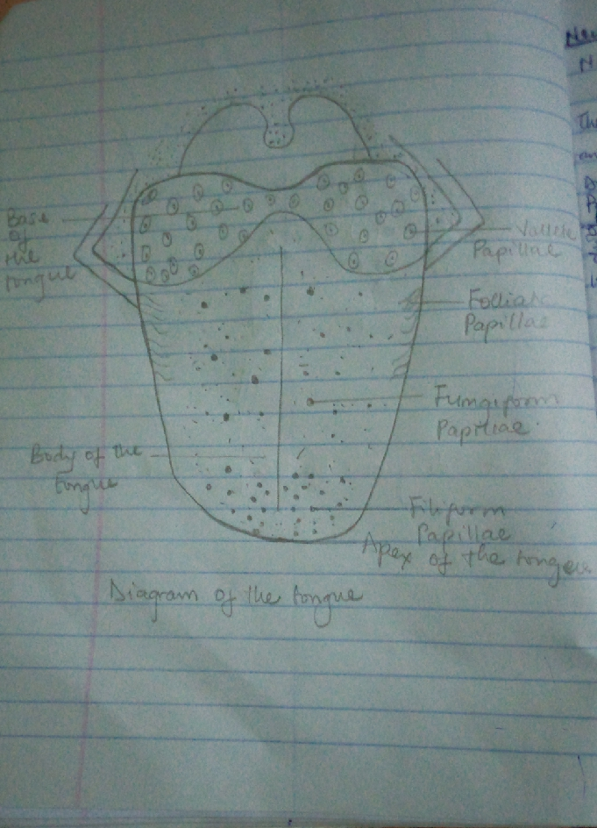
THE MUSCLES OF THE TONGUE
Intrinsic Muscles
The intrinsic muscles only attach to other structures in the tongue. There are four paired intrinsic muscles of the tongue and they are named by the direction in which they travel:
- The superior longitudinal
- Inferior longitudinal
- Transverse and
- Vertical muscles of the tongue.
These muscles affect the shape and size of the tongue and have a role in facilitating speech, eating and swallowing.
Motor innervation for the intrinsic muscles of the tongue is via the hypoglossal nerve (CNXII).
Extrinsic Muscles
The extrinsic muscles are as follows:
- Genioglossus
Attachments: Arises from the mandibular symphsis. Inserts into the body of the hyoid bone and the entire length of the tongue.
Function: Inferior fibres protrude the tongue, middle fibres depress the tongue, and superior fibres draw the tip back and down
Innervation: Motor innervation via the hypoglossal nerve (CNXII).
- Hyoglossus
Attachments: Arises from the hyoid bone and inserts into the side of the tongue
Function: Depresses and retracts the tongue
Innervation: Motor innervation via the hypoglossal nerve (CNXII).
- Styloglossus
Attachments: Originates at the styloid process of the temporal bone and inserts into the side of the tongue
Function: Retracts and elevates the tongue
Innervation: Motor innervation via the hypoglossal nerve (CNXII).
- Palatoglossus
Attachments: Arises from the palatine aponeurosis and inserts broadly across the tongue
Function: Elevates the posterior aspect of the tongue
Innervation: Motor innervation via the vagus nerve (CNX).
All of the intrinsic and extrinsic muscles are innervated by the hypoglossal nerve (CN XII), except palatoglossus, which has vagal innervation (CN X).
In the anterior 2/3, general sensation is supplied by the trigeminal nerve (CNV). Specifically the lingual nerve, a branch of the mandibular nerve (CN V3).
On the other hand, taste in the anterior 2/3 is supplied from the facial nerve (CNVII). In the petrous part of the temporal bone, the facial nerve gives off three branches, one of which is chorda tympani. This travels through the middle ear, and continues on to the tongue.

The posterior 1/3 of the tongue, both touch and taste are supplied by the glossopharyngeal nerve (CNIX).
VASCULATURE OF THE TONGUE
The lingual artery (branch of the external carotid) does most of the supply, but there is a branch from the facial artery, called the tonsillar artery, which can provide some collateral circulation. Drainage is by the lingual vein.
Lymphatic Drainage
The lymphatic drainage of the tongue is as follows:
Anterior two thirds : initially into the submental and submandibular nodes, which empty into the deep cervical lymph nodes
Posterior third : directly into the deep cervical lymph nodes
CLINICAL ANATOMY
1. Tongue tied: The tongue is attached anteroinferiorly by a piece of connective tissue called the frenulum, which lies in the midline. It presents in children. There are varying degrees of severity of tongue-tie and in some cases it can restrict the movement of the tongue causing difficulties with breast feeding. This can be managed with simple surgery.
2. Macroglossia (big tongue): This can be broken down into various categories based on the cause. These include congenital, inflammatory, traumatic, cancerous, and metabolic causes. Thyroid disease, lymphangiomas, and congenital abnormalities are among some of the causes of an enlarged tongue.
3. Burning mouth/burning tongue syndrome: a relatively common problem. The tongue feels burned or scalded, or strange tastes or sensations develop. Apparently harmless, burning mouth syndrome may be caused by a mild nerve problem.
4. Atrophic glossitis (bald tongue): The tongue loses its bumpy texture, becoming smooth. Sometimes this is due to anemia or a B vitamin deficiency.

2.
The paranasal sinuses are air-filled extensions of the respiratory part of the nasal cavity. There are four paired sinuses, named according to the bone in which they are located;
- Maxillary
- Frontal
- Sphenoid and
- Ethmoid.
The paranasal sinuses are thought to contribute to the humidifying of the inspired air. They also reduce the weight of the skull.
Sinuses are formed in childhood by the nasal cavity eroding into surrounding bone. As they are outgrowths of the nasal cavity, they all drain back into it. Openings to the paranasal sinuses are found on the roof and lateral walls of the nasal cavity. The inner surface is lined by a respiratory mucosa.
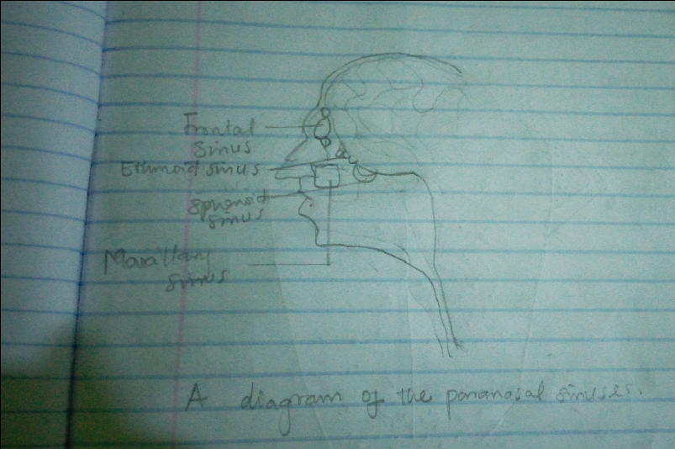
Frontal Sinuses: These are the most superior in location, found under the forehead. The frontal sinuses are variable in size, but always triangular-shaped. They drain into the nasal cavity through the frontonasal duct, which opens out at the hiatus semilunaris on the lateral wall.
Sphenoid Sinuses: The sphenoid sinuses also lie relatively superiorly, at the level of the spheno-ethmodial recess. They are found more posteriorly, and are related superiorly and laterally to the cranial cavity. The sphenoid sinuses drain out onto the roof of the nasal cavity. The relationships of this sinus are of clinical importance; the pituitary gland can be surgically accessed via passing through the nasal roof, into the sphenoid sinus and through the sphenoid bone.
Ethmoidal Sinuses: There are three ethmoidal sinuses; anterior, middle and posterior. They empty into the nasal cavity at different places:
Anterior: Hiatus semilunaris
Middle: Ethmoid bulla
Posterior: Superior meatus
Maxillary Sinuses: The largest of the sinuses. It is located laterally and slightly inferiorly to the nasal cavities. It drains into the nasal cavity at the hiatus semilunaris, underneath the frontal sinus opening. This is a potential pathway for spread of infection – fluid draining from the frontal sinus can enter the maxillary sinus.
CLINICAL SIGNIFICANCE

1. SINUSITIS: As the paranasal sinuses are continuous with the nasal cavity, an upper respiratory tract infection can spread to the sinuses. Infection of the sinuses causes inflammation (particularly pain and swelling) of the mucosa. If more than one sinus is affected, it is called pansinusitis.

2. The maxillary nerve supplies both the maxillary sinus and maxillary teeth, and so inflammation of that sinus can present with toothache.

