NAME:BANKOLE FISOPE CLEMENT
MATRIC NO: 17/MHS06/022
PHA 302 pharmacology and toxicology II
Write on a named bacterial protein synthesis inhibitor, stating its mechanism of action, indication for use, toxicity and adverse effect

Answer:
Tetracyclines are a group of broad-spectrum antibiotic compounds that have a common basic structure and are either isolated directly from several species of Streptomyces bacteria or produced semi-synthetically from those isolated compounds.Tetracycline molecules comprise a linear fused tetracyclic nucleus (rings designated A, B, C and D) to which a variety of functional groups are attached.Tetracyclines are named for their four ("tetra-") hydrocarbon rings ("-cycl-") derivation ("-ine"). They are defined as a subclass of polyketides, having an octahydro tetracene-2-carboxamide skeleton and are known as derivatives of polycyclic naphthacene carboxamide.While all tetracyclines have a common structure, they differ from each other by the presence of chloride, methyl, and hydroxyl groups. These modifications do not change their broad antibacterial activity, but do affect pharmacological properties such as half-life and binding to proteins in serum.[1]
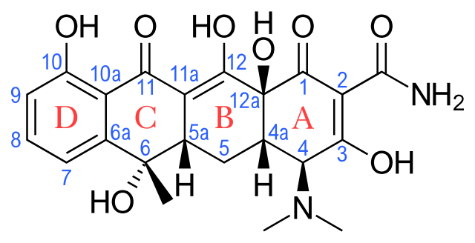
Skeletal formula of tetracycline with atoms and four rings numbered and labeled.
Tetracyclines are growth inhibitors (bacteriostatic) rather than killers of the infectious agent (bacteriocidal) and are only effective against multiplying microorganisms.They inhibit protein synthesis by binding reversibly to the bacterial 30S ribosomal subunit and preventing the aminoacyl tRNA from binding to the A site of the ribosome.

Mechanism of action
Tetracyclines and inhibit bacterial protein synthesis by binding to the 30S bacterial ribosome and preventing access of aminoacyl tRNA to the acceptor (A) site on the mRNA-ribosome complex. These drugs enter gram-negative bacteria by passive diffusion through channels formed by porins in the outer cell membrane and by active transport that pumps tetracyclines across the cytoplasmic membrane.
Inhibition of bacterial protein synthesis by tetracyclines. mRNA attaches to the 30S subunit of bacterial ribosomal RNA. The P (peptidyl) site of the 50S ribosomal RNA subunit contains the nascent polypeptide chain; normally, the aminoacyl tRNA charged with the next amino acid (aa) to be added moves into the A (acceptor) site, with complementary base pairing between the anticodon sequence of tRNA and the codon sequence of mRNA. Tetracyclines bind to the 30S subunit, block tRNA binding to the A site, and thereby inhibit protein synthesis.The binding of tetracyclines to cellular dsRNA (double stranded RNA) may be an explanation for their wide range of effect. It can also be attributed to the nature of ribosomal protein synthesis pathways among bacteria.

Indication for use
Tetracyclines are generally used in the treatment of infections of the urinary tract, respiratory tract, skin and the intestines and are also used in the treatment of chlamydia, especially in patients allergic to β-lactams and macrolides.
Tetracyclines are widely used in the treatment of moderately severe acne.It is also used for malaria treatment and prophylaxis, as well as treating elephantiasis filariasis.Tetracyclines remain the treatment of choice for infections caused by chlamydia (trachoma, psittacosis, salpingitis, urethritis and L. venereum infection), Rickettsia (typhus, Rocky Mountain spotted fever), brucellosis and spirochetal infections (borreliosis, syphilis and Lyme disease.

Toxicity and adverse side effects
At higher oral doses tetracycline may produce gastrointestinal irritation, with nausea, vomiting, and diarrhea, as well as renal failure. Bone and teeth discoloration are known to occur in humans under clinical treatment with high levels of tetracycline.
Side-effects from tetracyclines are not common, but of particular note is phototoxicity. It increases the risk of sunburn under exposure to light from the sun or other sources.
Common tetracycline side effects may include:
* nausea, vomiting, diarrhea, upset stomach, loss of appetite;
* white patches or sores inside your mouth or on your lips;
* swollen tongue, black or "hairy" tongue, trouble swallowing;
* sores or swelling in your rectal or genital area; or
* vaginal itching or discharge.

