ENGINEERING SURVEYING – CVE 310
QUESTION 1
- The two methods of levelling include;
- The Rise & Fall Method,
- The Height of Collimation Method.
Rise and Fall Method;
- Advantage - Effective checks can be performed and confirmed using the
reduced levels and with the rise and fall of the instrument.

- Disadvantage – The rise and fall method tends to become tedious on longer
roads and wider areas of a site.

Height of Collimation Method;
- Advantage – It is faster to perform the height of collimation method
compared to the rise and fall method.

- Disadvantage – It is more susceptible to errors and effective checks are only
confirmed using the reduced levels.
- Using Height of Collimation Method
B.S | I.S | F.S | H OF C | R.L | DISTANCE | REMARK
0.771 |  |  | 162.771 | 162.000 | 10 | OBM
0.802 |  | 1.520 | 162.053 | 161.251 | 20 | C.P
 | 2.311 |  |  | 159.742 | 30
3.580 |  | 1.990 | 163.643 | 160.063 | 40 | C.P
 | 1.220 |  |  | 162.423 | 50
 | 3.675 |  |  | 159.968 | 60
2.408 |  | 4.020 | 162.031 | 159.623 | 70 | C.P
 | 0.339 |  |  | 161.692 | 80
0.780 |  | 0.157 | 162.654 | 161.874 | 90 | C.P
 | 1.535 |  |  | 161.119 | 100
 | 1.955 |  |  | 160.699 | 110
 | 2.430 |  |  | 160.224 | 120
 | 2.985 |  |  | 159.669 | 130
1.155 |  | 3.480 | 160.329 | 159.174 | 140 | C.P
 | 1.960 |  |  | 158.369 | 150
 | 2.365 |  |  | 157.964 | 160
0.935 |  | 3.640 | 157.624 | 156.689 | 170 | C.P
 | 1.045 |  |  | 156.579 | 180
 | 1.630 |  |  | 155.994 | 190
 |  | 2.545 |  | 155.079 | 200
10.431 |  | 17.352

CHECKS
$\sum{F.S}$ - $\sum{B.S}$ = ${R.L}_{first}$ - ${R.L}_{last}$
= 17.352 – 10.431 = 162.000 – 155.079
= 6.921 = 6.921

QUESTION 2

Chainage (m) | 0 | 30 | 60 | 90 | 120 | 150 | 180 | 210 | 240 | 270
Offset length (m) | 0 | 2.65 | 3.80 | 3.75 | 4.65 | 3.60 | 5.00 | 5.80 | 6.10 | 5.85

USING MID-ORDINATE RULE;
A=$Σ$hd

h1= $\frac{0+2.65}{2}$=1.325m

h2= $\frac{2.65+3.80}{2}$=3.225m

h3= $\frac{3.80+3.75}{2}$=3.775m

h4= $\frac{3.75+4.65}{2}$=4.2m

h5= $\frac{4.65+3.60}{2}$=4.125m

h6= $\frac{3.60+5.00}{2}$=4.3m

h7= $\frac{5.00+5.80}{2}$=5.4m

h8= $\frac{5.80+6.00}{2}$=5.9m

h9= $\frac{6.00+5.85}{2}$=5.925m

$$Σh=1.325+3.225+3.775+4.2+4.125+4.3+5.4+5.9+5.925$$
$Σh=$38.175m

d=30m
A=$Σhd$
= $38.175×30$
A= $1145.25m^{2}$
∴A=0.11453 hectares

USING AVERAGE ORDINATE RULE;

A=$\frac{O_{1}+O_{2 }+O_{3}+…+O_{n}}{n+1}$ ×nd
n=9
d=30

$$ΣO=0+2.65+3.80+3.75+4.65+3.60+5.00+5.80+6.10+5.85$$
$ΣO=$41.2m

A=$\frac{41.2}{9+1}$×9×30
A=$1112.4m^{2}$
∴A= 0.11124 hectares

USING TRAPEZOIDAL RULE;

A=$d(\frac{O_{1}+O_{n }}{2}+O_{2}+O_{3}+O_{4}+.....+O_{n-1})$
$$d=30$$

A=$30(\frac{0+5.85}{2}+2.65+3.80+3.75+4.65+3.60+5.00+5.80+6.10)$

A=$30(38.275)$
A=$1148.25m^{2}$
∴A= 0.11483 hectares

USING SIMPSON'S RULE
$$A=\frac{d }{3 }\left[\left(O_{1}+O_{n}\right)+4\left(O_{2}+O_{4}+…+O_{n-1}\right)+2\left(O_{3}+O_{5}+…+O_{n-1}\right)\right]$$
$$d=30$$

NOTE: The last offset was removed because number of offsets were even

$$A=\frac{30}{3 }\left[\left(0+6.10\right)+4\left(2.65+3.75+3.60+5,80\right)+2\left(3.80+4.65+5.00\right)\right]$$
$$A=962m^{2}$$

Calculating for last offset using trapezoidal rule;

A=$d(\frac{O_{1}+O_{n }}{2}+O_{2}+O_{3}+O_{4}+…+O_{n-1})$

$$A=30\left[\frac{6.40+5.85}{2}\right]$$
$$A=183.75m^{2}$$

Therefore $ΣA=962+183.75$

$$A=1145.75m^{2}$$
∴A = 0.11458 hectares

- CHARACTERISTICS OF CONTOURS

- On a contour map, A Uniform slope is indicated where the contour lines are uniformly spaced and a plain surface is indicated when the contour lines are straight parallel and equally spaced
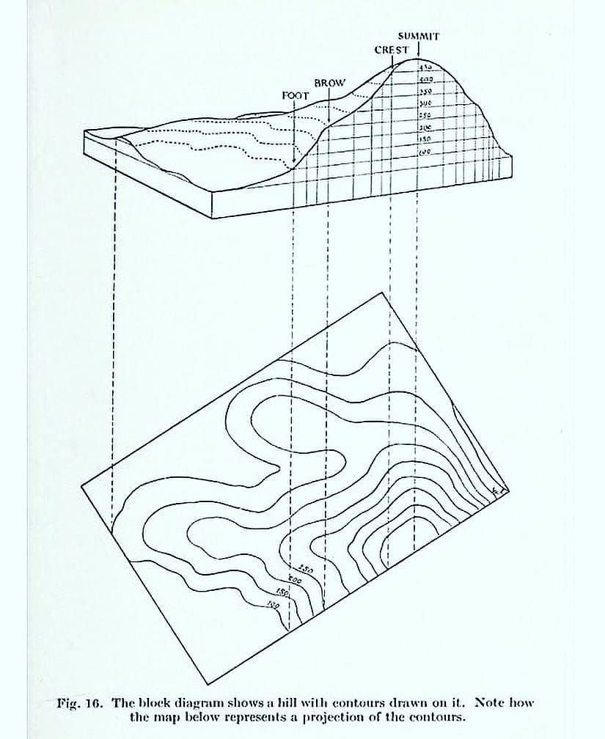
- Contour lines crosses a ridge or a valley at approximate right angles. If the higher values are inwards to the bend or loop in the contour map it represents a ridge and if the higher values are outwards to the bend it represents a valley.
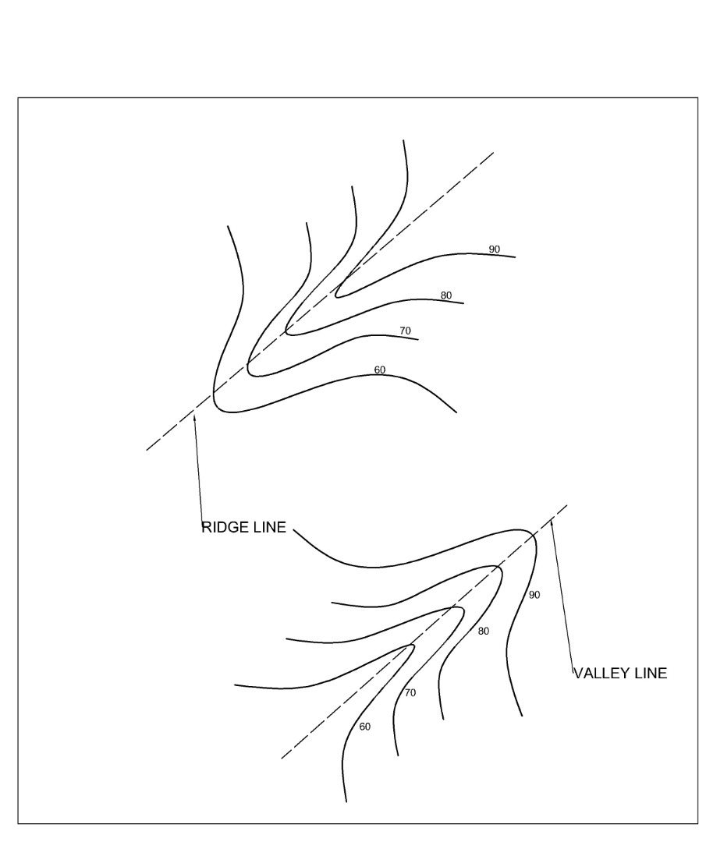
- Contour lines can not merge or cross one-another on a contour map except in the case of an overhanging cliff where the full perimeter of the base is only partially visible from the top.
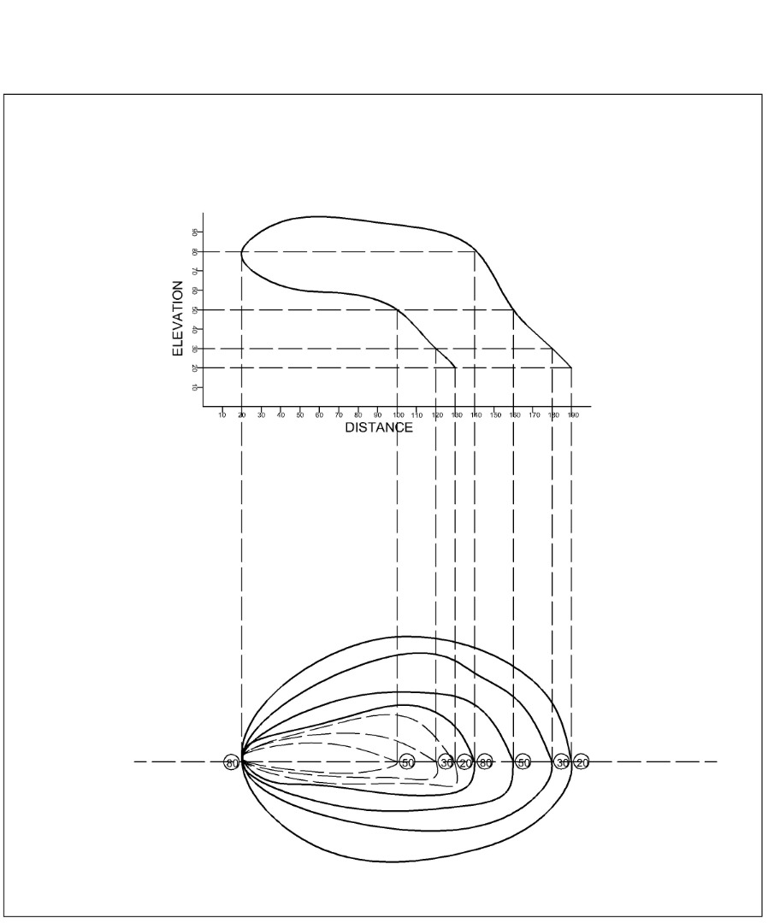
- A series of closed contours on a map indicates a depression if the higher values are outwards as shown.
- A series of closed contours on a map indicates a hill if the higher values are inwards as shown.
