NAME: OKONTE RICHARD-KOKO
MATRIC NO: 15/ENG01/015
DEPARTMENT: CHEMICAL ENGINEERING
COURSE CODE: CHE 574

ASSIGNMENT 1

Question 1 a: With adequate mathematical relations, explain the various forms of energy
- Electrical energy: This is energy derived from electric potential energy or kinetic energy. When used loosely, electrical energy refers to energy that has been converted from electric potential energy. This energy is supplied by the combination of electric current and electric potential that is delivered by an electrical circuit (e.g., provided by an electric power utility). At the point that this electric potential energy has been converted to another type of energy, it ceases to be electric potential energy. Thus, all electrical energy is potential energy before it is delivered to the end-use. Once converted from potential energy, electrical energy can always be called another type of energy (heat, light, motion, etc.). Electrical energy is usually sold by the kilowatt hour (1 kW·h = 3.6 MJ) which is the product of the power in kilowatts multiplied by running time in hours. The mathematical expression for electrical energy in a conducting circuit
$$Energy=Power×Time$$ | (1-1)
$$Power=V×I; Power=I^{2}×R$$ | (1-2)
$$Energy=V×I×T; Energy=I^{2}×R×T$$ | (1-3)
Where I= Current in amps
V= Voltage in volts
R = Resistance in ohms
T= Electricity flow in seconds
E= Amount of electrical energy in the system, in joules.

- Thermal energy: This refers to several distinct physical concepts, such as the internal energy of a system; heat or sensible heat, which are defined as types of energy transfer (as is work); or for the characteristic energy of a degree of freedom in a thermal system.
$$Q=MC_{p}(T_{f}-T_{i})$$ | (1-4)
Where Q= Heat transfer energy
M= Mass
Cp= Specific heat capacity
T_{f}= Final temperature
T_{i} = Initial temperature

- Radiant energy: This is the energy of electromagnetic and gravitational radiation. As energy, its SI unit is the joule (J). The quantity of radiant energy may be calculated by integrating radiant flux (or power) with respect to time.
$$F=σT^{4}; F=\frac{P}{A}; \frac{P}{A}=σT^{4}$$ | (1-5)
Where F = Energy flux
P = Net radiated power
A = Radiating area
=Stephan-Boltzmann constant
T= Temperature

- Gravitational energy: This is the potential energy a physical object with mass has in relation to another massive object due to gravity. It is potential energy associated with the gravitational field. Gravitational energy is dependent on the masses of two bodies, their distance apart and the gravitational constant (G). In everyday cases (i.e. close to the Earth's surface), the gravitational field is considered to be constant. For such scenarios the Newtonian formula for potential energy can be reduced to:
$$U=\frac{GMm}{r}$$ | (1-6)
Where U= Gravitational potential energy
G= Universal gravitational constant
M= Mass of the body
m= Mass of the body
r = Distance of the body from the centre of the earth

- Mechanical energy is the sum of potential energy and kinetic energy. It is the macroscopic energy associated with a system. The principle of conservation of mechanical energy states that in an isolated system that is only subject to conservative forces, the mechanical energy is constant. If an object moves in the opposite direction of a conservative net force, the potential energy will increase; and if the speed (not the velocity) of the object changes, the kinetic energy of the object also changes. In all real systems, however, nonconservative forces, such as frictional forces, will be present, but if they are of negligible magnitude, the mechanical energy changes little and its conservation is a useful approximation. Mathematically,
Mechanical energy = P.E + K.E
Potential energy (P.E) -This energy depends on the position of an object subjected to a conservative force. It is defined as the object's ability to do work and is increased as the object is moved in the opposite direction of the direction of the force

$$P.E=m*g*h$$ | (1-7)
Where m= Mass in kilogram
G=Gravity due to acceleration
H = Height in metres
Kinetic energy (K.E)- This energy depends on the motion of an object.
$$K.E=\frac{1}{2}mv^{2}$$ | (1-8)
Where m = Mass of the object in kg
V = Velocity of the moving object in m/s

- Sound energy: This is a form of energy that can be heard by humans. Sound is a mechanical wave and as such consists physically in oscillatory elastic compression and in oscillatory displacement of a fluid. The medium acts as a storage for both potential and kinetic energy
Consequently, the sound energy in a volume of interest is defined as the sum of the potential and kinetic energy densities integrated over that volume:
$$W=W_{potential}+W_{Kinetic}=\int_{v}{\frac{p^{2}}{2p_{0}c^{2}}dV+}\int_{v}{\frac{{pv}^{2}}{2}dV}$$ | (1-9)
Where
V is the volume of interest;
p is the sound pressure;
v is the particle velocity;
ρ₀ is the density of the medium without sound present;
ρ is the local density of the medium;
c is the speed of sound. ea of a sphere)

- Chemical energy: This is the potential of a chemical substance to undergo a chemical reaction to transform into other substances. Examples include batteries, food, gasoline, and etc. Breaking or making of chemical bonds involves energy, which may be either absorbed or evolved from a chemical system. Energy that can be released or absorbed because of a reaction between a set of chemical substances is equal to the difference between the energy content of the products and the reactants, if the initial and final temperatures are the same. This change in energy can be estimated from the bond energies of the various chemical bonds in the reactants and products. Mathematically,
$$dU=TdS-PdV+\sum_{i=1}^{n}{μ_{i}dN_{i}}$$ | (1-10)
Where
dU = infinitesimal change of internal energy U,
dS = infinitesimal change of entropy S, and
dV = infinitesimal change of volume V for a thermodynamic system in thermal equilibrium
dNi = infinitesimal change of particle number Ni of species i as particles are added or subtracted.
T = absolute temperature
S = entropy,
P = pressure
V =volume

- Nuclear energy: This is energy that comes from a nucleus, the core of an atom. Atoms are particles that make up every object; and there exists a lot of energy (binding forces) which holds these atoms together. Nuclear energy can be used to make electricity, but for this to happen the energy has to be released from atoms. Nuclear energy harvests the powerful energy in the nucleus, or core, of an atom. Nuclear energy is released through nuclear fission, the process where the nucleus of an atom splits. Nuclear power plants are complex machines that can control nuclear fission to produce electricity. The material most often used in nuclear power plants is the element uranium. Although uranium is found in rocks all over the world, nuclear power plants usually use a very rare type of uranium, U-235. Uranium is a non-renewable resource. Mathematically one of the laws of the universe is that matter and energy can neither be created nor destroyed. But they can be changed in form. Matter can be changed into energy. Albert Einstein’s famous mathematical formula below explains this:
$$E=mc^{2}$$ | (1-11)
Where
E =energy
m =mass
c= speed or velocity of light. This means that it is mass multiplied by the square of the velocity of light.

Question 1b: Distinguish between the sustainable energy and resources and non-sustainable energy and resources
Sustainable energy- This refers to the form of energy that meet our today’s demand of energy and will be available for future generation without putting them in danger of getting expired or depleted. This form of energy is widely encouraged as it does not cause any harm to the environment and is available widely free of cost. All renewable energy sources like solar, wind, geothermal, hydropower and ocean energy are sustainable as they are stable and available in plenty. For example, the sun will continue to provide sunlight till we all are here on earth, heat caused by sun will continue to produce winds, earth will continue to produce heat from inside and will not cool down anytime soon, movement of earth, sun and moon will not stop and this will keep on producing tides and the process of evaporation will cause water to evaporate that will fall down in the form of rain or ice which will go through rivers or streams and merge in the oceans and can be used to produce energy through hydropower. This clearly states that all these renewable energy sources are sustainable and will continue to provide energy to the coming generations. There are many forms of sustainable energy sources that can be incorporated by countries to stop the use of fossil fuels. Sustainable energy does not include any sources that are derived from fossil fuels or waste products. This energy is replenishable and helps us to reduce greenhouse gas emissions and causes no damage to the environment.
Non-sustainable energy -This refers to the energy which cannot be readily replaced by a natural means at a quick pace to keep up with its consumption. Resources which are considered as non-sustainable are earth minerals, metal ores, fossil fuels (local petroleum and natural gas) and ground water in certain aquifers. These energies are not eco-friendly because when turned they create pollution and carbon dioxide. Resources such as timber (when harvested sustainably) and wind (used to power energy conversion systems) are considered renewable resources, largely because their localized replenishment can occur within time frames meaningful to humans as well.

Question 2: With the aid of appropriate pie chart or bar chart briefly discuss the typical energy resource mix for sustainable energy development and provide your own view the case for the Nigerian environment

Integrating all exploitable energy sources is a viable way of achieving stability in energy supply as no single energy resource can sustainably meet the energy demands of any country. In Nigeria, energy availability, economic growth and sustainable development are grossly inseparable. Research indicates that the residential energy consumption is highest (53%), followed by commercial energy consumption (25%) and then, the industrial energy consumption (22%).
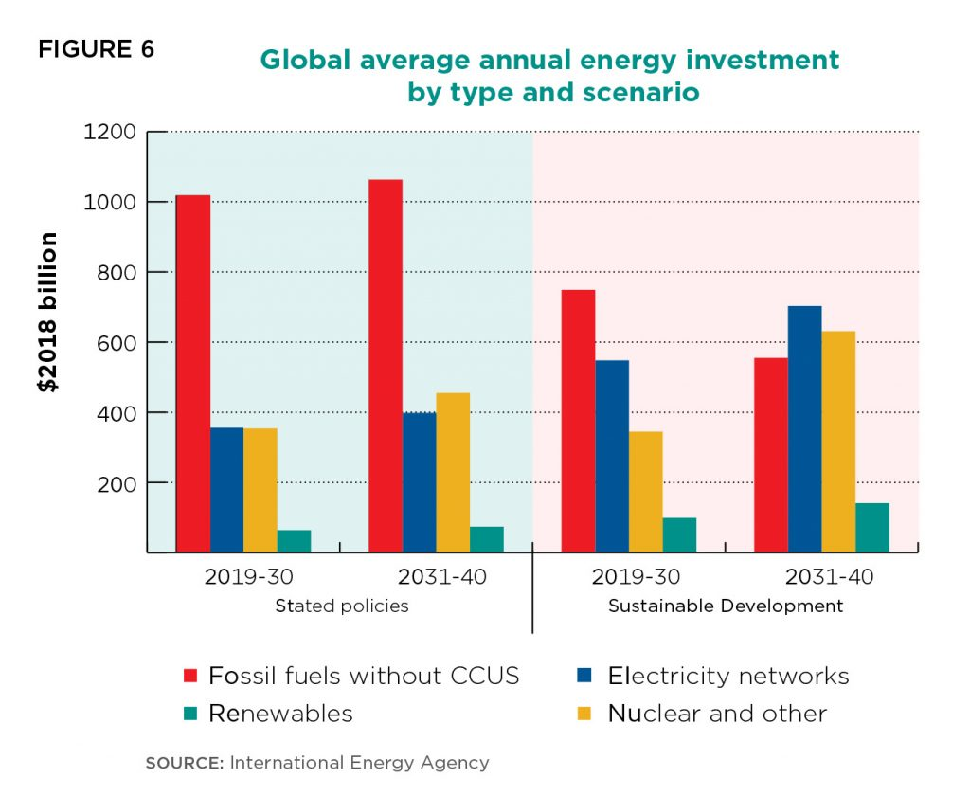
The energy sources should be diversified and power to good use in various sectors since power failure is a regular occurrence in Nigeria with attendant negative impact on the quality of living and business productivity, a new approach to electricity generation in which a mix of several energy sources including renewable sources is optimally utilized should be vigorously pursued and adopted. Also, the utilization of renewable energy technologies especially solar energy to provide off-grid electricity to remote communities should be intensified. Further research and development in the energy sector should be encouraged, especially renewable energy to increase energy sources and improve energy management systems that will promote sustainable development. There should also be an increase in the funding of the energy sector. The government should properly allocate the funds for each source energy and release these funds accordingly.
Nigeria is endowed with many energy resources, such as the renewable energy which when properly utilized or harnessed can enhance the socio-economic development of the nation. The strategies as enumerated above should be employed to optimally exploit these energy resources in full for national development creation of opportunities for investments and businesses in the energy sector.

ASSIGNMENT 2

Question 1: Estimate the average daily thermal energy from the sun reaching land
Monday
$$Q=P*∆T$$ | (2-1)
$$P=\frac{1.4×1300000×10}{0.991}=18365287.59W$$ | (2-2)
$$∆T=6hrs=6×3600=21600secs$$ | (2-3)
$$Q=18365287.59×21600=396700MJ$$ | (2-4)
Tuesday
$$P=\frac{1.4×1300000×11}{0.991}=20201816.35W$$ | (2-5)
$$Q=20201816.35×21600=436300MJ$$ | (2-6)

Wednesday
$$P=\frac{1.4×1300000×10}{0.991}=18365287.59W$$ | (2-7)
$$Q=18365287.59×21600=396700MJ$$ | (2-8)

Thursday
$$P=\frac{1.4×1300000×10}{0.991}=20201816.35W$$ | (2-9)
$$Q=20201816.35×21600=436300MJ$$ | (2-10)

Friday
$$P=\frac{1.4×1300000×12}{0.991}=22038345.11W$$ | (2-11)
$$Q=22038345.11×21600=476000MJ$$ | (2-12)
AVERAGE
$$Average=\frac{396700+436300+396700+436300+476000}{5}=420460MJ$$ | (2-13)

The average daily thermal energy reaching the sun from the sun is 420460MJ

Question 1b : Monitor the average ambient temperature between on Monday, 17th and Friday, 21st of February 2020 and
DAY | AMBIENT TEMPERATURE
 | DAY | NIGHT
Monday | 35˚C | 25 ˚C
Tuesday | 36 ˚C | 25 ˚C
Wednesday | 35 ˚C | 25 ˚C
Thursday | 36 ˚C | 25 ˚C
Friday | 37 ˚C | 25 ˚C
$$P=\frac{∆Q}{∆t}; P=\frac{K×A×∆T}{L}; Q=P×∆t$$ | (2-14)
Where
P = Rate of energy transfer in watts
Q = Energy transfer in J
∆t = Change in time in secs
K = Thermal conductivity
A= Area in m²
L= Thickness of material
∆T= Difference in temperature
Assumptions:
K air at (35 ˚C -37 ˚C) = 1.4
A = Area of land in ABUAD =1300000m²
L= Average thickness = 0.991m
FOR:
Monday ∆T = 35-25 =10 ˚C
Tuesday ∆T = 36-25 =11 ˚C
Wednesday ∆T =35-25 =10 ˚C
Thursday ∆T =36-25 =11 ˚C
Friday ∆T = 37-25=12 ˚C

Question 2 : With the aid of a beautiful diagram ONLY, describe anemometer.
An anemometer is a device for measuring the speed of airflow in the atmosphere, in wind tunnels, and in other gas-flow applications. Most widely used for wind-speed measurements is the revolving-cup electric anemometer, in which the revolving cups drive an electric generator. The output of the generator operates an electric meter that is calibrated in wind speed. The useful range of this device is approximately from 5 to 100 knots. A propeller may also be used to drive the electric generator, as in the propeller anemometer. In another type of wind-driven unit, revolving vanes operate a counter, the revolutions being timed by a stopwatch and converted to airspeed. This device is especially suited for the measurement of low airspeeds.
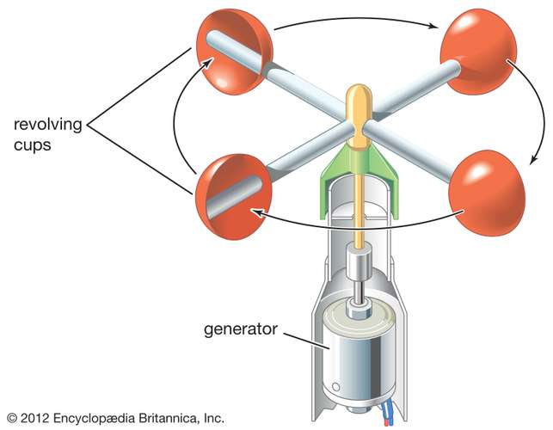
Figure 2-1: Diagram of an anemometer

ASSIGNMENT 3

Question 1: How much energy is being produced from the dams in Nigeria? Compare with the energy produced from crude.
Currently, the national energy consumption mix is dominated by oil, which is approximately 53 percent, seconded by natural gas which approximates to 39 percent and then hydroelectricity that is almost 7 percent.
HYDROPOWER
Nigeria is bestowed with large rivers and natural falls. The main water resources that provide rich hydropower potential are the Niger and Benue rivers as well as Lake Chad basin. Several small rivers and streams also provide opportunities for small-scale (less than 10MW) hydropower projects. With an estimated 1,800 m3 per capita per year of renewable water resources available, Nigerian’s Hydro Potential is high and hydropower currently accounts for about 32% of the total installed commercial electric power capacity. The overall large-scale potential (exploitable) is in excess of 11,000MW. Likewise, estimate of exploitable small-scale hydropower potential is at 734MW. Small hydropower plants for electricity provision are suitable in remote areas. Total hydro stations installed capacity= kanji installed capacity+ shiroro installed capacity+ jebba installed capacity. Thus, total hydro stations installed capacity = 760 + 600 +578.4 = 1938.4 MW. The total hydro stations installed capacity is 1938.4MW. From the total installed capacities obtained, it has been ascertained that 33% of the installed capacity is from hydro power stations and this is also the percentage overall input of the hydro power stations to the national electricity generation.
CRUDE OIL
Nigeria's petroleum industry is well grounded in successful exploration, beginning with the first commercially viable discovery at Oloibiri in the Niger Delta in 1956, with a modest production rate of 5,100 barrels per day. Reserves of crude oil stand at 28.2 billion barrels. Natural gas reserves total 165 trillion standard cubic feet (scf), including 75.4 trillion scf of non-associated gas. Oil has been dominant in the energy scene of the country at all levels of economic activities

