NAME: Festus-Ifode Ewomaoghene Chidera
Matric No: 18/MHS01/163
Department: Anatomy
Course Code: ANA212
Question
With the aid of a diagram, discuss the gross anatomy of the female external genitalia.

Answers
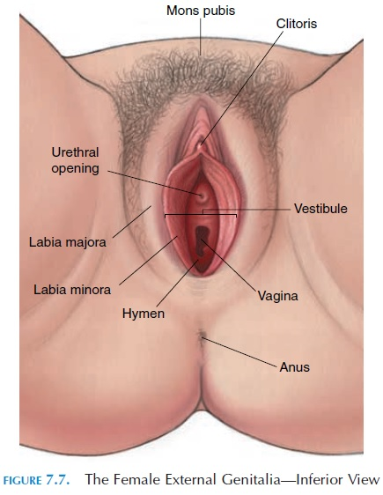
The external genitalia are the accessory structures of the female reproductive system that are external to the vagina. They are also called the pudendum or vulva. These include the mons pubis, clitoris, vestibule, the vaginal opening, labia majora, labia minora, urethral opening.

The Mons Pubis: The mons pubis is the rounded eminence, made by fatty tissue beneath the skin, lying in front of the pubic symphysis. A few fine hairs may be present in childhood; later, at puberty, they become coarser and more numerous. The upper limit of the hairy region is horizontal across the lower abdomen.
The Labia Majora : The labia majora are two marked folds of skin that extend from the mons pubis downward and backward to merge with the skin of the perineum. They form the lateral boundaries of the vulval or pudendal cleft, which receives the openings of the vagina and the urethra. The outer surface of each labium is pigmented and hairy; the inner surface is smooth but possesses sebaceous glands. The labia majora contain fat and loose connective tissue and sweat glands.
The Labia Minora: The labia minora are two small folds of skin, lacking fatty tissue, that extend backward on each side of the opening into the vagina. They lie inside the labia majora and are some 4 cm in length.
The Clitoris: The clitoris is a small erectile structure composed of two corpora cavernosa separated by a partition. Partially concealed beneath the forward ends of the labia minora, it possesses a sensitive tip of spongy erectile tissue, the glans clitoriis. The external opening of the urethra is some 2.5 cm behind the clitoris and immediately in front of the vaginal opening.
The utheral opening: The female external urethral orifice is the external opening of the urethra, from which urine is ejected during urination. It is located about 2.5 cm (0.98 in) behind form of a short, sagittal cleft with slightly raised margins
The Hymen: The hymen is a thin piece of mucosal tissue that surrounds or partially covers the external vaginal opening. It forms part of the vulva, or external genitalia, and is similar in structure to the vagina. The hymen is rich in nerve endings. Tearing the hymen during the first sexual intercourse usually causes pain and, sometimes, some light bleeding

