NAME: SEIGHA EBIFAGHA GLORY
DEPARTMENT: ANATOMY
COLLEGE: NHS
MATRIC NO: 18/MHS03/014
LEVEL: 200
COURSE: ANA 212

With the aid of diagram, discuss the gross anatomy of the female external genitalia

The external genital organs include the mons pubis, labia majora, labia minora, Bartholin glands, and clitoris. The area containing these organs is called the vulva.
The external genital organs have three main functions:
- Enabling sperm to enter the body
- Protecting the internal genital organs from infectious organisms
- Providing sexual pleasure
The mons pubis is a rounded mound of fatty tissue that covers the pubic bone. During puberty, it becomes covered with hair. The mons pubis contains oil-secreting (sebaceous) glands that release substances that are involved in sexual attraction (pheromones).
The labia majora (literally, large lips) are relatively large, fleshy folds of tissue that enclose and protect the other external genital organs. They are comparable to the scrotum in males. The labia majora contain sweat and sebaceous glands, which produce lubricating secretions. During puberty, hair appears on the labia majora.
The labia minora (literally, small lips) can be very small or up to 2 inches wide. The labia minora lie just inside the labia majora and surround the openings to the vagina and urethra. A rich supply of blood vessels gives the labia minora a pink color. During sexual stimulation, these blood vessels become engorged with blood, causing the labia minora to swell and become more sensitive to stimulation.

External Female Genital Organs
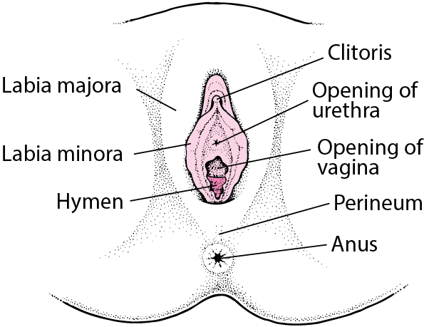
The area between the opening of the vagina and the anus, below the labia majora, is called the perineum. It varies in length from almost 1 to more than 2 inches (2 to 5 centimeters).
The labia majora and the perineum are covered with skin similar to that on the rest of the body. In contrast, the labia minora are lined with a mucous membrane, whose surface is kept moist by fluid secreted by specialized cells.
The opening to the vagina is called the introitus. The vaginal opening is the entryway for the penis during sexual intercourse and the exit for blood during menstruation and for the baby during birth.
When stimulated, Bartholin glands (located beside the vaginal opening) secrete a thick fluid that supplies lubrication for intercourse.
The opening to the urethra, which carries urine from the bladder to the outside, is located above and in front of the vaginal opening.
The clitoris, located between the labia minora at their upper end, is a small protrusion that corresponds to the penis in the male. The clitoris, like the penis, is very sensitive to sexual stimulation and can become erect. Stimulating the clitoris can result in an orgasm.

