NAME: ADEBIYI ITUNUNOLUWA ISAAC
MATRIC NO: 18/MHS01/013
DEPARTMENT: ANATOMY
COURSE: ANA 212

QUESTION: With the aid of diagram, discuss the gross anatomy of the female external genitalia
1.
The external female reproductive structures are referred to collectively as the vulva (Figure 2). The mons pubis is a pad of fat that is located at the anterior, over the pubic bone. After puberty, it becomes covered in pubic hair. The labia majora (labia = “lips”; majora = “larger”) are folds of hair-covered skin that begin just posterior to the mons pubis. The thinner and more pigmented labia minora (labia = “lips”; minora = “smaller”) extend medial to the labia majora. Although they naturally vary in shape and size from woman to woman, the labia minora serve to protect the female urethra and the entrance to the female reproductive tract.
The superior, anterior portions of the labia minora come together to encircle the clitoris (or glans clitoris), an organ that originates from the same cells as the glans penis and has abundant nerves that make it important in sexual sensation and orgasm. The hymen is a thin membrane that sometimes partially covers the entrance to the vagina. An intact hymen cannot be used as an indication of “virginity”; even at birth, this is only a partial membrane, as menstrual fluid and other secretions must be able to exit the body, regardless of penile–vaginal intercourse. The vaginal opening is located between the opening of the urethra and the anus. It is flanked by outlets to the Bartholin’s glands (or greater vestibular glands).
DIAGRAM
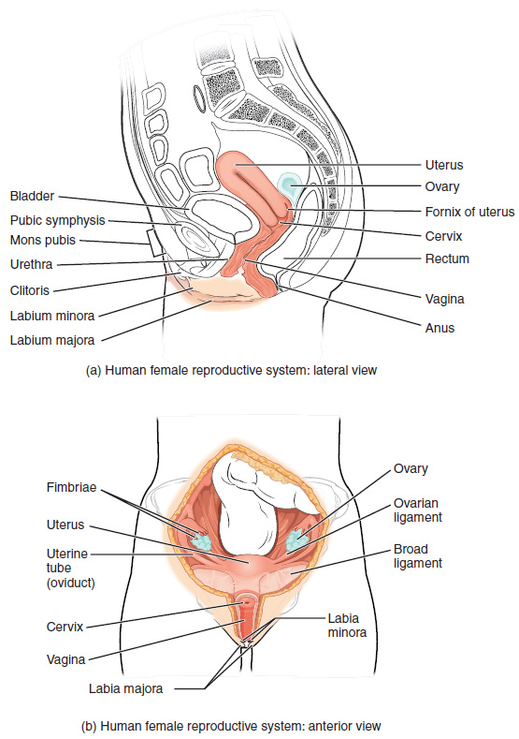
Figure 1. Female Reproductive System. The major organs of the female reproductive system are located inside the pelvic cavity.
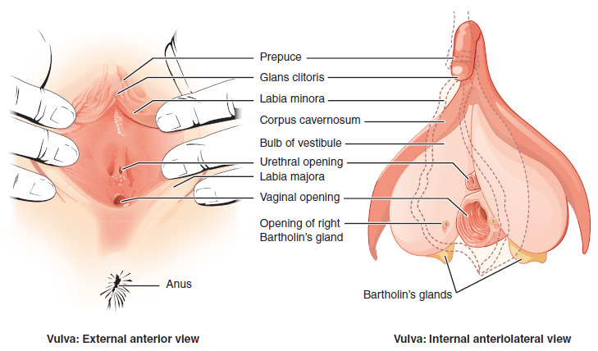Figure 2. The Vulva. The external female genitalia are referred to collectively as the vulva.

VAGINA
The vagina, shown at the bottom of Figure 1 and Figure 1, is a muscular canal (approximately 10 cm long) that serves as the entrance to the reproductive tract. It also serves as the exit from the uterus during menses and childbirth. The outer walls of the anterior and posterior vagina are formed into longitudinal columns, or ridges, and the superior portion of the vagina—called the fornix—meets the protruding uterine cervix. The walls of the vagina are lined with an outer, fibrous adventitia; a middle layer of smooth muscle; and an inner mucous membrane with transverse folds called rugae. Together, the middle and inner layers allow the expansion of the vagina to accommodate intercourse and childbirth. The thin, perforated hymen can partially surround the opening to the vaginal orifice. The hymen can be ruptured with strenuous physical exercise, penile–vaginal intercourse, and childbirth. The Bartholin’s glands and the lesser vestibular glands (located near the clitoris) secrete mucus, which keeps the vestibular area moist.
The vagina is home to a normal population of microorganisms that help to protect against infection by pathogenic bacteria, yeast, or other organisms that can enter the vagina. In a healthy woman, the most predominant type of vaginal bacteria is from the genus Lactobacillus. This family of beneficial bacterial flora secretes lactic acid, and thus protects the vagina by maintaining an acidic pH (below 4.5). Potential pathogens are less likely to survive in these acidic conditions. Lactic acid, in combination with other vaginal secretions, makes the vagina a self-cleansing organ. However, douching—or washing out the vagina with fluid—can disrupt the normal balance of healthy microorganisms, and actually increase a woman’s risk for infections and irritation. Indeed, the American College of Obstetricians and Gynecologists recommend that women do not douche, and that they allow the vagina to maintain its normal healthy population of protective microbial flora.

OVARIES
The ovaries are the female gonads (see Figure 1). Paired ovals, they are each about 2 to 3 cm in length, about the size of an almond. The ovaries are located within the pelvic cavity, and are supported by the mesovarium, an extension of the peritoneum that connects the ovaries to the broad ligament. Extending from the mesovarium itself is the suspensory ligament that contains the ovarian blood and lymph vessels. Finally, the ovary itself is attached to the uterus via the ovarian ligament.
The ovary comprises an outer covering of cuboidal epithelium called the ovarian surface epithelium that is superficial to a dense connective tissue covering called the tunica albuginea. Beneath the tunica albuginea is the cortex, or outer portion, of the organ. The cortex is composed of a tissue framework called the ovarian stroma that forms the bulk of the adult ovary. Oocytes develop within the outer layer of this stroma, each surrounded by supporting cells. This grouping of an oocyte and its supporting cells is called a follicle. The growth and development of ovarian follicles will be described shortly. Beneath the cortex lies the inner ovarian medulla, the site of blood vessels, lymph vessels, and the nerves of the ovary. You will learn more about the overall anatomy of the female reproductive system at the end of this section.

THE OVARIAN CYCLE
The ovarian cycle is a set of predictable changes in a female’s oocytes and ovarian follicles. During a woman’s reproductive years, it is a roughly 28-day cycle that can be correlated with, but is not the same as, the menstrual cycle (discussed shortly). The cycle includes two interrelated processes: oogenesis (the production of female gametes) and folliculogenesis (the growth and development of ovarian follicles).
REFRENCES:
https://opentextbc.ca/anatomyandphysiology/chapter/27-2-anatomy-and-physiology-of-the-female-reproductive-system/

