NAME: OGUNNIKE IYANUOLUWA.O
MATRIC NO: 18/MHS05/011
COURSE: ANA 206
DEPARTMENT: PHYSIOLOGY
COLLEGE: MHS

QUESTION
Write notes on the following;
- Development of the lungs
- Rotation of the stomach and the formation of the omental bursa.
- Development of the esophagus.

- DEVELOPMENT OF THE LUNGS
The lungs is derived from ectoderm, while the pulmonary blood vessels, smooth muscle, cartilage and other connective tissues are derived from the mesoderm. The development of the lungs can be divided into two phases:
- Lung growth (structural development)
- Lung maturation (functional development)
Development of the lungs proceeds through gestation. There is a progressive branching of the airways and finally development of alveolar spaces capable of gas exchange in the last trimester. There are five phases of structural lung development that occur at progressive times during gestation:
- The embryonic stage
It is apparent in the 3 weeks embryo. The lung bud develops from the foregut and in communication with it. Separation of the two lung buds takes place with fusion of the esophagotracheal ridges to form the esophagotrcheal septum. When its 5 weeks old, two primary lung buds are identifiable and go to form their first subdivisions, with 3 lobar buds developing in the right lung bud and 2 lobar buds developing in the left. By the 8th week, the lobar buds subdivides and form the bronchopulmonary segments.
- The pseudoglandular stage
Takes place from the 7th to the 16th week of embryonic development. Conducting airways are formed by progressive branching. Endodermal lung buds undergo branching only if they are exposed to bronchial mesoderm. All bronchial airways are formed by the 16th week. During this stage, the first differentiation of lung epithelium occurs. By the 13th week, cilia appears in the proximal airways.

- The canalicular stage
Takes place between the 16th to 25th week of development. The gas exchanging portion of the lung is formed by now and highly vascularized. Capillaries begins to grow in close proximity to the distal surface of the alveolar cells. At the same time, there is appearance of lamellar bodies, which is the site of surfactant storage, prior to its release into the alveolar space.

- The saccular stage
Also called the terminal stage. It occurs at the 26th week till term. At this stage, saccules form, there is decrease in interstitial tissue and a thinning of the airspace.

- The alveolar stage
Also called the postnatal stage. The saccules continue to mature.
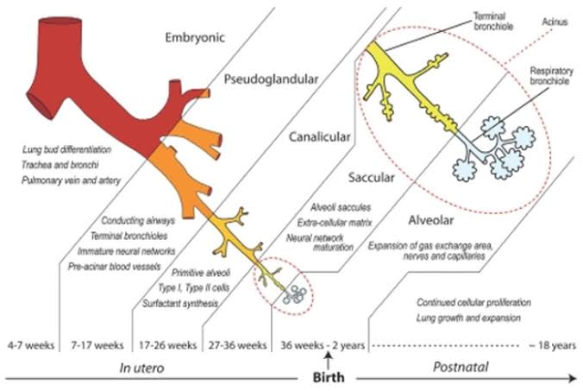
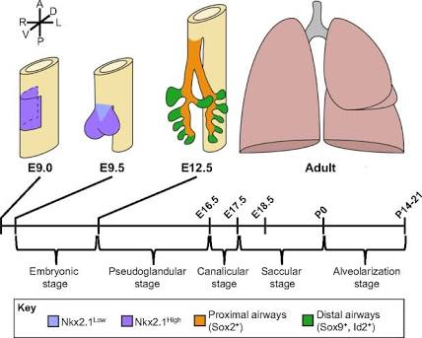

- ROTATION OF THE STOMACH AND FORMATION OF THE OMENTAL BURSA
- During the development, the stomach rotates 90 in a clockwise direction along its longitudinal axis.
- The ventral border moves to the right and the dorsal border to the left, making the initial left side become the ventral surface and the initial right side become the dorsal surface.
- The left vagus nerve which originally innervates the left side now innervates the anterior side and the right vagus nerve now innervates posterior side.
- During rotation, the cardiac portion moves to the left and slightly downwards, while the pyloric part moves to the right and upward.
- this rotation forms the omental bursa which is also called the lesser peritoneal sac.
- The stomach assumes its final position with its long axis almost transverse to the long axis of the body after the rotation.
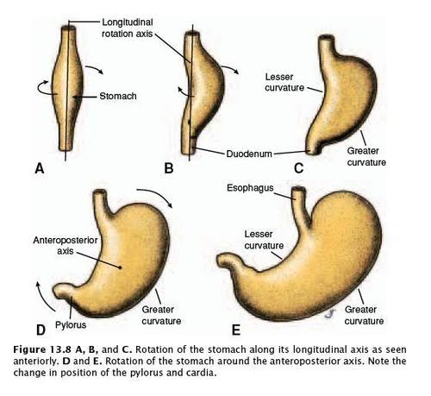
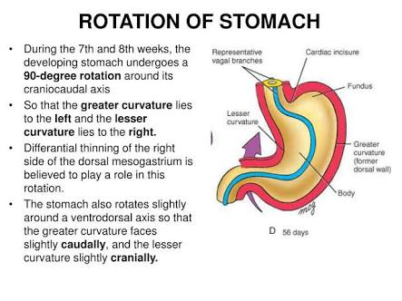
FORMATION OF THE OMENTAL BURSA
The omental bursa is a hollow space that is formed by the greater and lesser omentum and its adjacent organs. It communicates with the greater sac through the epiploic foramen of winslow, known as the general cavity of the abdomen that sits within the peritoneum, but outside the lesser sac.
- Anteriorly, it is surrounded by the quadrate lobe of liver, the gastrocolic ligament and the lesser omentum.
- By the left, it is formed by the left kidney, left adrenal gland
- By the right, it is formed by the epiploic foramen, lesser omentum and the greater sac
- Posteriorly, it is surrounded by the pancreas.
During embryonic development, the peritoneum is anchored to the gut in the midline of the abdomen anteriorly, with the dorsal mesentery securing it posteriorly. The mesenteric layers develop in an anterior direction carrying the blood supply and creating ventral mesentery.
Due to the growth of the organs, they gradually become larger and have to shift in order to fit in the abdominal cavity. The stomach rotates, the spleen is displaced and the liver moves to the right. The peritoneum twists with these movements which leads to the formation of the falciform ligament, the coronary ligaments of the liver and the lesser omentum. Throughout this process, the cavity of the lesser sac is formed.
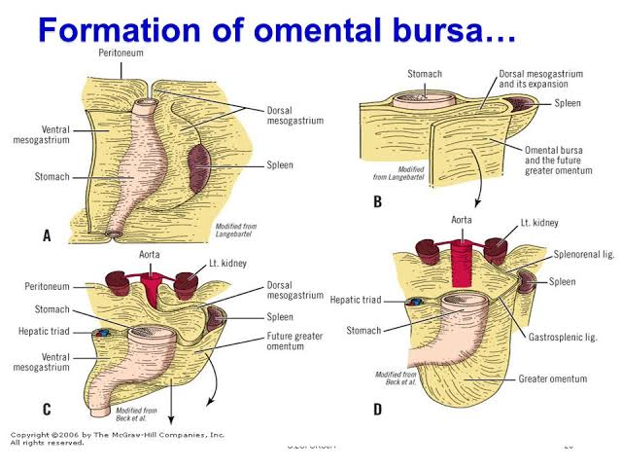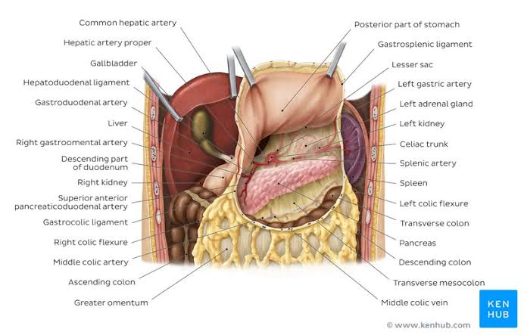
- DEVELOPMENT OF THE ESOPHAGUS
- In early embryogenesis, the esophagus develops from the endodermal primitive gut tube.
- The ventral part of the embryo abuts the yolk sac
- During the second week of embryonic development, as the embryo grows, it begins to surround the parts of the sac.
- The enveloped portions form the basis for the adult gastrointestinal tract.
- This sac is surrounded by a network of vitelline arteries which consolidate into three main arteries supplying the developing gastrointestinal tract. These arteries are: the celiac artery, the superior mesenteric artery and the mesenteric artery.
- This surrounded sac becomes the primitive gut which differentiates into esophagus, stomach and intestines.
- The esophagus develops as part of the foregut tube
- The innervation of the esophagus develops from the pharyngeal arches.
