Integrated CAD/CAM-systems are employed to achieve computer-aided integration in all production functions, from design and planning up to manufacturing and the assurance of quality standards. So far, however, overall integration of this kind has hardly been put into practice. This applies particularly to the medium and small batch production of the machine-building industry *). At present various concepts of CAD/CAM integration which complement or overlap each other, often to the extent of operating concurrently in the case of implementation, can be discerned. On the one hand, concepts are concerned with the integration of design functions with planning, controlling and programming functions (CAD/CAP). On the other hand, they are concerned with the integration of manufacturing functions with planning, controlling and programming functions (DNC). Overall computer-aided integration, from design through to manufacturing, has only been conceived for a small number of product elements and limited manufacturing processes so far.

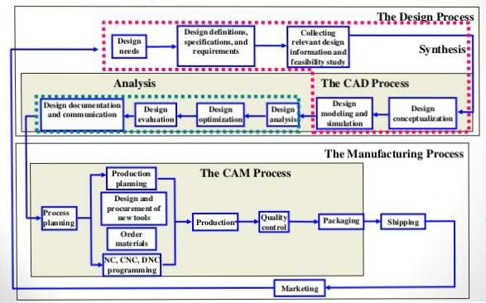

A) Efficiency-An Erricient software is that

which can usc less resources such as CPU in
tenns oftime and usage to give a better output.

B)

Simplicity-A soi\ware must be simple to usE
and easy to understand and must bc bc user
friendly.

C)

Flexibility-Thc software must be abic to
incorporate thc design modification with out
much of difficulty.

D)

Readability-This provides the capability
within the software to help the user as and
when required.

E)

Portability :-The software must have the
capacity to gct transfclTcd from onc system to
other.

F) Reliability-To avoid causality the software

must be able to avoid unwanted operation.

G)

Recover abiliw-A Good software must be
able to giv e w amings before getting crashed
and must bc abic to recover.

1. System Software: System software or operating system is the software used by the computer to translate inputs from various sources into a language which a machine can understand. Basically, the OS coordinates the different hardware components of a computer. There are many OS in the market. The most popular Os are from the stable of Microsoft. We have all heard, used and wondered at the Windows software, which is an OS. Starting with Windows, Microsoft has migrated to Vista, its latest offering in the market. It may come as a surprise to some that there are other operating systems used by others. Among these UNIX is used for large office setups with extensive networking. XENIX is software which has now become redundant. HP -UX and AIX are some operating systems used by HP computers. Apache OS is quite popular with web servers. IBM still uses proprietary operating systems for its main frames. Proprietary systems are generally built with the help of a variant of UNIX operating system.

2. Application software: A normal user rarely gets to see the operating system or to work with it. But all of us are familiar with application software which we must use to interact with a computer. Popular examples of application software are the Microsoft office suite which includes Word, Excel and PowerPoint. We have used these applications extensively. Internet explorer, Mozilla Firefox is two applications used to access the internet. E-mail software like Outlook express is used to manage Emails. It is obvious that all software utilized for working on a computer is classified as application software. In fact all user interfaces are an application. The anti-virus is an application and so is the Media player.

3. Programming languages: Now this is a kind of computer software which is used exclusively by computer programmers. Unless we are also programmers, we are unlikely to come across programming languages. A simple way to understand programming languages is to think of them as bricks which can be used to create applications and operating system. C++, Java and Simlab are some popular programming languages. Generally Java is used for internet applications. C++ is a language of professional developers and used extensively in developing operating systems. PHP is another language used for internet applications. There is a new class of languages which are being utilized for the mobiles. These are light weight, modular languages which are used to design mobile applications.

