NAME: UMOH GABRIEL ESSIEN
MATRIC NO: 13/ENG07/020
COURSE: CHE574
QUESTION ONE
A) EXPLANATION OF THE VARIOUS FORMS OF ENERGY
1) Mechanical energy is the sum of potential energy and kinetic energy. It is the energy that is possessed by an object due to its motion or due to its position. Mechanical energy can be either kinetic energy (energy of motion) or potential energy (stored energy of position). Objects have mechanical energy if they are in motion and/or if they are at some position relative to a zero potential energy position (for example, a brick held at a vertical position above the ground or zero height position). A moving car possesses mechanical energy due to its motion (kinetic energy). A moving baseball possesses mechanical energy due to both its high speed (kinetic energy) and its vertical position above the ground (gravitational potential energy). Mathematically:
E _{mechanical} = U+K
The potential energy, U, depends on the position of an object subjected to a conservative force. It is defined as the object's ability to do work and is increased as the object is moved in the opposite direction of the direction of the force If F represents the conservative force and x the position, the potential energy of the force between the two positions x₁ and x₂ is defined as the negative integral of F from x₁ to x₂
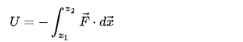
The kinetic energy, K, depends on the speed of an object and is the ability of a moving object to do work on other objects when it collides with them. It is defined as one half the product of the object's mass with the square of its speed, and the total kinetic energy of a system of objects is the sum of the kinetic energies of the respective objects.
K = 1÷2MV²
The principle of conservation of mechanical energy states that if a body or system is subjected only to conservative forces, the mechanical energy of that body or system remains constant. The difference between a conservative and a non-conservative force is that when a conservative force moves an object from one point to another, the work done by the conservative force is independent of the path. On the contrary, when a non-conservative force acts upon an object, the work done by the non-conservative force is dependent of the path.

2.) Electrical energy is a form of energy resulting from the flow of electric charge. Energy is the ability to do work or apply force to move an object. In the case of electrical energy, the force is electrical attraction or repulsion between charged particles. Electrical energy may be either potential energy or kinetic energy, but it's usually encountered as potential energy, which is energy stored due to the relative positions of charged particles or electric fields. The movement of charged particles through a wire or other medium is called current or electricity. There is also static electricity, which results from an imbalance or separation of the positive and negative charges on an object. Static electricity is a form of electrical potential energy. If sufficient charge builds up, the electrical energy may be discharged to form a spark (or even lightning), which has electrical kinetic energy.
The mathematical expression for electrical energy in a conducting circuit is E(e) = P×t = V×I×t. According to this relationship, leaving a 100-watt lightbulb burning for one minute expends 6,000 joules of energy. Where amount of current flowing through a conductor (I) in amperes, as well as on the electrical potential, or voltage (V), driving the current, in volts and the electricity flows (t) in seconds gives the amount of electrical energy in the system, in joules.

3.) Magnetic energy and electrostatic potential energy are related by Maxwell's equations. The potential energy of a magnet of magnetic moment in a magnetic field is defined as the mechanical work of the magnetic force (actually magnetic torque) on the re-alignment of the vector of the magnetic dipole moment and is equal to:
while the energy stored in an inductor (of inductance ) when a current flows through it is given by:

This second expression forms the basis for superconducting magnetic energy storage.
Energy is also stored in a magnetic field. The energy per unit volume in a region of space of permeability containing magnetic field is:

More generally, if we assume that the medium is paramagnetic or diamagnetic so that a linear constitutive equation exists that relates and , then it can be shown that the magnetic field stores an energy of
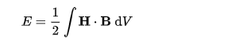

where the integral is evaluated over the entire region where the magnetic field exists

4.) Gravitational energy gravitational energy is energy associated with gravity. It is the potential energy stored by an object because of its higher position compared to a lower position. (e.g. if it's further away or closer to the ground). Systems can increase gravitational energy as mass moves away from the center of the Earth or other objects that are large enough to produce significant amounts of gravity (like our Sun, the planets and stars). The pendulum is a simple machine for transferring gravitational potential energy to kinetic energy, and back again. When the bob is at the highest point of its swing, it has no kinetic energy, but its gravitational potential energy is at a maximum. As the bob swings downwards, gravitational potential energy is transferred to kinetic energy, and the bob accelerates.
At the bottom of its swing, the bob's kinetic energy is at a maximum and its gravitational potential energy is at a minimum.
As the bob swings upwards, its kinetic energy is transferred to gravitational potential energy again. At the top of its swing, it once again has no kinetic energy, but its gravitational potential energy is at a maximum.
Note that the bob's swing will become lower with each swing, because some energy is also transferred as heat to the surroundings.
Mathematically:
U = mgh
where U is the gravitational potential energy, m is the mass, M is the gravitational field, and h is the height. This formula treats the potential energy as a positive quantity
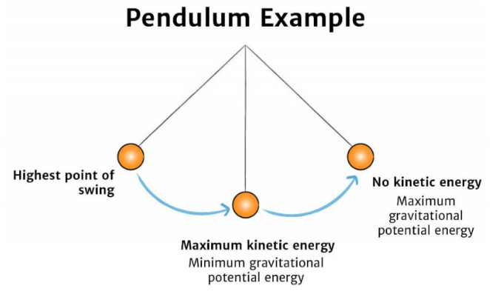
A pendulum converts potential energy from gravity into kinetic energy and back again.

5.) Chemical energy is energy stored in the bonds of chemical compounds, like atoms and molecules. This energy is released when a chemical reaction takes place.
Usually, once chemical energy has been released from a substance, that substance is transformed into a completely new substance.
Mathematically
where dU is the infinitesimal change of internal energy U, dS the infinitesimal change of entropy S, and dV is the infinitesimal change of volume V for a thermodynamic system in thermal equilibrium, and dN_{i} is the infinitesimal change of particle number N_{i} of species i as particles are added or subtracted. T is absolute temperature S is entropy, P is pressure, and V is volume. Other work terms, such as those involving electric,
magnetic or gravitational fields may be added
6.) Ionization energy denoted E_{i}, is the minimum amount of energy required to remove the most loosely bound electron, the valence electron, of an isolated neutral gaseous atom or molecule. It is quantitatively expressed as
X(g) + energy → X⁺(g) + e⁻
where X is any atom or molecule capable of ionization, X⁺ is that atom or molecule with an electron removed, and e⁻ is the removed electron.^{[1]} This is generally an endothermic process. Generally, the closer the outermost electrons to the nucleus of the atom, the higher the atom's or element's ionization energy.
In chemistry, the unit is the amount of energy required for all of the atoms in a mole of substance to lose one electron each: molar ionization energy or enthalpy, expressed as kilojoules per mole (kJ/mol) or kilocalories per mole (kcal/mol).^{[2]}
Comparison of E_{i} of elements in the periodic table reveals two periodic trends:
- E_{i} generally increases as one moves from left to right within a given period (that is, row).
- E_{i} generally decreases as one moves from top to bottom in a given group (that is, column).
The latter trend results from the outer electron shell being progressively farther from the nucleus, with the addition of one inner shell per row as one moves down the column.
The nth ionization energy refers to the amount of energy required to remove an electron from the species having a charge of (n-1). For example, the first three ionization energies are defined as follows:
1st ionization energy
X → X⁺ + e⁻
2nd ionization energy
X⁺ → X²⁺ + e⁻
3rd ionization energy
X²⁺ → X³⁺ + e⁻
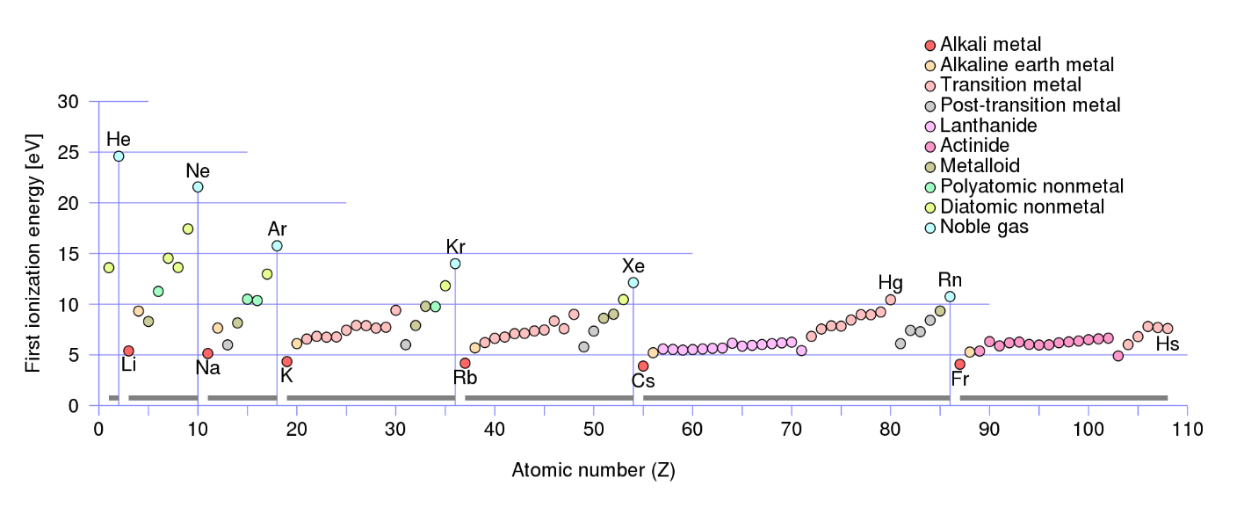
7.) Nuclear energy is energy that comes from a nucleus, the core of an atom. Atoms are particles that make up every object; and there exists a lot of energy (binding forces) which holds these atoms together. Nuclear energy can be used to make electricity, but for this to happen the energy has to be released from atoms. Nuclear energy harvests the powerful energy in the nucleus, or core, of an atom. Nuclear energy is released through nuclear fission, the process where the nucleus of an atom splits. Nuclear power plants are complex machines that can control nuclear fission to produce electricity. The material most often used in nuclear power plants is the element uranium. Although uranium is found in rocks all over the world, nuclear power plants usually use a very rare type of uranium, U-235. Uranium is a non-renewable resource.
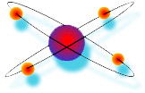
Mathematically one of the laws of the universe is that matter and energy can neither be created nor destroyed. But they can be changed in form. Matter can be changed into energy. Albert Einstein’s famous mathematical formula E = mc² explains this. The equation says: E [energy] equals m [mass] times c² [c stands for the speed or velocity of light]. This means that it is mass multiplied by the square of the velocity of light.
8.) Heat is energy in transfer to or from a thermodynamic system, by mechanisms other than thermodynamic work or transfer of matter. The various mechanisms of energy transfer that define heat are stated in the next section of this article. Like thermodynamic work, heat transfer is a process involving more than one system, not a property of any one system. In thermodynamics, energy transferred as heat (a process function) contributes to change in the system's cardinal energy variable of state, for example its internal energy, or for example its enthalpy. This is to be distinguished from the ordinary language conception of heat as a property of an isolated system. The quantity of energy transferred as heat in a process is the amount of transferred energy excluding any thermodynamic work that was done and any energy contained in matter transferred. For the precise definition of heat, it is necessary that it occur by a path that does not include transfer of matter.
9). Sound energy is a form of energy that can be heard by humans. Sound is a mechanical wave and as such consists physically in oscillatory elastic compression and in oscillatory displacement of a fluid. Therefore, the medium acts as storage for both potential and kinetic energy Consequently, the sound energy in a volume of interest is defined as the sum of the potential and kinetic energy densities integrated over that volume:
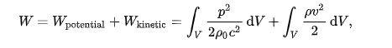
Here:
- V is the volume of interest;
- p is the sound pressure;
- v is the particle velocity;
- ρ₀ is the density of the medium without sound present;
- ρ is the local density of the medium;
- c is the speed of sound.
B) DIFFERENCE BETWEEN SUSTAINABLE ENERGY AND NON SUSTAINABLE ENERGY
I) Sustainable energy is a form of energy that meet our today’s demand of energy without putting them in danger of getting expired or depleted and can be used over and over again. Sustainable energy should be widely encouraged as it do not cause any harm to the environment and is available widely free of cost. All renewable energy sources like solar, wind, geothermal, hydropower and ocean energy are sustainable as they are stable and available in plenty. Sun will continue to provide sunlight till we all are here on earth, heat caused by sun will continue to produce winds, earth will continue to produce heat from inside and will not cool down anytime soon, movement of earth, sun and moon will not stop and this will keep on producing tides and the process of evaporation will cause water to evaporate that will fall down in the form of rain or ice which will go through rivers or streams and merge in the oceans and can be used to produce energy through hydropower. This clearly states that all these renewable energy sources are sustainable and will continue to provide energy to the coming generations. There are many forms of sustainable energy sources that can be incorporated by countries to stop the use of fossil fuels. Sustainable energy does not include any sources that are derived from fossil fuels or waste products. This energy is replenishable and helps us to reduce greenhouse gas emissions and causes no damage to the environment. If we are going to use fossil fuels at a steady rate, they will expire soon and cause adverse effect to our planet
II) Non- Sustainable Energy is a natural resource that cannot be readily replaced by natural means at a quick enough pace to keep up with consumption. An example is carbon-based fossil fuel. The original organic matter, with the aid of heat and pressure, becomes a fuel such as oil or gas. Earth minerals and metal ores, fossil fuels (coal, petroleum, natural gas) and groundwater in certain aquifers are all considered non-renewable resources, though individual elements are always conserved (except in nuclear reactions).
Conversely, resources such as timber (when harvested sustainably) and wind (used to power energy conversion systems) are considered renewable resources, largely because their localized replenishment can occur within time frames meaningful to humans as well.

B) With the aid of a pie chart or bar chart briefly discuss the typical energy resource mix for sustainable energy development and provide your own view the case for Nigeria
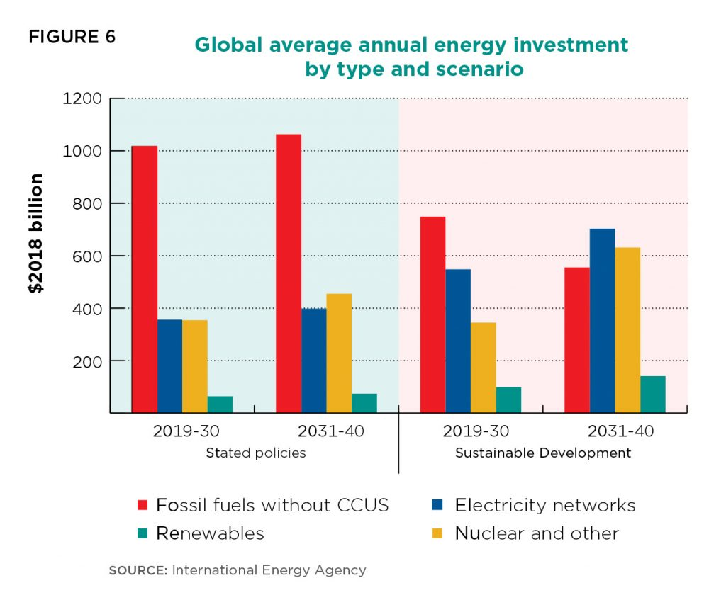
No single energy resource can sustainably meet the energy demands of any country. Integrating all exploitable energy sources is a viable way of achieving stability in energy supply for Nigeria Energy availability, economic growth and sustainable development are grossly inseparable. Generating adequate power has been a major challenge for successive Nigerian governments. Hydro-powers and thermal plants were established between 1960 and 1979. No other successful attempt was made to increase the energy generating capacity till 1999. First, that energy sources should be diversified. Since power failure is a regular occurrence in Nigeria with attendant negative impact on the quality of living and business productivity, a new approach to electricity generation in which a mix of several energy sources including renewable sources is optimally utilized should be vigorously pursued and adopted. Second, the utilization of renewable energy technologies especially solar energy to provide off-grid electricity to remote communities should be intensified. The scenario whereby combustible renewable and waste accounted for 80.2 percent of total energy consumption in Nigeria (fig.1) and mainly utilized by the rural areas to meet off-grid heating and cooking needs is not sustainable as it does not only contribute to greenhouse gas but also portends a threat to health, woodlands and the economy. Third, it is imperative to intensify research and development in the energy sector, especially renewable energy to increase energy sources and improve energy management systems that will promote sustainable development. Last, there should be increased funding in energy sector, which is capital intensive and requires huge amount of investment. The public and private sector could form a partnership to tackle this investment problem. Government should also increase the budgetary allocation to the energy sector and release these funds duly. Integrating energy sources is a viable way to address the energy problems of Nigeria, which include irregular power supply and rising costs / scarcity of conventional or traditional energy sources.
QUESTION 2: HOW MUCH ENERGY IS BEEN PRODUCED FROM NIGERIA DAMS AND COMPARE WITH THE ONE PRODUCE FROM CRUDE OIL
HYDROPOWER
Hydroelectric power comes from the potential energy of dammed water driving a water turbine and generator. The Niger and Benue Rivers and their tributaries form the core of the Nigerian river system with potential for large-scale (greater than 100MW) hydropower development. Several small rivers and streams also provide opportunities for small-scale (less than 10MW) hydropower projects. Estimate of total exploitable large-scale hydropower potential in Nigeria is over 10,000MW, capable of producing 36,000GWh of electricity annually only about one fifth had been developed as at 2001. Likewise, estimate of exploitable small-scale hydropower potential is at 734MW. Small hydropower plants for electricity provision are suitable in remote areas. By 1999, hydropower represented about 32% of the installed grid-connected electricity generation capacity (FGN, 2003).

CRUDE OIL

Following its discovery at Oloibiri, Delta State in 1956 (MBendi, 2011) oil would eventually become dominant in Nigeria’s energy scenario as the economic mainstay. Presently, oil accounts for over 95% of export earnings and over 65% of government revenue according to the International Monetary Fund- IMF (EIA, 2010). However, according to Odularu (2007) petroleum production and export, which play a dominant role in Nigeria’s economy accounts for about 90% of gross domestic earnings making Nigeria the “13thoil producer in the world” (Nation Master, 2008). Nigeria has an estimated 37.2 billion barrels of proven oil reserve situated
along the Niger River Delta and offshore in Bight of Benin, Gulf of Guinea and Bight of Bonny. Production capacity as at 2009 was over 2.2 million b/d making Nigeria the largest oil producer in Africa (EIA, 2010). An oil boom in the early 1970s drew the country’s attention away from agriculture, which hitherto was the mainstay and contributed an average of 72% of GDP between 1955 and 1969 (Folawewo & Olakojo, 2010). Since then, oil has been dominant in the energy scene of the country at all levels of economic activities.

QUESTION 3
- Diagram of Anemometer
Anemometer, device for measuring the speed of airflow in the atmosphere, in wind tunnels, and in other gas-flow applications. Most widely used for wind-speed measurements is the revolving-cup electric anemometer, in which the revolving cups drive an electric generator. The output of the generator operates an electric meter that is calibrated in wind speed. The useful range of this device is approximately from 5 to 100 knots. A propeller may also be used to drive the electric generator, as in the propeller anemometer. In another type of wind-driven unit, revolving vanes operate a counter, the revolutions being timed by a stopwatch and converted to airspeed. This device is especially suited for the measurement of low airspeeds.
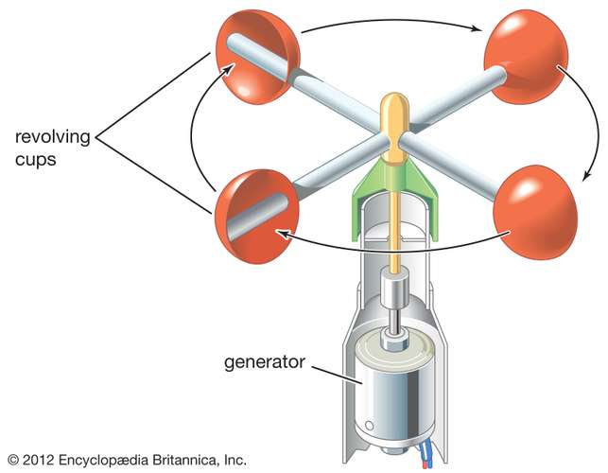

- Monitor abuad average ambient temperature
DAYS | AVG AMBIENT TEMP (DAY) ̊c | AVG AMBIENT TEMP (NIGHT) ̊c
MONDAY | 35 | 25
TUESDAY | 36 | 25
WEDNESDAY | 35 | 25
THURSDAY | 36 | 25
FRIDAY | 37 | 25

Q = mcΔT
Where:
Q = Thermal energy
M = mass
C = specific heat
ΔT = change in temperature
Step 1: calc ΔT
For Monday ΔT = 35 – 25 = 10
Tuesday ΔT = 36 – 25 = 11
Wednesday ΔT = 35 – 25 = 10
Thursday ΔT = 36 – 25 = 11
Friday ΔT = 37 – 25 = 12
Step 2: Take the following assumptions
Area of land in abuad (A) = 1300m²
Recall ρ_{A} = m/A
Where ρ_{A =} Average Area density
M = mass of object
A = area of object is 1.67kg/m²
ρ_{A} = m/A
m = ρ_{A} * A = 1.67 * 1300000 = 2171000kg
recall specific heat capacity of air = 1020J/Kg ̊c
Step 3: calculate the thermal energy for:
Monday
Q = mcΔT
= 217100*1020*11
= 22144200000J
Tuesday
Q = mcΔT
= 2171000*1020*11
= 24358620000J
Wednesday
Q = mcΔT
= 2171000*1020*10
=22144200000J
Thursday
Q = mcΔT
= 2171000*1020*11
=24358620000J
Friday
Q = mcΔT
=2171000*1020*12
= 26573040000J
Therefore, the average thermal energy of Abuad is
22144200000J + 24358620000J + 22144200000J + 24358620000J + 26573040000J
5
= 23915736000J.

