Name: Olaoye Omoniwuraola Islamiat
Matric No : 18/MHS01/283
Department: Human Nutrition & Dietetics
Course: NTD 206 , Human Biochemistry $ Nutrition 2

Answers
a) Glycolysis is the metabolic pathway that converts glucose into pyruvate, pyruvic acid, and a hydrogen ion. There is a free energy which is released in this process and which is also used to form the high-energy molecules ATP which stands for (adenosine triphosphate) and NADH which stands for (nicotinamide adenine dinucleotide). Glycolysis is a sequence of ten enzyme-catalyzed reactions. Most monosaccharides, such as fructose and galactose, can be converted to one of these intermediates. The intermediates may also be directly useful rather than just utilized as steps in the overall reaction.
Glycolysis is an oxygen-independent metabolic pathway. For most organisms, glycolysis occurs in the cytosol. The most common type of glycolysis is the Embden–Meyerhof–Parnas (EMP pathway). Glycolysis also refers to other pathways, such as the Entner–Doudoroff pathway and various heterofermentative and homofermentative pathways.
The glycolysis pathway has two phases:
A The Preparatory (or Investment) Phase in which ATP is consumed and Phosphorylation of glucose and its conversion to glyceraldehyde-3-phosphate

1. Glucose is first phosphorylated at the hydroxyl group on C-6.
2. The D-glucose 6-phosphate thus formed is converted to D-fructose 6-phosphate.
3. (2) is again phosphorylated, this time at C-1, to yield D- fructose 1, 6-bisphosphate. For both phosphorylations, ATP is the phosphoryl group donor.
4. Fructose 1,6-bisphosphate is split to yield two three-carbon molecules, dihydroxyacetone phosphate and glyceraldehyde 3-phosphate.
5. The dihydroxyacetone phosphate is isomerized to a second molecule of glyceraldehyde 3-phosphate

B The Pay Off Phase in which ATP is produced.� The energy payoff phase of glycolysis consists of five additional steps and results in the formation of four ATP, two NADH + H+, and two pyruvate molecules.
6. Glyceraldehyde phosphate is oxidized (NAD+ is reduced) and phosphorylated by the enzyme triose phosphate dehydrogenase to produce 1,3- bisphosphoglycerate. Two molecules of NADH + H+ are produced.
0. A phosphate group is removed from each 1,3-bisphosphoglycerate to make two ATP and 3-phosphoglycerate. This reaction is mediated by the enzyme phospho-glycerokinase.
8. The remaining phosphate group is transferred to the middle carbon by the enzyme phosphoglyceromutase. This reaction will energize the molecule and make it less stable. 2- phosphoglycerate results.
9. A water molecule is removed and a double bond is added to both 2-phosphoglycerate molecules to produce two phosphoenolpyruvate (also known as PEP) molecules.
10. Both PEP molecules are dephosphorylated by pyruvate kinase to produce two pyruvates and two ATP
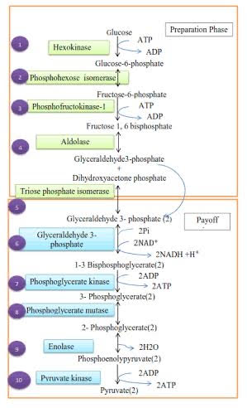

QUESTION 2 ANSWER
The Stoichiometry of Coenzyme Reduction and ATP Formation in the Aerobic Oxidation of Glucose via Glycolysis, the Pyruvate Dehydrogenase Complex Reaction, the Citric Acid Cycle, and Oxidative Phosphorylation:
REACTION | No of ATP/ red coenz | No of ATP
Glucose → glucose 6- phosphate | -1 ATP | -1
Fructose 6- phosphate → fructose 1,6- bisphosphate | -1 ATP | -1
A | 2 NADH | 5
2 1,3- bisphosphoglycerate → 2 3- phosphoglycerate | 2 ATP | 2
2 phosphoenolpyruvate → pyruvate | 2 ATP | 2
2 pyruvate → 2 acetyl CoA | 2 NADH | 5
2 isocitrate→2 a-ketoglurate | 2 NADH | 5
2a-ketoglurate →2succinyl-COa | 2 NADH | 5
2 succinyl-CoA→2 succinate | 2 ATP or 2GDP | 2
2 succinate→ 2 fumarate | 2 FADH2 | 3
2 malate→2 oxaloacetate | 2 NADH | 5
Total

This is calculated as 2.5 ATP per NADH and 1.5 ATP per FADH2 . A negative value in this indicates consumption

