Name: Adeyemo Sinmiloluwa
Course: Gross anatomy of the head and neck
Matric no: 17/MHS01/025
Department: Medicine and Surgery

ASSIGNMENT
CAVERNOUS SINUS
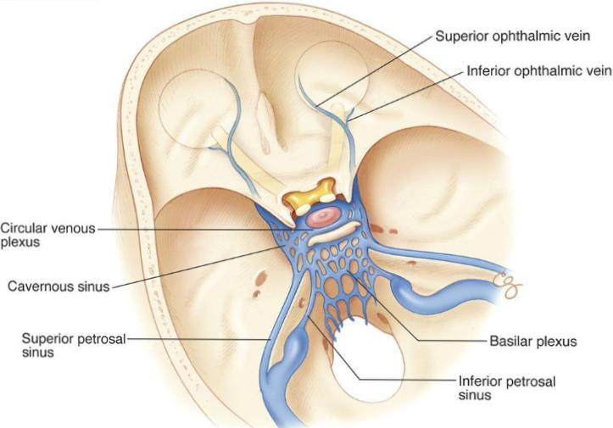
Diagram showing the cavernous sinus
The cavernous sinus is a paired dural venous sinus located within the cranial cavity. It is divided by septa into small ‘caves’ from which it gets its name.
Each cavernous sinus has a close anatomical relationship with several key structures in the head, and is arguably the most clinically important venous sinus.
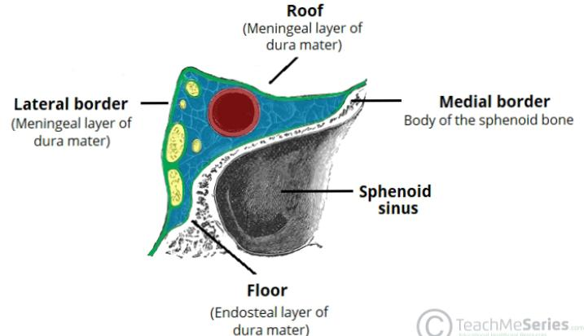
Anatomical Location and Borders
Diagram showing the borders of the cavernous sinus
The cavernous sinuses are located within the middle cranial fossa, on either side of the sella turcica of the sphenoid bone (which contains the pituitary gland). They are enclosed by the endosteal and meningeal layers of the dura mater.
The borders of the cavernous sinus are as follows:
- Anterior – superior orbital fissure.
- Posterior – petrous part of the temporal bone.
- Medial – body of the sphenoid bone.
- Lateral – meningeal layer of the dura mater running from the roof to the floor of the middle cranial fossa.
- Roof – meningeal layer of the dura mater that attaches to the anterior and middle clinoid processes of the sphenoid bone.
- Floor – endosteal layer of dura mater that overlies the base of the greater wing of the sphenoid bone.

Contents of the cavernous sinus
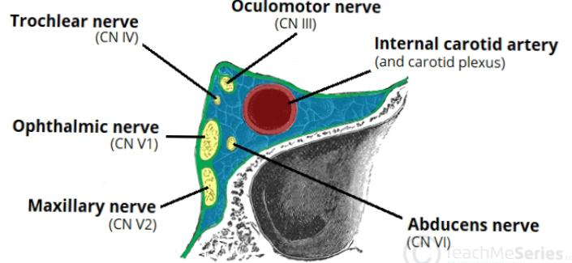
Diagram showing contents of the cavernous sinus
Several important structures pass through the cavernous sinus to enter the orbit. The can be sub-classified by whether they travel through the sinus itself, or through its lateral wall:
Travels through cavernous sinus:
- Abducens nerve (CN VI)
- Carotid plexus (post-ganglionic sympathetic nerve fibres)
- Internal carotid artery (cavernous portion)
Travels through lateral wall of the cavernous sinus:
- Oculomotor nerve (CN III)
- Trochlear nerve (CN IV)
- Ophthalmic (V1) and maxillary (V2) branches of the trigeminal nerve
The cavernous sinus is the only site in the body where an artery (internal carotid) passes completely through a venous structure. This is thought to allow for heat exchange between the warm arterial blood and cooler venous circulation.
Dural Venous Sinus System
Each cavernous sinus receives venous drainage from:
- Ophthalmic veins (superior and inferior) – these enter the cavernous sinus via the superior orbital fissure.
- Central vein of the retina – drains into the superior ophthalmic vein, or directly into the cavernous sinus.
- Sphenoparietal sinus – empties into the anterior aspect of the cavernous sinus.
- Superficial middle cerebral vein – contributes to the venous drainage of the cerebrum
- Pterygoid plexus – located within the infratemporal fossa.
It is important to note that the superior ophthalmic vein forms an anastomosis with the facial vein. Therefore, the ophthalmic veins represent a potential route by which infection can spread from an extra cranial to an intracranial site.
The cavernous sinuses empty into the superior and inferior petrosal sinuses, and ultimately, into the internal jugular vein. The left and right cavernous sinuses are connected in the midline by the anterior and posterior intercavernous sinuses. They travel through the sella turcica of the sphenoid bone.
CLINICAL SIGNIFICANCE
Cavernous sinus thrombosis
Cavernous sinus thrombosis (CST) referred to a clot within the cavernous sinus. The most common cause of CST is infection; which usually spread from and extra cranial location such as the orbit, paranasal sinuses or the “danger zone” of the face. Infection is able to spread in these areas due to the anastomosis between the facial vein and superior ophthalmic vein.
Common clinical features include; headache, unilateral periorbital oedema, proptosis (eye bulging) photophobia and cranial nerve palsies. The Abducens nerve is commonly affected.
Treatment is usually with antibiotic therapy. Where the cause is infection, thrombosis of the cavernous sinus can rapidly progress to meningitis.

Assignment 2
The Nose
The nose is an olfactory and respiratory organ. It consists of nasal skeleton, which houses the nasal cavity. The nasal cavity has four functions:
- Warms and humidifies the inspired air.
- Removes and traps pathogens and particulate matter from the inspired air.
- Responsible for sense of smell.
- Drains and clears the paranasal sinuses and lacrimal ducts.
The nasal cavity
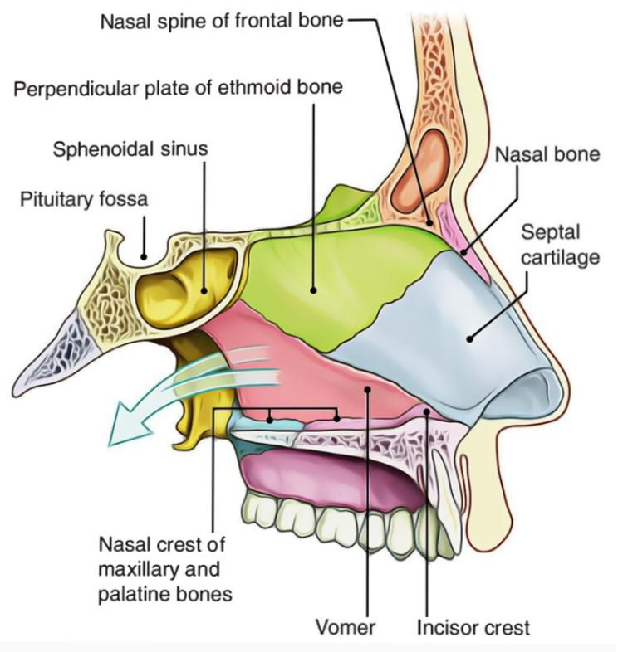
Diagram showing parts of the nasal cavity
The nasal cavity is a quadrangular prism with a larger base as the floor, a smaller base as the roof, and two vertical walls, one lateral and another medial (nasal septum). The lateral walls are both anatomically and functionally more complex than the other walls.
Nasal Conchae
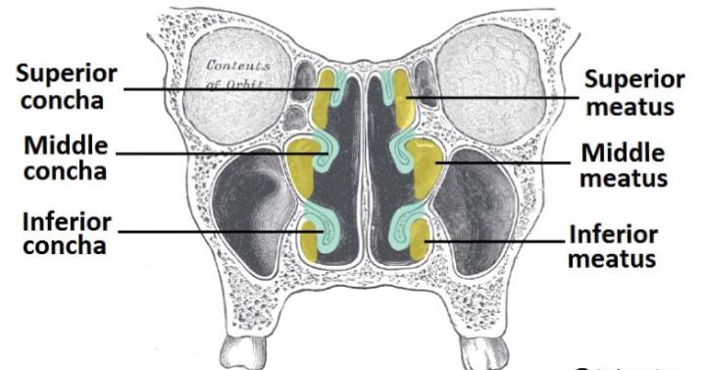
Diagram showing the nasal conchae
Projecting out of the lateral walls of the nasal cavity are curved shelves of bone. They are called conchae (or turbinates). The are three conchae – inferior, middle and superior. The nasal cavity is therefore divided into five passages: a posterosuperiorly placed spheno-ethmoidal recess, three laterally located nasal meatus (superior, middle, and inferior), and a medially placed common nasal meatus into which the four lateral passages open. The inferior concha is the longest and broadest of the conchae and is formed by an independent bone (of the same name, inferior concha) covered by a mucous membrane that contains large vascular spaces that can enlarge affecting the caliber of the nasal cavity.
The middle and superior conchae are medial processes of the ethmoid bone. When infected or irritated, the mucosa covering the conchae may swell rapidly, blocking the nasal passage(s) on that side. They project into the nasal cavity, creating four pathways for the air to flow. These pathways are called meatuses:
- Inferior meatus – between the inferior concha and floor of the nasal cavity.
- Middle meatus – between the inferior and middle concha.
- Superior meatus – between the middle and superior concha.
- Spheno-ethmoidal recess – superiorly and posteriorly to the superior conchae
The function of the conchae is to increase the surface area of the nasal cavity – this increases the amount of inspired air that can come into contact with the cavity walls. They also disrupt the fast, laminar flow of the air, making it slow and turbulent. The air spends longer in the nasal cavity, so that it can be humidified.
BOUNDARIES OF NASAL CAVITIES
The nasal cavities have a roof, floor, and medial and lateral walls: The roof of the nasal cavities is curved and narrow, except at its posterior end, where the hollow body of the sphenoid forms the roof. It is divided into three parts (frontonasal, ethmoidal, and sphenoidal) named from the bones forming each part.
- The floor of the nasal cavities is wider than the roof and is formed by the
palatine processes of the maxilla and the horizontal plates of the palatine
bone.
- The medial wall of the nasal cavities is formed by the nasal septum.
- The lateral walls of the nasal cavities are irregular owing to three bony
plates, the nasal conchae, which project inferiorly, somewhat like louvers
ARTERIAL SUPPLY AND INNERVATION
The arterial supply of the medial and lateral walls of the nasal cavity is from five sources:
- Anterior ethmoidal artery (from the ophthalmic artery).
- Posterior ethmoidal artery (from the ophthalmic artery).
- Sphenopalatine artery (from the maxillary artery).
- Greater palatine artery (from the maxillary artery).
- Septal branch of the superior labial artery (from the facial artery).

The first three arteries divide into lateral and medial (septal) branches. The greater palatine artery reaches the septum via the incisive canal through the anterior hard palate. The anterior part of the nasal septum is the site of an anastomotic arterial plexus involving all five arteries supplying the septum (Kiesselbach area). The external nose also receives blood from first and fifth arteries listed above, plus nasal branches of the infra-orbital artery and the lateral nasal branches of the facial artery.
A rich sub mucosal venous plexus, deep to the nasal mucosa, provides venous drainage of the nose via the sphenopalatine, facial, and ophthalmic veins. The plexus is an important part of the body’s thermoregulatory system, exchanging heat and warming air before it enters the lungs. Venous blood from the external nose drains mostly into the facial vein via the angular and lateral nasal veins. However, recall that it lies within the “danger area” of the face because of communications with the cavernous (dural venous) sinus.
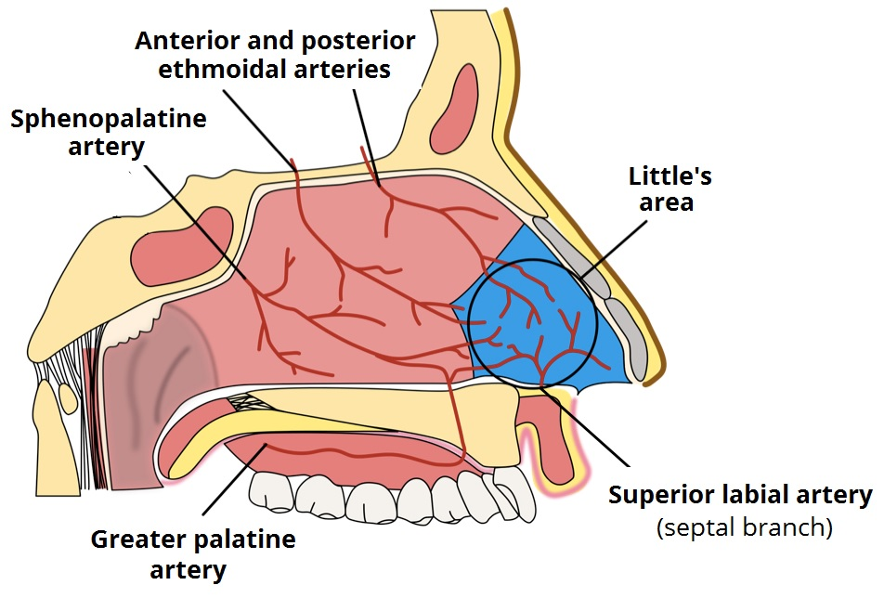
Diagram showing nerve supply of the nose
Regarding the nerve supply of the nose, the nasal mucosa can be divided into postero-inferior and anterosuperior portions by an oblique line passing approximately through the anterior nasal spine and the spheno-ethmoidal recess. The nerve supply of the postero-inferior portion of the nasal mucosa is chiefly from the maxillary nerve, by way of the nasopalatine nerve to the nasal septum, and posterior superior lateral nasal and inferior lateral nasal branches of the greater palatine nerve to the lateral wall. The nerve supply of the anterosuperior portion is from the ophthalmic nerve (CN V1) by way of the anterior and posterior ethmoidal nerves, branches of the nasociliary nerve.

CLINICAL SIGNIFICANCE
Diseases of the nasal cavity include viral, bacterial and fungal infections, nasal cavity tumors, both benign and much more often malignant, as well as inflammations of the nasal mucosa. Many problems can affect the nose, including:
- Deviated septum - a shifting of the wall that divides the nasal cavity into halves
- Nasal polyps - soft growths that develop on the lining of the nose or sinuses
- Nosebleeds
- Rhinitis - inflammation of the nose and sinuses sometimes caused by allergies. The main symptom is a runny nose.
- Nasal fractures, also known as a broken nose
- Common cold

