ABDULRAZZAQ HINDU MA’AJI
17/MHS01/004
MBBS 300LEVEL
GROSS ANATOMY OF HEAD AND NECK ASSIGNMENT
NO1
Write an essay on the cavernous sinus
Answer:
The cavernous sinus is part of the brains dural venous sinus and contains multiple neurovasculatures. It is situated in the middle cranial fossa on each side of the sella turcica. It consist of a venous plexus. It extends anteriorly from the superior orbital fissure to the petrous part of the temporal bone posteriorly. The venous blood that flows to the cavernous sinus are from the anterior and posterior ophthalmic veins, cerebral veins, emissary veins and sphenoparietal sinus. The communication between the right and left cavernous sinuses is made by the intercavernous sinuses anterior and posterior to the pituitary stalk. The cavernous sinus works as a conduit. Cranial nerves leaving the brain stem travel through the cavernous sinus before entering the orbit. The nerves are the oculomotor nerve (CN III), trochlear nerve (CN IV), ophthalmic nerve (V1), maxillary nerve (V2), abduscens nerve (CN VI), and the sympathetic plexus around the internal carotid artery. Different venous tributaries drain into the cavernous sinus. The superior ophthalmic vein collects venous blood from the ethmoidal, vorticose, central retinal and nasofrontal veins before draining into the anterior part of the cavernous sinus through the superior orbital fissure. The superior ophthalmic vein on the other hand receives blood from the lacrimal sac, eyelids, inferior rectus and inferior oblique muscles, the vorticose vein, and from the anterior and medial wall of the orbit. It then runs posteriorly toward the lower part of the orbit and divides into two branches. One of these branches joins the cavernous sinus while the other one drains into the pterygoid plexus. The cerebral veins originates on the lateral surface of the hemisphere, runs in the lateral sulcus and drains most of the temporal lobe into the cavernous sinus. The emissary veins receive blood from the pterygoid plexus of veins in the infratemporal fossa. The sphenoparietal sinus receives blood from some branches of the middle meningeal vein before draining into the cavernous sinus. It is noteworthy to mention that efferent hypophyseal veins also drain into the cavernous sinus. After collecting venous blood from different veins, the cavernous sinus drains to the superior and inferior petrosal sinuses, which then joins the sigmoid sinus to form the internal jugular vein. The internal jugular vein connects with the subclavian vein to become the right or left brachiocephalic vein.
CLINICAL SIGNIFICANCE
CAROTID-CAVERNOUS FISTULA
Head trauma resulting in rupture of the cavernous part of the internal carotid artery can produce what is known as carotid-cavernous fistula. A pulsating exophthalmos can result as the venous pressure in the sinus would increase and reserve the flow of blood in the ophthalmic veins.
CAVERNOUS SINUS THROMBOSIS
The sinus also has communicating branches from the sin of the face. Particularly in the DANGER AREA (at the nasolabial crease and at the crease between the ala of the nose and the cheek), an infection can spread to the cavernous sinus, which can result in a cavernous sinus thrombosis. This condition can result in internal strabismus (crossed eyes) if the CN VI is damaged, doubled vision while looking downward if CN IV was damaged, or ophthalmoplegia (paralysis or weakness in muscles of movement of the eye).

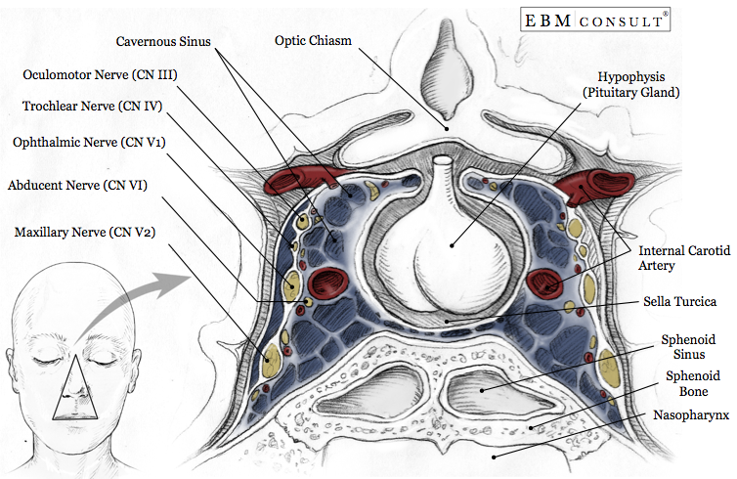

NO2
Discuss the walls of the nose
Answer
MEDIAL WALL (NASAL SEPTUM): It is formed by the perpendicular plate of the ethmoid bone, the vomer bone, and the septal cartilage.
LATERAL WALL: It is formed by the superior, middle and inferior nasal conchae. In addition the maxillary, sphenoid and palatine bones contribute to the lateral wall. The lateral wall contains the following openings:
- Sphenoethmoidal recess. The space between the superior nasal concha and the sphenoid bone, with openings from the sphenoid sinus.
- Superior meatus. The space inferior to the superior nasal concha, with openings from the posterior ethmoidal air cells.
- Middle meatus. The space inferior to the middle nasal concha, with openings from the frontal sinus via the nasofrontal duct, the middle ethmoidal air cells on the ethmoidal bulla, and the anterior ethmoidal air cells and maxillary sinus in the hiatus semilunaris.
- Inferior meatus. The space inferior to the inferior nasal concha, with an opening for the nasolacrimal duct, which drains tears from the eye into the nasal cavity.
- Sphenopalatine foramen. An opening posterior to the middle nasal concha receives the nasopalatine nerve and the sphenopalatine artery from the pterygopalatine fossa into the nasal cavity.
- The common nasal meatus. Is the medial part of the nasal cavity between the concha and the nasal septum, into which the lateral recesses and meatus opens.
Inferior nasal concha: this is one of the three paired nasal chonchae in the nose. It extends horizontally along the lateral of the nasal cavity and consist of lamina of a spongy bone. The inferior nasal conchae are considered a pair of independent bone covered by a mucous membrane. As air passes through the turbinate, the air is churned against these mucous lined bones in order to receive moisture, warmth and cleansing. This bone articulates with four bones: the ethmoid, lacrimal, maxilla and palatine. It has two surfaces, two extremities and two borders. The medial surface is convex while the lateral surface is concave and forms part of the inferior meatus. Its upper border is thin, irregular and connected various bones along the lateral wall of the nasal cavity. The inferior border is free, thick and cellular in structure more especially in the middle of the bone. Both extremities are more or less pointed, the posterior being the more tapering. If infected or irritated, the mucosa may swell rapidly, blocking the nasal passage on that side.
Middle nasal conchae: it consist of the medial surface of the labyrinth of ethmoid which is a thin lamella that descends from the undersurface of the cribriform plate and ends in a thin convoluted margin. It is rough, and marked above by numerous grooves, directed nearly vertically downward from the cribriform plate; they branches of the olfactory nerves, which are distributed to the mucous membrane covering the superior nasal concha.
Superior nasal conchae: this is one of the conchae in the nose and is part of the labyrinth of ethmoid bone, arising as a bony projection from its posterior surface. The superior nasal concha is similar to that of the middle. The superior concha is less vascularized and it forms the upper boundary of the superior meatus of the nose separating it from the sphenoethmoidal recess.

