NAME:ADEJUMO LATEEFAH MUHAMMAD
MATRIC NUMBER:18/MHS02/012
DEPARTMENT: NURSING
LEVEL:200 LEVEL
COURSE TITLE:PHYSIOLOGY
COURSE CODE:PHS 212

QUESTION 1
- THE CYCLIC CHANGES IN CERVIX

Your cervix changes position many times throughout your menstrual cycle.
For example, it may rise alongside ovulation to prepare for conception or lower to allow menstrual tissue to pass through the vagina.
Each change in position is tied to a particular phase in your menstrual cycle or other hormonal change, such as pregnancy.
Checking the position and texture of your cervix — as well as any cervical mucus — can help you gauge where you are in your cycle.
The following chart explains some of the changes that take place in your cervix over the course of your menstrual cycle or pregnancy.

 | High | Medium | Low | Soft | Firm | Completely open | Partially open | Completely closed
Follicular phase | X |  |  |  | X |  |  | X
Ovulation | X |  |  | X |  |  | X
Luteal phase |  |  | X |  | X |  |  | X
Menstruation |  |  | X |  | X |  | X
Early pregnancy |  | X | X | X |  |  | X
Late pregnancy |  |  | X | X |  |  | X
Approaching labor |  |  | X | X |  | possibly | X
Postpartum |  |  | X | X |  |  | X
Although these characteristics reflect the average cervix, it’s normal to experience slight variations.
It’s also important to note that people who have an inverted uterus may find that their cervical characteristics are the exact opposite of what’s listed in this chart.
If your cervix feels different than expected, talk to a doctor or other healthcare provider. They should be able to answer any questions you have.

Cervix characteristics during follicular phase
During the follicular phase, your body is preparing the uterine lining for a fertilized egg to attach.
Estrogen levels are low now, so your cervix usually feels firmer. Estrogen will make it feel softer as your menstrual cycle progresses.

Cervix characteristics during ovulation
During ovulation, your estrogen levels start to rise. This causes the uterine lining to thicken, making it feel softer.
You’ll also start to notice more mucus coming from your cervix and vagina at this time. The mucus has a thin, slippery consistency.
If you take birth control pills that suppress ovulation, you may not notice these changes because you don’t ovulate.

Cervix characteristics during luteal phase
During the luteal phase, your estrogen levels decrease, but progesterone remains to keep the uterine lining thick should a fertilized egg implant.
You’ll notice that your cervix may still feel soft. Your cervical mucus will get thicker though, and is usually sticky and somewhat cloudy in appearance.
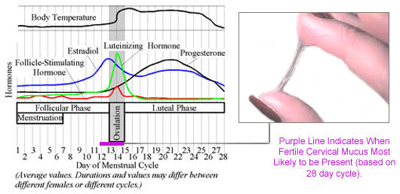
- CYCLIC CHANGE IN BREAST
- Each month, women go through changes in the hormones that make up the normal menstrual cycle. The hormone estrogen is produced by the ovaries in the first half of the menstrual cycle. It stimulates the growth of milk ducts in the breasts. The increasing level of estrogen leads to ovulation halfway through the cycle. Next, the hormone progesterone takes over in the second half of the cycle. It stimulates the formation of the milk glands. These hormones are believed to be responsible for the cyclical changes that many women feel in their breasts just before menstruation. These include swelling, pain, and soreness.
- During menstruation, many women also have changes in breast texture. Their breasts may feel very lumpy. This is because the glands in the breast are enlarging to get ready for a possible pregnancy. If pregnancy does not happen, the breasts go back to normal size. Once menstruation starts, the cycle begins again.
- By the time a woman reaches her late 40s and early 50s, perimenopause is starting or is well underway. At this time, the levels of estrogen and progesterone begin to change. Estrogen levels dramatically decrease. This leads to many of the symptoms commonly linked to menopause. Without estrogen, the breast’s connective tissue becomes dehydrated and is no longer elastic. The breast tissue, which was prepared to make milk, shrinks and loses shape. This leads to the "saggy" breasts associated with women of this age.
- Women who are taking hormone therapy may have some of the premenstrual breast symptoms that they had while they were still menstruating, such as soreness and swelling. But if a woman’s breasts were saggy before menopause, this will not change with hormone therapy.

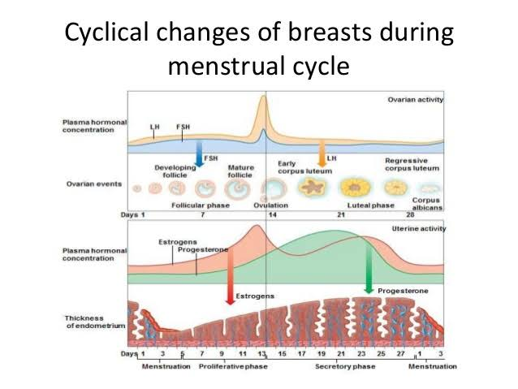

What is menstruation?
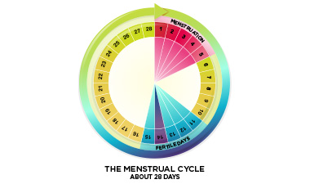Menstruation is the technical term for getting your period. About once a month, females who have gone through puberty will experience menstrual bleeding. This happens because the lining of the uterus has prepared itself for a possible pregnancy by becoming thicker and richer in blood vessels. If pregnancy does not occur, this thickened lining is shed, accompanied by bleeding. Bleeding usually lasts for 3-8 days. For most women, menstruation happens in a fairly regular, predictable pattern. The length of time from the first day of one period to the first day of the next period normally ranges from 21-35 days.

How does the menstrual cycle work?
The menstrual cycle is controlled by a complex orchestra of hormones, produced by two structures in the brain, the pituitary gland and the hypothalamus along with the ovaries
The menstrual cycle includes several phases. The exact timing of the phases of the cycle is a little bit different for every woman and can change over time.

Comprehensive explanation of the menstrual cycle:
The menstrual cycle has three phases:

1. Follicular Phase (Days 1-14)
This phase of the menstrual cycle occurs from approximately day 1-14. Day 1 is the first day of bright red bleeding, and the end of this phase is marked by ovulation. While menstrual bleeding does happen in the early part of this phase, the ovaries are simultaneously preparing to ovulate again. The pituitary gland (located at the base of the brain) releases a hormone called FSH – follicle stimulating hormone. This hormone causes several ‘follicles’ to rise on the surface of the ovary. These fluid filled “bumps” each contain an egg. Eventually, one of these follicle becomes dominant and within it develops a single mature egg; the other follicles shrink back. If more than one follicle reaches maturity, this can lead to twins or more. The maturing follicle produces the hormone estrogen, which increases over the follicular phase and peaks in the day or two prior to ovulation. The lining of the uterus (endometrium) becomes thicker and more enriched with blood in the second part of this phase (after menstruation is over), in response to increasing levels of estrogen. High levels of estrogen stimulate the production of gonadotropin-releasing hormone (GnRH), which in turn stimulates the pituitary gland to secrete luteinizing hormone (LH). On about day 12, surges in LH and FSH cause the egg to be released from the follicle. The surge in LH also causes a brief surge in testosterone, which increases sex drive, right at the most fertile time of the cycle.

2. Ovulatory Phase (Day 14)
The release of the mature egg happens on about day 14 as a result of a surge in LH and FSH over the previous day. After release, the egg enters the fallopian tube where fertilization may take place, if sperm are present. If the egg is not fertilized, it disintegrates after about 24 hours. Once the egg is released, the follicle seals over and this is called the corpus luteum.

3. Luteal Phase (Days 14-28)
After the release of the egg, levels of FSH and LH decrease. The corpus luteum produces progesterone. If fertilization has occurred, the corpus luteum continues to produce progesterone which prevents the endometrial lining from being shed. If fertilization has not occurred, the corpus luteum disintegrates, which causes progesterone levels to drop and signals the endometrial lining to begin shedding.

What is normal bleeding?
There is a range of normal bleeding – some women have short, light periods and others have longer, heavy periods. Your period may also change over time.
Normal menstrual bleeding has the following features:
- Your period lasts for 3-8 days
- Your period comes again every 21-35 days (measured from the first day of one period to the first day of the next)
- The total blood loss over the course of the period is around 2-3 tablespoons but secretions of other fluids can make it seem more

