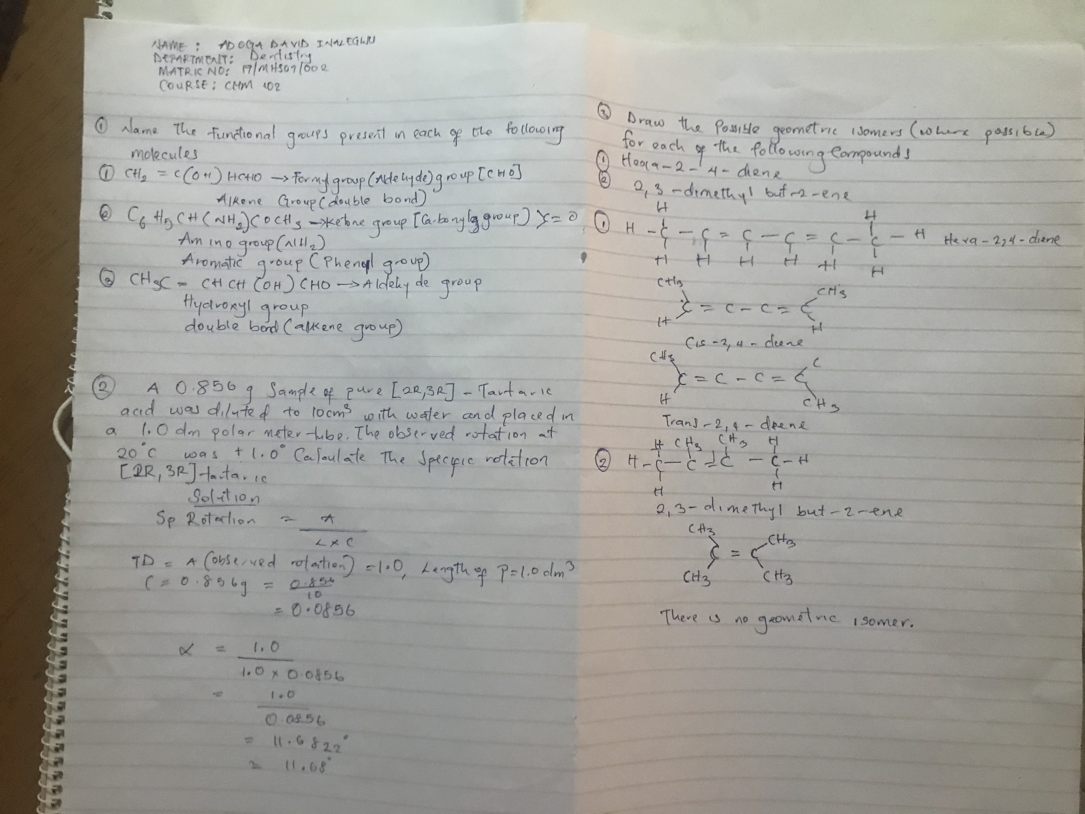
Adoga David inalegwu
Dentistry
19/mhs09/002
Chm 102

