**Nwabueze precious Akunna**

**18/sci01/055**

**Mat 204**

**QUESTIONS**

**1). Explain with 2 examples what you understand by linear transformation.**

**2). Given a linear transformation of a matrix operator A on a vector x, compute T(x) if A=(1,9,3), (-2,6,7), (0, -1,3) and**

**x= 1**

**4**

**-8**

**3). Define completely with mathematical examples what you understand by Rank of a matrix.**

# **1) Linear Transformations**

**A **linear transformation** is a function from one vector space to another that respects the underlying (linear) structure of each vector space. A linear transformation is also known as a linear operator or map. The [range](/wiki/function-terminology/" \o "range" \t "_blank) of the transformation may be the same as the domain, and when that happens, the transformation is known as an endomorphism or, if invertible, an automorphism. The two vector spaces must have the same underlying field.**

**The defining characteristic of a linear transformation T:V→W*T*:*V*→*W* is that, for any vectors v1*v*1​ and v2*v*2​in V*V* and scalars a*a* and b*b* of the underlying field,**

**T(av1+bv2)=aT(v1)+bT(v2).*T*(*av*1​+*bv*2​)=*aT*(*v*1​)+*bT*(*v*2​).**

**Linear transformations are useful because they preserve the structure of a vector space. So, many qualitative assessments of a vector space that is the domain of a linear transformation may, under certain conditions, automatically hold in the image of the linear transformation. For instance, the structure immediately gives that the [kernel](/wiki/kernel/" \o "kernel" \t "_blank) and image are both subspaces (not just subsets) of the range of the linear transformation.**

**, Example: Let T : R1 → R1 be defined by T(x) = 5x. For any u,v ∈ R1,**

**T(u + v) = 5(u + v) = 5u + 5v = T(u) + T(v) and**

**for any c ∈ R, T(cu) = 5cu = c5u = cT(u). So T is a linear transformation.**

**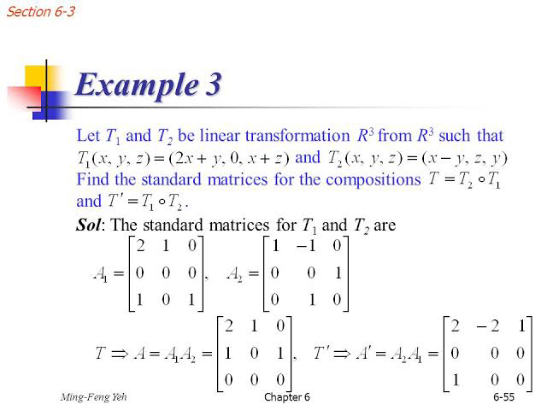**

**2) (TX) = (AX)**

**1 -2 0 1**

**9 6 -1 = 4**

**3 7 3 -8**

**= 1 \* 1. + 4 \* -2. -8 \* 0**

**9. 6. -1**

**3 7. 3**

**= 1. + -8. - 0. 7**

**9. 24. 8. =. 25**

**3 28. -24 7**

**Hence the transformation of**

**(1 4 -8) = (-7 25 7)**

**3)The rank is how many of the rows are "unique": not made of other rows. (Same for columns.)**

**EXAMPLE 1**

**Find the rank of the matrix IMG_256**

**Let A= IMG_257**

**Order of *A* is 2 × 2 ∴          *ρ*(*A*)≤ 2**

**Consider the second order minor**

**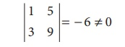**

**There is a minor of order 2, which is not zero. ∴*ρ* (*A*) = 2**

**2)**

**Find the rank of the matrix 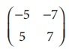**

**Let A= **

**Order of *A* is 2 × 2 ∴*ρ*(*A*)≤ 2**

**Consider the second order minor**

**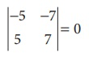**

**Since the second order minor vanishes, *ρ*(*A*) ≠ 2**

**Consider a first order minor |−5| ≠ 0**

**There is a minor of order 1, which is not zero**

**∴*ρ*(*A*)=1**

**3)**

**Find the rank of the matrix 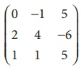**

**Let A= **

**Order Of A is 3x3**

**∴*ρ*(*A*)≤3**

**Consider the third order minor 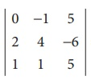 = 6 ≠ 0**

**There is a minor of order 3, which is not zero**

**∴*ρ*(*A*)=3.**