SURVEY ASSIGNMENT (CVE310);
AJISAFE BOLUWATIFE AYOMIDE
17/ENG03/008

1a) Methods of levelling
Height of collimation system
Advantages
- It is rapid as it involves few Calculation
- This system is suitable for longitudinal leveling where number of intermediate sights
- Visualization is not necessary regarding the nature of the ground
Disadvantages
- There is no check on the RL of the intermediate sight
- Errors in the intermediate RLs cannot be detected.

Rise and fall system
Advantages
- This system is suitable where there are no intermediate sights
- Errors in the intermediate RLs can be detected as all the points are correlated
- There are three checks on the accuracy of RL calculation
Disadvantages
- It is laborious involving several calculations.
- Visualization is necessary regarding the nature of the ground

1b)
R. L=110+Matric No.=110+008=118
B.S | I.S | F.S | H OF C | R.L | DISTANCE
0.771 |  |  | 118.771 | 118 | 10
0.802 |  | 1.52 | 118.053 | 117.251 | 20
 | 2.311 |  |  | 115.742 | 30
3.580 |  | 1.990 | 119.643 | 116.063 | 40
 | 1.220 |  |  | 118.423 | 50
 | 3.675 |  |  | 115.968 | 60
2.408 |  | 4.020 | 118.031 | 115.623 | 70
 | 0.339 |  |  | 117.692 | 80
0.780 |  | 0.157 | 118.654 | 117.874 | 90
 | 1.535 |  |  | 117.119 | 100
 | 1.955 |  |  | 116.699 | 110
 | 2.430 |  |  | 116.224 | 120
 | 2.985 |  |  | 115.669 | 130
1.155 |  | 3.480 | 116.329 | 115.174 | 140
 | 1.960 |  |  | 114.369 | 150
 | 2.365 |  |  | 113.964 | 160
0.935 |  | 3.640 | 113.624 | 112.689 | 170
 | 1.045 |  |  | 112.579 | 180
 | 1.630 |  |  | 111.994 | 190
 |  | 2.545 |  | 111.079 | 200
$Σ$=10.431 |  | $Σ$=17.352

HC=RL+BS
HC (1) =118+0.711=118.771
RL=HC-FS
RL (1) = 118.771-1.52=117.251
HC (2) = 117.251+0.802=118.053
RL (2) = 118.053-2.311=115.742
RL (3) = 118.053-1.990=116.063
HC (3) = 116.063+3.580=119.643
RL (4) = 119.643-1.220=118.423
RL (5) = 119.643-3.675=115.968
RL (6) = 119.643-4.020=115.623
HC (4) = 115.623+2.408=118.031
RL (7) = 118.031-0.339=117.692
RL (8) = 118.031-0.157=117.874
HC (5) = 118.654+0.780=118.654
RL (9) = 118.654-1.535=117.119
RL (10) = 118.654-1.955=116.699
RL (11) = 118.654-2.430=116.224
RL (12) = 118.654-2.985=115.669
RL (13) = 118.654-3.480=115.174
HC (6) = 115.174+1.155=116.329
RL (14) = 116.329-1.960=114.369
RL (15) = 116.329-2.365=113.964
RL (16) = 116.329-3.640=112.689
HC (7) =150.689+0.935=113.624
RL (17) = 151.624-1.045=112.579
RL (17) = 151.624-1.630=111.994
RL (17) = 151.624-2.545=111.079

Check=$ΣF.S-ΣB.S$=R.L at first point-R.L at last point
17.32-10.431=118-11.079
=6.921=6.921

QUESTION 2

Chainage(m) | 0 | 30 | 60 | 90 | 120 | 150 | 180 | 210 | 240 | 270
Offset length(m) | 0 | 2.65 | 3.80 | 3.75 | 4.65 | 3.60 | 5.00 | 5.80 | 6.10 | 5.85

- Using Mid-ordinate rule:

A=$Σ$hd

h1= $\frac{0+2.65}{2}$=1.325m

h2= $\frac{2.65+3.80}{2}$=3.225m

h3= $\frac{3.80+3.75}{2}$=3.775m

h4= $\frac{3.75+4.65}{2}$=4.2m

h5= $\frac{4.65+3.60}{2}$=4.125m

h6= $\frac{3.60+5.00}{2}$=4.3m

h7= $\frac{5.00+5.80}{2}$=5.4m

h8= $\frac{5.80+6.00}{2}$=5.9m

h9= $\frac{6.00+5.85}{2}$=5.925m

$$Σh=1.325+3.225+3.775+4.2+4.125+4.3+5.4+5.9+5.925$$
$Σh=$38.175m

d=30m
A=$Σhd$
= $38.175×30$
A= $1145.25m ^{2}$

- Using average ordinate rule;

A=$\frac{ndΣO}{n+1}$

n=9

d=30
$$ΣO=0+2.65+3.80+3.75+4.65+3.60+5.00+5.80+6.10+5.85$$
$ΣO=$41.2m

A=$\frac{9×30×41.2}{9+1}$

A=$112.4m ^{2}$

- Using trapezoidal rule;

A=$d(\frac{O_{1}+O_{n }}{2}+O_{2}+O_{3}+O_{4}............O_{n-1})$

$$d=30$$

A=$30(\frac{0+5.85}{2}+2.65+3.80+3.75+4.65+3.60+5.00+5.80+6.10)$

A=$30(38.275)$
A=$1148.25m ^{2}$

- Using Simpson's rule
$$A=\frac{d }{3 }\left[\left(O_{1}+O_{n}\right)+4\left(O_{2}+O_{4}+.........O_{n-1}\right)+2\left(O_{3}+O_{5}........O_{n-1}\right)\right]$$

$$d=30$$

Note: Last offset was removed because number of offsets were even

$$A=\frac{30}{3 }\left[\left(0+6.10\right)+4\left(2.65+3.75+3.60+5,80\right)+2\left(3.80+4.65+5.00\right)\right]$$
$$A=962m ^{2}$$

Calculating for last offset using trapezoidal rule

A=$d(\frac{O_{1}+O_{n }}{2}+O_{2}+O_{3}+O_{4}............O_{n-1})$

$$A=30\left[\frac{6.40+5.85}{2}\right]$$
$$A=183.75m ^{2}$$

Therefore $ΣA=962+183.75$

$$A=1145.75m ^{2}$$

2b)
- A series of closed contour lines on the map represent a hill if the high values are inside as shown;

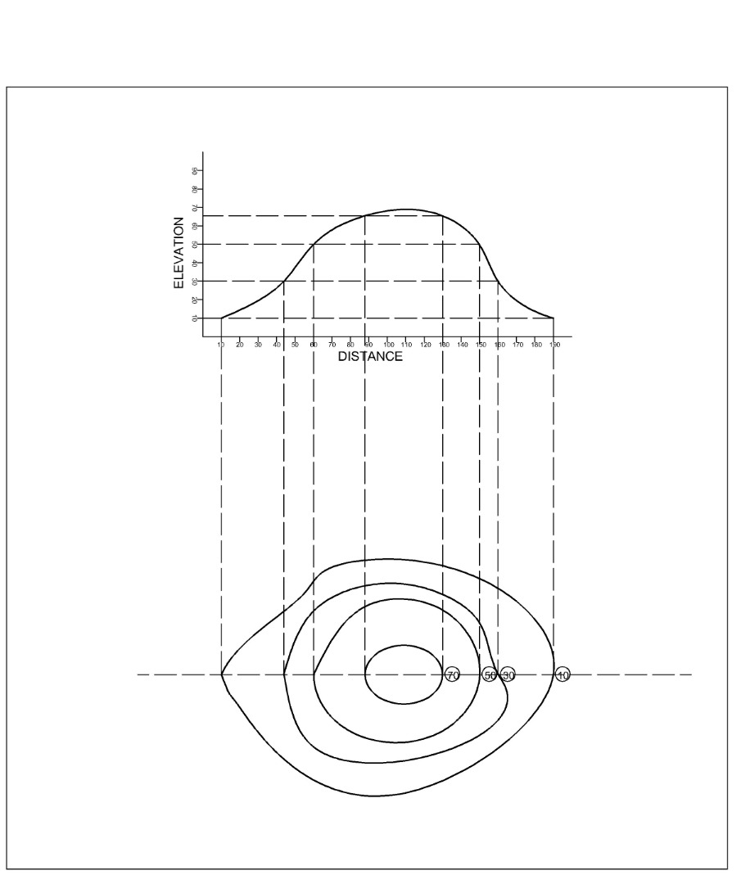

- A series of closed contours on a map indicate a depression of the higher values are outside as shown;
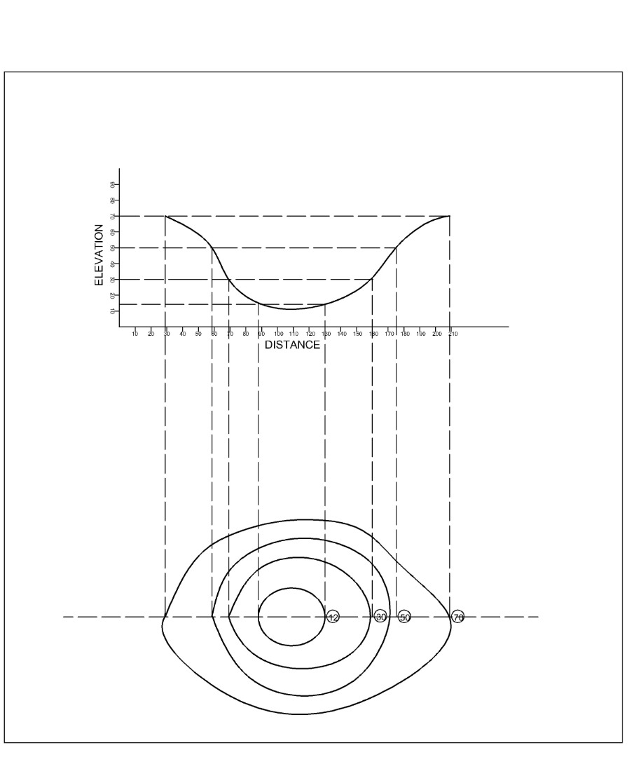

- Contour lines cannot merge or cross one another on a map except in the case of an overhanging cliff;
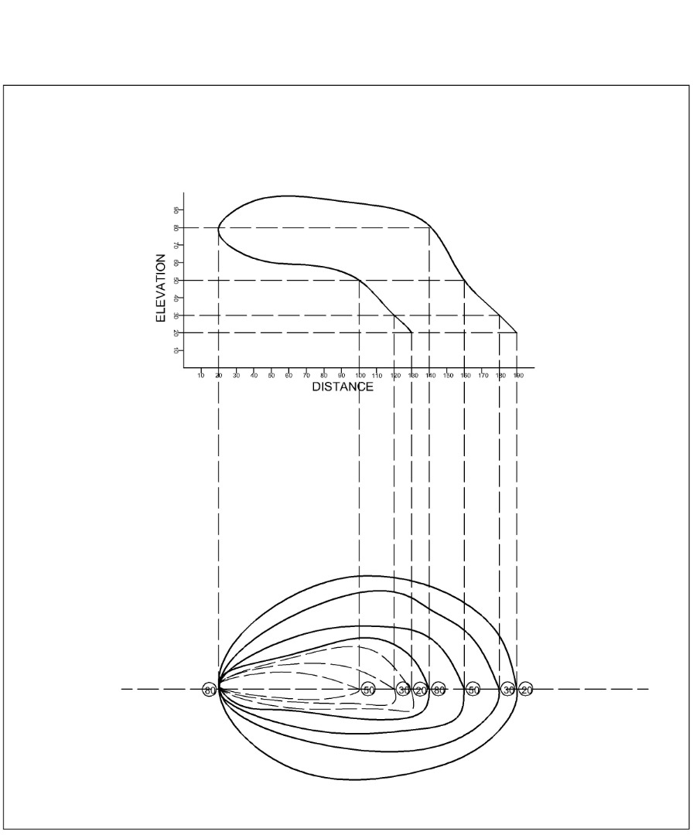

- Contours never run into one another except in the case of a vertical cliff. In other case, several contours coincide and the horizontal equivalent becomes zero.
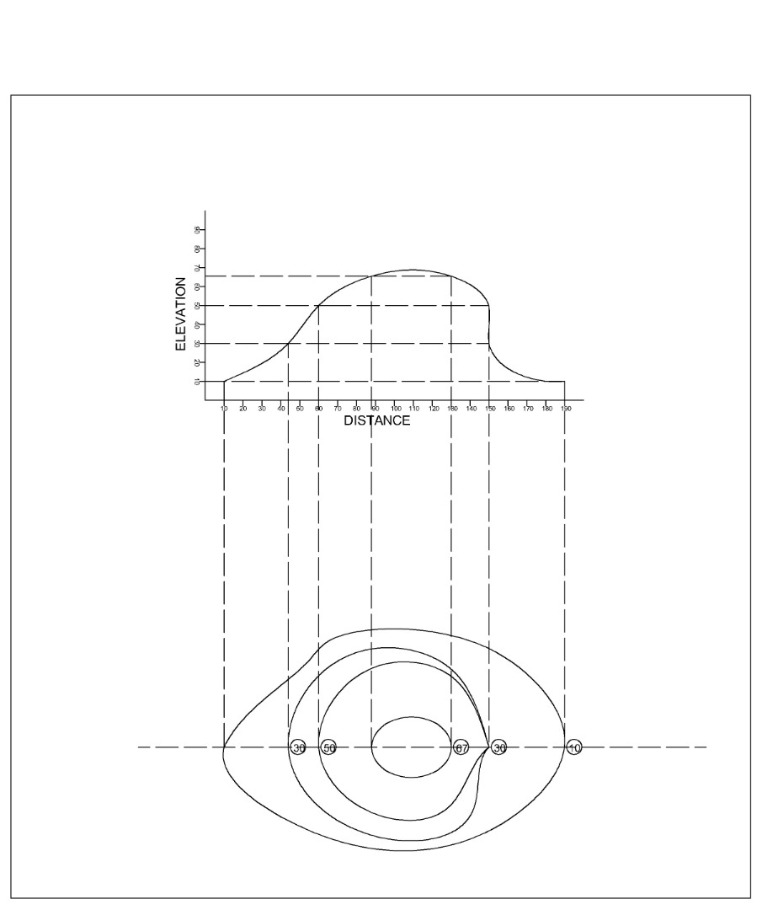

- Contour line crosses a ridge or valley at right angle. If the higher values are inside the bend/loop in the contour, it represents a ridge and if the higher values are outside the bend, it represents a valley.
