MATRIC NUMBER: 18/MHS01/160
NAME: FASIPE BLESSING
COURSE CODE: ANA 212
ASSIGNMENT: With the aid of a diagram, discuss the gross anatomy of the female external genitalia.

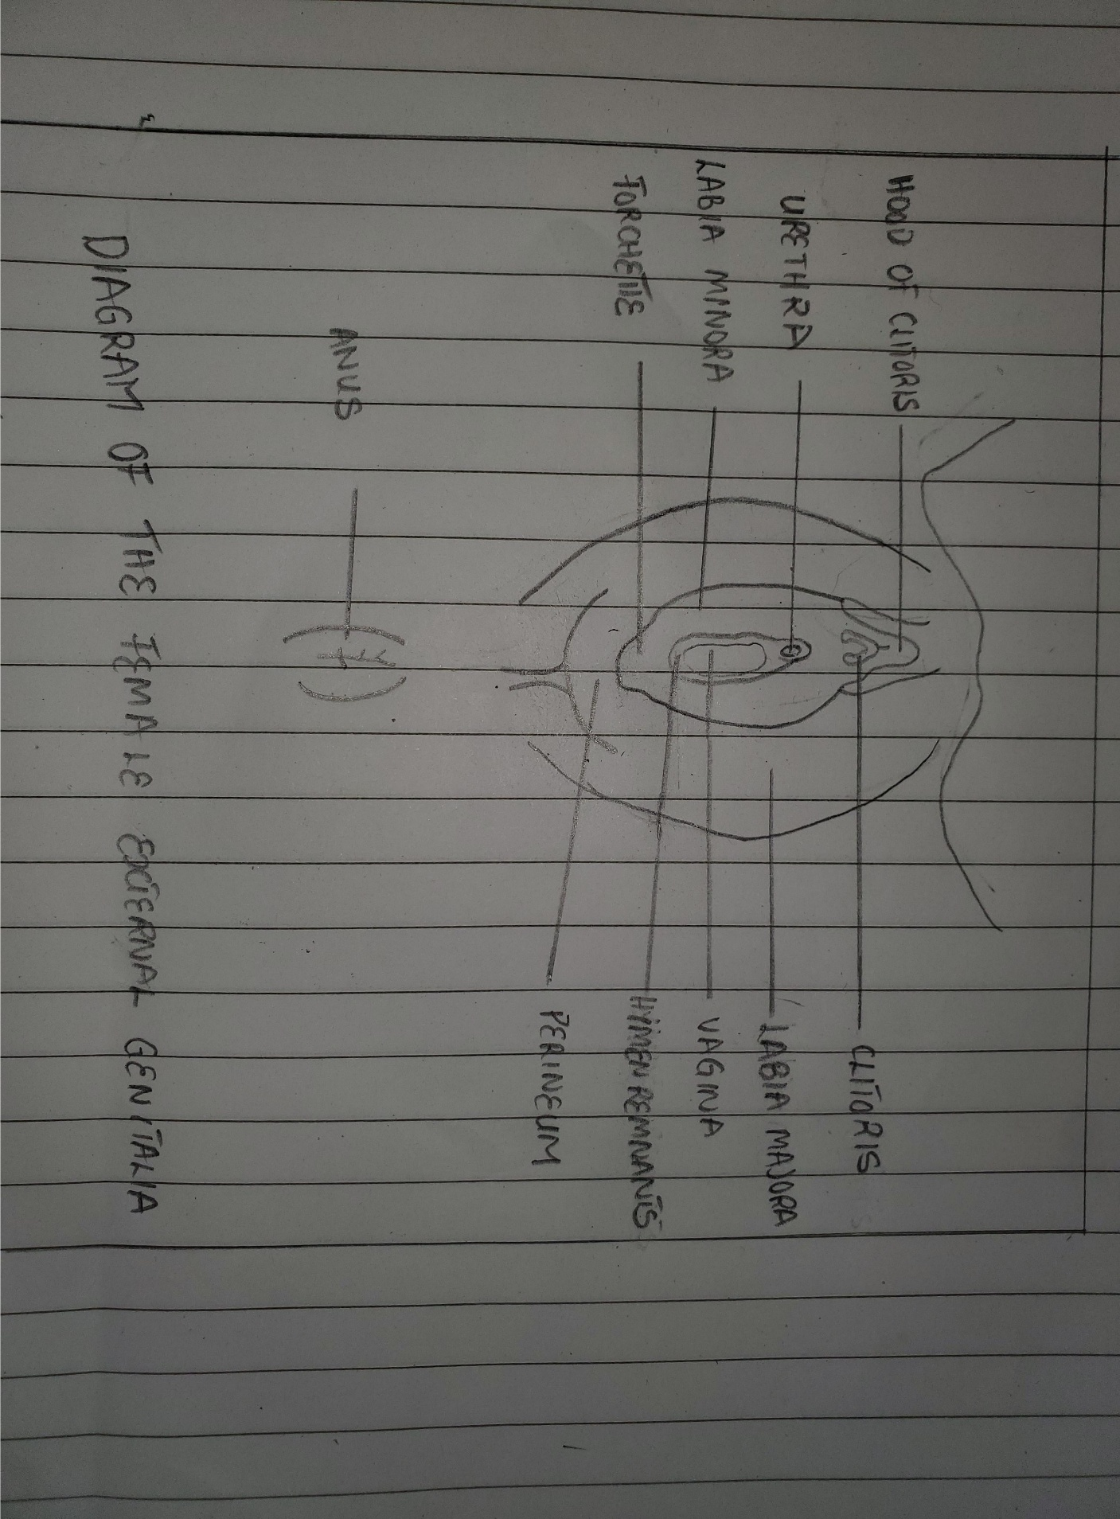

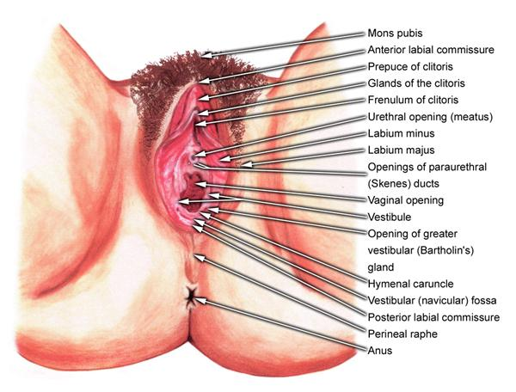

The external genitalia are the accessory structures of the female reproductive system that are external to the vagina. They are also referred to as the vulva or pudendum. The external genitalia lies outside the true pelvis. These include the perineum, mons pubis, clitoris, urethral (urinary) meatus, labia majora and minora, vestibule, greater vestibular (Bartholin) glands, Skene glands, and periurethral area. Components of the external female genitalia occupy a large part of the female perineum and together they are called the vulva.

The external genital organs have three main functions:
- Enabling sperm to enter the body
- Protecting the internal genital organs from infectious organisms
- Providing sexual pleasure

VULVA
The vulva is the external genitalia of the female reproductive tract, situated immediately external to the genital orifice.
Its development occurs during several phases, chiefly during the fetal and pubertal periods.
As the outer portal of the human uterus or womb, the vulva protects its opening with a “double door”: the labia majora (large lips) and the labia minora (small lips). The vulva also contains the opening of the female urethra, and thus serves the vital function of passing urine.
In human beings, major structures of the vulva are:
- The mons pubis
- The labia majora and the labia minora
- The external portion of the clitoris and the clitoral hood
- The vulval vestibule (vestibule of vagina)
- The pudendal cleft
- The frenulum labiorum pudendi or fourchette
- The opening (or urinary meatus) of the urethra
- The opening (or introitus) of the vagina
- The hymen
Other notable structures include:
- The perineum
- The sebaceous glands on labia majora
- The vaginal glands (Bartholin’s glands and paraurethral or Skene’s glands)

STRUCTURES OF VULVA
- Mons Pubis : The mons pubis consists of a rounded mass of subcutaneous adipose tissue anterior to the pubic symphysis. After the onset of puberty, the mons pubis and become covered by pubic hair. The mons pubis contains oil-secreting (sebaceous) glands that release substances that are involved in sexual attraction (pheromones).

- Labia Majora: The labia majora (singular, labium majus) are a pair of thick folds of skin and adipose tissue found inferior to the mons. The fissure between the folds is called the pudendal cleft. Pubic hair can be found on the lateral surfaces of the labia majora once puberty hits, while the medial/internal surfaces will remain hairless. The round ligament of the uterus passes through the inguinal canal and continues into the labia majora, where the nerve fibers spread and mix with the tissue of the mons pubis. The labia majora are thicker in the front where they form by joining the anterior commissure, and is found below the mons pubis. The posterior commissure of the labia majora is the rear joining of the labia majora, and is located above the perineum. The labia majora contain sweat and sebaceous glands, which produce lubricating secretions.

- Labia Minora : (literally, small lips) can be very small or up to 2 inches wide. They are found medial to the labia majora are the labia minora (singular, labium minus), which are much thinner devoid of fat and entirely hairless. Their frontal ends split to form upper and lower layers. The upper layer goes superior to the clitoris and forms a fold called prepuce. The lower layer passes inferior to clitoris and forms the frenulum of the clitoris. The labia minora lie just inside the labia majora and surround the openings to the vagina and urethra. A rich supply of blood vessels gives the labia minora a pink color. During sexual stimulation, these blood vessels become engorged with blood, causing the labia minora to swell and become more sensitive to stimulation.

- Clitoris: The clitoris is analogous to the structure of the penis but it does not contain urethra and has no urinary role. It is richly supplied with autonomic efferent motor nerve endings via the cavernosal nerve of the clitoris and is highly sensitive to sexual stimulation. Also unlike the penis, the clitoris is nearly entirely internal and does not have a corpus spongiosum or enclose the urethra. A prepuce, the clitoral hood, normally covers and protects the clitoris; however, in women with particularly large clitorises or small prepuces, the clitoris may be partially or wholly exposed. The clitoral hood is the female equivalent of the male foreskin and may be partially hidden inside of the pudendal cleft. The clitoris has a pair of corpora cavernosa which consist of erectile tissue enclosed in dense fibrous tissue. Each corpus (body) passes internally, and is attached to the ischiopubic ramus by a crus. The suspensory ligament and two small muscles (ischiocavernosi) are attached to the crura just like the penis. The glans (head) of the clitoris is a small tubercle, which protrudes slightly from the prepuce. Arteries here include the dorsal and clitoral cavernosal arteries, which arise from the iliohypogastric pudendal bed. It is innervated by the dorsal nerve of the clitoris, a terminal branch of the pudendal nerve.

- Vestibule and urethra: Between the clitoris and the vaginal introitus (opening) is a triangular area known as the vestibule, which extends to the posterior fourchette. The labia minora enclose an area called the vestibule, which contains the urinary and vaginal orifices along with the openings of the greater and lesser vestibular glands. The prepuce is found at the anterior margin of the vestibule.
The vestibule is where the urethral (urinary) meatus is found, approximately 1 cm anterior to the vaginal orifice, and it also gives rise to the opening of the Skene glands bilaterally. The urethra is composed of membranous connective tissue and links the urinary bladder to the vestibule externally. A female urethra ranges in length from 3.5 to 5.0 cm.

- Hymen: Most females (but not all) are born with a hymen, which is generally in the form of an elliptical/oval-shaped membranous ring around the vaginal orifice (It is generally perforated to some degree, most often in the centre, kind of like a 'donut' shape). The remnants of this membranous ring in adult females in known as hymenal caruncles, which appear as small thin elevations of mucous membrane around the vaginal opening. When the hymen completely covers the vaginal orifice, it is known as an imperforate hymen. An imperforate hymen may rupture naturally during various types of physical activity (aside from intercourse). Some females may undergo a hymenotomy, which involves the surgical removal, or opening of the hymen, most often to facilitate menstruation, or relieve discomfort during intercourse. This procedure may also be undertaken in the instance when the hymen is abnormally thick, and/or when the opening is small, limiting access to the vaginal orifice.
- Vestibular bulbs: The vestibular bulbs are 2 masses of erectile tissue that lie deep to the bulbocavernosus muscles bilaterally. Vestibular bulbs are located on each side of the vestibule. They consist of a pair of subcutaneous erectile tissues which correspond to the penile bulb and corpus spongiosum. Both bulbs join in front of urethral orifices under the vestibule of the vagina. The vestibule bulbs are two bulbs of erectile tissue that starts close to the inferior side of the body of the clitoris. The vestibular bulbs then extend towards the urethra and vagina on the medal edge of the crus of the clitoris. Eventually, the vestibular bulbs will split and surround the lateral border of the urethra and vaginal. The vestibular bulbs are believed to function closely with the clitoris. During sexual arousal, the vestibular bulbs will become engorged with blood. The engorgement of blood then exerts pressure onto the corpus cavernosum of the clitoris and the crus of the clitoris. This exertion of pressure onto the clitoris is believed to induce a pleasant sensation during sexual arousal.
- Vestibular glands (Skene and Bartholin glands):
  - Bartholin’s (greater vestibular): The Bartholin's glands also known as the greater vestibular glands (homologous to the bulbourethral glands in males) are two pea-sized glands located slightly lateral and posterior to the vagina opening. These two glands function to secrete a mucus-like substance into the vagina and within the borders of the labia minora. This mucus functions as a lubricant to decrease friction during intercourse and a moisturizer for the vulva.
  - Skene’s (paraurethral) glands: The Skene's glands, which are also known as the lesser vestibular glands (homologous to the prostate glands in males), are two glands located on either side of the urethra. These glands are believed to secrete a substance to lubricate the urethra opening. This substance is also believed to act as an antimicrobial. This antimicrobial is used to prevent urinary tract infections. The function of Skene's gland is not fully understood but is believed to be the source of female ejaculation during sexual arousal.

- Perineum: The perineum is the region between the genitals and the anus, including the perineal body and surrounding structures. the perineum is the surface region between the pubic symphysis and coccyx in both males and females, including the perineal body and surrounding structures. The boundaries vary in classification but generally include the genitals and anus. It is an erogenous zone for both males and females. The term perineum may refer to only the superficial structures in this region or be used to include both superficial and deep structures. Perineal tears and episiotomy often occur in childbirth with first-time deliveries, but the risk of these injuries can be reduced by preparing the perineum through massage.

BLOOD SUPPLY AND LYMPHATICS
Arterial Supply
The internal pudendal artery perfuses the majority of the external female genitalia. The internal pudendal artery is a branch of the internal iliac artery. Once the pudendal artery branches from the internal iliac artery, it descends towards the external genitalia. The internal pudendal artery will then become the dominant blood supply to the female external genitalia. The labia majora also received blood from the superficial external pudendal artery. The superficial external pudendal artery is a tributary of the femoral artery.
Venous Drainage
The venous drainage of the external female genitalia is via the external and internal pudendal veins. The external pudendal vein will drain towards the great saphenous vein. The saphenous vein will drain back into the femoral vein. As the femoral vein ascends pass the inguinal ligament, it becomes the external iliac vein. While the internal pudendal vein drains back into the internal iliac vein. Both the external and internal iliac veins will ascend and merge to form the common iliac veins. The common iliac veins from both sides of the body will ascend to about the level of the fourth lumbar vertebra. At the level of the fourth lumbar vertebra, the common iliac veins merge to drain venous blood back into the inferior vena cava. The inferior vena cava will ascend towards the heart. Upon reaching the heart, the inferior vena cava drains its venous blood back into the right atrium.

LYMPHATIC DRAINAGE
The lymphatic drainage of the external female genitalia drains toward the superficial inguinal lymph nodes except for the clitoris. The lymph from the clitoris will drain towards the deep inguinal lymph nodes. The lymph from the superficial and deep inguinal lymph nodes will ascend toward the common iliac lymph nodes. All of this lymph will ascend towards the distant part of the thoracic duct called the cisterna chyli. Once at the cisterna chyli, the lymph will drain into the thoracic duct and ascends toward the angle formed from the left subclavian vein and the left internal jugular vein. All of the lymph from the external female genitalia will drain back into the central circulation via the thoracic duct.

INNERVATION
The vulva is innervated from a variety of sources. The mons pubis and anterior labia is innervated via the anterior labial nerves, which derive from the lumbar plexus. The posterior aspect of the vulva is innervated via the pudendal nerve and its branches (posterior labial nerves), together with branches from the posterior cutaneous nerve of the thigh. Sensitive innervation to the clitoris is provided by the dorsal nerve of the clitoris.

MUSCLES
- Bulbospongiosus muscle.
- Ischiocavernosus muscle
- Deep transverse perineal muscle
- Superficial transverse perineal muscle
- Levator ani muscle
- External anal sphincter.
- Perineal body
- External urethral sphincter.

EPITHELIUM
Histologically, the vulva is predominantly keratinized, stratified squamous epithelium. The labia majora are composed of both sebaceous and sweat glands; the labia minora are made up of dense connective tissue with erectile tissue and elastic fibres.
The hymen consists of fibrous tissue with a few small blood vessels and is covered by stratified squamous epithelium. The body of the clitoris is composed of 2 channels of vessels and nerve endings that function as erectile tissue, the corpora cavernosa.

CLINICAL SIGNIFICANCE
Urinary Tract Infection: One common pathology that involves the urethra is a urinary tract infection (UTI). In urinary tract infections, the patient classically complains of dysuria, increased urination, foul-smelling urination, and cloudy urine. This condition commonly affects females due to their urethrae are shorter than males' urethrae. The short urethra in females allows the bacteria to ascend the urethra more readily, and the anatomical location of the urethra, vagina, and anus allows for cross-contamination between the vaginal and anal bacteria into the urethra. The most common bacteriologic etiology of urinary tract infections is gram-negative rods, with the most common bacteria being Escherichia coli.

