James Harrison

17/ENG03/024

Civil Engineering

CVE 310(ENGINEERING SURVEYING) ASSIGNMENT

QUESTION 1
1a)
Methods of levelling
- Height of collimation method
- Rise and fall method

Advantages of Height of Collimation Method
- It isn't time consuming as the calculation involved is small Calculation
- The accuracy of the method can be checked which makes little space for errors
- This system is suitable for longitudinal leveling where number of intermediate sights
Disadvantages of Height of Collimation Method
- There is no check on the RL of the intermediate sight
- Errors in the intermediate RLs cannot be detected.

Advantages Of Rise and Fall Method
- There is a check on the RL of the intermediate points
- Errors in the intermediate RLs can be detected as all the points are correlated
- There are three checks on the accuracy of RL calculation
- This system is suitable where there are no intermediate sights
Disadvantages Of Rise and Fall Method
- It is time consuming
- Having a visual representation for this method is necessary

1b)

B.S | I.S | F.S | H OF C | R.L | Remarks | DISTANCE
0.771 |  |  | 134.771 | 134 |  | 0
0.802 |  | 1.52 | 134.053 | 133.251 | C.P | 10
 | 2.311 |  |  | 131.742 |  | 20
3.580 |  | 1.990 | 135.643 | 132.063 | C.P | 30
 | 1.220 |  |  | 134.423 |  | 40
 | 3.675 |  |  | 131.968 |  | 50
2.408 |  | 4.020 | 134.031 | 131.623 | C.P | 60
 | 0.339 |  |  | 133.692 |  | 70
0.780 |  | 0.157 | 134.654 | 133.874 | C.P | 80
 | 1.535 |  |  | 133.119 |  | 90
 | 1.955 |  |  | 132.699 |  | 100
 | 2.430 |  |  | 132.224 |  | 110
 | 2.985 |  |  | 131.669 |  | 120
1.155 |  | 3.480 | 132.329 | 131.174 | C.P | 130
 | 1.960 |  |  | 130.369 |  | 140
 | 2.365 |  |  | 129.964 |  | 150
0.935 |  | 3.640 | 129.624 | 128.689 | C.P | 160
 | 1.045 |  |  | 128.579 |  | 170
 | 1.630 |  |  | 127.994 |  | 180
 |  | 2.545 |  | 127.079 |  | 190
$Σ$=10.431 |  | $Σ$=17.352

Calculations:
HC=RL+BS
HC(1)=124+0.711=134.771
RL=HC-FS
RL(1)=134.771-1.52=133.251
HC(2)=133.251+0.802=134.053
RL(2)=134.053-2.311=131.742
RL(3)=134.053-1.990=132.063
HC(3)=132.063+3.580=135.643
RL(4)=135.643-1.220=134.423
RL(5)=135.643-3.675=131.968
RL(6)=135.643-4.020=131.623
HC(4)=131.623+2.408=134.031
RL(7)= 134.031-0.339=133.692
RL(8)= 134.031-0.157=133.874
HC(5)=133.874+0.780=134.654
RL(9)= 134.654-1.535=133.119
RL(10)= 134.654-1.955=132.699
RL(11)= 134.654-2.430=132.224
RL(12)= 134.654-2.985=131.669
RL(13)= 134.654-3.480=131.174
HC(6)=131.174+1.155=132.329
RL(14)= 132.329-1.960=130.369
RL(15)= 132.329-2.365=129.964
RL(16)= 132.329-3.640=128.689
HC(7)=128.689+0.935=129.624
RL(17)= 129.624-1.045=128.579
RL(18)= 129.624-1.630=127.994
RL(19)= 129.624-2.545=127.079

Check=$ΣF.S-ΣB.S$=R.L at first point-R.L at last point
=6.921=6.921

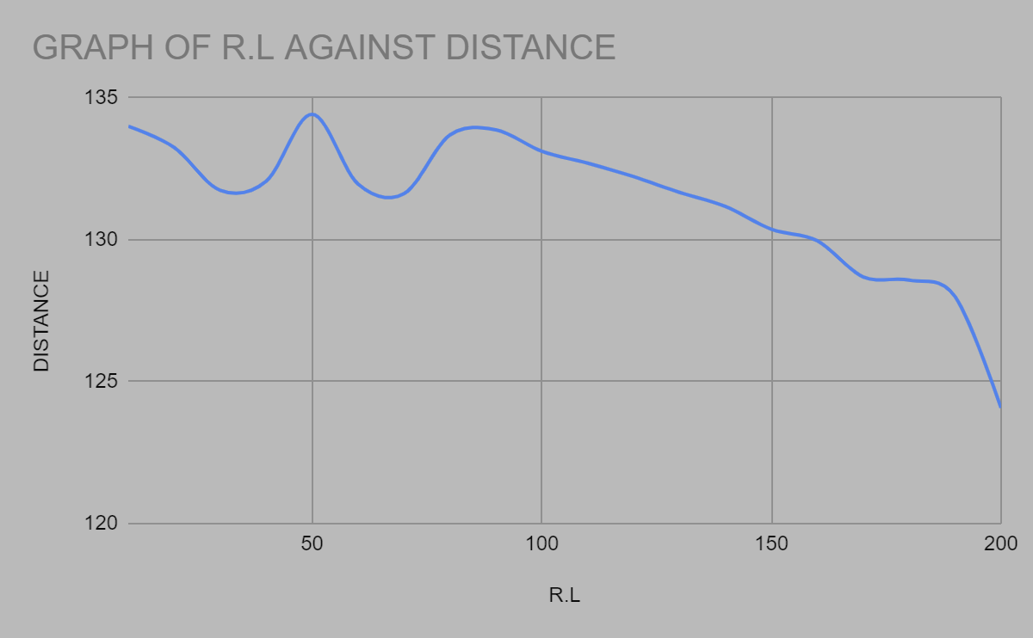

QUESTION 2

Chainage(m) | 0 | 30 | 60 | 90 | 120 | 150 | 180 | 210 | 240 | 270
Offset length(m) | 0 | 2.65 | 3.80 | 3.75 | 4.65 | 3.60 | 5.00 | 5.80 | 6.10 | 5.85

Using Mid-ordinate rule:
A=$Σ$hd

h1= $\frac{0+2.65}{2}$=1.325m

h2= $\frac{2.65+3.80}{2}$=3.225m

h3= $\frac{3.80+3.75}{2}$=3.775m

h4= $\frac{3.75+4.65}{2}$=4.2m

h5= $\frac{4.65+3.60}{2}$=4.125m

h6= $\frac{3.60+5.00}{2}$=4.3m

h7= $\frac{5.00+5.80}{2}$=5.4m

h8= $\frac{5.80+6.00}{2}$=5.9m

h9= $\frac{6.00+5.85}{2}$=5.925m

$Σh=1.325+3.225+3.775+4.2+4.125+4.3+5.4+5.9+5.925$
$Σh=$38.175m

d=30m
A=$Σhd$
= $38.175×30$
A= $1145.25m{}^{2}$

Using average ordinate rule

A=$\frac{ndΣO}{n+1}$

n=9

d=30
$ΣO=0+2.65+3.80+3.75+4.65+3.60+5.00+5.80+6.10+5.85$
$ΣO=$41.2m

A=$\frac{9×30×41.2}{9+1}$

A=$112.4m{}^{2}$

Using trapezoidal rule

A=$d(\frac{0{}_{1}+0{}_{n }}{2}$$+0{}_{2}+0{}_{3}+0{}_{4}............0{}_{n-1})$

$d=30$

A=$30(\frac{0+5.85}{2}$$+2.65+3.80+3.75+4.65+3.60+5.00+5.80+6.10)$

A=$30(38.275)$
A=$1148.25m{}^{2}$

Using Simpson's rule
$A=\frac{d }{3 }$$\left[\left(0{}_{1}+0{}_{n}\right)+4\left(0{}_{2}+0{}_{4}+.........0{}_{n-1}\right)+2\left(0{}_{3}+0{}_{5}........0{}_{n-1}\right)\right]$

$d=30$

Note: Last offset was removed because number of offsets were even

$A=\frac{30}{3 }$$\left[\left(0+6.10\right)+4\left(2.65+3.75+3.60+5,80\right)+2\left(3.80+4.65+5.00\right)\right]$
$A=962m{}^{2}$

Calculating for last offset using trapezoidal rule

A=$d(\frac{0{}_{1}+0{}_{n }}{2}$$+0{}_{2}+0{}_{3}+0{}_{4}............0{}_{n-1})$

$A=30\left[\frac{6.40+5.85}{2}\right]$
$A=183.75m{}^{2}$

Therefore $ΣA=962+183.75$

$A=1145.75m{}^{2}$

Question 2b

Characteristics of contours

- Depression between summits(saddle): Depression between summits is called a saddle. It is represented by 4 sets of contours

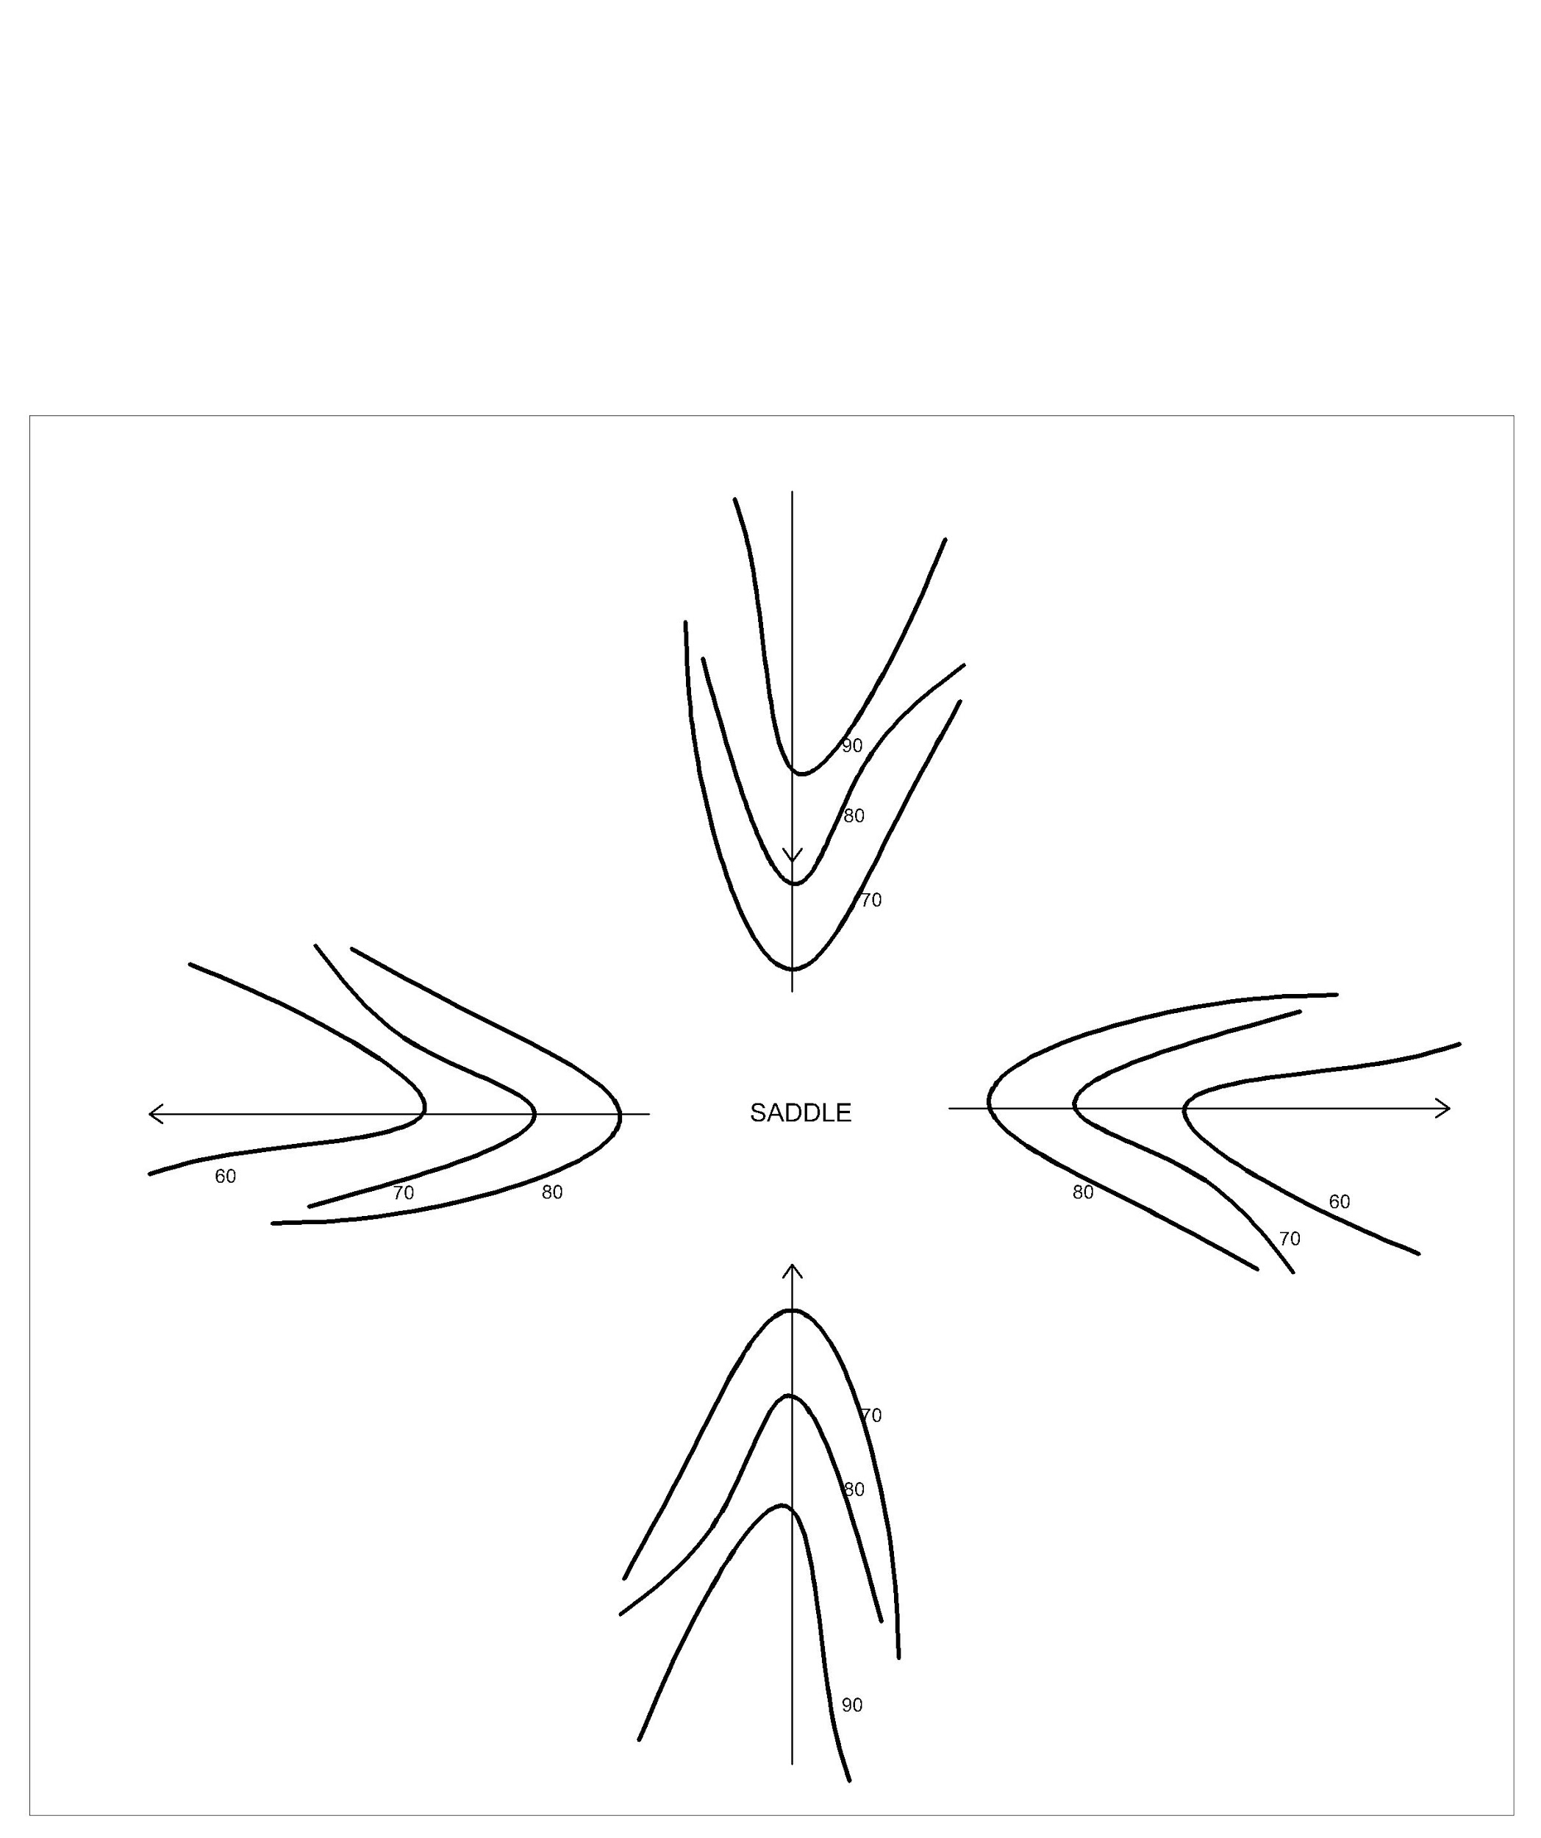

- Contour lines cannot end anywhere but close on themselves either within or outside the limit of the map

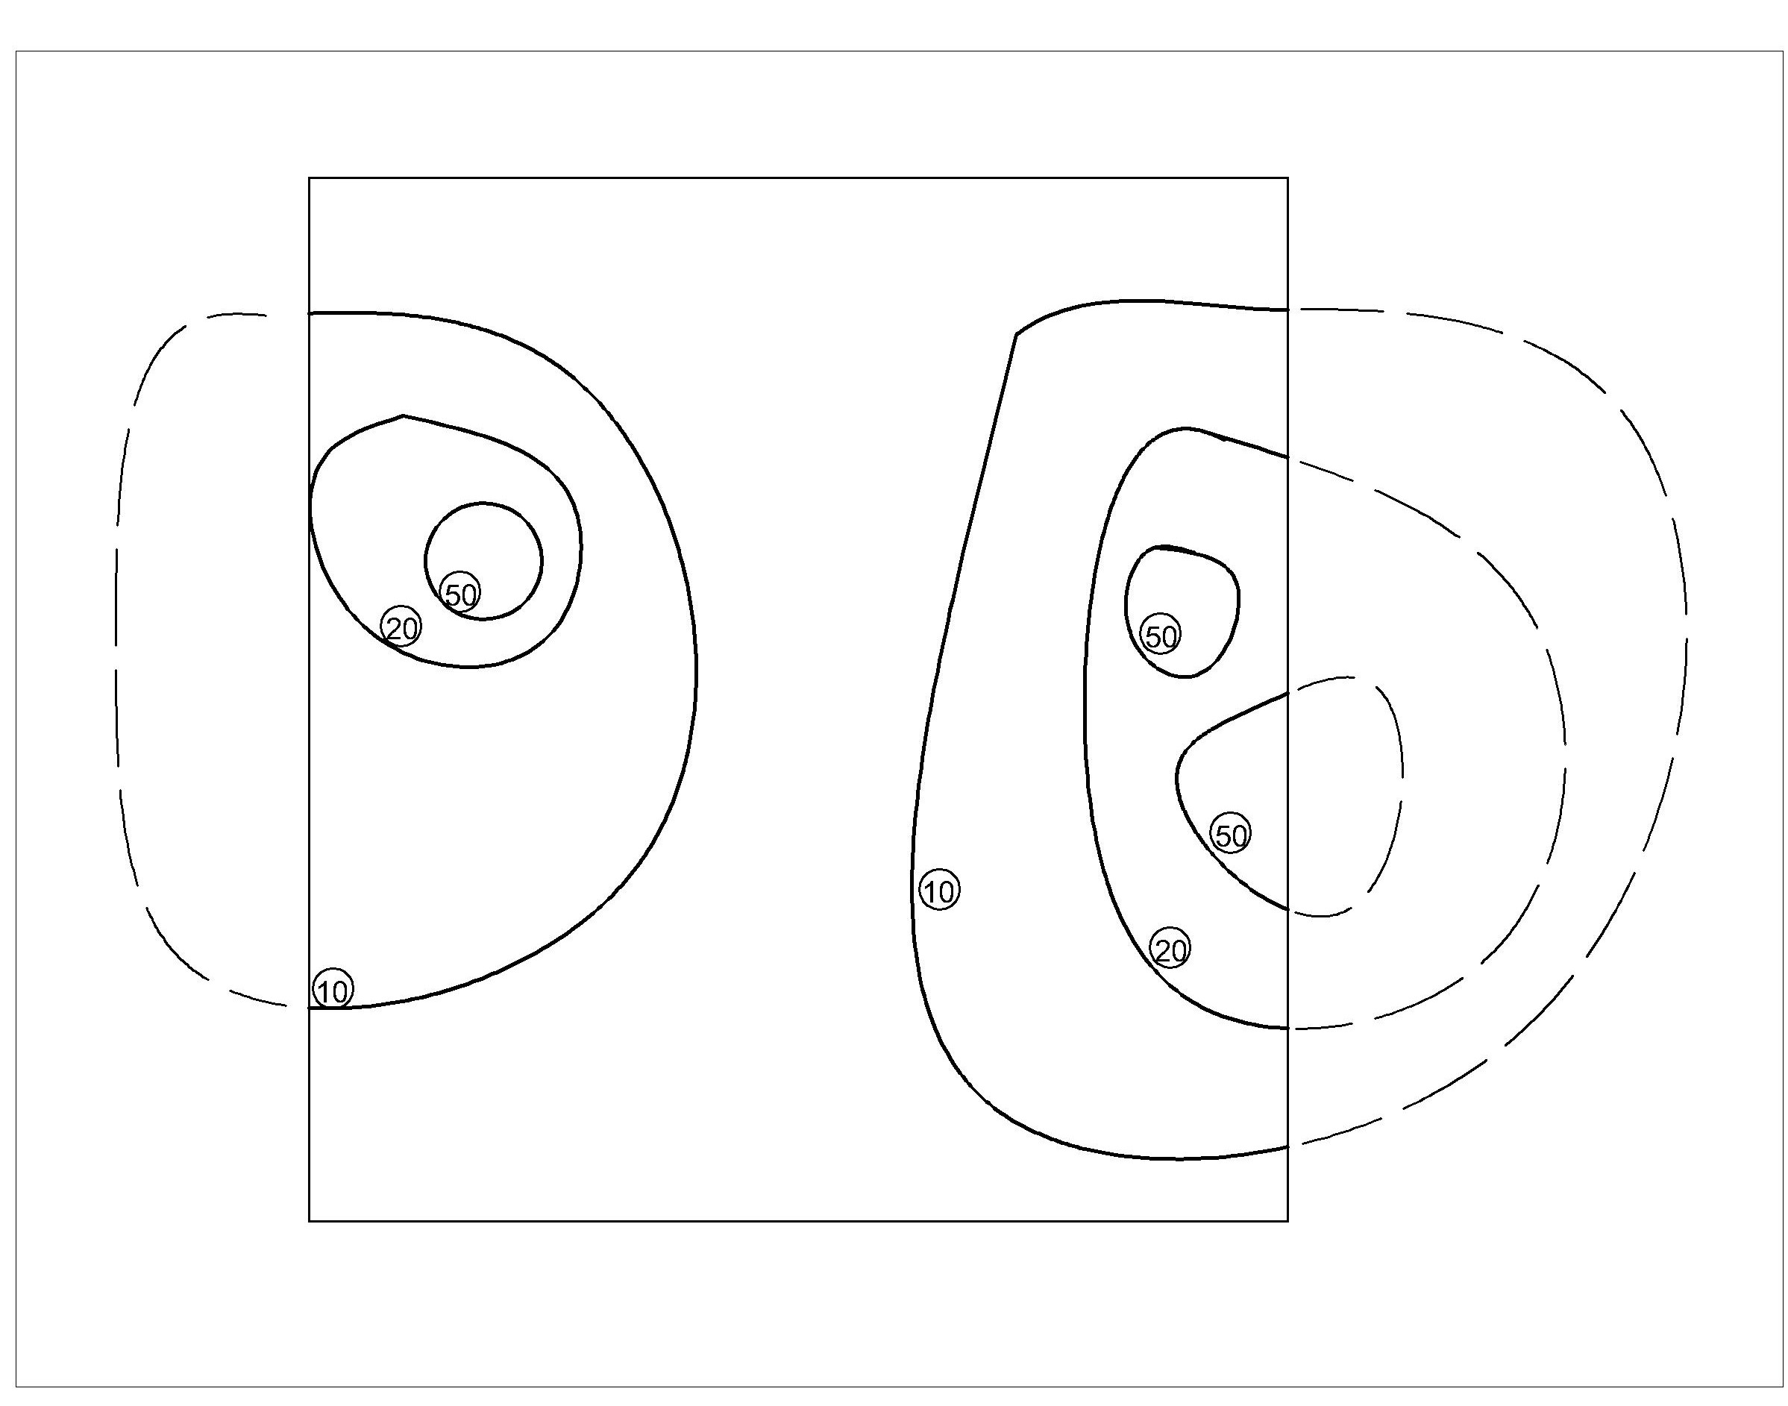

- Contour lines cross a ridge or valley at right angles. If the higher values are inside the bend or loop on the contour, it represents a ridge and if the higher values are outside a bend it represents a valley
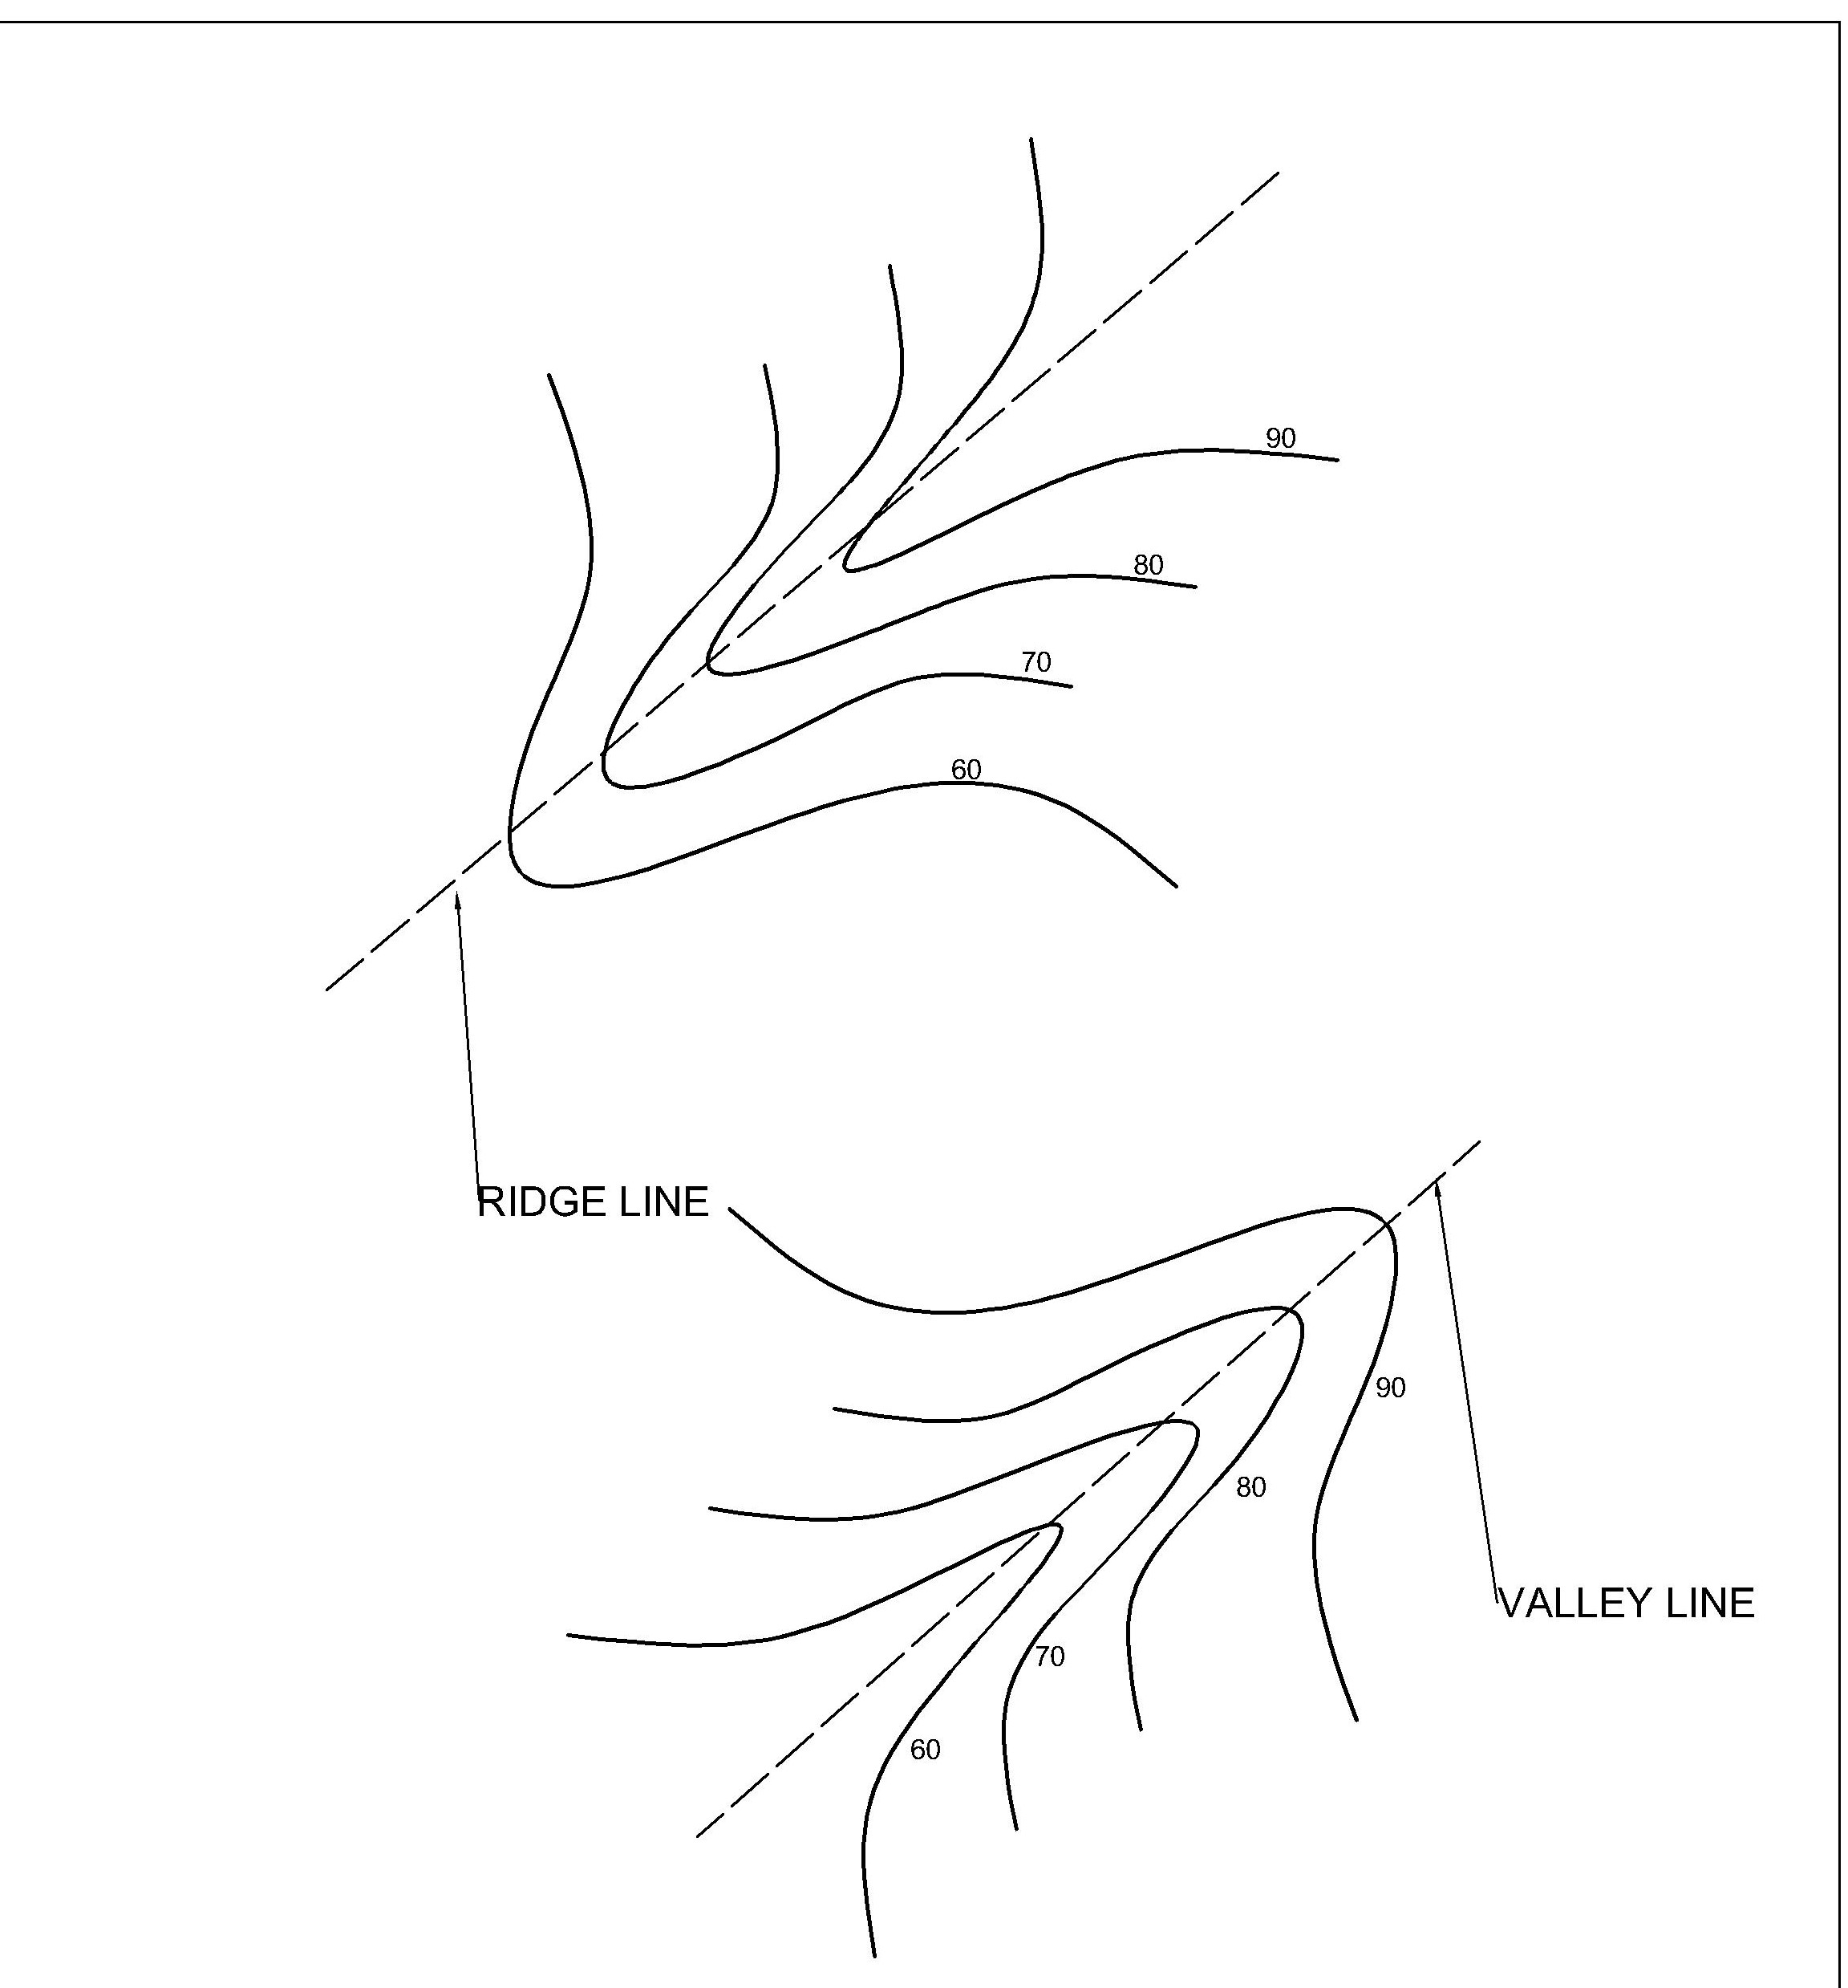

- Contours never run into 1 another unless in the case of a vertical cliff. In this case several contours coincide and the horizontal equivalent becomes zero.

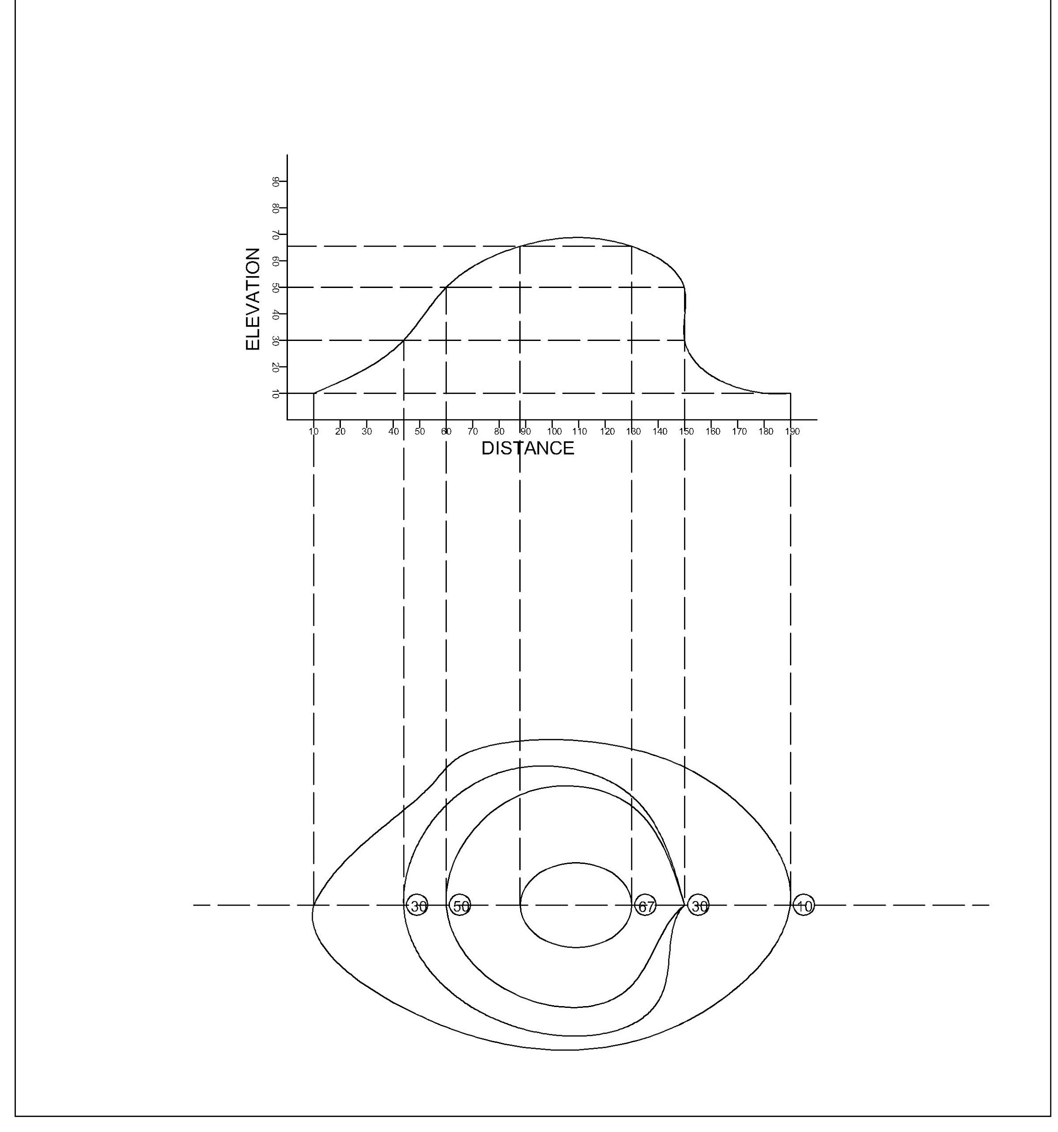

- Contour lines cannot merge or cross one another on a map except in the case of an overhanging cliff.

