IDOWU OLAGOKE
17/ENG03/025
CIVIL ENGINEERING
CVE 310
SURVEY
1a.)
Methods of levelling
- Rise and fall method
- Height of culmination method

RISE AND FALL METHOD
Advantages
- It is easy to spot errors.
- There is a check on the RL of the intermediate points
- Errors in the intermediate RLs can be detected as all the points are correlated
- There are three checks on the accuracy of RL calculation
- This system is suitable where there are no intermediate sights
Drawbacks
- it is tedious
- Visualization is necessary regarding the nature of the ground

HEIGHT OF CULIMINATION METHOD
Advantages
- It is faster than rise and fall method
- There are two checks on the accuracy of RL calculation
- This system is suitable for longitudinal leveling where number of intermediate sights
- Visualization is not necessary regarding the nature of the ground

Drawbacks
- There is no check on the RL of the intermediate sight
- Errors in the intermediate RLs cannot be detected.

1b.)
Rl =110+matric no=110+25=135
B.S | I.S | F.S | H OF C | R.L | DISTANCE | REMARKS
0.771 |  |  | 135.771 | 135 | 0 | RL
0.802 |  | 1.52 | 135.053 | 134.251 | 10 | CP
 | 2.311 |  |  | 132.742 | 20
3.580 |  | 1.990 | 136.643 | 133.663 | 30 | CP
 | 1.220 |  |  | 135.423 | 40
 | 3.675 |  |  | 132.968 | 50
2.408 |  | 4.020 | 135.031 | 132.623 | 60 | CP
 | 0.339 |  |  | 134.692 | 70
0.780 |  | 0.157 | 132.654 | 134.874 | 80 | CP
 | 1.535 |  |  | 134.119 | 90
 | 1.955 |  |  | 133.699 | 100
 | 2.430 |  |  | 133.224 | 110
 | 2.985 |  |  | 132.669 | 120
1.155 |  | 3.480 | 133.329 | 132.174 | 130 | CP
 | 1.960 |  |  | 131.369 | 140
 | 2.365 |  |  | 130.964 | 150
0.935 |  | 3.640 | 130.624 | 129.689 | 160 | CP
 | 1.045 |  |  | 129.579 | 170
 | 1.630 |  |  | 128.994 | 180
 |  | 2.545 |  | 128.079 | 190
$Σ$bs=10.431 |  | $Σ$fs=17.352

$Σ$fs-$Σ$bs=RL@first –RL@last
17.352-10.431=135-128.079
6.921 = 6.921
RL=HC + Staff readings
Rl(1) =110+matric no=110+25=135
Hc(1)=135+0.771=135.771
RL(2) = 135.771-1.52 =134.251
HC (2)= 134.251 +0.802=135.053
RL (3) =135.053-2.311 = 132.742
RL(4) = 135.053-1.990 =133.063
HC(4) = 133.063+3.580 = 136.643
RL(5) = 136.643-1.220=135.423
RL (6) = 136.643 -3.673 =132.968
RL(7) = 136.643 – 4.020 =132.623
HC (7) = 132.623 + 2.408 = 135.031
RL (8) = 135.031-0.339 = 134.692
RL (9) = 135.031-0.157 = 134.874
HC (9) = 134.874 + 0.780 = 135.654
RL (10) = 135.654 – 1.535 = 134.119
RL (11) =135.654-1.955 =133.699
RL(12) =135.654-2.430 =133.224
RL (13) = 135.654 – 2.985 = 132.669
RL (14) = 135.654 - 3.480 =132.174
HC (14) = 132.174 + 1.155 = 133.329
RL(15) = 133.329 -1.960 =131.369
RL (16) =133.329 -2.365 = 130.964
RL (`17) = 133.329-3.640 = 129.689
HC (17) = 129.689 +O.935 =130.624
RL (18) =130.624-1.045 =129.579
RL (19) =130.624 – 1.630 =128.994
RL (20) = 130.624 – 2.545 = 128 .079

2a.)

Chainage(m) | 0 | 30 | 60 | 90 | 120 | 150 | 180 | 210 | 240 | 270
Offset length(m) | 0 | 2.65 | 3.80 | 3.75 | 4.65 | 3.60 | 5.00 | 5.80 | 6.10 | 5.85

Using Mid-ordinate rule:
A=$Σ$hd

h1= $\frac{0+2.65}{2}$=1.325m

h2= $\frac{2.65+3.80}{2}$=3.225m

h3= $\frac{3.80+3.75}{2}$=3.775m

h4= $\frac{3.75+4.65}{2}$=4.2m

h5= $\frac{4.65+3.60}{2}$=4.125m

h6= $\frac{3.60+5.00}{2}$=4.3m

h7= $\frac{5.00+5.80}{2}$=5.4m

h8= $\frac{5.80+6.00}{2}$=5.9m

h9= $\frac{6.00+5.85}{2}$=5.925m

$$Σh=1.325+3.225+3.775+4.2+4.125+4.3+5.4+5.9+5.925$$
$Σh=$38.175m

d=30m
A=$Σhd$
= $38.175×30$
A= $1145.25m$²

Using average ordinate rule

A=$\frac{ndΣO}{n+1}$

n=9

d=30
$$ΣO=0+2.65+3.80+3.75+4.65+3.60+5.00+5.80+6.10+5.85$$
$ΣO=$41.2m

A=$\frac{9×30×41.2}{9+1}$

A=$112.4m$²

Using trapezoidal rule

A=$d(\frac{0{}_{1}+0{}_{n }}{2}+0{}_{2}+0{}_{3}+0{}_{4}............0{}_{n-1})$

$$d=30$$

A=$30(\frac{0+5.85}{2}+2.65+3.80+3.75+4.65+3.60+5.00+5.80+6.10)$

A=$30(38.275)$
A=$1148.25m{}^{2}$

Using Simpson's rule
$$A=\frac{d }{3 }\left[\left(0{}_{1}+0{}_{n}\right)+4\left(0{}_{2}+0{}_{4}+.........0{}_{n-1}\right)+2\left(0{}_{3}+0{}_{5}........0{}_{n-1}\right)\right]$$

$$d=30$$

Note: Last offset was removed because number of offsets were even

$$A=\frac{30}{3 }\left[\left(0+6.10\right)+4\left(2.65+3.75+3.60+5,80\right)+2\left(3.80+4.65+5.00\right)\right]$$
$A=962m$²

Calculating for last offset using trapezoidal rule

A=$d(\frac{0{}_{1}+0{}_{n }}{2}+0{}_{2}+0{}_{3}+0{}_{4}............0{}_{n-1})$

$$A=30\left[\frac{6.40+5.85}{2}\right]$$
$$A=183.75m{}^{2}$$

Therefore $ΣA=962+183.75$

$$A=1145.75m{}^{2}$$
2b.)
Characteristics of contours
- All points on a contour have the same elevations.
- Flat ground is indicated where the contour are widely separated and the steep are shown where the contour lines draw close to each other.
- A series of closed contour lines on a map represents a hill, if the higher values are inside.
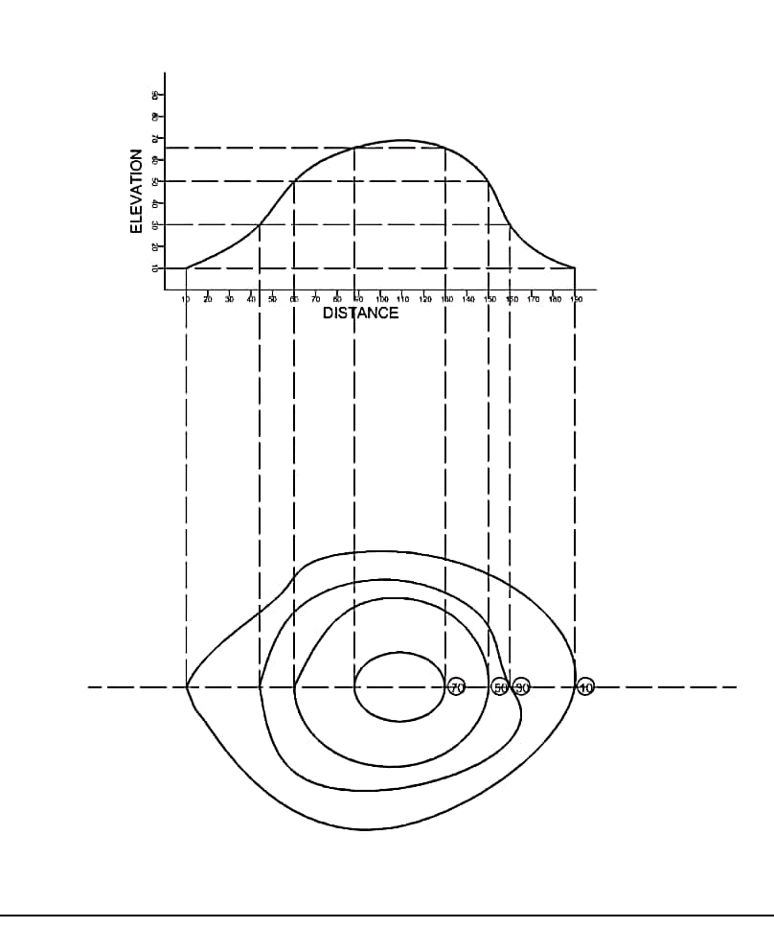
- A series of closed contour lines on a map indicates a depression, if the higher values are outside.
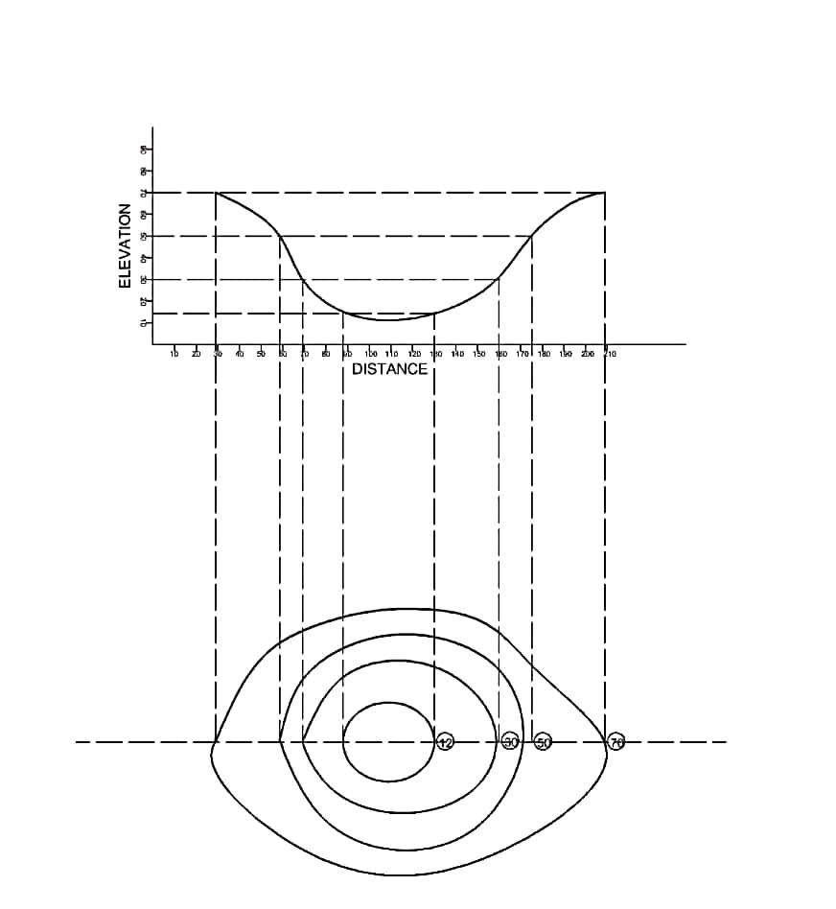
- Contour lines crosses a bridge or a valley at right angle. If higher values are inside the bend in the contour it represents a ridge while if higher values are outside the bend it represents a valley.
