30/04/2020

Name: OFOEYENO KelVin

MATRIC NO: 19/ENG03/034

DEPT: CIVIL ENGINEERING

A Zener diode is a silicon semiconductor device that permits current to flow in either a forward or reverse direction. The diode consists of a special, heavily doped p-n junction, designed to conduct in the reverse direction when a certain specified voltage is reached.
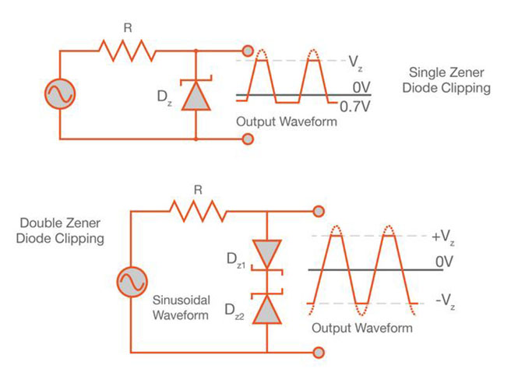

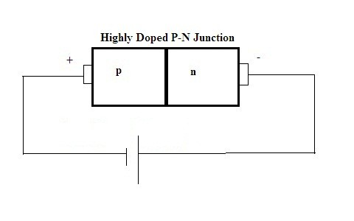

Max power = 5w, Iz = 500mA = 0.5A , Vs = 20vmax,

Maximum current= Max power/voltage = 5W/V = 0.5A

Vz = 10volts

Maximum Resistance = (Vs-Vz)/Iz

Vdc = 0.637vmax = 0.637 * 20 = 12.74vdc

Minimum Vdc = (12.74-10)/0.5 = 5.48Ohms

Load Current = Il = Vz/Rl = 10/500 =0.02A or 20mA

Iz = Is – Il = 500 – 20 = 480mA.

