1a.

Rise and Fall :
- It is easy to spot errors
- It is tedious
- It is preffered if there are many intermediate stations
- It has more calculations.

Height Of Collimation:
- It is faster than rise and fall
- It is fairly
- It is preffered if there are less or no intermediate stations
- It is quicker and less of calculation needed.

QUESTION 2a

Chainage(m) | 0 | 30 | 60 | 90 | 120 | 150 | 180 | 210 | 240 | 270
Offset length(m) | 0 | 2.65 | 3.80 | 3.75 | 4.65 | 3.60 | 5.00 | 5.80 | 6.10 | 5.85

Using Mid-ordinate rule:
A=$Σ$hd

h1= $\frac{0+2.65}{2}$=1.325m

h2= $\frac{2.65+3.80}{2}$=3.225m

h3= $\frac{3.80+3.75}{2}$=3.775m

h4= $\frac{3.75+4.65}{2}$=4.2m

h5= $\frac{4.65+3.60}{2}$=4.125m

h6= $\frac{3.60+5.00}{2}$=4.3m

h7= $\frac{5.00+5.80}{2}$=5.4m

h8= $\frac{5.80+6.00}{2}$=5.9m

h9= $\frac{6.00+5.85}{2}$=5.925m

$$Σh=1.325+3.225+3.775+4.2+4.125+4.3+5.4+5.9+5.925$$
$Σh=$38.175m

d=30m
A=$Σhd$
= $38.175×30$
A= $1145.25m{}^{2}$

Using average ordinate rule

A=$\frac{ndΣO}{n+1}$

n=9

d=30
$$ΣO=0+2.65+3.80+3.75+4.65+3.60+5.00+5.80+6.10+5.85$$
$ΣO=$41.2m

A=$\frac{9×30×41.2}{9+1}$

A=$112.4m{}^{2}$

Using trapezoidal rule

A=$d(\frac{0{}_{1}+0{}_{n }}{2}+0{}_{2}+0{}_{3}+0{}_{4}............0{}_{n-1})$

$$d=30$$

A=$30(\frac{0+5.85}{2}+2.65+3.80+3.75+4.65+3.60+5.00+5.80+6.10)$

A=$30(38.275)$
A=$1148.25m{}^{2}$

Using Simpson's rule
$$A=\frac{d }{3 }\left[\left(0{}_{1}+0{}_{n}\right)+4\left(0{}_{2}+0{}_{4}+.........0{}_{n-1}\right)+2\left(0{}_{3}+0{}_{5}........0{}_{n-1}\right)\right]$$

$$d=30$$

Note: Last offset was removed because number of offsets were even

$$A=\frac{30}{3 }\left[\left(0+6.10\right)+4\left(2.65+3.75+3.60+5,80\right)+2\left(3.80+4.65+5.00\right)\right]$$
$$A=962m{}^{2}$$

Calculating for last offset using trapezoidal rule

A=$d(\frac{0{}_{1}+0{}_{n }}{2}+0{}_{2}+0{}_{3}+0{}_{4}............0{}_{n-1})$

$$A=30\left[\frac{6.40+5.85}{2}\right]$$
$$A=183.75m{}^{2}$$

Therefore $ΣA=962+183.75$

$$A=1145.75m{}^{2}$$
2b

NolivALlJlLlJ
contour lines cannot merge or cross one another except in the case of an hanging beam
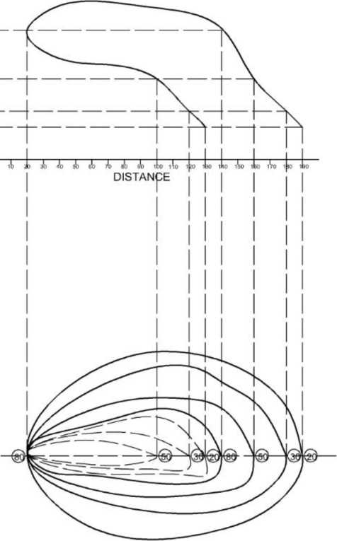

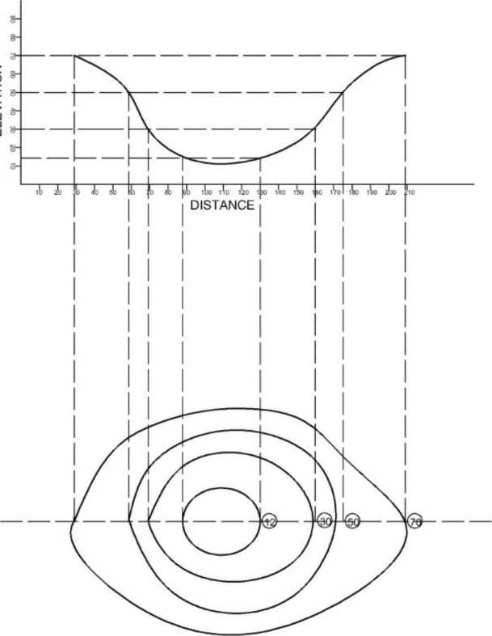

NOI1<>11J_J山

