ONIHA ROBERT AGBONIGHALE
17/ENG03/046
CIVIL ENGINEERING
1a) Methods of levelling
Height of collimation system
Advantages
- It is rapid as it involves few Calculation
- There are two checks on the accuracy of RL calculation
- This system is suitable for longitudinal levelling where number of intermediate sights
- Visualization is not necessary regarding the nature of the ground
Disadvantages
- There is no check on the RL of the intermediate sight
- Errors in the intermediate RLs cannot be detected.

Rise and fall system
Advantages
- There is a check on the RL of the intermediate points
- Errors in the intermediate RLs can be detected as all the points are correlated
- There are three checks on the accuracy of RL calculation
- This system is suitable where there are no intermediate sights
Disadvantages
- It is laborious involving several calculations.
- Visualization is necessary regarding the nature of the ground

1b)
RL=110+matric No.=110+46=156
B.S | I.S | F.S | H OF C | R.L | CHAINAGE | REMARKS
0.771 |  |  | 156.771 | 156 | 0 | RL
0.802 |  | 1.52 | 156.053 | 155.251 | 10 | CP
 | 2.311 |  |  | 153.742 | 20
3.580 |  | 1.990 | 157.643 | 154.063 | 30 | CP
 | 1.220 |  |  | 156.423 | 40
 | 3.675 |  |  | 153.968 | 50
2.408 |  | 4.020 | 156.031 | 153.623 | 60 | CP
 | 0.339 |  |  | 155.692 | 70
0.780 |  | 0.157 | 156.654 | 155.874 | 80 | CP
 | 1.535 |  |  | 155.119 | 90
 | 1.955 |  |  | 154.699 | 100
 | 2.430 |  |  | 154.224 | 110
 | 2.985 |  |  | 153.669 | 120
1.155 |  | 3.480 | 154.329 | 153.174 | 130 | CP
 | 1.960 |  |  | 152.369 | 140
 | 2.365 |  |  | 151.964 | 150
0.935 |  | 3.640 | 151.624 | 150.689 | 160 | CP
 | 1.045 |  |  | 150.579 | 170
 | 1.630 |  |  | 149.994 | 180
 |  | 2.545 |  | 146.079 | 190
$Σ$=10.431 |  | $Σ$=17.352

HC=RL+BS
HC(1)=156+0.711=156.771
RL=HC-FS
RL(1)=156.771-1.52=155.251
HC(2)=155.251+0.802=156.053
RL(2)=156.053-2.311=153.742
RL(3)=156.053-1.990=154.063
HC(3)=154.063+3.580=157.643
RL(4)=157.643-1.220=156.423
RL(5)=157.643-3.675=153.968
RL(6)=157.643-4.020=153.623
HC(4)=153.623+2.408=156.031
RL(7)= 156.031-0.339=155.692
RL(8)= 156.031-0.157=155.874
HC(5)=156.654+0.780=156.654
RL(9)= 156.654-1.535=155.119
RL(10)= 156.654-1.955=154.699
RL(11)= 156.654-2.430=154.224
RL(12)= 156.654-2.985=153.669
RL(13)= 156.654-3.480=153.174
HC(6)=154.329+1.155=154.329
RL(14)= 154.329-1.960=152.369
RL(15)= 154.329-2.365=151.964
RL(16)= 154.329-3.640=150.689
HC(7)=150.689+0.935=151.624
RL(17)= 151.624-1.045=150.579
RL(17)= 151.624-1.630=149.994
RL(17)= 151.624-2.545=146.079

Check=$ΣF.S-ΣB.S$=R.L at first point-R.L at last point
=6.921=6.921

2a)

Chainage(m) | 0 | 30 | 60 | 90 | 120 | 150 | 180 | 210 | 240 | 270
Offset length(m) | 0 | 2.65 | 3.80 | 3.75 | 4.65 | 3.60 | 5.00 | 5.80 | 6.10 | 5.85

- Using average ordinate rule;

A=ndΣO/(n+1)

n=9

d=30
ΣO=0+2.65+3.80+3.75+4.65+3.60+5.00+5.80+6.10+5.85
ΣO=41.2m

A=(9×30×41.2)/(9+1)

A=1112.4m²

- Using Mid-ordinate rule;
A=$Σ$hd

h1= $\frac{0+2.65}{2}$=1.325m

h2= $\frac{2.65+3.80}{2}$=3.225m

h3= $\frac{3.80+3.75}{2}$=3.775m

h4= $\frac{3.75+4.65}{2}$=4.2m

h5= $\frac{4.65+3.60}{2}$=4.125m

h6= $\frac{3.60+5.00}{2}$=4.3m

h7= $\frac{5.00+5.80}{2}$=5.4m

h8= $\frac{5.80+6.00}{2}$=5.9m

h9= $\frac{6.10+5.85}{2}$=5.925m

$$Σh=1.325+3.225+3.775+4.2+4.125+4.3+5.4+5.9+5.925$$
$Σh=$38.175m

d=30m
A=$Σhd$
= $38.175×30$
A= $1145.25m{}^{2}$

- Using trapezoidal rule;

A=$d(\frac{0{}_{1}+0{}_{n }}{2}+0{}_{2}+0{}_{3}+0{}_{4}............0{}_{n-1})$

$$d=30$$

A=$30(\frac{0+5.85}{2}+2.65+3.80+3.75+4.65+3.60+5.00+5.80+6.10)$

A=$30(38.275)$
A=$1148.25m{}^{2}$

- Using Simpson's rule;
$$A=\frac{d }{3 }\left[\left(0{}_{1}+0{}_{n}\right)+4\left(0{}_{2}+0{}_{4}+.........0{}_{n-1}\right)+2\left(0{}_{3}+0{}_{5}........0{}_{n-1}\right)\right]$$

$$d=30$$

$$A=\frac{30}{3 }\left[\left(0+6.10\right)+4\left(2.65+3.75+3.60+5,80\right)+2\left(3.80+4.65+5.00\right)\right]$$
$$A=962m{}^{2}$$

Calculating for last offset using trapezoidal rule

A=$d(\frac{0{}_{1}+0{}_{n }}{2}+0{}_{2}+0{}_{3}+0{}_{4}............0{}_{n-1})$

$$A=30\left[\frac{6.40+5.85}{2}\right]$$
$$A=183.75m{}^{2}$$

Therefore $ΣA=962+183.75$

$$A=1145.75m{}^{2}$$

2b)
Characteristics of contours
- Approximately concentric closed contours with decreasing values towards centre indicate a pond or depression. 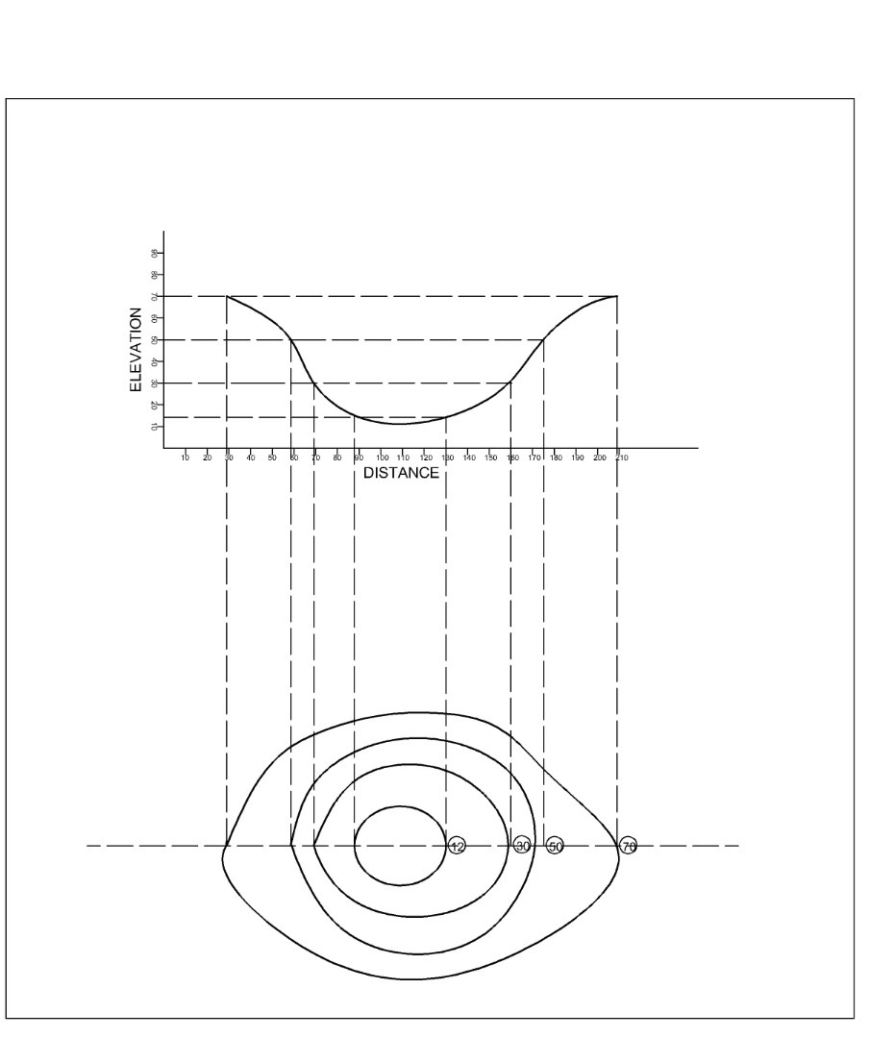
- Approximately concentric closed contours with increasing values towards centre indicate hills.
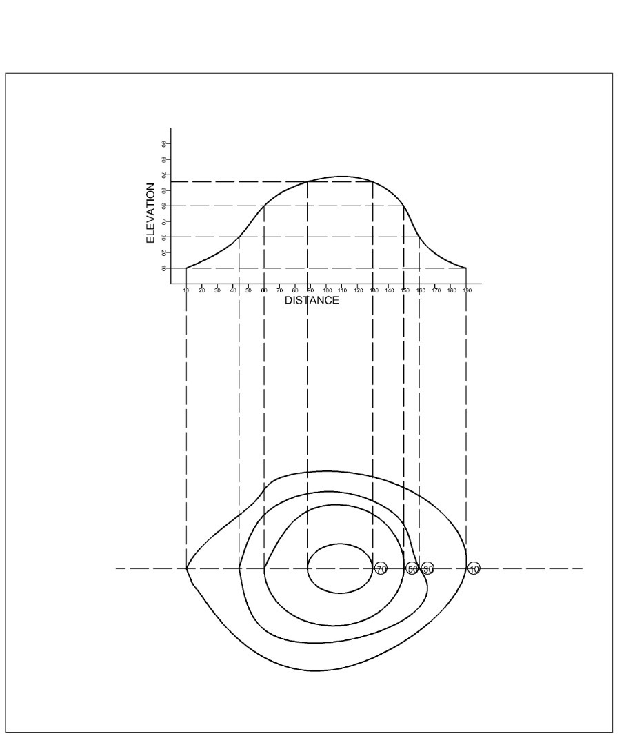
- U-shaped contour lines with convexity towards lower ground indicate ridge while U-shaped contour lines with convexity towards higher ground indicate valley.
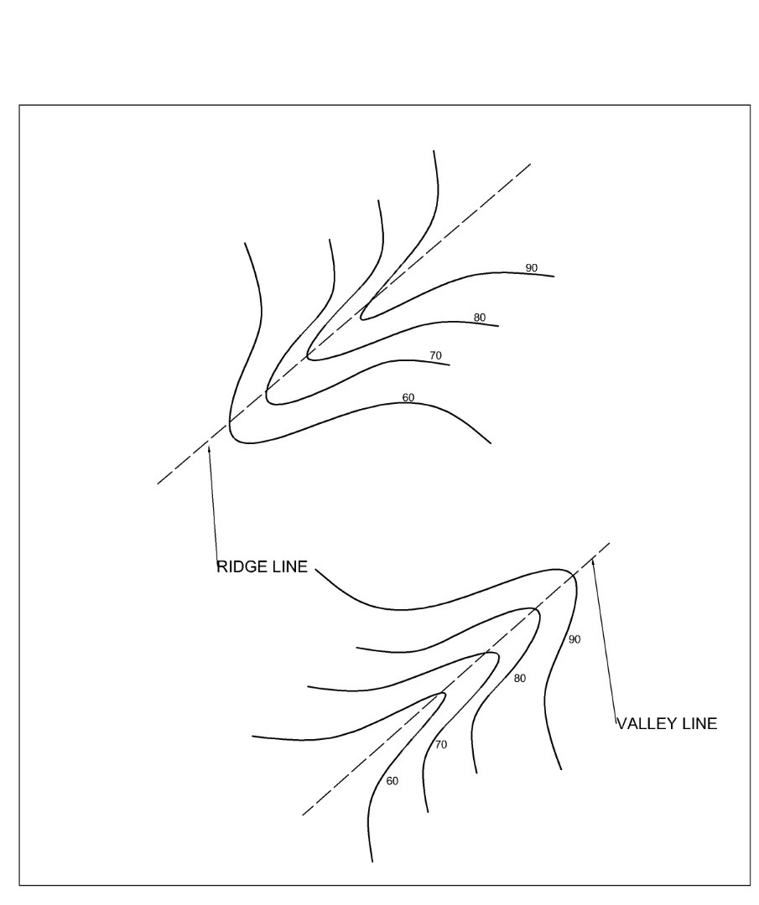
- Contours of different elevations cannot cross each other. If contour lines cross each other, it shows existence of overhanging cliffs or a cave.
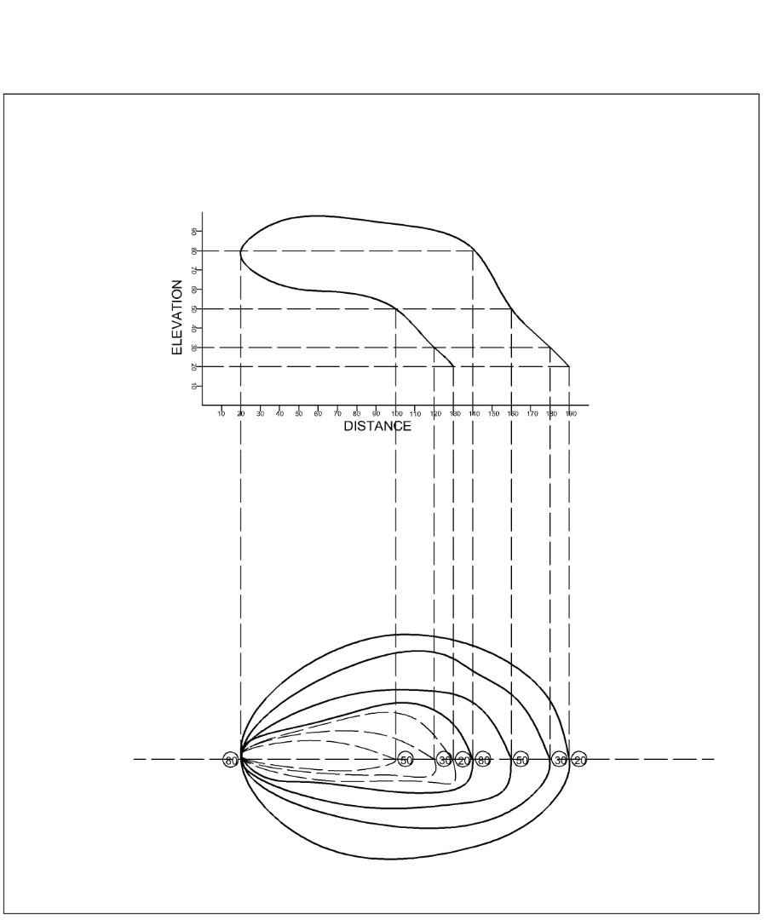
- Contour lines generally do not meet or intersect each other. If contour lines are meeting in some portion, it shows existence of a vertical cliff.
