Question 2
MESNSTURAL CYCLE
menstruation is the process in a woman of discharging blood and other materials from the lining of the uterus at about one monthly interval from puberty until menopause , except during pregnancy. This discharging process lasts about 3-5 days. This cycle starts during puberty.A brain structure called the hypothalamus causes the nearby pituitary gland to produce certain chemicals, which prompt the ovaries to produce the sex hormones oestrogen and progesterone.

A cycle is counted from the first day of 1 period to the first day of the next period. The average menstural cycle is 28 days long. Cycles can range anywhere from 21 to 35 days in adults and from 21 to 45 days in young teens. The rise and fall of levels of hormones during the month control the menstrual cycle.

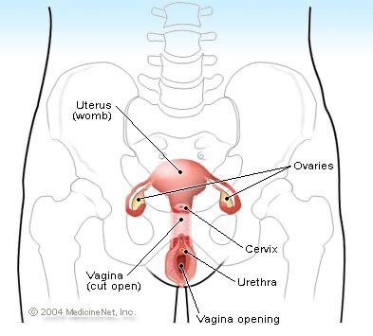

The menstrual cycle is the hormonal driven cycle; Day 1 is the first day of your period (bleeding) while day 14 is the approximate day you ovulate and if an egg is not fertilized, hormone levels eventually drop and at about day 25; the egg begins to dissolve and the cycle begins again with the period at about day 30. Menstruation begins day 1 and normally ends days 3-5 of the menstrual cycle.

PHASES OF MENSTURAL CYCLE
The four main phases of the menstrual cycle are:
- menstruation
- the follicular phase
- ovulation
- the luteal phase.

Menstruation
Menstruation is the elimination of the thickened lining of the uterus (endometrium) from the body through the vagina. Menstrual fluid contains blood, cells from the lining of the uterus (endometrial cells) and mucus. The average length of a period is between three days and one week.

Follicular phase
The follicular phase starts on the first day of menstruation and ends with ovulation. Prompted by the hypothalamus, the pituitary gland releases follicle stimulating hormone (FSH). This hormone stimulates the ovary to produce around five to 20 follicles (tiny nodules or cysts), which bead on the surface.
Each follicle houses an immature egg. Usually, only one follicle will mature into an egg, while the others die. This can occur around day 10 of a 28-day cycle. The growth of the follicles stimulates the lining of the uterus to thicken in preparation for possible pregnancy.

Ovulation
Ovulation is the release of a mature egg from the surface of the ovary. This usually occurs mid-cycle, around two weeks or so before menstruation starts.
During the follicular phase, the developing follicle causes a rise in the level of oestrogen. The hypothalamus in the brain recognises these rising levels and releases a chemical called gonadotrophin-releasing hormone (GnRH). This hormone prompts the pituitary gland to produce raised levels of luteinising hormone (LH) and FSH.
Within two days, ovulation is triggered by the high levels of LH. The egg is funnelled into the fallopian tube and toward the uterus by waves of small, hair-like projections. The life span of the typical egg is only around 24 hours. Unless it meets a sperm during this time, it will die.
When you want to have a baby you can improve your chance of getting pregnant if you know about ovulation and the ‘fertile window’ in the menstrual cycle.

Luteal phase
During ovulation, the egg bursts from its follicle, but the ruptured follicle stays on the surface of the ovary. For the next two weeks or so, the follicle transforms into a structure known as the corpus luteum. This structure starts releasing progesterone, along with small amounts of oestrogen. This combination of hormones maintains the thickened lining of the uterus, waiting for a fertilised egg to stick (implant).
If a fertilised egg implants in the lining of the uterus, it produces the hormones that are necessary to maintain the corpus luteum. This includes human chorionic gonadotrophin (HCG), the hormone that is detected in a urine test for pregnancy. The corpus luteum keeps producing the raised levels of progesterone that are needed to maintain the thickened lining of the uterus.
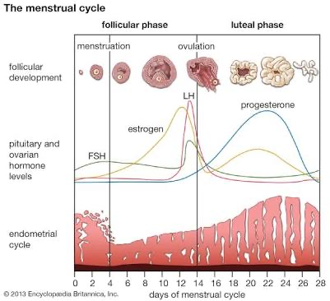
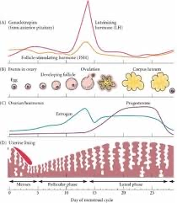

Irregular menstural cycle
It is when a cycle is Missed, delayed or erratic periods or abnormal bleeding patterns.
causes of this symptom
Irregular menstruation can have causes that aren't due to underlying disease. Examples include family history of irregular menstruation, menopause or menarche, physical stress, psychological stress, smoking or medication side effects.

How to stop irregular menstural cycle
Exercise
Maintain a healthy weight
Always have a daily dose of vitamins
Eat pineapple
Drink cider vinegar daily

You might be able to get your cycle back after this
If you don’t ensure to see a doctor.

Question 1
Cyclic change in breast
The hormone estrogen is produced by the ovaries in the first half of the menstrual cycle. It stimulates the growth of milk ducts in the breasts. The increasing level of estrogen leads to ovulation halfway through the cycle. Next, the hormone progesterone takes over in the second half of the cycle. It stimulates the formation of the milk glands. These hormones are believed to be responsible for the cyclical changes that many women feel in their breasts just before menstruation. These include swelling, pain, and soreness. During menstruation, many women also have changes in breast texture. Their breasts may feel very lumpy. This is because the glands in the breast are enlarging to get ready for a possible pregnancy. If pregnancy does not happen, the breasts go back to normal size. Once menstruation starts, the cycle begins again.

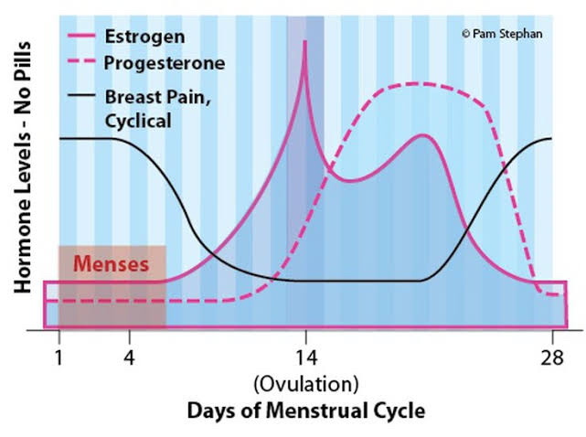
Cyclical and non cyclical breast pain

Cyclic change in vagina
Vaginal mucosal thickness was compared in 46 rhesus macaques grouped as juvenile (1-3 years old), mature cycling (3-21 years old), and geriatric (> 21 years old). Epithelia of mature cycling macaques were also compared at different stages of the menstrual cycle. Older females (> 21 years) had the thinnest and least keratinized epithelium of all groups, followed by the youngest females (< 3 years). The vaginal epithelium was also thinner in cycling macaques during menses compared to the follicular stage. In addition, young, geriatric, or cycling macaques during menses had minimal keratinization. We hypothesize that normal physiologic changes in the vaginal epithelium of women occur with age and menses, which may affect a woman's susceptibility to HIV-1 transmission and other sexually transmitted diseases. Also, age and menstrual cycle should be considered when designing vaginal transmission experiments in rhesus macaques.
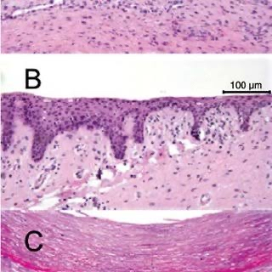

This part was quite confusing but I hope I was able to impress you
Goodnight ma

