MATRIC NUMBER:16/MHS03/033
NAME: ZUBAIRU KAMARU MAHMUD
DEPARTMENT: HUMAN ANATOMY
COURSE CODE: ANA402
COURSE NAME: HISTOPATHOLOGY
LECTURER: DR OGEDENGBE OLUWATOSIN O.

Brief Introduction to Glass Knifemaking for Electron and Light Microscope Applications
Perfect sections start with a perfect glass knife
Glass knives are used in an ultramicrotome to cut ultrathin slices of samples for electron and light microscope applications.
For resin and for cryosections (Tokuyasu samples) the knife edge must be extremely sharp, strong and stable. An important requirement for breaking glass knives of superior quality is the quality of the glass strips. Glass strips are produced from specially selected glass, the thickness and quality of which is precisely controlled. Only strict tolerances ensured by careful quality control allow breaking of two high quality knives from one square.
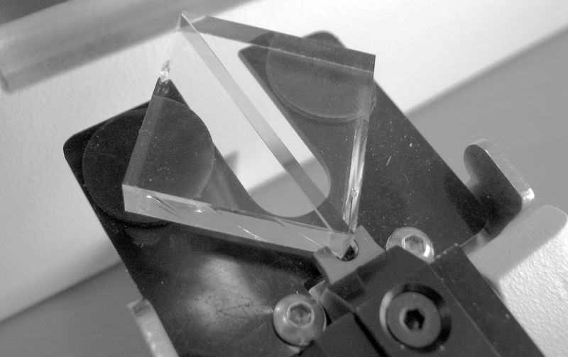
The balanced break concept
The technique of producing a straight, controlled break in a strip of scientific-quality glass requires that the knife maker apply equal weight and pressure to each side of the score. In addition, the support elements that touch the glass from below must have minimum surface contact to avoid uncontrolled stress applied to the glass prior to the break.
In the balanced break method (Figure 2), a glass strip, is scored and broken into two equal halves.With an equal mass of glass on each side of the score, the break is balanced and the freshly fractured surfaces are plane. By continuing to divide each piece produced into two equal halves a certain amount of squared can be produced.
All squares have straight sides and precise right angled corners unlike squares produced from sequential breaking of a glass trip which have curved surfaces.
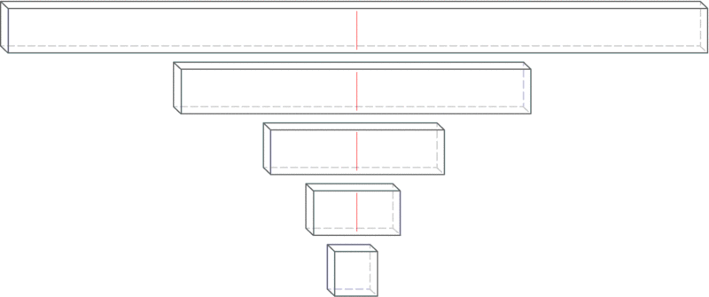

Scoring and breaking principles
Producing good glass knives routinely depends on a supply of reproducible squares, an accurately positioned score and controlled pressure precisely applied to make the break.
As a general rule, the knife edge is straighter and the counterpiece (knife shoulder) is small when the fracture occurs close to the corner (long score). Using a short score was in the past suggested for cryo knives as the free break is longer resulting in the sharpest, longest useable knife edge [1, 2].
Each score is preset and equidistant from the corners of the square. During the break the glass sits on two steel hemispheres and is held from above by two pins. The break follows the score line as far as it goes and then a free break occurs. The direction of this free break is determined by the mass of the glass on either side of the break and the breaking forces.
The free break curves to the edge of the square resulting in one knife and one flatedge counterpiece (knife shoulder) opposite the knife edge (Figure 3a). When the score runs centrally through a square a very small counterpice is obtained and the knife angle is very close to 45° (Figure 3b).
This is the optimal result for cryo knives. For resin sectioning, the user sets the knife shoulder adjustment a little larger (~0.5 mm), to produce a larger knife angle which is more stable for resin sectioning.
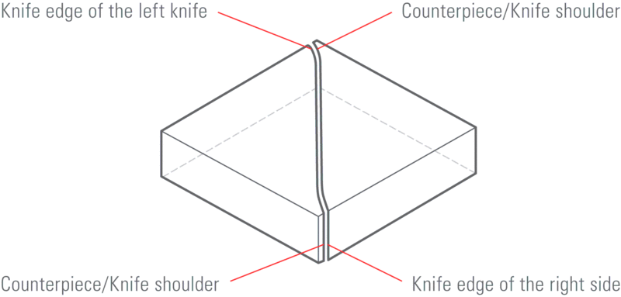
The real knife angle
When scoring the square all scores stop some distance from the corner. When pressure is applied under the score, the fracture is initiated and is seen first as a deepening of the score. The fracture extends towards the corners of the square following the line of the score. Where the score ends and the break is free, the fracture deviates from the line of the score to curve away from the corner, towards one of the edges of the square. This results in the real angle of the knife being somewhat greater than the angle of scoring.
The real angle of the knife increases as the score is moved further from the diagonal. This is when the knife shoulder becomes larger.
For example, when preparing knives from a square, the real angle of the knife is close to 45° when the knife shoulder is smaller (<0.5 mm). Increasing the size of the knife shoulder (>0.5 mm) results in an even larger knife angle which can be over 55°
Length of useful edge
When a glass knife edge is examined under darkfield illumination using a stereo microscope (or using back light on an Ultramicrotomes using ), it can be seen that the central part is most useful for ultrathin sectioning. The right side of the edge has visible marks (saw teeth) which reduce the quality of the knife, and the left corner is also unsuitable for sectioning because of the stress line (Figure 5).
The useful knife edge starts where the stress line moves away form the knife edge until the part where the stress marks (saw teeth) can be seen.
Important
The useful knife edge is 30 % longer on knives produced from 8 mm thick glass compared to 6.4 mm thick glass!
When less force has been used to break the knife, the stress line falls away rapidly from the knife edge and fewer saw teeth can be seen. Resulting in a longer usable knife edge.
Evaluation of the knife edge
After making a pair of knives, evaluation of the quality can be carried out in an ultramicrotome.
Using the backlight illumination and setting the clearance angle to maximum a fine white line can be seen (Figure 6). The image of the line indicates the quality of the knife edge, which must be straight, free of any dirt such as dust, grease and finger prints and free of glass splinters.
The top light of the ultramicrotome can also be used for checking knife quality (Figure 7).
An example of a knife which should not be used is shown in Figure 8. This has been picked up incorrectly leaving a finger print over the knife edge.
In Figure 9 (top) a pair of knives is shown, broken and placed side by side. The detail (Figure 9 bottom) shows the knife shoulder of both knives. The right hand knife edge was opposite the left hand knife shoulder during breaking
and the left hand knife edge was opposite the right hand knife shoulder.

Glass Knife Making
Materials: LKB Knife maker, glass strips that are approximately 40 cm x 2.5 cm x 1 cm or 8 mm or 6.4 mm, small paint brush, LKB Knife maker metal fork, lint-free powder-free gloves or lens paper, glass knife holder box.

Procedure:

- Wash a new glass strip in the sink with warm water, liquid soap and towel paper. Be careful not to cut yourself while handling the glass. Stand the strip up against the sink wall while using towel paper to wash it. Then rinse the strip well in running 2X distilled water. Allow it to dry standing up against some wall.
- With gloved hands or holding a lens tissue against the broad side of the glass, place the strip, serrated or rough edge down and broad side down on the knife maker. Avoid touching the narrow sides of the strip, as these will be the knife-edges. Position the strip against the white guide plate, which is set at 90-degrees. Also, extend the glass strip as far as the black dot on the knife maker. See diagram of the LKB knife maker
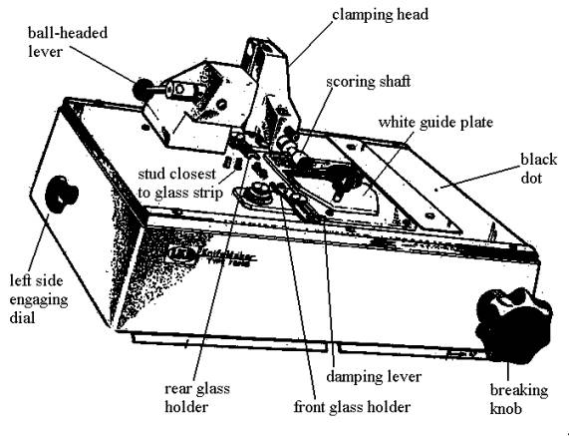

- Prepare to divide the length of the 400 mm strip into two useable 200 mm strips. Continue to maintain your hold on the glass strip.
- Lower the clamping head onto the glass strip by flipping the ball headed lever from the back to the front position. This will secure the glass strip in place. Now, remove your hold on the glass.
- Turn the scoring selector to this symbol for this first major break:
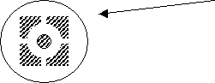

- The breaking knob should be in the most counterclockwise position at this point.
- Pull out the scoring shaft all the way. You should hear a faint scratching as the score wheel cuts lightly into the glass. If no score mark is made then prepare to repeat steps by first raising the clamping head (flip ball-headed lever from front to back position). Push score wheel all the way back in. Reposition strip if necessary and maintain hold on glass strip until clamping head is lowered and secured on glass. Then try re-scoring. Repeat this entire procedure again if necessary.
- Start turning the breaking knob slowly clockwise. The pressure should soon break the glass. As soon as the strip is broken into two halves, reset the breaking knob completely counterclockwise.
- Raise the clamping head by flipping the ball lever from the front to the rear position. Then push in the scoring shaft. Finally, remove both glass strips.
- Brush away any glass chips from the knife maker using the small paintbrush.

Making glass squares:

- Reposition one of the 200 mm glass strips, serrated side down, back into the knife maker. Brace it against the white guide plate and push the strip against the closest metal stud. See above diagram. Do not remove your hold on the glass strip yet.
- Lower the clamping head until it securely touches the glass. Remove your hold on the glass.
- The scoring selector should be at the same symbol for bisecting glass strips, and that is the following:

- Place the metal fork under the glass strip near the stud.
- Repeat the procedure described in steps #6 through #10. To briefly reiterate, score the glass by pulling out the scoring shaft. Then apply pressure to the strip by turning the breaking knob slowly clockwise. Once the break is completed, reset the breaking knob immediately.
- Raise clamping head with ball lever, push in scoring shaft and remove the glass square by means of the fork. Place this glass square aside for now.
- Continue to create more glass squares in the same way as described. Brush away any glass chips.
Making glass knives or triangles:

- As soon as a glass square is made, one can go on to make many more squares or one can choose to continue working with the same glass square, by rotating the square in place, counterclockwise 90-degrees. Note the two dimples in one corner of the glass. It is this corner that is braced against the front glass holder. The opposite corner is braced against the rear glass holder. To engage the rear glass holder, turn the left side engaging dial forward or in the clockwise direction. This dial is located on the left side of the knife maker.
- Set the score selector to this symbol for making knives
- Place the fork under the glass square.
- Lower the clamping head with the ball lever to secure the glass square.
- Pull out the scoring shaft to score the glass.
- Turn the damping lever clockwise (to a 6 o’clock position, approximately) until the damping pad just touches the glass.
- Proceed to slowly turn the breaking knob clockwise until the glass breaks.
- Once the glass breaks, then reset the breaking knob immediately.
- Reset the damping lever counterclockwise to its three o’clock position.
- Raise the clamping head and then push in the scoring shaft.
- Turn the left rear engaging dial backwards or counterclockwise, to release the glass knives.
- Pick up the two glass knives by means of the metal fork
- Examine the front aspects of each knife. See diagram:
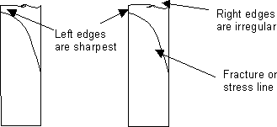

The sharpest and best cutting edge of the knife will be on the left edge. The right side of the knife, although very irregular, can be used to “rough face” an Epon block. See above.
- The glass knives are ready to use or can be stored in a dust-free box until ready to use. If a boat attachment is needed, see instructions for these under Special Procedures in Thick Sectioning chapter.
Attaching boats to glass knives:A boat or trough can be attached to a glass knife. The boats, either a pre-shaped plastic or an adhesive tape (Electron Microscopy Sciences, Ft. Washington, PA), are leak proof up to a certain point. Then they must be replaced or the glass knife is replaced. To secure a plastic boat to a glass knife, melted dental wax is needed. See diagram and procedure:

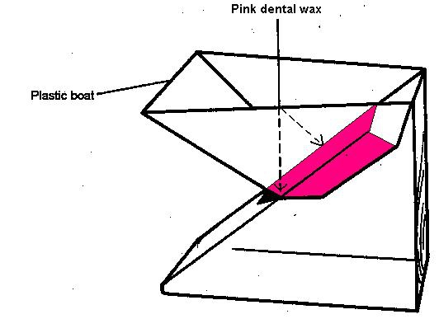

- Melt some dental wax in a small Petri dish (~60 mm diameter) over a hot plate.
- Apply some of the melted dental wax to the attachable portions of the boat with a fine artist’s brush.
- Quickly attach the boat to the glass knife, as diagrammed above.
- Apply additional melted wax to seal the outside boat edges to the glass.
- An alternative boat is the silver boat tape. See diagram:
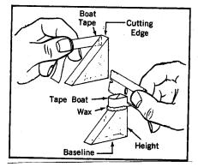
- Press one end of a two to three inch length piece of tape onto one side of the knife, at the same level as the knife-edge.
- The rest of the tape is wrapped around the front of the glass knife, as diagrammed.
- Press the tape to the other side of the glass knife.
- Trim off the excess tape with a razor blade.

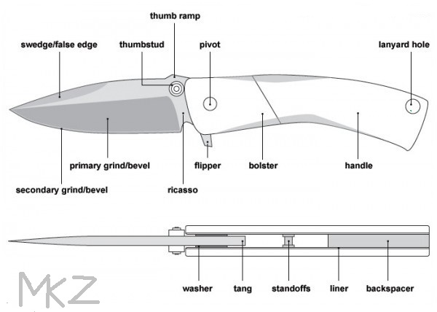
References
- Griffiths G, Simons K, Warren G and Tokuyasu KT (1983): Immunoelectron microscopy using thin, frozen sections: Application to studies of the intracellular transport of Semliki Forest virus spike glycoproteins. In: Methods in Enzymology 466–485.
- Tokuyasu KT (1986).: Application of cryoultramicrotomy to immunocytochemistry. Journal of Microscopy 143 (2): 139–149.

