ABEL CHIBUIKE DAVID
17/ENG03/002
CIVIL ENGINEERING
1a) Methods of leveling
Height of collimation system
Advantages
- It is rapid as it involves few Calculation
- There are two checks on the accuracy of RL calculation
- This system is suitable for longitudinal leveling where number of intermediate sights
- Visualization is not necessary regarding the nature of the ground
Disadvantages
- There is no check on the RL of the intermediate sight
- Errors in the intermediate RLs cannot be detected.

Rise and fall system
Advantages
- There is a check on the RL of the intermediate points
- Errors in the intermediate RLs can be detected as all the points are correlated
- There are three checks on the accuracy of RL calculation
- This system is suitable where there are no intermediate sights
Disadvantages
- It is laborious involving several calculations.
- Visualization is necessary regarding the nature of the ground

1b)
RL=110+matric No=110+2=112
B.S | I.S | F.S | H OF C | R.L | DISTANCE | REMARKS
0.771 |  |  | 112.771 | 112 | 0 | RL
0.802 |  | 1.52 | 112.053 | 111.251 | 10 | CP
 | 2.311 |  |  | 1109.742 | 20
3.580 |  | 1.990 | 113.643 | 110.063 | 30 | CP
 | 1.220 |  |  | 112.423 | 40
 | 3.675 |  |  | 108.968 | 50
2.408 |  | 4.020 | 112.031 | 109.623 | 60 | CP
 | 0.339 |  |  | 111.692 | 80
0.780 |  | 0.157 | 112.654 | 111.874 | 90 | CP
 | 1.535 |  |  | 111.119 | 100
 | 1.955 |  |  | 110.699 | 110
 | 2.430 |  |  | 110.224 | 120
 | 2.985 |  |  | 109.669 | 130
1.155 |  | 3.480 | 110.329 | 109.174 | 140 | CP
 | 1.960 |  |  | 108.369 | 150
 | 2.365 |  |  | 107.964 | 160
0.935 |  | 3.640 | 107.624 | 106.689 | 170 | CP
 | 1.045 |  |  | 106.579 | 180
 | 1.630 |  |  | 104.994 | 190
 |  | 2.545 |  | 105.079 | 200
=10.431 |  | =17.352

Check==R.L at first point-R.L at last point
=6.921=6.921

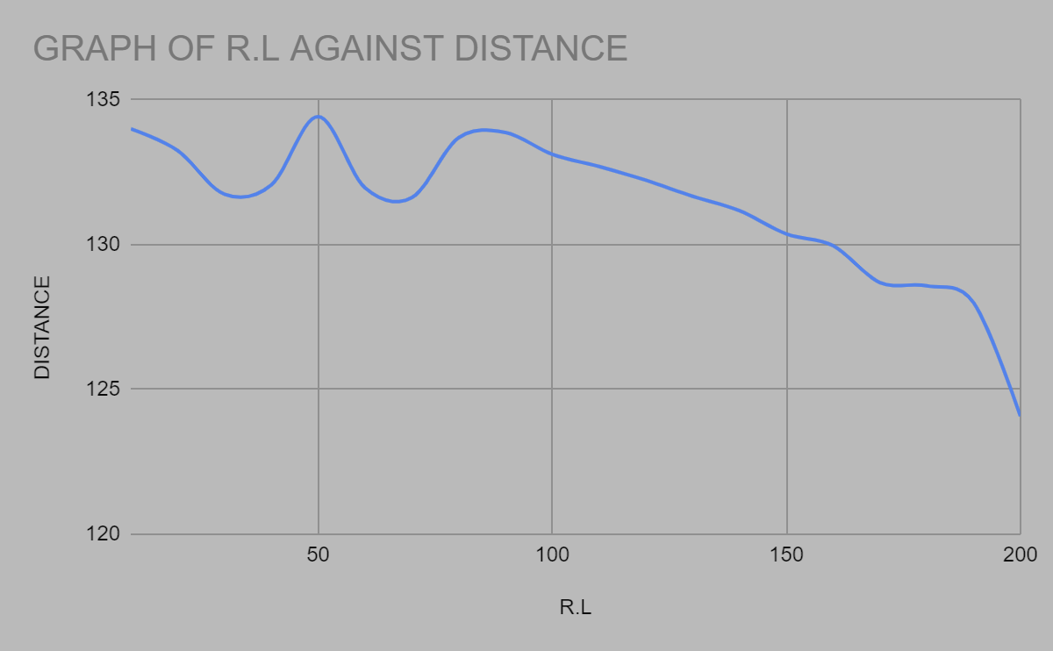

QUESTION (2a)

Chainage(m) | 0 | 30 | 60 | 90 | 120 | 150 | 180 | 210 | 240 | 270
Offset length(m) | 0 | 2.65 | 3.80 | 3.75 | 4.65 | 3.60 | 5.00 | 5.80 | 6.10 | 5.85

Using Mid-ordinate rule:
A=$Σ$hd

h1= $\frac{0+2.65}{2}$=1.325m

h2= $\frac{2.65+3.80}{2}$=3.225m
h3= $\frac{3.80+3.75}{2}$=3.775m

h4= $\frac{3.75+4.65}{2}$=4.2m

h5= $\frac{4.65+3.60}{2}$=4.125m

h6= $\frac{3.60+5.00}{2}$=4.3m

h7= $\frac{5.00+5.80}{2}$=5.4m

h8= $\frac{5.80+6.00}{2}$=5.9m

h9= $\frac{6.00+5.85}{2}$=5.925m

$$Σh=1.325+3.225+3.775+4.2+4.125+4.3+5.4+5.9+5.925$$
$Σh=$38.175m

d=30m
A=$Σhd$
= $38.175×30$
A= $1145.25m{}^{2}$

Using average ordinate rule

A=$\frac{ndΣO}{n+1}$

n=9

d=30
$$ΣO=0+2.65+3.80+3.75+4.65+3.60+5.00+5.80+6.10+5.85$$
$ΣO=$41.2m

A=$\frac{9×30×41.2}{9+1}$

A=$112.4m{}^{2}$

Using trapezoidal rule

A=$d(\frac{0{}_{1}+0{}_{n }}{2}+0{}_{2}+0{}_{3}+0{}_{4}............0{}_{n-1})$

$$d=30$$

A=$30(\frac{0+5.85}{2}+2.65+3.80+3.75+4.65+3.60+5.00+5.80+6.10)$

A=$30(38.275)$
A=$1148.25m{}^{2}$

Using Simpson's rule
$$A=\frac{d }{3 }\left[\left(0{}_{1}+0{}_{n}\right)+4\left(0{}_{2}+0{}_{4}+.........0{}_{n-1}\right)+2\left(0{}_{3}+0{}_{5}........0{}_{n-1}\right)\right]$$

$$d=30$$

Note: Last offset was removed because number of offsets were even

$$A=\frac{30}{3 }\left[\left(0+6.10\right)+4\left(2.65+3.75+3.60+5,80\right)+2\left(3.80+4.65+5.00\right)\right]$$
$$A=962m{}^{2}$$

Calculating for last offset using trapezoidal rule

A=$d(\frac{0{}_{1}+0{}_{n }}{2}+0{}_{2}+0{}_{3}+0{}_{4}............0{}_{n-1})$

$$A=30\left[\frac{6.40+5.85}{2}\right]$$
$$A=183.75m{}^{2}$$

Therefore $ΣA=962+183.75$

$$A=1145.75m{}^{2}$$

QUESTION (2b)
CHARACTERISTICS OF CONTOURS WITH WELL DIMENSIONED DIAGRAMS
- A series of closed contour lines represent a hill, if the higher values are inside as shown.
- A series of closed contour on a map indicate a depression if the higher values are outside as shown.
- Contour lines cannot end anywhere but close on themselves either within or outside the limit of the map.
- Contour lines are not merged or cross one another on a map or less in a case of overhanging cliff.
- Contour will not run into one another except in the case of vertical cliff. In this several contours corniced and there horizontal equivalent becomes zero.

