OKPALA CHARLES CHIEMERIE
17/ENG03/040
CIVIL ENGINEERING
1a) Methods of levelling
Height of collimation system
Advantages
- It is rapid as it involves few Calculation
- There are two checks on the accuracy of RL calculation
- This system is suitable for longitudinal leveling where number of intermediate sights
- Visualization is not necessary regarding the nature of the ground
Disadvantages
- There is no check on the RL of the intermediate sight
- Errors in the intermediate RLs cannot be detected.

Rise and fall system
Advantages
- There is a check on the RL of the intermediate points
- Errors in the intermediate RLs can be detected as all the points are correlated
- There are three checks on the accuracy of RL calculation
- This system is suitable where there are no intermediate sights
Disadvantages
- It is laborious involving several calculations.
- Visualization is necessary regarding the nature of the ground

1b)
RL=110+matric No =110+40=150
B.S | I.S | F.S | H OF C | R.L | DISTANCE | REMARKS
0.771 |  |  | 150.771 | 150.000 | 0 | RL
0.802 |  | 1.52 | 150.053 | 149.251 | 10 | CP
 | 2.311 |  |  | 147.742 | 20
3.580 |  | 1.990 | 151.643 | 148.063 | 30 | CP
 | 1.220 |  |  | 150.423 | 40
 | 3.675 |  |  | 147.968 | 50
2.408 |  | 4.020 | 150.031 | 147.623 | 60 | CP
 | 0.339 |  |  | 149.692 | 80
0.780 |  | 0.157 | 150.654 | 149.874 | 90 | CP
 | 1.535 |  |  | 149.119 | 100
 | 1.955 |  |  | 148.699 | 110
 | 2.430 |  |  | 148.224 | 120
 | 2.985 |  |  | 147.669 | 130
1.155 |  | 3.480 | 148.329 | 147.174 | 140 | CP
 | 1.960 |  |  | 146.369 | 150
 | 2.365 |  |  | 145.964 | 160
0.935 |  | 3.640 | 145.624 | 144.689 | 170 | CP
 | 1.045 |  |  | 144.579 | 180
 | 1.630 |  |  | 143.994 | 190
 |  | 2.545 |  | 143.079 | 200
$Σ$=10.431 |  | $Σ$=17.352

HC=RL+BS
HC(1)=150+0.711=150.771
RL=HC-FS
RL(2)=150.771-1.52=149.251
HC(2)=149.251+0.802=150.053
RL(3)=150.053-2.311=147.742
RL(4)=150.053-1.990=148.063
HC(4)=148.063+3.580=151.643
RL(5)=151.643-1.220=150.423
RL(6)=151.643-3.675=147.968
RL(7)=151.643-4.020=147.623
HC(7)=147.623+2.408=150.031
RL(8)= 150.031-0.339=149.692
RL(9)= 150.031-0.157=149.874
HC(9)=149.874+0.780=150.654
RL(10)= 150.654-1.535=149.119
RL(11)= 150.654-1.955=148.699
RL(12)= 150.654-2.430=148.224
RL(13)= 150.654-2.985=147.669
RL(14)= 150.654-3.480=147.174
HC(14)=147.174+1.155=148.329
RL(15)= 148.329-1.960=146.369
RL(16)= 148.329-2.365=145.964
RL(17)= 148.329-3.640=144.689
HC(17)=144.689+0.935=145.624
RL(18)= 145.624-1.045=144.579
RL(19)= 145.624-1.630=143.994
RL(120)= 145.624-2.545=143.079

Check=$ΣF.S-ΣB.S$=R.L at first point-R.L at last point
=6.921=6.921

QUESTION 2

Chainage(m) | 0 | 30 | 60 | 90 | 120 | 150 | 180 | 210 | 240 | 270
Offset length(m) | 0 | 2.65 | 3.80 | 3.75 | 4.65 | 3.60 | 5.00 | 5.80 | 6.10 | 5.85

Using Mid-ordinate rule:
A=$Σ$hd

h1= $\frac{0+2.65}{2}$=1.325m

h2= $\frac{2.65+3.80}{2}$=3.225m

h3= $\frac{3.80+3.75}{2}$=3.775m

h4= $\frac{3.75+4.65}{2}$=4.2m

h5= $\frac{4.65+3.60}{2}$=4.125m

h6= $\frac{3.60+5.00}{2}$=4.3m

h7= $\frac{5.00+5.80}{2}$=5.4m

h8= $\frac{5.80+6.00}{2}$=5.9m

h9= $\frac{6.00+5.85}{2}$=5.925m

$$Σh=1.325+3.225+3.775+4.2+4.125+4.3+5.4+5.9+5.925$$
$Σh=$38.175m

d=30m
A=$Σhd$
= $38.175×30$
A= $1145.25m{}^{2}$

Using average ordinate rule

A=$\frac{ndΣO}{n+1}$

n=9

d=30
$$ΣO=0+2.65+3.80+3.75+4.65+3.60+5.00+5.80+6.10+5.85$$
$ΣO=$41.2m

A=$\frac{9×30×41.2}{9+1}$

A=$112.4m{}^{2}$

Using trapezoidal rule

A=$d(\frac{0{}_{1}+0{}_{n }}{2}+0{}_{2}+0{}_{3}+0{}_{4}............0{}_{n-1})$

$$d=30$$

A=$30(\frac{0+5.85}{2}+2.65+3.80+3.75+4.65+3.60+5.00+5.80+6.10)$

A=$30(38.275)$
A=$1148.25m{}^{2}$

Using Simpson's rule
$$A=\frac{d }{3 }\left[\left(0{}_{1}+0{}_{n}\right)+4\left(0{}_{2}+0{}_{4}+.........0{}_{n-1}\right)+2\left(0{}_{3}+0{}_{5}........0{}_{n-1}\right)\right]$$

$$d=30$$

Note: Last offset was removed because number of offsets were even

$$A=\frac{30}{3 }\left[\left(0+6.10\right)+4\left(2.65+3.75+3.60+5,80\right)+2\left(3.80+4.65+5.00\right)\right]$$
$$A=962m{}^{2}$$

Calculating for last offset using trapezoidal rule

A=$d(\frac{0{}_{1}+0{}_{n }}{2}+0{}_{2}+0{}_{3}+0{}_{4}............0{}_{n-1})$

$$A=30\left[\frac{6.40+5.85}{2}\right]$$
$$A=183.75m{}^{2}$$

Therefore $ΣA=962+183.75$

$$A=1145.75m{}^{2}$$

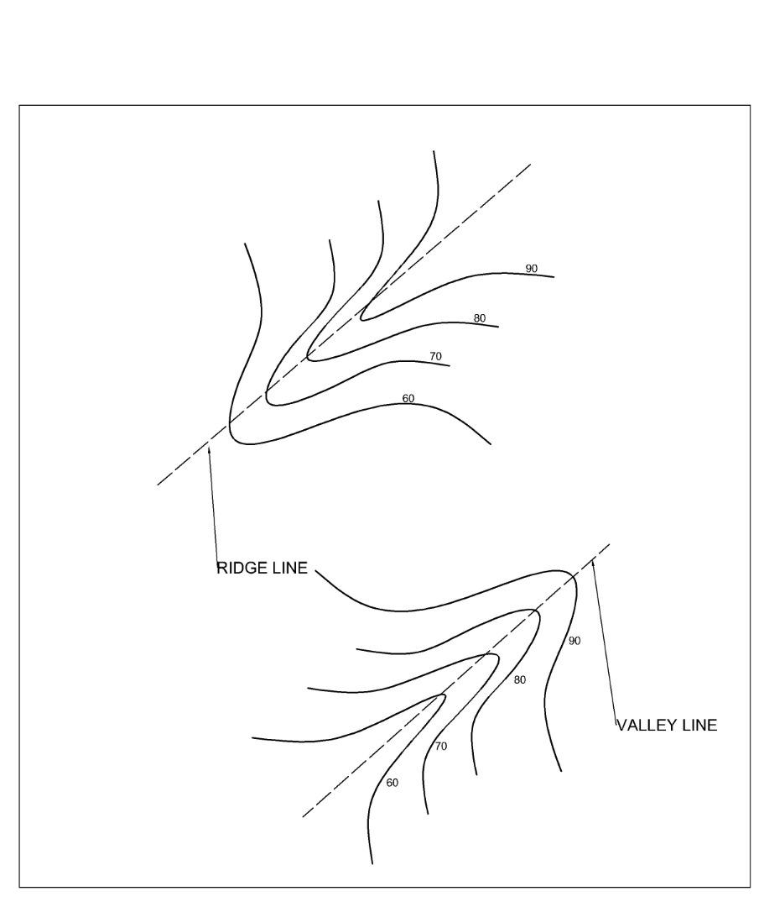
Contour lines crosses a ridge or valley at right angles. If the higher values are inside the bend or loop in the contour. It represents a ridge and if the higher values are outside the bend it represents the value
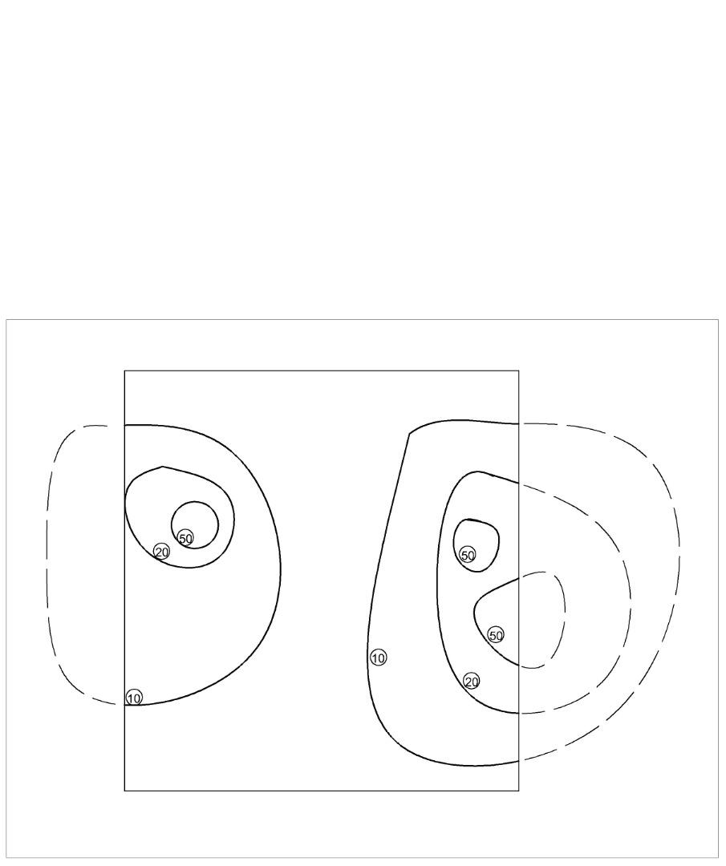 Contour lines cannot end anywhere but close on themselves either within or outside the limit of the map
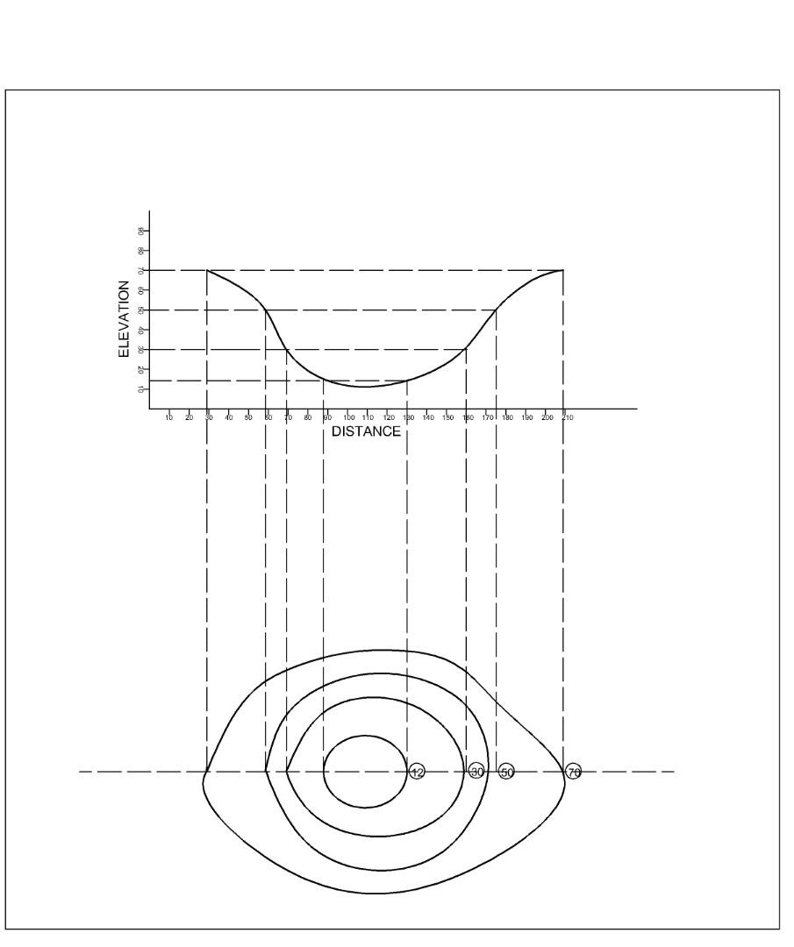A series of closed contours on a map indicate a depression if the higher values are outside 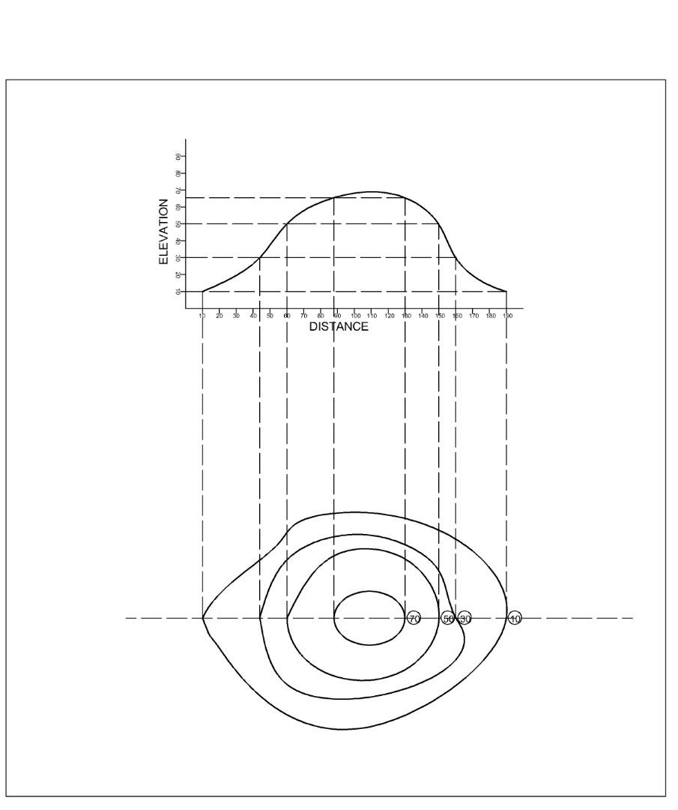A series of closed contour lines represent a hill if the higher values are inside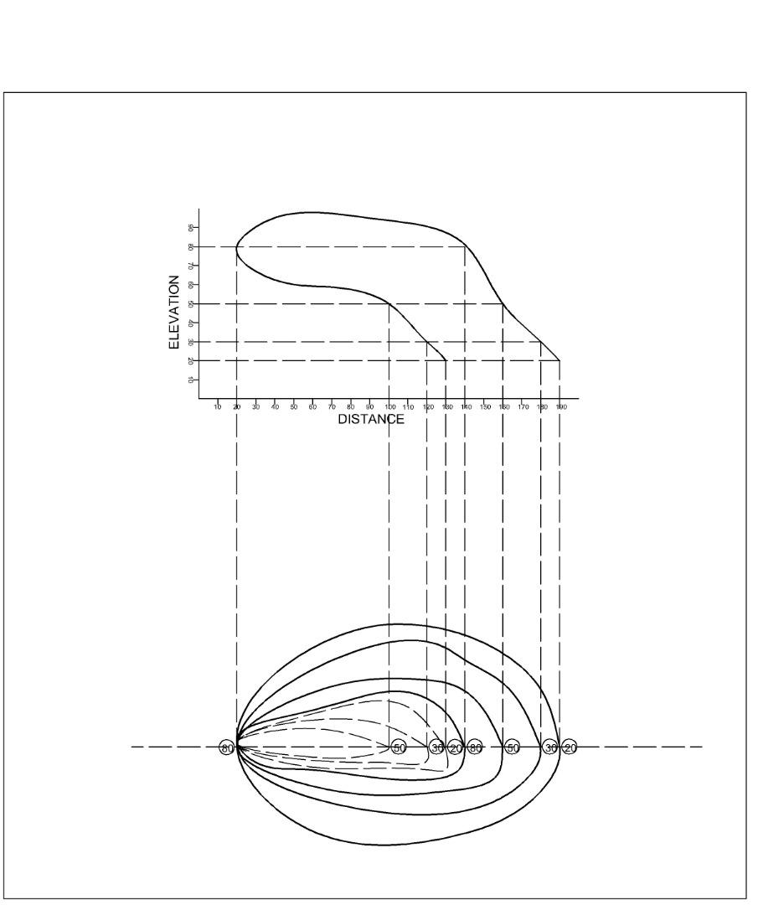 Contour lines cannot merge or cross another on a map except in the case of an overhanging cliff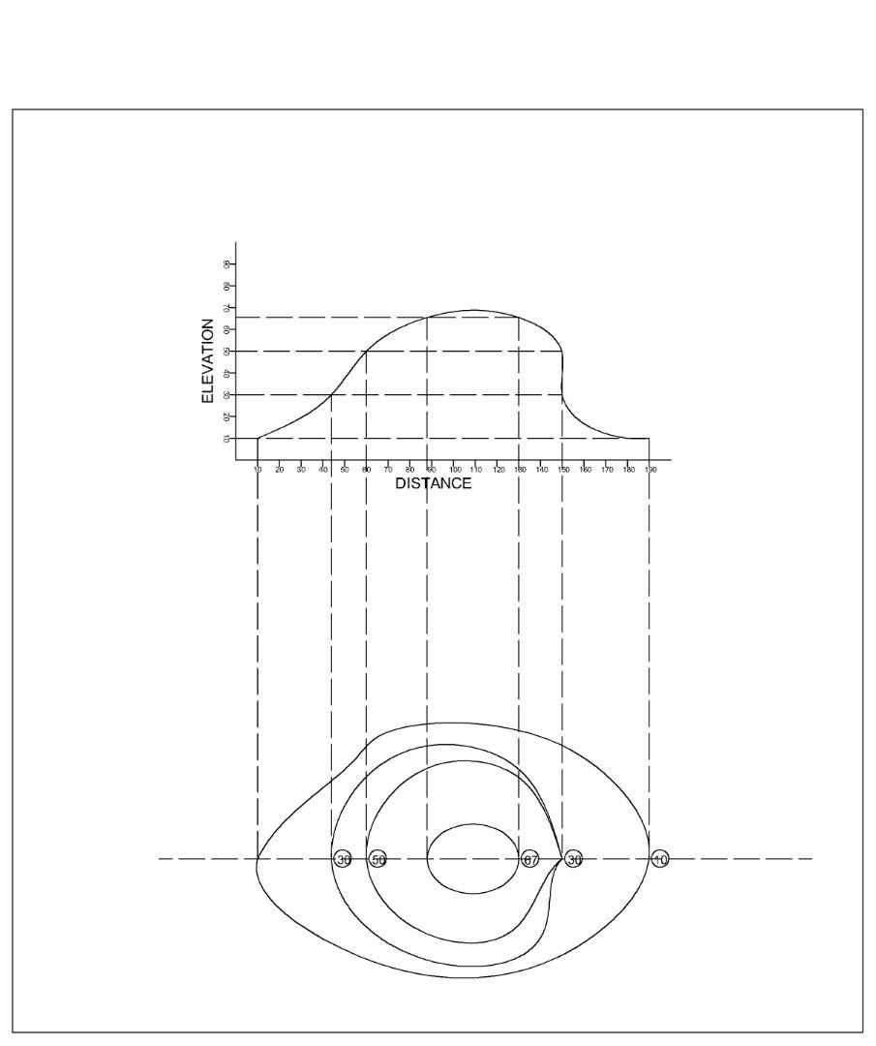Contour lines run into one another except in the case of a vertical cliff. In this case several contours coincide and horizontal equivalent becomes zero

