NAME: ALADE EMMANUEL ADEMOLA
MATRIC NUMBER: 18/MHS07/006
DEPARTMENT: PHARMACOLOGY
COURSE CODE: PHS 212

Question
Briefly discuss the CYCLIC CHANGES in any two of the following:
a) CERVIX (b) VAGINA (c) BREASTS

Explicate any one of the following:
1) Menstrual cycle
2) Hormonal regulation of the menstrual cycle

1.Vagina: The vagina also changes in response to hormonal fluctuations of the menstrual cycle. Around mid-cycle, when estrogen is highest, vaginal tissue becomes thicker and fuller. The cervix, at the top of the vagina, moves and changes shape throughout the cycle. Before and after the fertile window, the cervix is low and can be felt in the vagina, with a firm texture, and the hole in the center of the cervix is closed. During the fertile window, the hole in the cervix opens to facilitate the entrance of sperm into the uterus, the cervix rises higher in the vagina, and is softer when touched.

Breast: Breasts can go through changes during a menstrual cycle. They get tender, and even seem to shift a bit in size and shape. Total breast volume, and parenchymal volume, T1 relaxation time and water content were lowest between days 6 and 15. Between days 16 and 28, parenchymal volume, T1 relaxation time and water content rose sharply by 38.9%, 15.1% and 24.5%, respectively, and peaked after day 25. Within 5 days of the onset of menses, parenchymal volume fell sharply by 30.3%, while water content declined by 17.5%. Rising parenchymal volume in the second half of the menstrual cycle is not solely due to increased tissue water content and provides in vivo evidence for both growth and increased tissue fluid at this time.

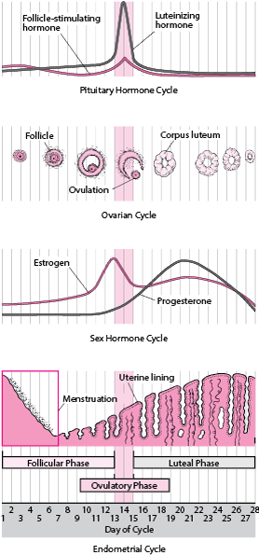
2. Hormonal regulation of the menstrual
The menstrual cycle is regulated by the coordinated functions of the hypothalamus, pituitary, ovaries, and endometrium. The pulsatile secretion of gonadotrophin-releasing hormone from the hypothalamus stimulates the anterior pituitary to secrete follicle-stimulating hormone (FSH) and luteinizing hormone (LH), which in turn stimulates the development of ovarian follicles and the production of ovarian steroids. A negative feedback mechanism is crucial for its control and regulation. During the follicular phase, the recruited follicle prepares for ovulation. After the LH surge and ovulation, the luteal phase begins. The follicular and luteal phases correspond to the proliferative and secretory phases of the endometrium, which develops during the proliferative phase and is maintained during the secretory phase to prepare for implantation of the fertilized embryo. The endometrium is shed during menses in the early follicular/proliferative phase, and the cycle continues. The menstrual cycle is regulated by the complex interaction of hormones: luteinizing hormone, follicle-stimulating hormone, and the female sex hormones estrogen and progesterone. The menstrual cycle has three phases: Follicular (before release of the egg) Ovulatory (egg release)

