NWANI IKECHUKWU
17/ENG03/035
CIVIL ENGINEERING
1a) Methods of levelling
Height of collimation system
Advantages
- It is rapid as it involves few Calculation
- There are two checks on the accuracy of RL calculation
- This system is suitable for longitudinal leveling where number of intermediate sights
- Visualization is not necessary regarding the nature of the ground
Disadvantages
- There is no check on the RL of the intermediate sight
- Errors in the intermediate RLs cannot be detected.

Rise and fall system
Advantages
- There is a check on the RL of the intermediate points
- Errors in the intermediate RLs can be detected as all the points are correlated
- There are three checks on the accuracy of RL calculation
- This system is suitable where there are no intermediate sights
Disadvantages
- It is laborious involving several calculations.
- Visualization is necessary regarding the nature of the ground

QUESTION 2

Chainage(m) | 0 | 30 | 60 | 90 | 120 | 150 | 180 | 210 | 240 | 270
Offset length(m) | 0 | 2.65 | 3.80 | 3.75 | 4.65 | 3.60 | 5.00 | 5.80 | 6.10 | 5.85

Using Mid-ordinate rule:
A=$Σ$hd

h1= $\frac{0+2.65}{2}$=1.325m

h2= $\frac{2.65+3.80}{2}$=3.225m

h3= $\frac{3.80+3.75}{2}$=3.775m

h4= $\frac{3.75+4.65}{2}$=4.2m

h5= $\frac{4.65+3.60}{2}$=4.125m

h6= $\frac{3.60+5.00}{2}$=4.3m

h7= $\frac{5.00+5.80}{2}$=5.4m

h8= $\frac{5.80+6.00}{2}$=5.9m

h9= $\frac{6.00+5.85}{2}$=5.925m

$$Σh=1.325+3.225+3.775+4.2+4.125+4.3+5.4+5.9+5.925$$
$Σh=$38.175m

d=30m
A=$Σhd$
= $38.175×30$
A= $1145.25m{}^{2}$

Using average ordinate rule

A=$\frac{ndΣO}{n+1}$

n=9

d=30
$$ΣO=0+2.65+3.80+3.75+4.65+3.60+5.00+5.80+6.10+5.85$$
$ΣO=$41.2m

A=$\frac{9×30×41.2}{9+1}$

A=$112.4m{}^{2}$

Using trapezoidal rule

A=$d(\frac{0{}_{1}+0{}_{n }}{2}+0{}_{2}+0{}_{3}+0{}_{4}............0{}_{n-1})$

$$d=30$$

A=$30(\frac{0+5.85}{2}+2.65+3.80+3.75+4.65+3.60+5.00+5.80+6.10)$

A=$30(38.275)$
A=$1148.25m{}^{2}$

Using Simpson's rule
$$A=\frac{d }{3 }\left[\left(0{}_{1}+0{}_{n}\right)+4\left(0{}_{2}+0{}_{4}+.........0{}_{n-1}\right)+2\left(0{}_{3}+0{}_{5}........0{}_{n-1}\right)\right]$$

$$d=30$$

Note: Last offset was removed because number of offsets were even

$$A=\frac{30}{3 }\left[\left(0+6.10\right)+4\left(2.65+3.75+3.60+5,80\right)+2\left(3.80+4.65+5.00\right)\right]$$
$$A=962m{}^{2}$$

Calculating for last offset using trapezoidal rule

A=$d(\frac{0{}_{1}+0{}_{n }}{2}+0{}_{2}+0{}_{3}+0{}_{4}............0{}_{n-1})$

$$A=30\left[\frac{6.40+5.85}{2}\right]$$
$$A=183.75m{}^{2}$$

Therefore $ΣA=962+183.75$

$$A=1145.75m{}^{2}$$

2b

characteristics of contours

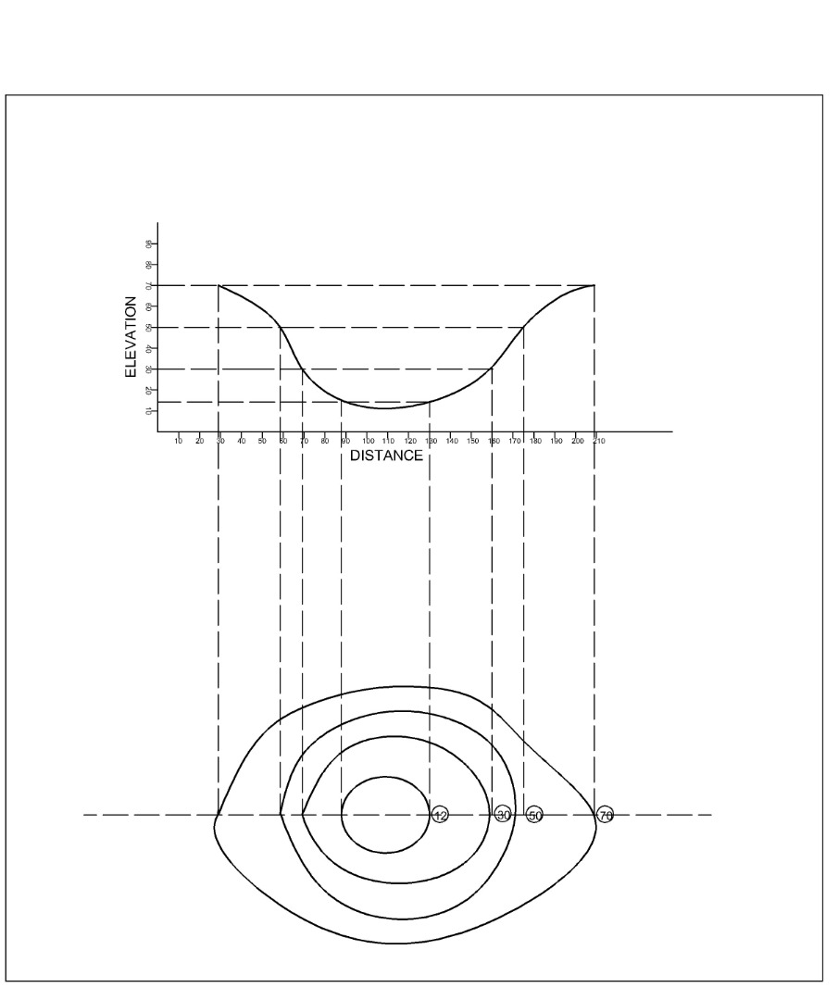

Irregular contours indicate uneven surface.
Approximately concentric closed contours with decreasing values towards centre indicate a pond.

Approximately concentric closed contours with increasing values towards centre indicate hills.
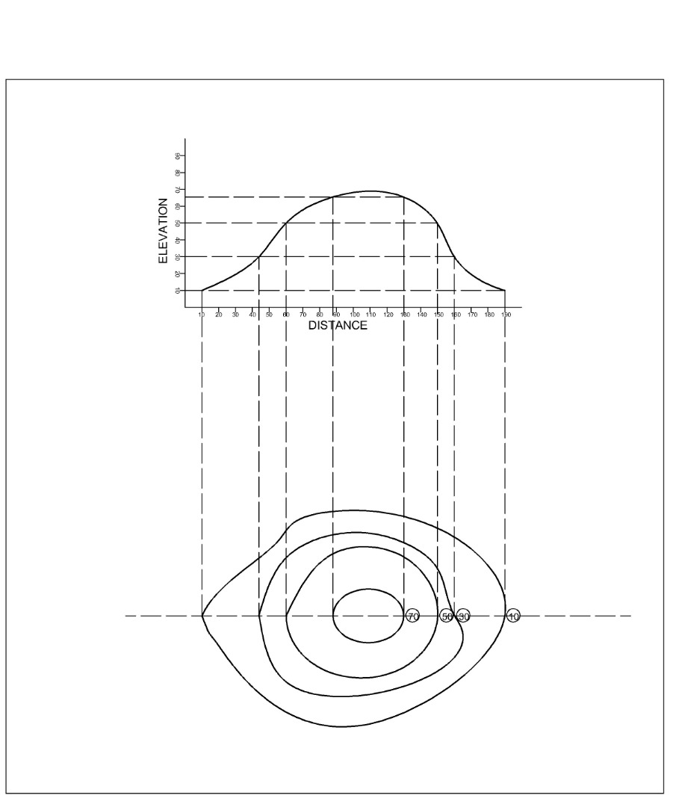

Contour lines generally do not meet or intersect each other. If contour lines are meeting in some portion, it shows existence of a vertical cliff.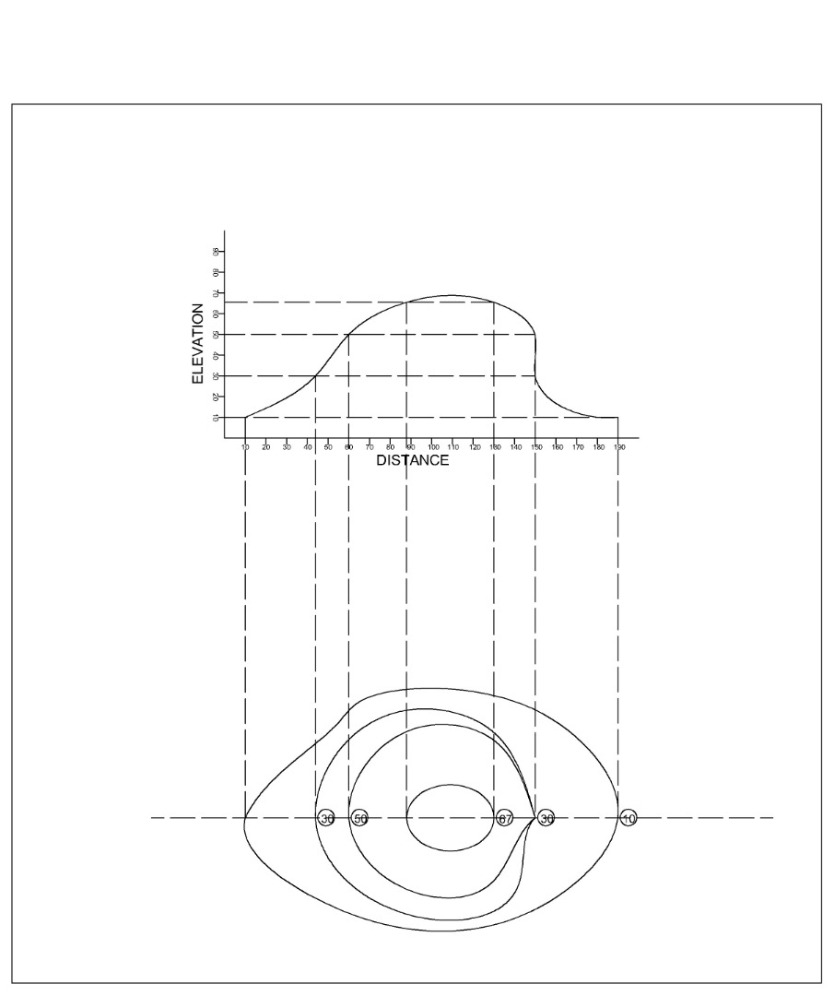

Contours of different elevations cannot cross each other. If contour lines cross each other, it shows existence of overhanging cliffs or a cave.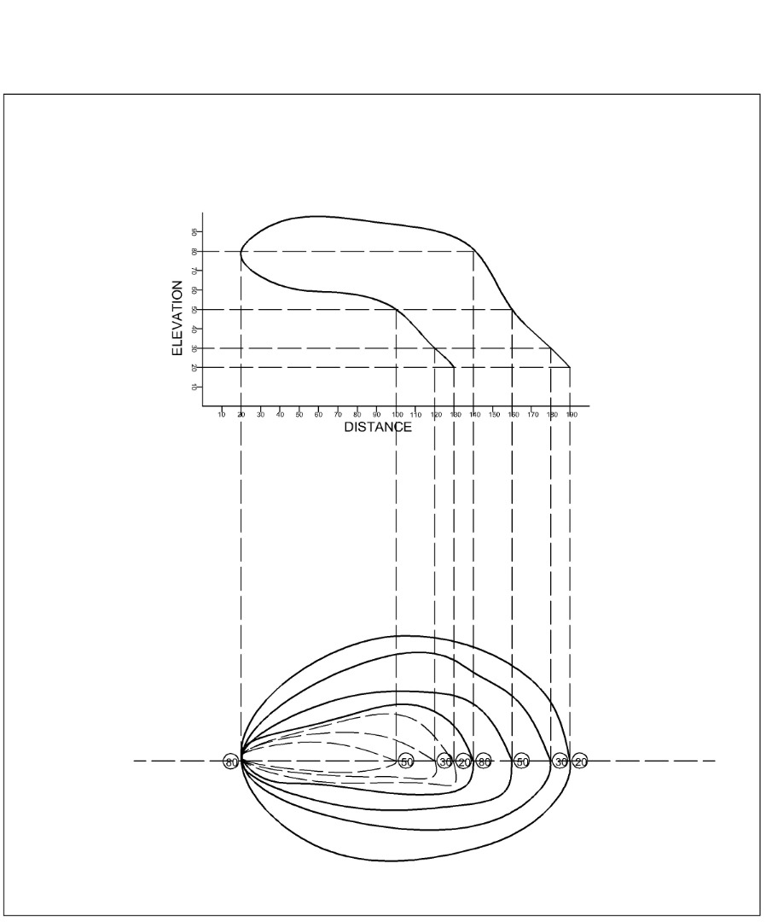

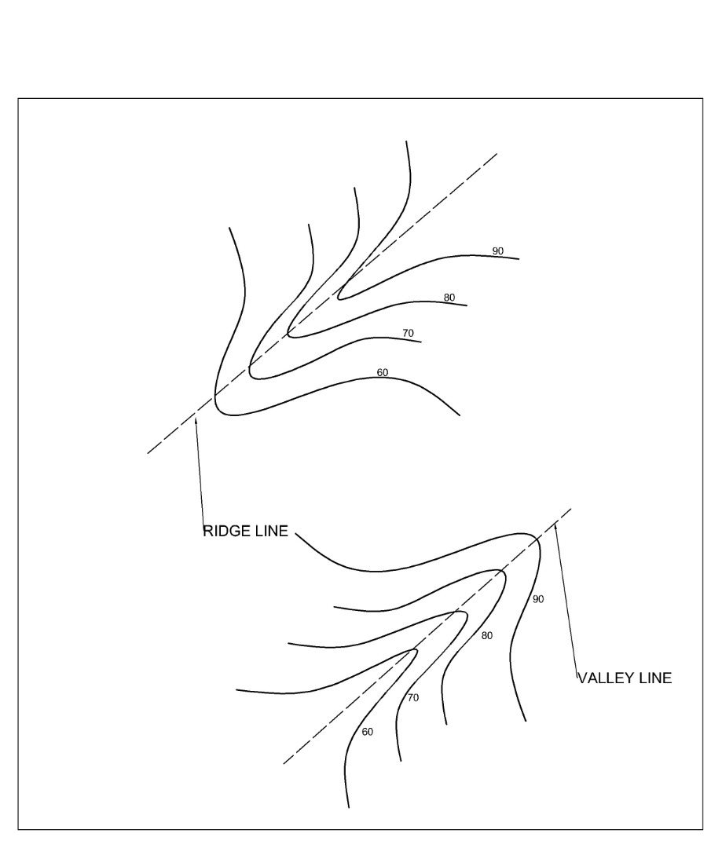
Contour lines with U-shape with convexity towards lower ground indicate ridge.
Contour lines with V-shaped with convexity towards higher ground indicate valley.

