Name: Abubakar Aisha Abbas
College: MHS. Dept: MBBS
Course: Chemistry 102
Carboxylic Acids Assignment
UEPAC Names
- Methanoic acid
- Penta-1,5-dioic acid
- Butanoic acid
- Ethernoic acid
- Hexanoic acid
- Hex-4-enoic acid u

Physical Properties of carboxylic acid

PHYSICAL STATE AND COLOR OF CARBOXYLIC ACIDS
1. Aliphatic carboxylic acids upto nine carbon atoms are colourless liquids at room temperature.
2. The higher acids are wax like solids due to their low volatility.

SOLUBILITY TRENDS OF CARBOXYLIC ACIDS
1. Simple aliphatic carboxylic acids having upto four carbon atoms are miscible in water due to the formation of hydrogen bonds with water.
2. The solubility decreases with increasing number of carbon atoms due to the increased hydrophobic interaction of hydrocarbon part.
3. Carboxylic acids are also soluble in less polar organic solvents like benzene, ether, alcohol, chloroform, etc.

BOILING POINT TRENDS OF CARBOXYLIC ACIDS
1. Carboxylic acids have much higher boiling points than hydrocarbons, alcohols, ethers, aldehydes, or ketones of similar molecular weight.
2. This is due to more extensive association of carboxylic acid molecules through intermolecular hydrogen bonding. The hydrogen bonds are not broken completely even in the vapor phase. In fact, most carboxylic acids exist as dimer in the vapor phase or in the aprotic solvents.
3. As the molecular mass increases, boiling point of carboxylic acid also increases.

Industrial preparation of carboxylic acid

Preparation from Aldehydes
As discussed in the above topic, Preparation of carboxylic acid is possible from the usual strong oxidizing agents. Carboxylic acids formation is possible with mild oxidizing agents such as Tollen’s reagents [Ag(NH ₃) ₂ ⁺OH ⁻] and manganese dioxide (MnO₂).
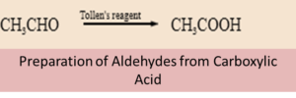

Preparation from Amides
Amide undergoes hydrolysis in the presence of catalyst H⁺ or OH– to form carboxylic acids.
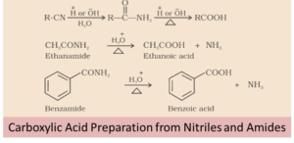

Synthesis Of Carboxylic Acids
Most of the methods for the synthesis of carboxylic acids can be put into one of two categories: (1) hydrolysis of acid derivatives and (2) oxidation of various compounds.

Hydrolysis of acid derivatives
All acid derivatives can be hydrolyzed (cleaved by water) to yield carboxylic acids; the conditions required range from mild to severe, depending on the compound involved.
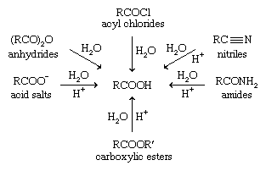

Oxidation
The oxidation of primary alcohols is a common method for the synthesis of carboxylic acids: RCH₂OH → RCOOH. This requires a strong oxidizing agent, the most common being chromic acid (H₂CrO₄), potassium permanganate(KMnO₄), and nitric acid (HNO₃).

Reductions of carboxylic acid
Most reductions of carboxylic acids lead to the formation of primary alcohols. These reductions are normally carried out using a strong reducing agent, such as lithium aluminium hydride (LiAlH ₄).

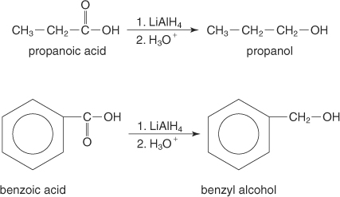

You can also use diborane (B ₂H ₆) to reduce carboxylic acids to alcohols.

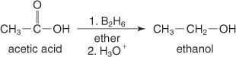

Decarboxylation of carboxylic acid
Decarboxylation reaction is defined as a chemical reaction that eliminates a carboxyl group and liberates carbon dioxide (CO₂). Decarboxylation mostly refers to a reaction of carboxylic acids erasing a carbon atom from a chain of carbons. Carboxylation is a completely reversible process which is the first chemical step in photosynthesis, where CO₂ is added to the compound. Whereas, Enzymes that catalyze decarboxylations are known as decarboxylases.
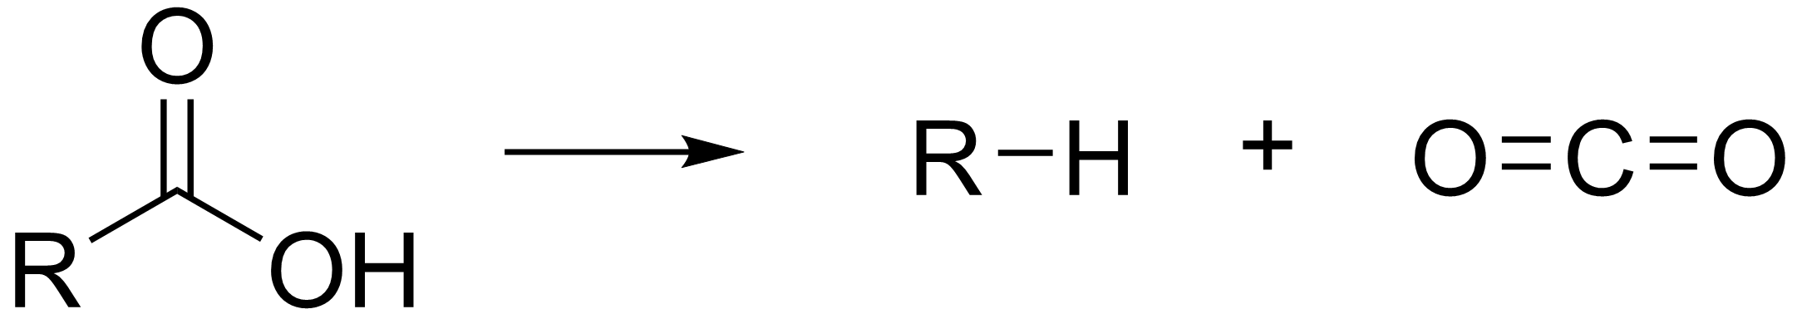

Esterification of carboxylic acid
When a carboxylic acid is treated with an alcohol and an acid catalyst, an ester is formed (along with water). This reaction is called the Fischer esterification.
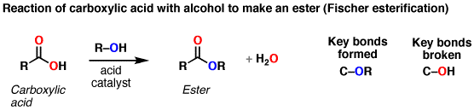
Notes: The reaction is actually an equilibrium. The alcohol is generally used as solvent so is present in large excess. Many different acids can be used; it’s common to see just “H+”, although H2SO4 (sulfuric acid) and TsOH (tosic acid) are also often used.
Examples:
