ACHONWA-NJEMANZE CHUKWUMA
17/ENG 03/003
QUESTION 1: COMPARE THE METHODS OF LEVELLING CONSIDERING ADVANTAGES AND DRAW BACKS
HCM: It is more rapid and saves a considerable time and labour.
RFM: It is laborious as the staff reading of each station is compared to get a rise or fall.
HCM: It is well adopted for reduction of levels for construction work such as longitudinal or cross-section levelling operations.
RFM: It is well adopted for determining the difference in levels of two points where precision is required.
HCM: There is no check on reduction of R.L. of intermediate stations.
RFM: There is a complete check on the reduction of RL of the intermediate stations.
HCM: There are only two arithmetical checks i.e. the difference between the sums of the fore sights must be equal to be the difference in R.L. of the last station and first station.
RFM : There are three arithmetical checks i.e. the difference between the sum of the back sights and the sum of fore sights must be equal to the difference between the sum of the rises and the sum of the falls as well as it must also be equal to the difference in RL of the last station and first station.
HCM: Errors if any in intermediate sights are not detected.
RFM: Errors in intermediate sights are noticed as these are used for finding out rises and falls.
1b
RL=110+MATRIC NO=110+003=113
B.S | I.S | F.S | H OF C | R.L | DISTANCE
0.771 |  |  | 113.771 | 113 | 10
0.802 |  | 1.52 | 113.053 | 112.251 | 20
 | 2.311 |  |  | 110.742 | 30
3.580 |  | 1.990 | 114.643 | 111.063 | 40
 | 1.220 |  |  | 113.423 | 50
 | 3.675 |  |  | 110.968 | 60
2.408 |  | 4.020 | 113.031 | 110.623 | 70
 | 0.339 |  |  | 112.692 | 80
0.780 |  | 0.157 | 113.654 | 112.874 | 90
 | 1.535 |  |  | 112.119 | 100
 | 1.955 |  |  | 111.699 | 110
 | 2.430 |  |  | 111.224 | 120
 | 2.985 |  |  | 110.669 | 130
1.155 |  | 3.480 | 111.329 | 110.174 | 140
 | 1.960 |  |  | 109.369 | 150
 | 2.365 |  |  | 108.964 | 160
0.935 |  | 3.640 | 108.624 | 107.689 | 170
 | 1.045 |  |  | 107.579 | 180
 | 1.630 |  |  | 106.994 | 190
 |  | 2.545 |  | 103.079 | 200
$Σ$=10.431 |  | $Σ$=17.352

Check=$ΣF.S-ΣB.S$=R.L at first point-R.L at last point
=6.921=6.921

HC=RL+BS
HC(1)=113+0.711=113.771
RL=HC-FS
RL(1)=113.771-1.52=112.251
HC(2)=112.251+0.802=113.053
RL(2)=113.053-2.311=110.742
RL(3)=113.053-1.990=111.063
HC(3)=111.063+3.580=114.643
RL(4)=114.643-1.220=113.423
RL(5)=114.643-3.675=110.968
RL(6)=114.643-4.020=110.623
HC(4)=110.623+2.408=113.031
RL(7)= 113.031-0.339=112.692
RL(8)= 113.031-0.157=112.874
HC(5)=113.654+0.780=113.654
RL(9)= 113.654-1.535=112.119
RL(10)= 113.654-1.955=111.699
RL(11)= 113.654-2.430=111.224
RL(12)= 113.654-2.985=110.669
RL(13)= 113.654-3.480=110.174
HC(6)=110.329+1.155=111.329
RL(14)= 111.329-1.960=109.369
RL(15)= 111.329-2.365=108.964
RL(16)= 111.329-3.640=107.689
HC(7)=108.689+0.935=108.624
RL(17)= 108.624-1.045=107.579
RL(17)= 108.624-1.630=106.994
RL(17)= 108.624-2.545=103.079

Check=$ΣF.S-ΣB.S$=R.L at first point-R.L at last point
=6.921=6.921

QUESTION 2

Chainage(m) | 0 | 30 | 60 | 90 | 120 | 150 | 180 | 210 | 240 | 270
Offset length(m) | 0 | 2.65 | 3.80 | 3.75 | 4.65 | 3.60 | 5.00 | 5.80 | 6.10 | 5.85

Using Mid-ordinate rule:
A=$Σ$hd

h1= $\frac{0+2.65}{2}$=1.325m

h2= $\frac{2.65+3.80}{2}$=3.225m

h3= $\frac{3.80+3.75}{2}$=3.775m

h4= $\frac{3.75+4.65}{2}$=4.2m

h5= $\frac{4.65+3.60}{2}$=4.125m

h6= $\frac{3.60+5.00}{2}$=4.3m

h7= $\frac{5.00+5.80}{2}$=5.4m

h8= $\frac{5.80+6.00}{2}$=5.9m

h9= $\frac{6.00+5.85}{2}$=5.925m

$$Σh=1.325+3.225+3.775+4.2+4.125+4.3+5.4+5.9+5.925$$
$Σh=$38.175m

d=30m
A=$Σhd$
= $38.175×30$
A= $1145.25m{}^{2}$

Using average ordinate rule

A=$\frac{ndΣO}{n+1}$

n=9

d=30
$$ΣO=0+2.65+3.80+3.75+4.65+3.60+5.00+5.80+6.10+5.85$$
$ΣO=$41.2m

A=$\frac{9×30×41.2}{9+1}$

A=$112.4m{}^{2}$

Using trapezoidal rule

A=$d(\frac{0{}_{1}+0{}_{n }}{2}+0{}_{2}+0{}_{3}+0{}_{4}............0{}_{n-1})$

$$d=30$$

A=$30(\frac{0+5.85}{2}+2.65+3.80+3.75+4.65+3.60+5.00+5.80+6.10)$

A=$30(38.275)$
A=$1148.25m{}^{2}$

Using Simpson's rule
$$A=\frac{d }{3 }\left[\left(0{}_{1}+0{}_{n}\right)+4\left(0{}_{2}+0{}_{4}+.........0{}_{n-1}\right)+2\left(0{}_{3}+0{}_{5}........0{}_{n-1}\right)\right]$$

$$d=30$$

Note: Last offset was removed because number of offsets were even

$$A=\frac{30}{3 }\left[\left(0+6.10\right)+4\left(2.65+3.75+3.60+5,80\right)+2\left(3.80+4.65+5.00\right)\right]$$
$$A=962m{}^{2}$$

Calculating for last offset using trapezoidal rule

A=$d(\frac{0{}_{1}+0{}_{n }}{2}+0{}_{2}+0{}_{3}+0{}_{4}............0{}_{n-1})$

$$A=30\left[\frac{6.40+5.85}{2}\right]$$
$$A=183.75m{}^{2}$$

Therefore $ΣA=962+183.75$

$$A=1145.75m{}^{2}$$

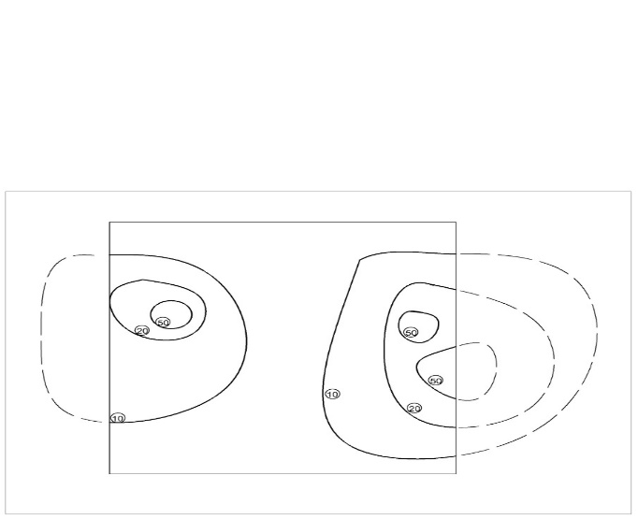

Contour lines cannot end anywhere but close on themselves within or outside the limits of the map.
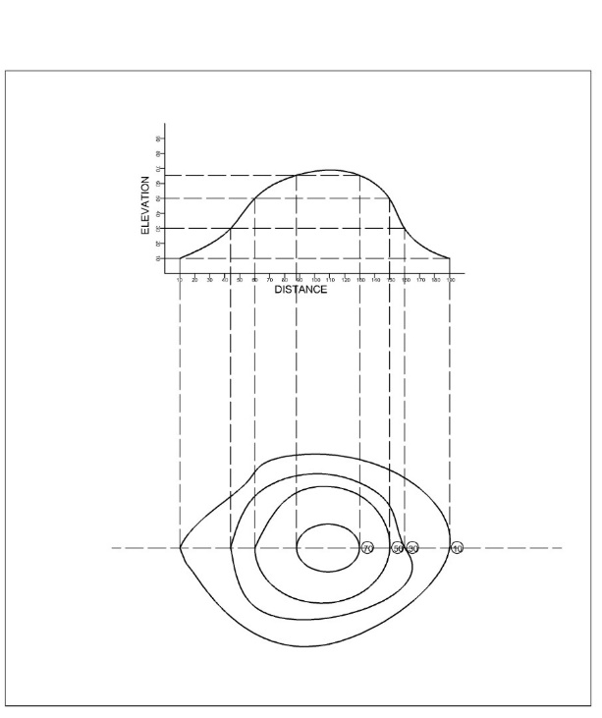
A series of closed contour lines on the map represent a hill, if the higher values are inside as shown above
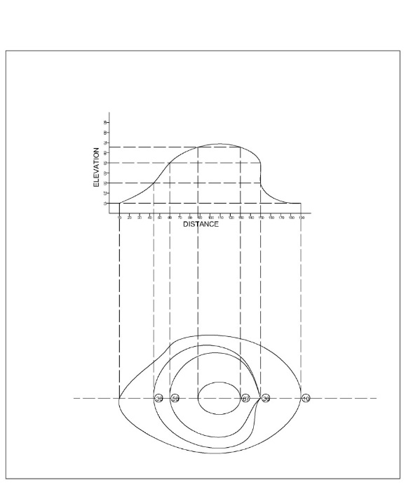
Contours never run into one another except for the us eof vertical cliff. In this are several contours considered and the horizontal equivalent becomes zero

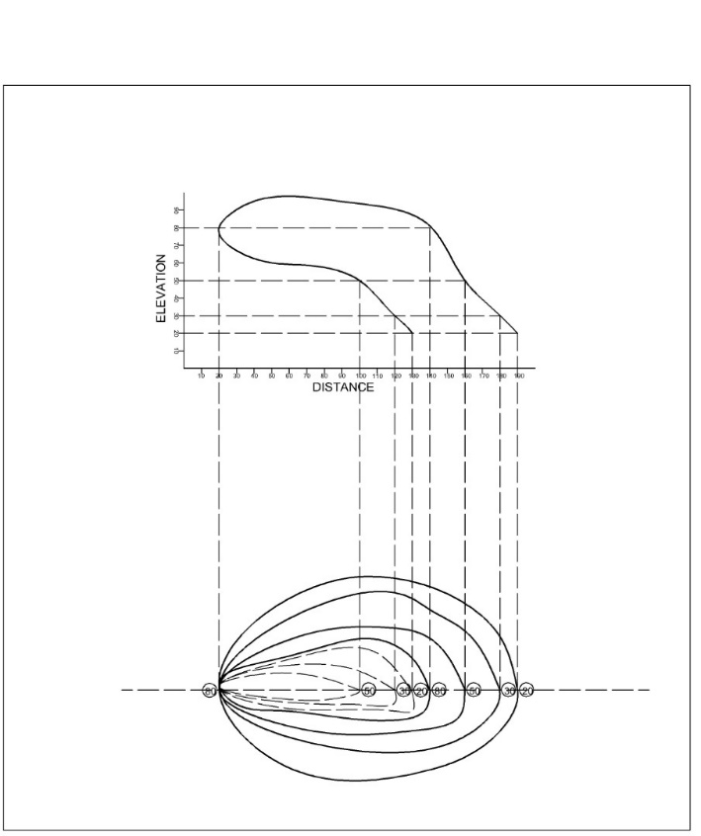
Contour lines cannot merge or cross each other on a map except in the case of an overhanging cliff.
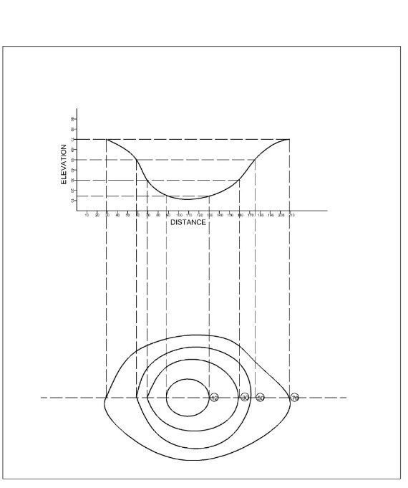
A series of closed contour on a map indicates a depression if the higher values are outside as shown above

