MY FEEDBACK FORM

S/N | PARAMETER | RESPONSE LEVEL
 |  | YES  (5 points) | NO  (0 points) | NOTSURE  (3points)
1 | Are you learning valuable information? |  |  | -
2 | Are the explanations of concepts clear? |  |  | -
3 | Is the Instructor’s delivery engaging? |  |  | -
4 | Are there enough helpful practice activities? |  |  | -
5 | Was the course description accurate? |  |  | -
6 | Is the instructor knowledgeable about the topic? | -
TOTAL SCORE |  | 20
FINAL REMARKS |  | An average course overall.
EXCELLENT (5POINTS) |  | -
FAIR (3 POINT)
POOR (0 POINTS)

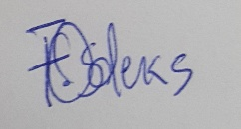
NAME/SIGNATURE/DATE: Sarah Odekwo 18/ENG02/066; ; 01-05-2020

